Arduino-based Wireless Motion Detecting System

Siti Syaidatul Syazlina Mohd Soleh
Faculty of Computer Science and Information Technology,
Universiti Tun Hussein Onn Malaysia, Parit Raja, 86400 Batu Pahat,
Johor, Malaysia ai150021@siswa.uthm.edu.my

Aida Mustapha Faculty of Computer Science and Information Technology,
Universiti Tun Hussein Onn Malaysia, Parit Raja, 86400 Batu Pahat,
Johor, Malaysia aidam@uthm.edu.my

Mohamad Md Som
Center of Diploma Studies Universiti Tun Hussein Onn Malaysia,
Parit Raja, 86400 Batu Pahat, Johor, Malaysia mohamads@uthm.edu.my

Nurul Ain Othman
Center of Language Studies, Universiti Tun Hussein Onn Malaysia,
Parit Raja, 86400 Batu Pahat, Johor, Malaysia nurulain@uthm.edu.my
Mohd Helmy Abd Wahab Faculty of Electrical and Electronic Engineering
Universiti Tun Hussein Onn Malaysia, Parit Raja, 86400 Batu Pahat,
Johor, Malaysia helmy@uthm.edu.my

Mohd Zainuri Saringat Faculty of Computer Science and Information Technology,
Universiti Tun Hussein Onn Malaysia, Parit Raja, 86400 Batu Pahat,
Johor, Malaysia zainuri@uthm.edu.my

Abstract—This project aims to help the public in protecting and avoiding criminal cases that are likely to occur in their neighbourhood. Such cases occur when the occupants are not at home or possibly even occur when the occupants are in the house. Intruders can unlock the house unknowingly by anyone. The Arduino Security System is a technology that uses PIR (Passive Infrared Sensor) sensors to detect such motions. This device has been created for home security systems. It uses Arduino Uno as a data processor. When the PIR detector detects movement, Arduino processes the data and triggers an alarm. At the same time, Arduino will also send the data via Wi-Fi modules to users via applications that have been uploaded to a user’s smartphone. Only homeowners can turn off the alarm system using a smartphone. The connection between the application and the circuit is connected using a Wi-Fi module. The application of this detector system can be a suitable security system in accordance with the current development.
Index Terms—security, motion, wireless, arduino

- INTRODUCTION
The project developed is the Application of Wireless Mo- tion Detection System using Arduino. This system app uses Arduino with the aim to help users from becoming victims of criminal cases such as house breakage, theft and aggression. The Arduino Security System is a technology that uses PIR (Passive Infrared Sensor) sensors to detect the movement. This device has been created for home security systems. Using Arduino Uno as a data processor, it can be a suitable security system in accordance with the current development. When the PIR detector detects movement, Arduino processes the data and triggers an alarm. At the same time, Arduino will also send the data via the Wi-Fi module to the user through the application in user’s smartphone.
There were many criminal offenses such as house breakage, invasion and theft. Such cases can be seen from the mass media or in the newspapers. They occurred when the occupants
of the house were not at home or even with the the possibility of occupants were in the house. Intruders can easily unlock the house unnoticed by anyone. The existing alarm system may be helpful or vice versa. Among the advantages that can be seen is that if there are movements detected, the alarm system will notify users with a sound. But if the occupants are not at home, how would they get the notification? It is because the alarm system has no connection with the users.
This project is set to develop an application of Wireless Motion Detection System by using Arduino platform and performing User Acceptance Testing as well as implementing external tester beta test (end user). This system application will be used by homeowners. Only the homeowners can turn off the alarm system using a smartphone. The apps and the circuit are connected using a Wi-Fi module. Wi-Fi module is connected only within limited distances. The alarm system between the Arduino circuits will be connected with the application developed for user. Wi-Fi module is used to connect the circuit and the application and it allows users to communicate between circuits through the developed applications.
The remaining of this paper is organized as follows. Section 2 presents systems similar to the proposed system. Section 3 presents the development methodology. Section 3 presents the prototype implementation and Section 4 presents the testing. Finally, Section 5 concludes with some indication for future works.
- RELATED WORK
Safety is defined as a condition that where one is protected from physical, political, social, financial, and other related matters involving undesirable events. Safety and security are important aspects in today’s life as everyone needs security guarantee when they are not at home. Therefore, various types of developments in technology were designed to provide

security at all times to protect one’s assets. This system application focuses on providing security when the users are outside or even inside their houses [1].
The alarm system helped users to be more alert about their home safety. Alarm system will warn the users if PIR sensor detected movement via the Wi-Fi module. This way, users will be notified if someone has intruded their residence and they could take immediate action to prevent something bad from happening. When the alarm system detected movements, users can track those movements through the mobile application.
- Arduino
Software is a generic term for various types of programmes used to operate computers and related devices. Software is divided into system application software that consists of op- erating system and programmes that supports the application. Arduino is a computer hardware and software company, project, and open source consumer community that designs and manufactures single microcontroller and microcontroller kits to build digital devices and interactive objects that can detect and handle objects in the physical world. Arduino board designs used a variety of microprocessors and controllers. The board is equipped with digital and analog input/output pin which can be connected with various expansion boards and other circuits. The board has serial communication interface, including Universal Serial Bus (USB) on some models that are also used for loading programmes from personal computers [2]. The microcontroller is usually programmed using C and
C++ programming language [3].
Android is a Linux-powered operating system developed by Google and designed for touch screen mobile devices like smartphones and tablets [4]. Android is an open source operating system, and Google has issued its source code under the Apache License. Android is very popular with technology companies that produces high-tech but low-cost devices.
- Comparison with Existing Systems
These existing systems have some advantages and disadvan- tages. Based on the research done, these systems are selected to create new systems to be developed. The hardware and software used were also taken into consideration.
  - PIR Sensor Arduino Alarm: PIR Sensor Arduino Alarm (Fig. 1) was created in June 2010 by John Edgar Park, an electrical engineer at Disney Research [5]. The alarm system used was the alarm trigger and the sensor used was PIR detector. This system did not use any other hardware or software. This system only used the basic hardware to create a motion detection system. This PIR sensor detected movements from a distance of 20 feet that equals to 7 meters only. The alarm system triggered the alarm when the sensor detected movements but there were no connection from the system to the user. This means that if the user was not in the area and the alarm system make sounds, the user will not be notified.
  - Arduino Controlled Motion Sensor: Arduino Controlled Motion Sensor (Fig. 2) was created in June, 2010 by Frank
G. Goethals working at IESEG School of Management, Lille,

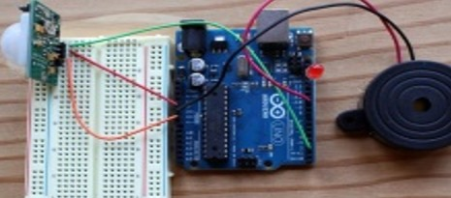

Fig. 1. PIR sensor arduino alarm.

France [6]. The alarm system used is LCD and the sensor used was PIR type parallax detector. The system used two different XBee model hardware namely XBeeSparkFun Explorer and XBee Adapter Kit. The system used advanced technology which was XBee, model hardware that can display messages via the LCD. When the sensor detected movements, the alarm system will display the message through the LCD. This means that users were aware of their home security when the user sees the LCD screen. The system did not use alarm trigger system.
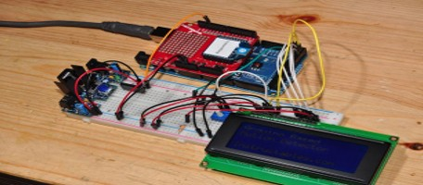
Fig. 2. Arduino controlled motion sensor.

This PIR sensor detected movement from a distance of 15 feet that equals to 4 meters only. This alarm system triggered alarm when the sensor detected movement and displays the message via the LCD but did not have any connection with the user. The user will only found out about their home security only when they see it on the LCD display.
  - Arduino Based Security System using GSM: Arduino Based Security System using GSM (Fig. 3) was created in August, 2017 by MaxPhi [7].
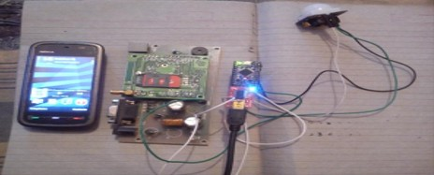
Fig. 3. Arduino-based security system using GSM.

The alarm system used was the alarm trigger and the sensor

used was PIR detector. This system used the Global System for Mobile Communications (GSM) hardware model. The system were using advanced technology with GSM modeling hardware that can send short messages that were set prior to the user. If the sensor detected movements, the alarm system triggered the alarm and sends a short message to the user. Users will only found out about their home security via short message but the alarm system will not be shut down until a specified time frame.
This PIR sensor detected movements from a distance of 20 feet that equals to 7 meters only. The detector distance value depends on specific conditions. This alarm system will trigger an alarm if the sensor detects movement and sends a short message to the user. The user will only found out about their home security when a short message is received but the alarm system cannot be turned off directly by the user.
  - Application of Wireless Motion Sensor System: This sys- tem was developed as a result of the combination of existing systems that have been modified to facilitate users. The system used ESP8266 NodeMcu Wi-Fi module technology to transmit data to the users through applications developed. The sensor system used was the same as the previous one which is the PIR sensor to detect the movements within a specified distance. Communication between user-shared circuits was through the application developed and connected using Blutooth module. Table I shows the comparison of existing systems with the new system developed in terms of sensors, alarm systems, hardware and software used. Overall, the system to be devel- oped has its own advantages and disadvantages depending on certain aspects. One of the advantages that can be stated, is that this system can send data to users through the application
system that has been uploaded to user’s smartphone.
Data transmission to the user is parallel with the alarm system used. Applications that have been uploaded to users’ smartphone will trigger an alarm if the alarm system detects movements. However, this application can only send warnings to the user but the user cannot view or monitor their residence area through this app because this system did not use camera type alarm system.

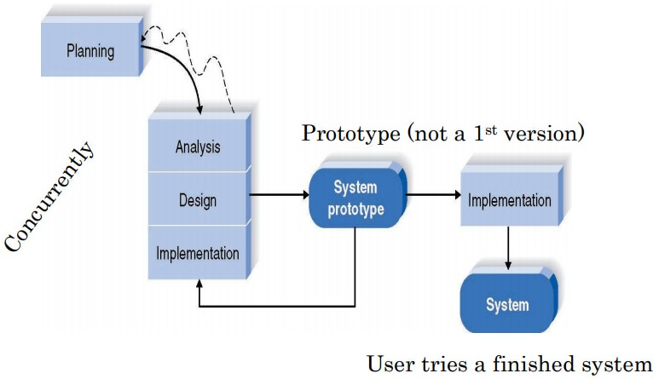

Fig. 4. Prototyping methodology.

materials to be used; and planning for the cost for each hardware and electronics items to develop this project.
- Analysis: Review and analyze any weaknesses and strengths of existing systems, hardware and electronic gadgets to be used in this of this project.
- Design: Designing application interface and circuit inter- face, schematic diagram, Arduino circuit flow charts and applications, use case diagrams, sequences, state transi- tion diagram, applications interface as well as circuit.
- Implementation: Application implementation, testing the system application, testing document.
IV. PROTOTYPE DEVELOPMENT
- Application System Design
Figure 5 illustrates the android application interface that has been developed using Android Studio 3.1 software. This application was developed to facilitate users to control the alarm system by simply pressing the buttons provided. This android app contains 3 modules which are the Wi-Fi connec- tion (Enable Wi-Fi), turn off Wi-Fi connection (Disable Wi-Fi) and turn off the alarm (Turn Off).

III. METHODOLOGY
The motion detector sensie system developed in this project is based on the Prototyping Methodology as shown in Figure
- This model has four main phases namely planning phase, analysis phase, design phase and implementation phase. The testing phase is combined together in the implementation phase for the purpose of simplifying the application and the circuit developed.
The work flow process for the prototype model is as follows. In each phase, there were certain activities that have been carried out before proceeding the next phase. These activities were set according to the correct flow of work to develop this project.
  - Planning: Identify the problems, objectives, purposes and scope of the project; identify hardware and electronic

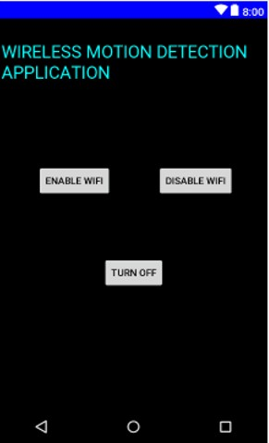
Fig. 5. Application interface.

TABLE I
COMPARISON BETWEEN THE PREVIOUS SYSTEMS WITH THE PROPOSED SYSTEM

Table  Head | Systems
 | PIR Sensor Arduino Alarm | Arduino Controlled Motion  Sensor | Arduino-based Security  System using GSM | Arduino Wireless Motion  Detector
Sensor  Microcontroller Alarm Connectivity | PIR Motion Sensor | PIR Motion Sensor | PIR Motion Sensor | PIR Motion Sensor
 | Arduino | Arduino | Arduino | Arduino
 | Trigger Sensor | LCD | Trigger Sensor | Trigger Sensor
 | None | XBee | GSM | Wi-Fi

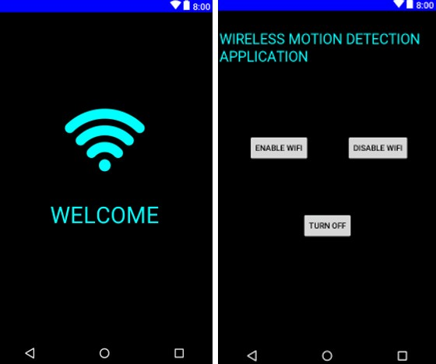
- Arduino Circuit Design
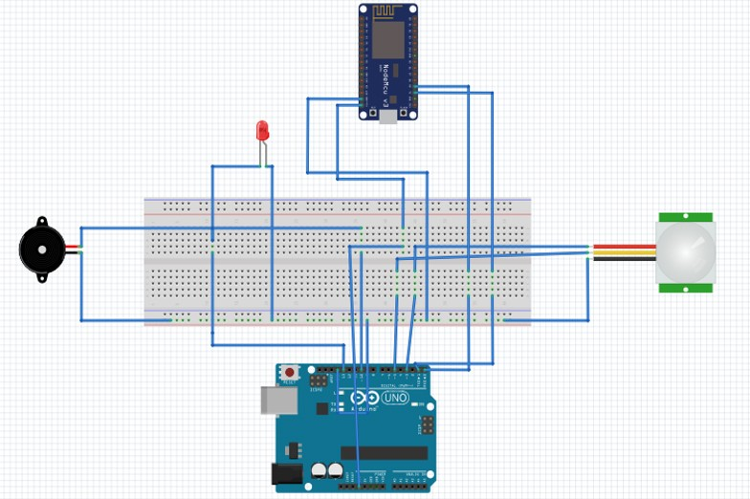
Figure 6 illustrates the Arduino circuit interface that has been created for this project by using the Fritzing software. Arduino circuit was designed to detect movement. Compo- nents used were Arduino Uno R3, ESP8266 NodeMcu Wi- Fi module, alarm, Red Light Emitting Diode (LED) and PIR Sensor. The connection between these components did not require soldering but requires sufficient jumper wires [?].

Fig. 7. Application main and sensor page.

Fig. 6. Arduino circuit interface.

From the figure, the design board was used to facilitate the components that were connected to the Arduino pins. The components used must be connected with the Male-Male jumper wire or Male-Female jumper wire in order to connect to the design board and the Arduino involved.
- Implementation and Testing
Android Studio 3.1 software was used to develop this system application. The system application used Java pro- gramming language. Arduino Software IDE 1.8.5 was used to develop an alarm system and also to programme Arduino Uno with the ESP8266 NodeMcu Wi-Fi module and other components. The application homepage was a startup to the application developed. On this page, users did not have to press any button to proceed to the next page. The sensor app page is a page used by users for connecting the Wi-Fi modules and turning off the alarms. On this page, there were three modules used, which were Wi-Fi connection (Enable Wi-Fi), Turn off Wi-Fi (Disable Wi-Fi), and turn off the alarm (Turn Off). Figure 7 shows the main page as well as the site where the sensor application developed.
The tracking system was the hardware used to track move- ment and send data to the application. This sensor system uses sophisticated technology such as Arduino Uno R3 ATmega, ESP8266 NodeMcu V3 Wi-Fi module, PIR sensor system, alarm and LED.
V. CONCLUSIONS
This project was developed with the intention to help users to keep their home safe. Security and safety including their personal belongings and property. Crime cases can occur unex- pectedly. To prevent criminal cases, the system was developed to help solve the problem. This system application could detect movements within specified distance and sends out data or notifications to the users through the application installed.
The system application was also developed to help users track movements using the Arduino platform that has been connected to users’ smartphone using Wi-Fi network. Among the advantages of this system application that has been iden- tified was that this system application can send a notification message to the user if the motion sensor detects movement over a Wi-Fi network. Additionally, the application also has a simple design that is easy to be used by the users.
In conclusion, the Application of Wireless Motion Detection System using Arduino can help users to ensure the safety of their home and properties. Using advanced technology such as Arduino and Wi-Fi ESP8266 V3 as well as the connec- tion between the alarm systems together with the developed

applications, it allows users to be well informed about their home security. The system has been successfully completed within a predetermined time frame and achieved the objectives outlined. However, there are still some weaknesses that need to be improved to produce a better detection system in the future.
REFERENCES
- N. F. Sallehuddin, “Kesedaran terhadap amalan keselamatan dalam kalan- gan pelajar di makmal kejuruteraan uthm,” Ph.D. dissertation, Universiti Tun Hussein Onn Malaysia, 2013.

- Y. Tawil, “Understanding arduino uno hardware design,” Allaboutcircuits. com, 2016.
- A. G. Smith, “Introduction to arduino,” published in September, vol. 30, pp. 115–125, 2011.
- “Android operating system,” https://www.investopedia.com/terms/a/android- operating-system.asp, accessed Septermber 21, 2018.
- J. E. Park, “Pir sensor arduino alarm,” https://makezine.com/projects/pir- sensor-arduino-alarm/, accessed Septermber 21, 2018.
- “Arduino controlled motion sensor,” https://www.instructables.com/id/Arduino-Controlled-Motion-Sensor/, accessed Septermber 21, 2018.
- A. Raj, “Arduino motion detector using pir sensor,” https://circuitdigest.com/microcontroller-projects/arduino-motion- detector-using-pir-sensor, accessed Septermber 21, 2018.

