# Geophysics Practical 7: Global seismology - Solutions

2. Ray parameter

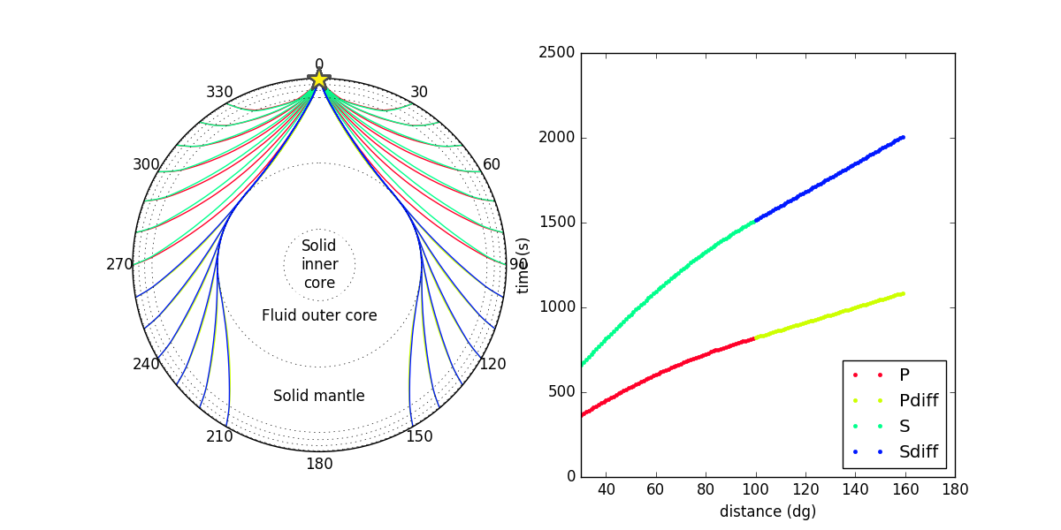

a) At what distance do diffracted P waves (which diffract at the core-mantle boundary) arrive at seismic stations? And diffracted S waves?

*Diffracting waves arrive at around 100 degrees epicentral distance from the earthquake (at 10 km depth).*

b) Why does the ray parameter of P and S phases decrease of a function of epicentral distance?

*As velocity increases as a function of depth, phases that turn deeper have lower horizontal slowness or ray parameter. Think of the ray parameter being defined at the turning point (tp) where :*

*With r decreasing with depth and v increasing with depth, the ray parameter decreases.*

c) Calculate from a plot the ray parameter for a P wave around 60 degree epicentral distance for a 500 km deep earthquake. What is the incidence angle of this phase at the station, given the P wave velocity at the surface is 5.8km/s? What is the outgoing angle at the earthquake for a P wave velocity of 9.6 km/s at 500 km depth?

*Read off the arrival times at 59 and 61 degrees:*

d) Why do we need the outgoing angle of a P wave to construct a fault plane solution?

*The outgoing angle (combined with the azimuth) are needed to plot the polarity of the P wave in a southern hemisphere projection to constrain the fault planes.*

e) The ray parameter for Pdiff and Sdiff is constant. It does not depend on earthquake depth or epicentral distance. Compute the ray parameter for Pdiff

\\in *s/rad*. Why do you think the ray parameter constant? Use the ray parameter to compute the velocity of Pdiff at the core-mantle boundary in km/s.

*Pdiff and Sdiff phases propagate along the core-mantle boundary (when the incidence angle exceeds the critical angle), there ray parameter or horizontal slowness is determined by their velocity at this depth (unlike other phases that turn at different depths).*

*Since their ray parameters are constant, you can read off two values anywhere in the plot. I took 100 and 140 deg distance:*

*Pdiff:*

Pdiff velocity at CMB

3. Core phases

a) At what range distances do SKS waves arrive? Why at these distances?

What about SKKS or SKKKS? What do the different branches of SKKS and SKKKS represent?

*SKS waves arrive between ~62 and 144 degrees. At shorter distances the S phase bottoms in the mantle, and not in the outer core. And longer distances the phase 'hits' the inner core.*

*A first 'direct' SKKS arrival arrives between 62 and 180 degrees. Because it bounces once at the core-mantle boundary, it does not interact with the inner core like the SKS phases does, and reaches further distances. Note that there is also a second SKKS phase between 84 and 180 degrees, which travels the long arc and bounces the CMB on the opposite side.*

*The 'first' SKKKS arrival as a similar range to SKKS, the long arc arrival arrives at all distances. There is also a third phase that circles the entire planet more than once.*

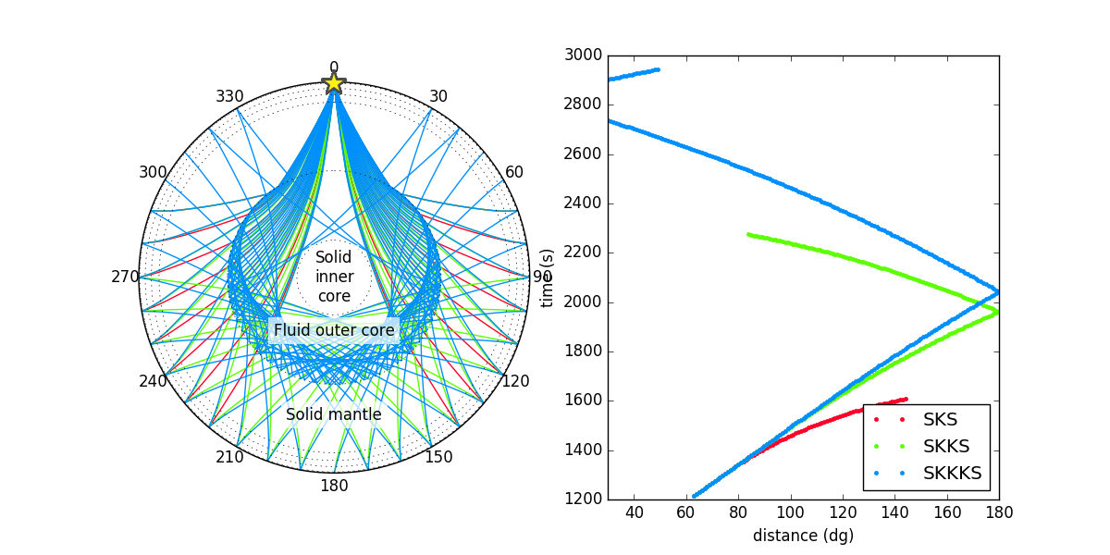

b) Look at the ray paths for PKIKP and PKJKP. Why are they so different?

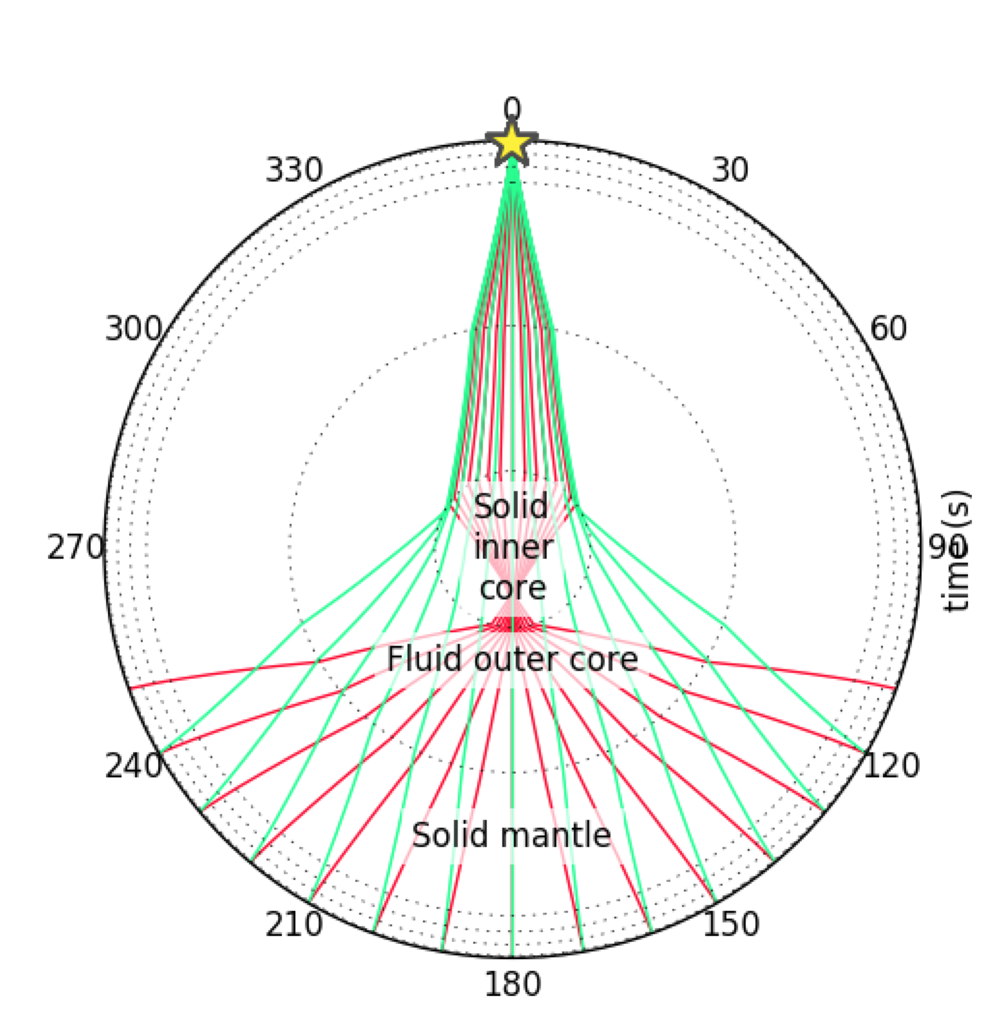 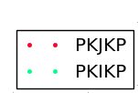

*It the inner core boundary the refracted P wave sees a slight increase in velocity, while the P-to-S converted wave sees a strong drop in velocity. This is why the incidence angle of the converted wave changes a lot. Using Snell's law:*

*As , will increase.*

*As , will decrease significantly*

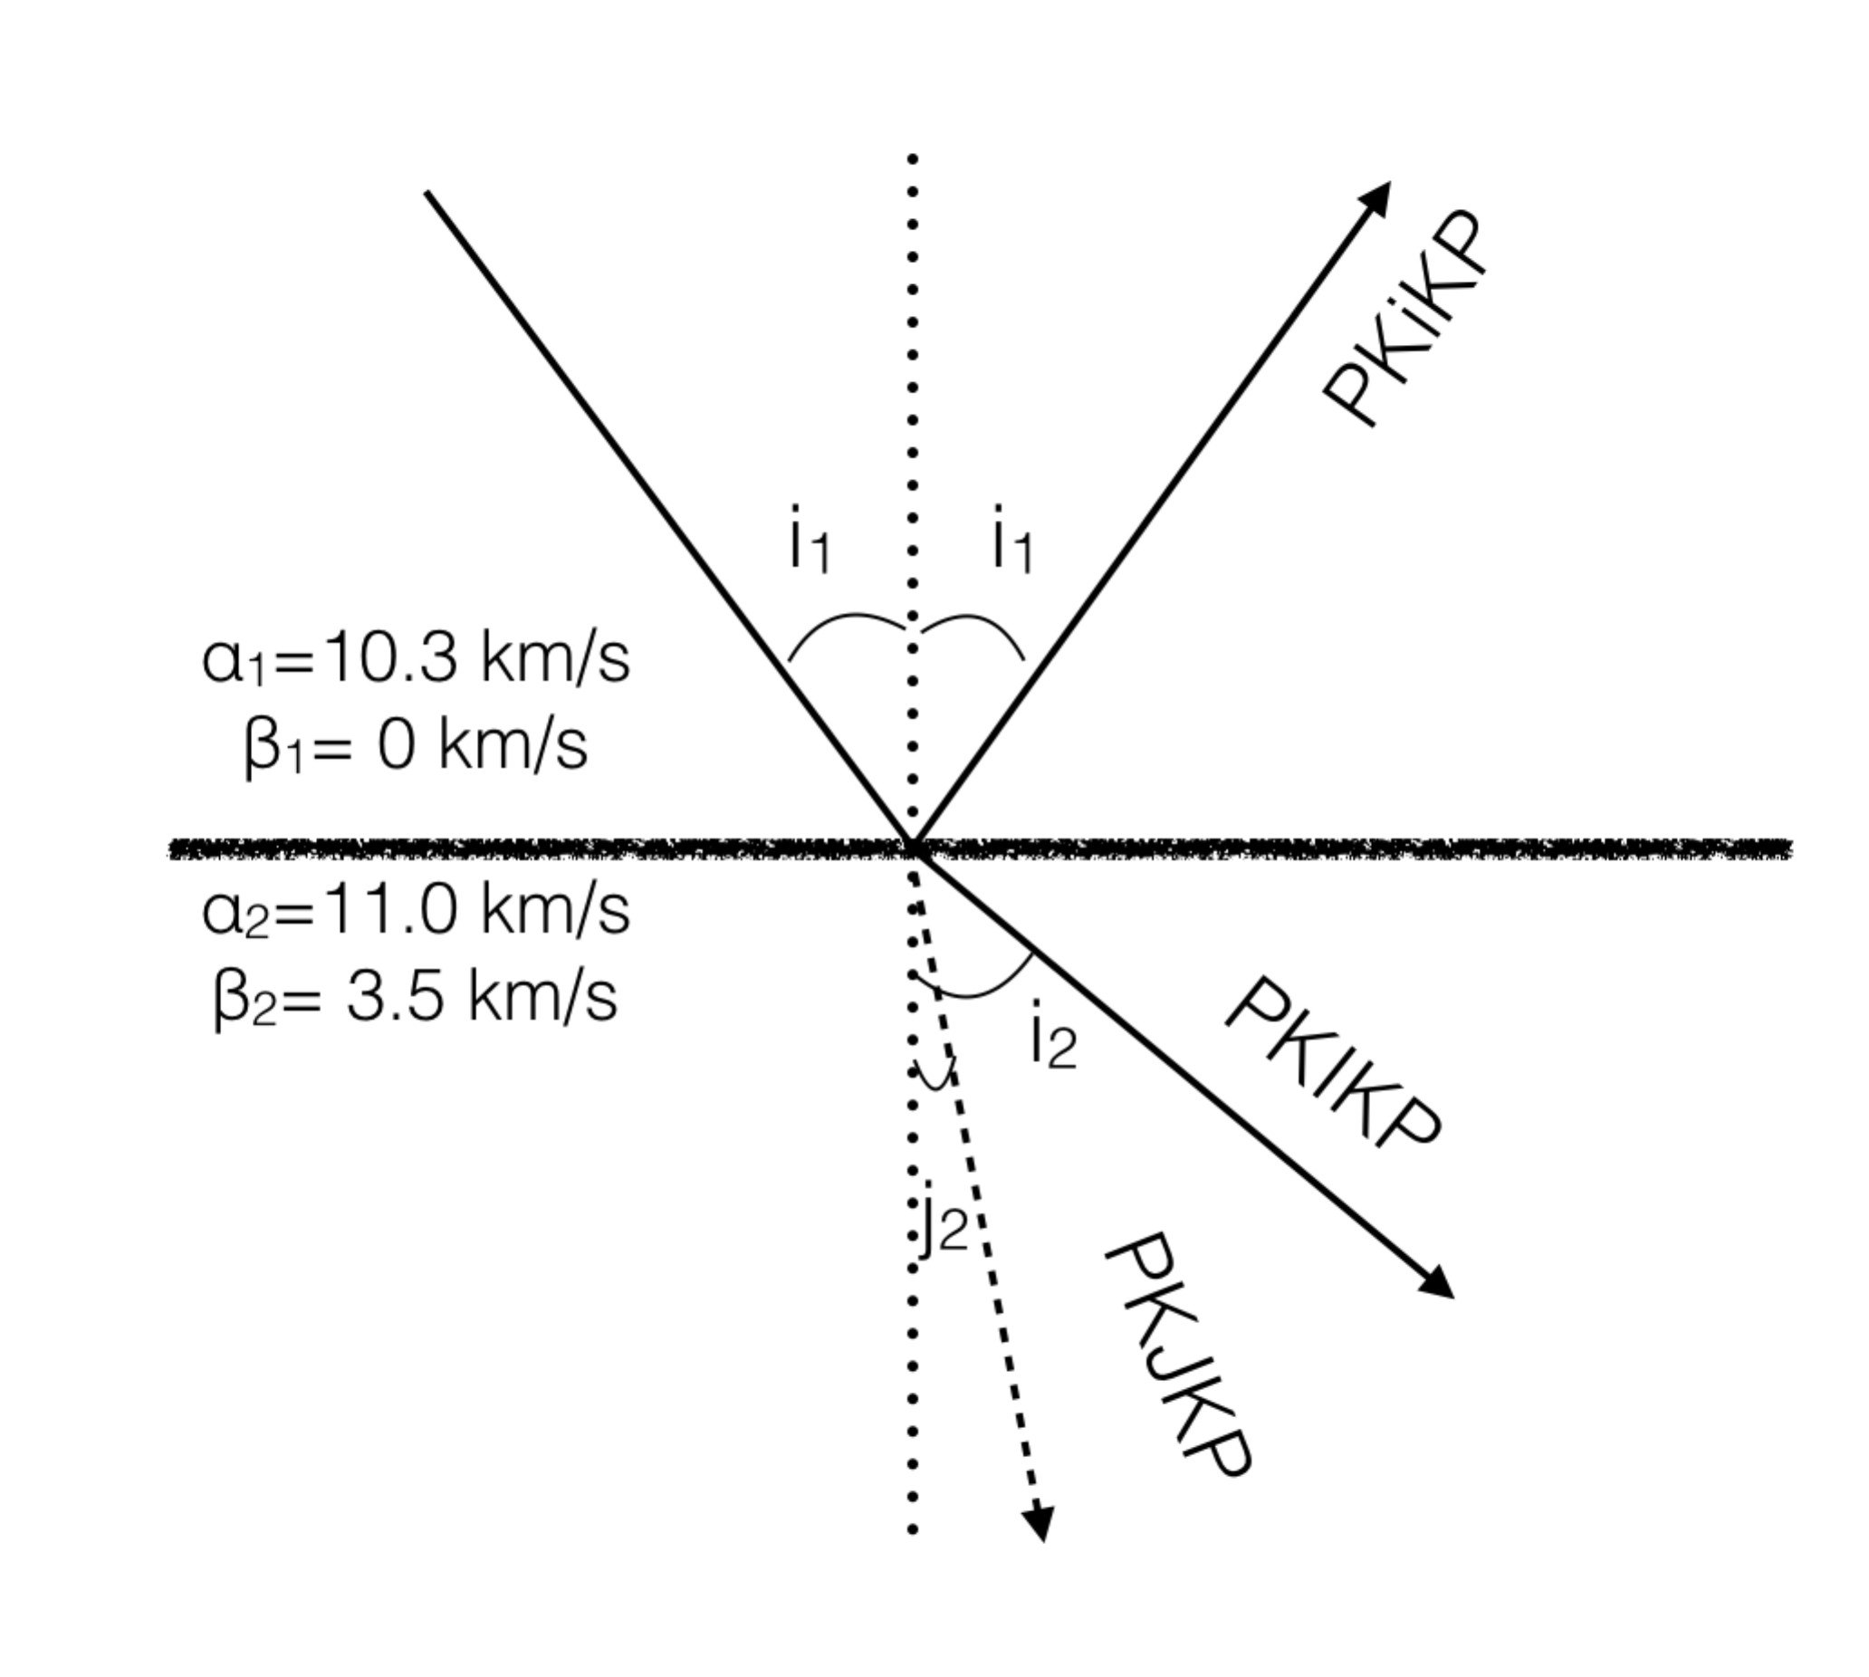

*When the phases exit the inner core, again the P-to-S wave will see a strong change in velocity and refract a lot.*

bonus question) Calculate the mean P wave and S wave velocities across the inner core. (Hint: you need a separate phase that represents the travel time across the mantle and outer core).

*The PKiKP phase (which reflects off the inner core boundary) for a 0 km depth earthquake at 0 deg distance can be used as a reference travel time. This wave arrives at roughly 994 seconds. The PKIKP wave at 180 degrees arrives at 1212 seconds so:*

*The PKJKP wave arrives around 1685 seconds:*

*The S wave velocity of the inner core is almost three times slower than the P wave.*

bonus question) Why do you think PKJKP is extremely difficult to observe in the real world?

*PKJKP waves are extremely small and cannot be seen in an individual trace due to noise. Many seismograms need to be combined to tease out the signal. Some observations have been made over the last two decades, which have all led to a publication.*

*The conversion from P-to-S at the ICB results in small amplitudes. The wave reduces in amplitude through absorption and scattering while traversing the Earth (relatively long ray path). In the true Earth 3D velocity affects cause the wave to arrive at a slightly unexpected travel time. 3D topographic effects on the ICB boundaries could also send the phases into slightly different directions and change their travel times. Unfortunately most large earthquakes do not have a lot of down-going P-wave energy to study the core (inner core research has 'benefitted' from nuclear tests decades ago).*

4. In Figure 2 you see the three components of a (synthetic) seismogram for station CDE in network AB and for a 100 km deep earthquake at 40 degrees distance.

a) Identify as many body and surface waves as you can using of the predicted travel times. Why do some phases only appear on specific components?

*Love waves arrive on the Transverse component. Rayleigh waves on the Vertical and Radial. P, pP, PP, PcP, are identifiable on the vertical and radial. S and sS on all three. Others (like ScS) arrive during the surface waves, which are much larger in amplitude. See figure below.*

*Phases that have purely SH motion (e.g. Love wave) appear on the transverse. P and SV energy appears on the vertical and radial (depending on the angle of incidence, e.g. a near-vertical S phase will arrive on the radial component).*

b) Which wave do you think has caused the most damage during this earthquake (if it wasn't a synthetic)?

*Love waves, due to their large amplitudes (check the y-scale) and destructive motions (buildings don't like being sheared).*

