# Geophysics Practical 7: Global seismology

To do this practical you need computer access to the script *body_wave_predictions.py*.

This script computes and plots ray paths and travel time predictions for body wave phases.



Figure Example output plot for 'P', 'PKP' and 'PKIKP' phases.

These computations are for a '1D Earth' with only velocity variations as a function of depth. The true Earth also has lateral velocity variations and topography on interfaces, which complicates identifying phases in a seismogram.

Remember the radius of the inner core boundary is at roughly 1220 km and of the core-mantle boundary at 3480 km.

|  |  |
| --- | --- |
|  | Body phase name examples |
| Mantle phases | P, S, PP, SS, PcP, ScS, Pdiff, Sdiff,... |
| Depth phases | pP, sP, pS, sS,... |
| Outer core phases | PKP, SKS, PKKP, SKKS, PKiKP, SKiKS |
| Inner core phases | PKIKP, PKJKP |

1. Run the script

a) Start your computer in Ubuntu. If your computer is on windows, turn it off and then on (if you reboot, Ubuntu will not work properly). While the computer is booting a screen will pop up with choices, where you can pick 'ubuntu' as the second option from the top. If you don't do anything it will start windows.

b) Use your username and password to log-in.

c) Once you are in Ubuntu we need to start a 'terminal', in which to execute the commands to run the script. Click on this symbol 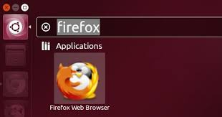 in the upper left corner, and type 'terminal' to search this application on the computer. To start the terminal, click on 'terminal' under 'applications'. This should bring up a screen in which you can type commands.

d) If this is your first time in a terminal, try some of these standard terminal commands to move around:

*pwd* shows path directory of the directory you are in

*ls* shows the files and directories that are in the directory

*mkdir ESA13* makes a directory named 'ESA13'

*cd ESA13* goes into the directory 'ESA13'

*cd ..*  goes 'up' one directory

Ways to move and copy files:

*cp file1 file2* Copies file1 to file2

*cp file1 dest.* Copies file into destination directory, giving it the same name

*cp file1 ./* Copies file to current directory

*mv file1 dest.* Moves file1 to a destination directory, without keeping the old version

*rm file1* Removes file1

e) Now you can retrieve the files for the practical by typing:

*cp /usr/local/practicals/ESA13/*.py ./*

(* is a wild card, so this copies all files that end with *.py. ./* is the destination to copy to*.*)

If you type *ls* now, you should see the files *body_wave_predictions.py* and *phases.py.*

f) To run the script *body_wave_predictions.py*, you have to be in the same directory as the script (and *phases.py* should also be in the directory). Run by typing:

*python body_wave_predictions.py*

If all goes well, a figure similar to Figure 1 should pop up within several seconds.

* You can hover the pointer over the plot and read off x and y values in the lower right corner.
* Clicking on the magnifying glass in the lower left corner allows you to zoom in on part of the travel time plot (this will not work for the polar projection on the left). Pressing the left arrow key, will 'undo' the zooming.

g) To edit what is being plot, open the script in an editor:

*gedit body_wave_predictions.py &*

The main lines to change are between lines 22 and 39. Feel free to change more, if you break it, you can recopy the original file.

Change the phases to be plot to ["S", "SKS", "SKIKS"]. Press save and rerun in the terminal.

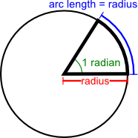2. Ray parameter

a) At what distance do P waves start diffracting at the core-mantle boundary? And S waves? Plot the direct and core-diffracted phases to answer this question. The diffracted phases are known as 'Pdiff' and 'Sdiff'.

The horizontal slowness (inverse of velocity) of a ray, a.k.a. the ray parameter, is constant along a ray path. The ray parameter for a spherical earth is given by:

Figure . ***r***is equal to the *radius* and the *arc length*

$$p=\frac{r\sin{i}}{v} =\frac{dT}{dX}= [s/rad]$$

where

$$r =arc length per radians = radius from center=\left[km/rad\right]$$

$i = the angle of propoagation$

$$v = wave velocity =[km/s]$$

$$dT = change in time =[s]$$

$$dX = angular change in distance =[rad]$$

Note that while *p* is constant along a ray, *r*, *i* and *v* vary.

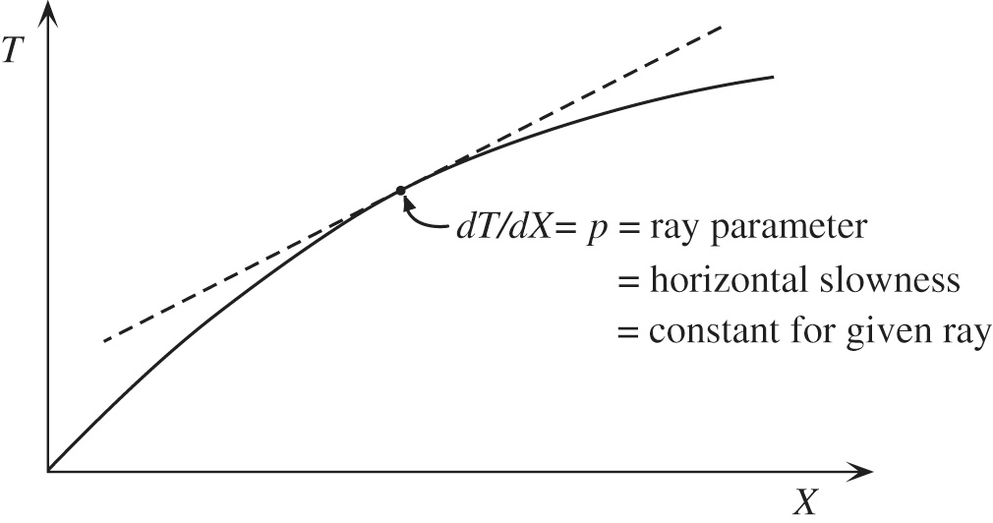

Figure Relationship between ray parameter and a travel time curve.

b) Why does the ray parameter of P and S phases decrease of a function of epicentral distance?

c) Estimate the ray parameter for a P wave at 60 degree epicentral distance for a 500 km deep earthquake. What is the incidence angle of this phase at the station, given the P wave velocity at the surface is 5.8 km/s? What is the outgoing angle at the earthquake for a P wave velocity of 9.6 km/s at 500 km depth?

*From the diagram you can compute dT/dX in s/deg. Then convert to s/rad to use the above equation:*

$\left[s/{deg}\right]∙{180}/π=\left[s/{rad}\right]$

d) Why do we need the outgoing angle of a P wave to construct a fault plane solution?

e) The ray parameter for Pdiff and Sdiff is constant and does not depend on earthquake depth or epicentral distance. Compute the ray parameter for Pdiff in *s/rad* by reading off the travel times as a function of distance. Why do you think the ray parameter constant? Use the ray parameter to compute the velocity of Pdiff at the core-mantle boundary in km/s.

3. Core phases

a) To test if there is an anomalous layer at the top of the outer core, seismologists try to measure the travel time differences between SKS and SKKS, SKKS and SKKKS etc.

At what range distances do SKS waves arrive? Why at these distances?

What about SKKS or SKKKS? What do the different branches of SKKS and SKKKS represent?

b) Look at the ray paths for PKIKP and PKJKP. Why are they so different? Consider how phases refract at the inner-core boundary.

*Bonus Question:* Calculate the mean P wave and S wave velocities across the inner core. (Hint: you need a separate phase that represents the travel time across the mantle and outer core).

*Bonus Question:* Why do you think PKJKP is extremely difficult to observe in the real world?

4. Detection of phases on a seismogram

In Figure 4 you see the three components of a (synthetic) seismogram for station CDE in network AB and for a 100 km deep earthquake at 40 degrees distance.

a) Identify as many body and surface waves as you can making use of the predicted travel times. Why do some phases only appear on specific components?

b) Which wave do you think has caused the most damage during this earthquake (if it wasn't a synthetic)?

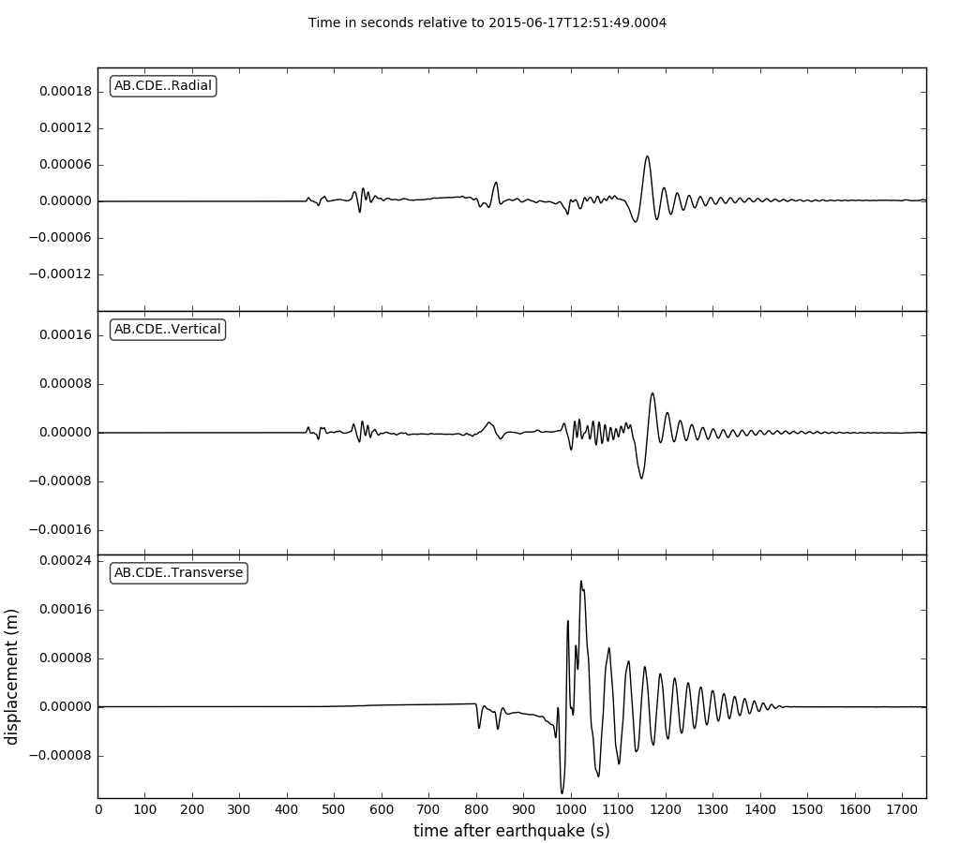

Figure Three components of a (synthetic) seismogram for station CDE in network AB and for a 100 km deep earthquake at 40 degrees distance.