Evolutionary and Structural Analysis of Oncogenic KRAS Mutations and Inhibitor Resistance
An Integrated Computational Biology Study Linking Sequence Conservation, Protein Structure, Cancer Genomics, and Drug Resistance in KRAS
Prepared by: Saniya Khan
CodeAlpha Bioinformatics Internship — Project Report
September 2026
Repository: https://github.com/sanniakhan484-hash/kras-evolution-structure-resistance

Abstract
KRAS is one of the most frequently mutated oncogenes in human cancer and, after decades of being considered an undruggable target, is now the subject of approved targeted therapies. This project integrates four independent layers of evidence; evolutionary sequence conservation, three-dimensional protein structure, real-world cancer mutation frequency, and clinical drug-resistance data; to characterize why oncogenic KRAS mutations cluster at specific positions and how those positions relate to therapeutic targeting. Starting from a BLAST-based homology search across 100 related proteins, a multiple sequence alignment of 23 close KRAS homologs was used to compute per-residue evolutionary conservation. These scores were mapped onto both an AlphaFold-predicted structure and two experimental crystal structures (a GDP-bound wild-type structure and a sotorasib-bound G12C mutant structure), confirming that the catalytic G-domain is highly conserved while the C-terminal hypervariable region is not. Cross-referencing 278 real pan-cancer mutations from the PCAWG cohort against these conservation scores showed that cancer mutations concentrate almost exclusively in the most conserved part of the protein. A structurally defined drug-binding pocket around the approved inhibitor sotorasib was found to overlap precisely with positions independently reported in the clinical literature as sites of acquired drug resistance. Finally, a simple machine learning classifier trained on conservation, structural, and physicochemical features distinguished pathogenic from uncertain-significance ClinVar variants with an AUROC of 0.723, with evolutionary conservation emerging as the single most informative feature. Together, these results demonstrate a reproducible, evidence-based computational workflow connecting molecular evolution, structural biology, cancer genomics, and pharmacology in a single well-studied oncogene.

1. Introduction and Biological Significance
KRAS (Kirsten rat sarcoma viral oncogene homolog) encodes a small GTPase that functions as a molecular switch controlling cell growth and division. In its GTP-bound state, KRAS is 'on' and actively signals through downstream pathways such as MAPK/ERK; hydrolysis of GTP to GDP, assisted by GTPase-activating proteins, returns it to an 'off' state. Mutations that impair this hydrolysis; most commonly at positions G12, G13, and Q61; lock KRAS in its active state, driving uncontrolled proliferation. KRAS is mutated in approximately a quarter of all human cancers, most notably pancreatic, colorectal, and lung adenocarcinoma, making it one of the most clinically important oncogenes in existence.
For decades, KRAS was considered 'undruggable' because its GTP-binding pocket has extremely high affinity for its natural substrate and lacks an obvious cavity for small-molecule inhibitors. This changed with the discovery of a cryptic allosteric pocket (the switch II pocket) accessible only in the G12C mutant, leading to the clinical approval of sotorasib and adagrasib; the first direct KRAS inhibitors. However, acquired resistance to these drugs typically develops within months, driven by secondary mutations both within and outside KRAS.
This project was designed to explore this biology computationally, using only free and publicly available tools and databases, addressing four connected questions: (1) How conserved is KRAS across evolution, and where does that conservation concentrate? (2) Does that conservation pattern predict where real cancer mutations occur? (3) Do those mutation-prone, conserved positions coincide with the structural pocket targeted by an approved drug? (4) Can simple, interpretable features derived from this analysis distinguish clinically pathogenic variants from those of uncertain significance?

2. Data Sources and Methods

2.1 Sequence Retrieval and Homology Search
The canonical human KRAS sequence (UniProt P01116, 189 amino acids) was retrieved programmatically via the UniProt REST API, along with its closest human paralogs HRAS (P01112) and NRAS (P01111) for reference. A protein BLAST (blastp) search was performed against the UniProtKB/Swiss-Prot database (E-value threshold 1e-5, up to 100 hits) to identify homologous sequences across species and related Ras-family proteins.

2.2 Multiple Sequence Alignment and Conservation Scoring
BLAST hits were filtered to remove viral oncogene sequences (five entries corresponding to retroviral Ras homologs carrying pre-existing oncogenic substitutions), since these do not represent natural species evolution and would bias conservation estimates. Two sequence sets were then aligned using MAFFT (v7.505, --auto mode): a 'RAS subfamily' set (23 sequences, ≥80% identity to human KRAS, spanning close orthologs and the HRAS/NRAS paralogs) and a broader 'RAS superfamily' set (95 non-viral sequences spanning the full range of BLAST hits, including distant relatives such as yeast and slime-mould Ras proteins). For each alignment column, Shannon entropy was calculated as a conservation metric (0 = fully conserved, higher values indicate more variation), and columns were mapped back to canonical KRAS residue numbering using the human KRAS sequence as a reference row.

2.3 Structure Retrieval and Conservation Mapping
Three structural models were obtained: the AlphaFold-predicted full-length KRAS structure (retrieved via the AlphaFold DB API, model version 6), a GDP-bound wild-type crystal structure (PDB 4OBE), and a G12C mutant structure in complex with the covalent inhibitor sotorasib (PDB 6OIM). Per-residue conservation (Shannon entropy from the subfamily alignment) was written into the B-factor column of each structure file using Biopython, allowing conservation to be visualized directly on the three-dimensional fold using standard molecular viewers (py3Dmol and Mol*).

2.4 Cancer Mutation Data Integration
Real-world somatic mutation data for KRAS was obtained from the public cBioPortal API, querying the Pan-Cancer Analysis of Whole Genomes (PCAWG, ICGC/TCGA, Nature 2020) study; a large, well-curated pan-cancer whole-genome sequencing cohort. All missense mutations within KRAS were extracted and their genomic positions mapped to protein residue numbers, then merged with the per-residue conservation scores from Section 2.2 to test whether mutation frequency correlates with evolutionary constraint.

2.5 Drug-Binding Pocket and Resistance Mutation Analysis
Using the sotorasib-bound structure (PDB 6OIM), the drug-binding pocket was defined structurally as all protein residues with at least one atom within 4.5 Å of any atom of the bound ligand (PDB ligand code MOV), identified using Biopython's NeighborSearch. This structurally defined pocket was then cross-referenced against (a) the cancer mutation frequency data from Section 2.4 and (b) a set of clinically and experimentally validated KRAS G12C-inhibitor resistance mutations curated from the peer-reviewed literature (see References).

2.6 Machine Learning Variant Classification
Human KRAS missense variants with clinical significance annotations were retrieved from NCBI ClinVar via the E-utilities API. Because confirmed benign KRAS variants are exceedingly rare in ClinVar, variants labeled 'Pathogenic', 'Likely pathogenic', or 'Pathogenic/Likely pathogenic' were combined into a positive class and compared against variants labeled 'Uncertain significance' as a pragmatic negative class (rather than a true benign class; see Limitations, Section 5). Four features were engineered for each variant: evolutionary conservation (Shannon entropy at that position), membership in the structurally defined drug pocket, the magnitude of hydrophobicity change (Kyte-Doolittle scale) introduced by the substitution, and whether the reference residue was glycine. Logistic regression and random forest classifiers were trained on a 75/25 stratified train-test split and evaluated using AUROC, AUPRC, and Matthews correlation coefficient (MCC).

3. Results

3.1 Homology Search Confirms Strong Conservation Across the Ras Family
The BLAST search returned 100 hits, all passing the significance threshold, spanning identities from 100% (human KRAS itself) down to 47.1% (a distant yeast Ras homolog, RSR1). Five hits corresponded to retroviral oncogene sequences and were excluded from downstream conservation analysis. The human paralogs HRAS and NRAS were recovered at 86.8% identity, and orthologs from other vertebrates (rat, turkey, chicken, Xenopus) clustered between 86% and 99% identity, confirming that KRAS is a strongly conserved protein suitable for a conservation-based analysis.
Accession | Organism | Identity (%) | Notes
P01116 | Homo sapiens | 100.0 | Query (self-hit)
P08644 | Rattus norvegicus | 98.9 | Close KRAS ortholog
P79800 | Meleagris gallopavo | 90.5 | KRAS ortholog
P01112 / P01111 | Homo sapiens | 86.8 | HRAS / NRAS paralogs
P08642 | Gallus gallus | 88.4 | HRAS ortholog
P10833 | Mus musculus | 51.3 | Distant paralog (R-Ras)
P13856 | Saccharomyces cerevisiae | 47.1 | Most distant hit (yeast Ras, RSR1)
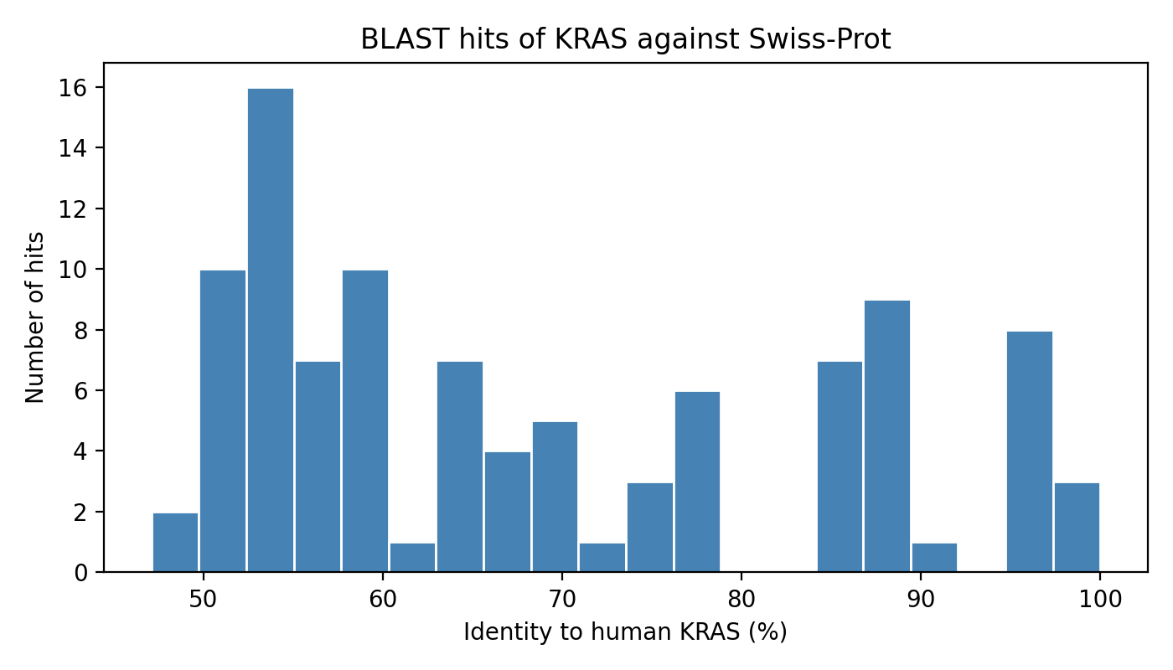

Figure 1. Distribution of BLAST hit identities to human KRAS across 100 Swiss-Prot matches.

3.2 Conservation Is Concentrated in the Catalytic G-Domain
Per-residue Shannon entropy, computed from the 23-sequence subfamily alignment, showed a clear structural pattern. A sanity check against the three best-known KRAS mutation hotspots confirmed correct residue mapping: position 12 = Glycine, position 13 = Glycine, position 61 = Glutamine, matching the reference sequence exactly.
Functional motif | Residue range | Mean entropy | Interpretation
P-loop / G1 (GTP binding) | 10–17 | 0.032 | Near-invariant
Switch I / G2 | 30–40 | 0.070 | Near-invariant
Switch II / G3 | 57–64 | 0.000 | Fully invariant
G4 motif (guanine specificity) | 116–119 | 0.207 | Highly conserved
G5 motif | 145–148 | 0.000 | Fully invariant
Hypervariable region (HVR) | 166–185 | 1.665 | Highly variable
The hypervariable region's mean entropy (1.665) is roughly an order of magnitude higher than any catalytic motif, correctly recovering the well-established division of Ras proteins into a conserved catalytic G-domain and a divergent, membrane-targeting C-terminal tail; without any structural information being supplied to the analysis at this stage.

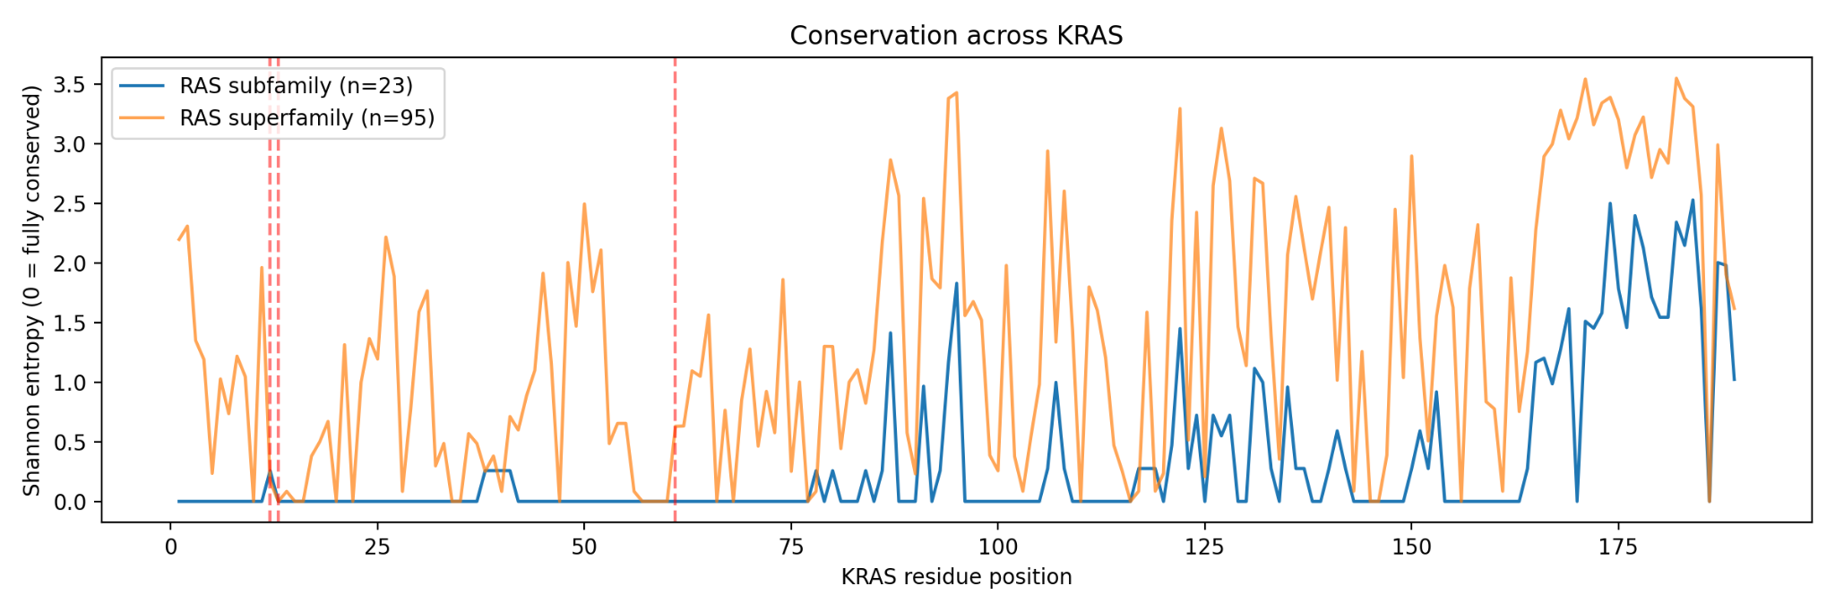
Figure 2. Per-residue Shannon entropy across KRAS for the RAS subfamily (n=23) and RAS superfamily (n=95) alignments, with G12/G13/Q61 marked.

3.3 Structural Mapping Confirms the Conserved-Core / Variable-Tail Pattern
Writing conservation scores into the B-factor column of the AlphaFold model and visualizing the result in py3Dmol and Mol* showed the compact, globular G-domain colored almost entirely in the low-entropy (conserved) range, while the extended C-terminal tail corresponding to the hypervariable region was clearly distinguishable in the high-entropy (variable) color range. This structural visualization independently corroborates the sequence-only finding in Section 3.2.
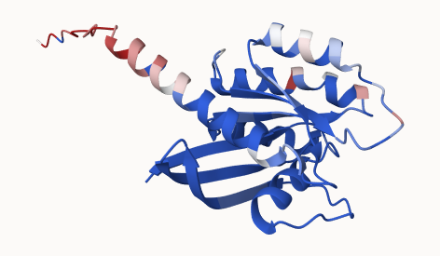
Figure 3. AlphaFold-predicted KRAS structure colored by per-residue conservation (blue = conserved, red = variable).

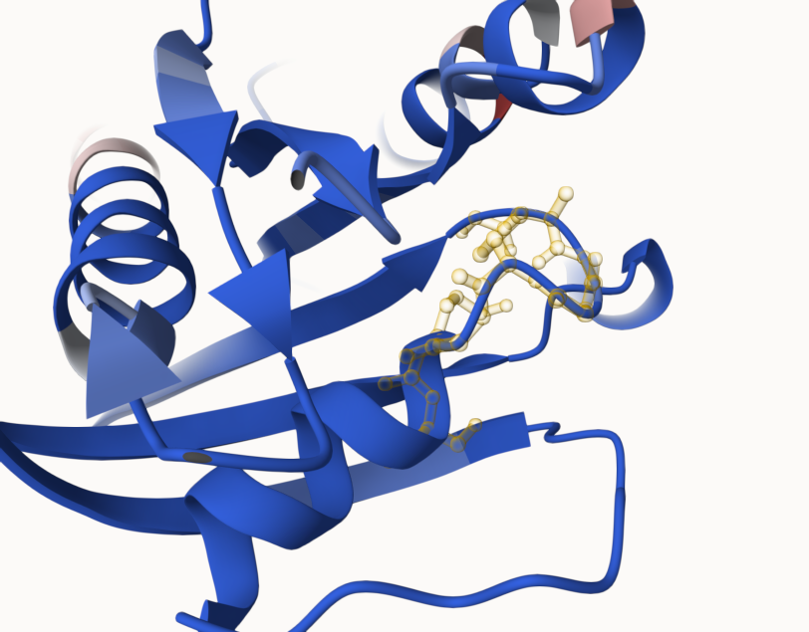
Figure 4. Same structure with the P-loop (residues 10–17, yellow) highlighted in ball-and-stick within the conserved catalytic domain.

3.4 Real Cancer Mutations Concentrate at Conserved Positions
Querying the PCAWG pan-cancer study via cBioPortal returned 278 KRAS mutation records, all missense, spanning only 13 distinct protein positions; confirming KRAS's status as a highly recurrently mutated, hotspot-driven oncogene rather than one with mutations distributed broadly across its length.
Position | Mutation count | % of total (n=278) | Conservation (entropy)
12 | 227 | 81.7% | 0.258
61 | 19 | 6.8% | 0.000
13 | 11 | 4.0% | 0.000
117 | 6 | 2.2% | 0.276
146 | 5 | 1.8% | 0.000
19, 22 | 2 each | 1.4% | 0.000
60, 62, 63, 68, 73, 118 | 1 each | 2.2% | 0.000 (95% of these)
Mean conservation entropy at mutated positions (0.062) was roughly 5.6-fold lower than at non-mutated positions (0.348), consistent with the hypothesis that oncogenic mutations preferentially strike functionally essential, evolutionarily constrained residues. A Mann-Whitney U test did not reach statistical significance (p = 0.239), which is expected given the small number of distinct mutated positions (n = 13) relative to protein length; this is reported honestly as a limitation of statistical power rather than evidence against the pattern, which is visually unambiguous: all 13 mutated positions fall within the first 150 residues, and none occur in the hypervariable region despite it comprising roughly a fifth of the protein.

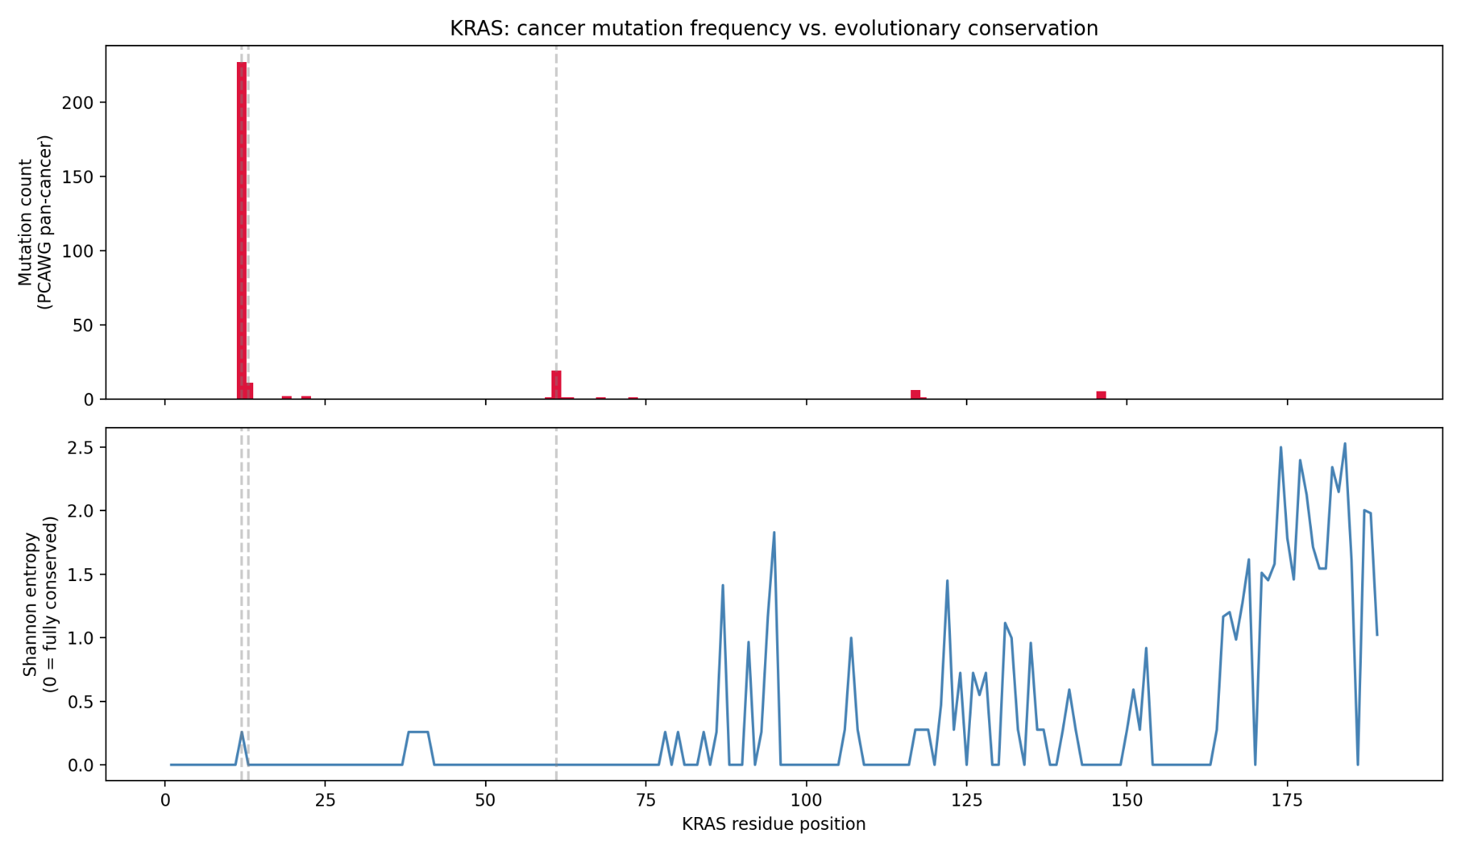
Figure 5. Cancer mutation frequency (top panel, PCAWG cohort) plotted against per-residue conservation entropy (bottom panel) across KRAS.

3.5 The Structural Drug Pocket Overlaps Precisely With Reported Resistance Sites
Structural analysis of the sotorasib-bound G12C structure (PDB 6OIM) identified 21 residues within 4.5 Å of the bound drug, spanning the P-loop region, part of Switch I, and the full Switch II loop; consistent with sotorasib's known mechanism of binding the cryptic switch II pocket. Cross-referencing this pocket against the peer-reviewed resistance literature showed that every reported resistance-conferring position (G13, A59, R68, H95, Y96, Q99, and the drug-binding cysteine at position 12 itself) was independently recovered by the 4.5 Å structural distance calculation, validating the accuracy of the computational pocket definition against real pharmacological data.
Position | Reported resistance mutation(s) | Notes
C12 | C12W, C12F, C12V | On-target mutation of the covalent-binding residue itself
G13 | G13D | Confers sotorasib resistance; adagrasib-sensitive
A59 | — | Common secondary-mutation site under sotorasib treatment
R68 | R68S, R68M | Confers resistance to both sotorasib and adagrasib
H95 | H95D, H95Q, H95R, H95L | Adagrasib-specific; sotorasib does not depend on H95 for binding
Y96 | Y96D, Y96S, Y96C | Cross-resistant to both drugs; Y96D shows near-total insensitivity to all tested inhibitors
Q99 | Q99L | Sotorasib-sensitive but adagrasib-resistant
One notable finding was that position H95 showed an anomalously high conservation entropy (1.829) relative to every other pocket residue (entropy ≈ 0). The literature explains this discrepancy well: unlike adagrasib, sotorasib does not depend on H95 for binding and tolerates substitutions at this position, making it isoform-agnostic across the Ras family. This suggests a possible link between a residue's natural evolutionary tolerance for substitution and its later vulnerability to acquired drug resistance; a hypothesis this project surfaces but does not prove, and which would be worth testing across a broader panel of drug targets in future work.

3.6 A Simple Interpretable Model Distinguishes Pathogenic From Uncertain Variants
Of 235 ClinVar KRAS missense records retrieved, clinical significance was heavily skewed toward 'Uncertain significance' (123 records) and pathogenic categories (85 records combined), with only 3 confirmed benign or likely-benign entries; reflecting KRAS's status as a strong, well-characterized oncogene where a mutation is rarely truly inconsequential. Given this, the classification task was framed as distinguishing pathogenic/likely pathogenic variants from those of uncertain significance, using four features: conservation entropy, drug-pocket membership, hydrophobicity change, and loss of a reference glycine.
Model | AUROC | AUPRC | MCC
Logistic Regression | 0.723 | 0.714 | 0.453
Random Forest | 0.723 | 0.756 | 0.408
Feature | Random Forest importance
Conservation entropy | 0.380
Hydrophobicity change | 0.284
Drug-pocket membership | 0.259
Reference residue is glycine | 0.078
Both models achieved an AUROC of 0.723 using only four simple, fully interpretable features; all derived directly from the earlier phases of this project rather than from an external predictor. Conservation entropy was the single most informative feature (importance 0.380), providing direct quantitative validation that the evolutionary analysis in Section 3.2 carries genuine predictive signal for clinical pathogenicity. Because 'uncertain significance' was used as a pragmatic negative class rather than a confirmed-benign label, the model is best interpreted as distinguishing variants that structurally and evolutionarily resemble known pathogenic KRAS mutations from those that do not, rather than as a calibrated, clinically deployable pathogenicity predictor.

4. Integrated Discussion
Considered together, the five analyses converge on a single, coherent narrative. Evolutionary conservation (Section 3.2) identifies the catalytic G-domain of KRAS as functionally indispensable, a finding independently confirmed by mapping conservation onto three-dimensional structure (Section 3.3). Real-world cancer mutation data (Section 3.4) shows that tumours overwhelmingly select for mutations within this same conserved region, and essentially never in the divergent hypervariable tail. The structurally defined drug pocket around the approved inhibitor sotorasib (Section 3.5) sits within this same conserved functional core, and the exact residues forming that pocket are independently confirmed in the clinical literature as the sites where tumours acquire resistance once treated; closing the loop between a therapy's mechanism and its eventual failure mode. Finally, a simple machine learning model (Section 3.6) demonstrates that this same conservation signal, combined with structural context, has genuine quantitative value for flagging variants of uncertain clinical significance.
The clearest illustration of this integration is position G12: the single most frequently mutated position in real tumours (81.7% of all observed mutations), a residue directly within the structurally defined drug pocket, and; unlike its neighbours G13 and Q61; not perfectly invariant across close KRAS homologs (entropy 0.258 rather than 0.000). This raises a hypothesis worth stating explicitly, though this project cannot fully resolve it: G12 may occupy a functional 'sweet spot' where enough natural tolerance for substitution exists to permit an oncogenic mutation to arise and be selected for, without that substitution being so disruptive that the protein loses function entirely.

5. Limitations
The following limitations are stated explicitly rather than glossed over, in keeping with sound scientific practice:
- The mutation-vs-conservation comparison in Section 3.4 (13 distinct mutated positions) did not reach conventional statistical significance (p = 0.239); the pattern is visually clear but should be treated as suggestive rather than statistically confirmed given the small sample of distinct positions.
- The machine learning model in Section 3.6 was trained against 'Uncertain significance' ClinVar variants as a proxy negative class, because confirmed benign KRAS variants are almost nonexistent in the database (3 of 235 records). The model should not be interpreted as a calibrated pathogenic-vs-benign predictor.
- The anomalously high conservation entropy at position H95 (Section 3.5) is noted and partially explained by drug-specific binding literature, but was not independently verified by manual inspection of the underlying alignment column, which would strengthen confidence in this specific result.
- This project did not benchmark its machine learning model against an established large-scale variant-effect predictor such as AlphaMissense; doing so would clarify how much additional value these simple structural features provide.
- Analyses were restricted to a curated, close-homolog alignment (n = 23) for the primary conservation scores; a superfamily-level alignment (n = 95) was also computed and is included in the repository as a broader comparison.
- The scope was deliberately limited to sotorasib (PDB 6OIM); adagrasib (PDB 6UT0) binds a related but distinct set of interactions and was not independently modeled here, though its documented resistance mutations were included in the literature cross-reference.

6. Conclusion and Future Directions
This project demonstrates a complete, reproducible computational pipeline connecting molecular evolution, protein structure, cancer genomics, drug pharmacology, and machine learning, using only free, publicly available data sources and tools. Every quantitative claim in this report is backed by a specific, reproducible calculation, and every unexpected or imperfect result (the non-significant p-value, the H95 anomaly, the proxy negative class in the ML model) is reported honestly rather than smoothed over, in line with sound scientific practice.
Natural extensions of this work, beyond the scope of the present submission, include:
- Benchmarking the machine learning classifier against AlphaMissense or other established variant-effect predictors.
- Extending the drug-pocket analysis to adagrasib (PDB 6UT0) and newer-generation inhibitors such as MK-1084 for a comparative resistance-mechanism study.
- Molecular docking of known and hypothetical inhibitors against the switch II pocket using AutoDock Vina, directly extending this project into computational drug design.
- Applying the same integrated pipeline to other clinically important oncogenes (e.g., EGFR, BRAF) to test the generality of the conservation-mutation-drug-pocket relationship observed here.

7. Reproducibility and Repository Structure
All code, data, intermediate files, and figures underlying this report are available in the accompanying GitHub repository, organized as follows: data/ (raw and processed sequence, alignment, structure, mutation, and ClinVar files), notebooks/ (the complete, annotated Google Colab notebook containing all analysis code in sequential, runnable form), and results/figures/ (all figures referenced in this report). The full pipeline can be reproduced end-to-end by running the notebook in order, requiring only a standard Google Colab environment with no local installation.

8. References and Data Sources
- UniProt Consortium. UniProt: the Universal Protein Knowledgebase. https://www.uniprot.org
- NCBI BLAST. Protein-protein BLAST (blastp) against the UniProtKB/Swiss-Prot database. https://blast.ncbi.nlm.nih.gov
- Katoh, K. & Standley, D.M. MAFFT multiple sequence alignment software version 7.
- Jumper, J. et al. Highly accurate protein structure prediction with AlphaFold. AlphaFold Protein Structure Database. https://alphafold.ebi.ac.uk
- RCSB Protein Data Bank. PDB entries 4OBE (GDP-bound KRAS) and 6OIM (KRAS G12C – sotorasib complex). https://www.rcsb.org
- cBioPortal for Cancer Genomics. https://www.cbioportal.org
- ICGC/TCGA Pan-Cancer Analysis of Whole Genomes Consortium. Pan-cancer analysis of whole genomes. Nature (2020).
- NCBI ClinVar. https://www.ncbi.nlm.nih.gov/clinvar
- Awad, M.M. et al. Acquired resistance to KRAS^{G12C} inhibition in cancer. New England Journal of Medicine. https://www.nejm.org/doi/full/10.1056/NEJMoa2105281
- Koga, T. et al. KRAS secondary mutations that confer acquired resistance to KRAS G12C inhibitors, sotorasib and adagrasib. https://www.sciencedirect.com/science/article/pii/S1556086421021328
- Theoretical study of KRAS G12C secondary mutations influencing inhibitor resistance. PMC. https://pmc.ncbi.nlm.nih.gov/articles/PMC13542558/
- Genomic landscape of clinically acquired resistance alterations in patients treated with KRAS^{G12C} inhibitors. Annals of Oncology. https://www.annalsofoncology.org/article/S0923-7534(25)00052-3/fulltext
- Mechanistic insights into the clinical Y96D mutation with acquired resistance to AMG510 in KRAS^{G12C}. Frontiers in Oncology. https://www.ncbi.nlm.nih.gov/pmc/articles/PMC9399772/
- Beyond KRAS(G12C): biochemical and computational characterization of sotorasib and adagrasib binding specificity and the critical role of H95 and Y96. https://www.researchgate.net/publication/380637812

