**ABSTRACT:**

The world of health care is becoming increasingly complex as new questions arise that need to be answered with more depth and greater insight.Information technology is contributing in significant ways to enhance health care delivery and to improve the quality of human life.Medico is a Cognitive application(chatbot) to help the people from different diseases.Now a days they are lot of diseases are entered into the society.In that some are more dangerous and some are little things.But most of the people unable to identify the disease I.e. which is dangerous and which is normal.So our bot can help people to identify the disease.we have a huge data set to predict the future using Machine learning.The main aim of Machine learning is to develop algorithms for predictive analysis.So Machine Learning is used to reduce the healthcare costs and it targets the patients safety.Here we are using classifiers to predict the disease and for analysis.Scikit-learn is a python module for machine learning.Medical or Health Informatics is a scientific field that deals with the storage, retrieval, and optimal use of medical information, data, and provides knowledge for problem solving and decision making

**EXISTING SYSTEM:**

There are many websites and many mobile apps to predict the diseases and showing the hospitals.but most of the people don’t know that which one is fake.Most of the people don’t know the websites and most of the people unable to maintain the app in mobiles.Most of the existing apps and websites contains the Static data.They provides the information based on the disease.They shows the nearest hospitals available in the users location.

**PROPOSED SYSTEM:**

We proposed a new system through cognitive application.We provide the information based on the type of disease,gender and age of the patient.We provide the treatment information dynamically.It predicts the user experience and gives suggestions.Now a days most of the people are using social networks.So we integrate the chat bot with whatsapp so that it can reach more users and easy to use,its like a conversation between two people and more interactive.We provide the hospital information based on the type of specialist based on the given location.User can able to treat himself by the information.

**SYSTEM ARCHITECTURE**

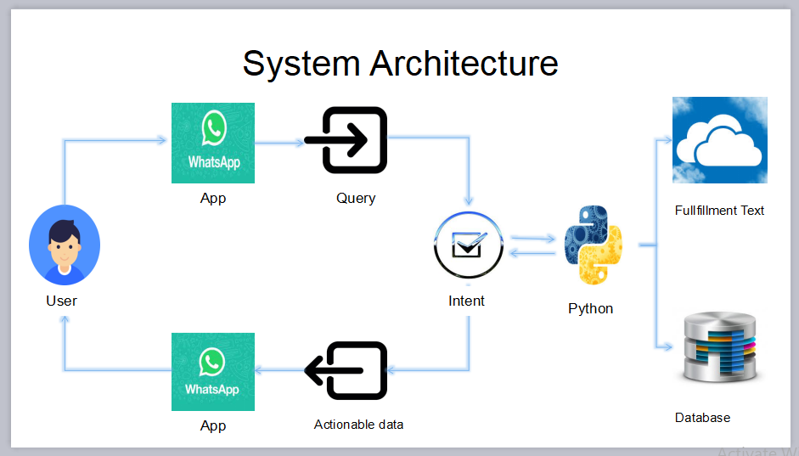

**SYSTEM RQUIREMENTS**

HARDWARE REQUIREMENYTS

* System :pentium dual Core
* Hard Disk :120 GB
* Monitor :15’ LED
* Input Devices :Keyboard ,mouse
* RAM :1 GB

SOFTWARE REQUIREMNTS

* Operating System : Windows 7
* Coding Language : Python
* Tool : Visual Studio Code,Dialog Flow

Project Guide

Vijaya Kumari

Team Members:

G.Ramavasanthi (15JN1A0544)

V.Jyothi Naga Durga(15JN1A0547)

S.Nagadevi(15JN1A0544)

G.Shanmukeshwari(15JN1A0535)