

DEPARTMENT OF

COMPUTER APPLICATIONS
MINOR PROJECT
A Multi-Category Service Discovery and Ranking System
GATE 0
Submitted by:
Sannidhi Sunkad- 01FE24ICA004
Soumya Hiremath – 01FE24ICA013
Shrusti N Koudi – 01FE24ICA019
Chinmayee V Gandhad – 01FE24ICA055

INTEGRATED MCA
DIV: F
Submitted to:
A1. Problem Statement with Stakeholders Named

Problem Statement
Finding suitable and reliable service providers is a common challenge faced by individuals and organizations. Customers often depend on personal recommendations, social media, online directories or multiple websites to find professionals such as electricians, tutors, photographers, designers and repair technicians.
These methods require customers to manually compare service providers based on experience, location, availability, pricing and customer feedback. This process is time-consuming and does not always produce the most suitable result.
Service providers also face difficulties reaching relevant customers, while customers lack a centralized platform that provides transparent and explainable recommendations.
To address this problem, ServiceMatch proposes a web-based multi-category service discovery platform that filters and ranks service providers using a weighted scoring algorithm and a manually implemented max-heap priority queue.

Stakeholders and How They Are Affected
Stakeholder | Problem Faced
Customers | Spend time searching, comparing and verifying multiple providers manually
Service Providers | Face difficulty reaching relevant customers and displaying their professional experience
Administrators | Need to manage provider information, verification and customer complaints
Small Businesses | Face difficulty identifying suitable professionals for occasional service requirements

A2. AS-IS Workflow and TO-BE Workflow

AS-IS Workflow (Existing Manual Process)
The existing process depends mainly on manual searching and comparison.
- Customer Requires a Service
- Search Through Google, Social Media or Personal Contacts
- Collect Multiple Provider Details
- Contact Providers Individually
- Manually Compare Price, Experience and Availability
- Choose a Provider
Limitations: Repeated searching, inconsistent information, manual comparison and uncertainty about provider suitability.

TO-BE Workflow (Proposed ServiceMatch System)
- Customer Logs into ServiceMatch
- Enters Service Category, Location, Budget and Availability
- System Filters Eligible and Verified Providers
- Weighted Ranking Algorithm Calculates Suitability Scores
- Max-Heap Priority Queue Retrieves Top-Ranked Providers
- Customer Compares Ranked Recommendations
- Customer Selects Provider and Submits Service Request
Expected improvement: The proposed system reduces repetitive searching, centralizes provider information and enables customers to make decisions using transparent ranking criteria.

A3. Scope, Out-of-Scope, Feasibility and Risk Note

1. Project Scope
The following functionalities will be implemented:
- Customer and service provider registration.
- Role-based authentication.
- Multi-category service management.
- Service provider profile creation.
- Administrative provider verification.
- Search based on category, location, budget and availability.
- Weighted service provider ranking.
- Custom max-heap priority queue implementation.
- Service request submission and tracking.
- Customer ratings and reviews.
- Administrative dashboard.

2. Out-of-Scope
The following features will not be implemented in the initial version:
- Online payment gateway.
- Live GPS tracking.
- Real-time chat.
- AI-based recommendations.
- Automatic professional background verification.
- Native Android or iOS application.

3. Feasibility Analysis
Type | Feasibility
Technical | Can be developed using React.js, Java Spring Boot and PostgreSQL
Economic | Uses free and open-source development technologies
Operational | Supports customers, providers and administrators through separate interfaces
Schedule | Proposed development duration of approximately 10–12 weeks

4. Risk Analysis
Identified Risk | Impact | Mitigation Strategy
Incorrect provider information | Inaccurate recommendations | Administrative verification
Outdated availability | Failed service requests | Allow providers to update availability
Ranking bias | Unsuitable recommendations | Normalize parameters and test scoring weights
Duplicate bookings | Scheduling conflicts | Database transactions and availability validation
Unauthorized access | Data security issues | Authentication and role-based authorization
Limited initial data | Difficulty evaluating ranking quality | Use realistic synthetic provider datasets

A4. Integration Map V1 – Five Course Areas
This section demonstrates how all five compulsory subjects are integrated into one working ServiceMatch application.
Course Area | Where It Appears in ServiceMatch | Implementation
Database Management Systems | Database Layer | Relational tables, primary keys, foreign keys, constraints, transactions and SQL queries
Data Structures & Programming | Search and Ranking Engine | Manually implemented weighted scoring algorithm and max-heap priority queue
Web Technologies | Frontend and Backend | React pages, REST APIs, server-side validation and role-based access
Software Engineering & SDLC | Entire Development Lifecycle | Requirement analysis, SRS, UML diagrams, testing, defect log, GitHub and final report
Object-Oriented Programming | Backend Application | User, Provider, Service, RankingEngine and RequestManager classes, reusable modules and exception handling

Integration Map Diagram
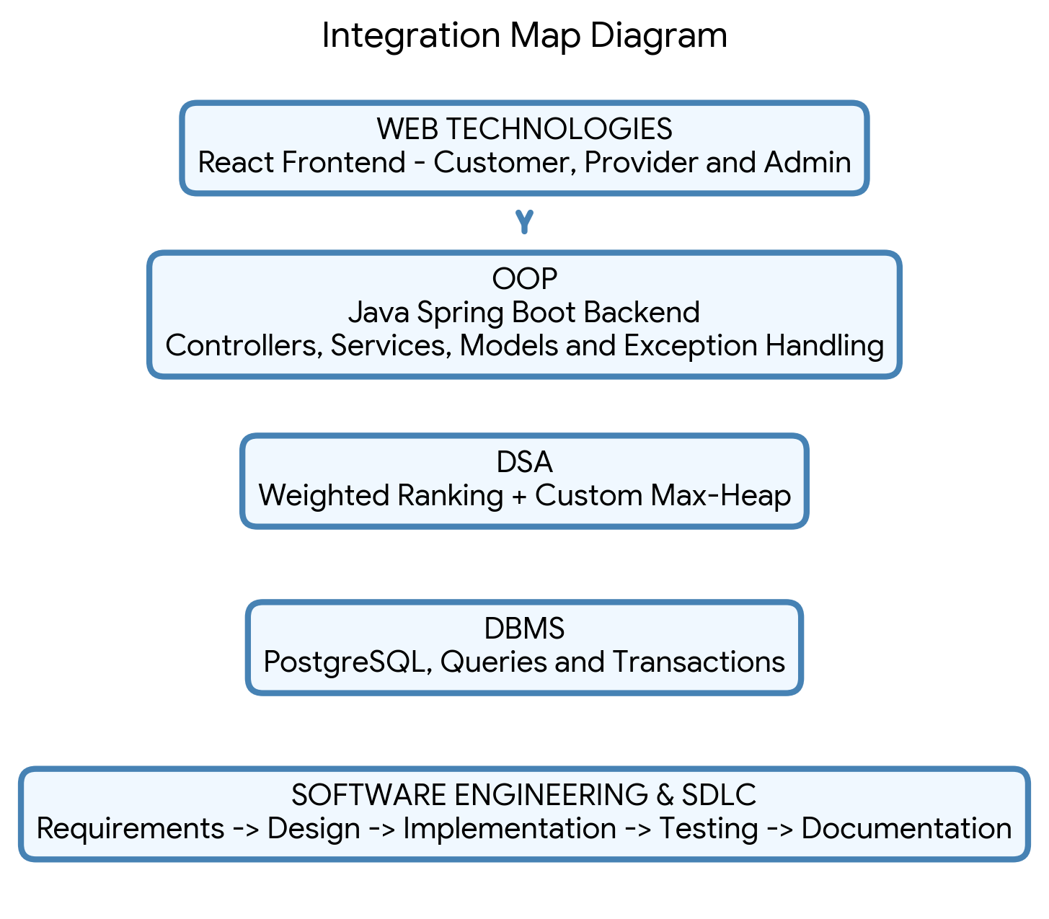
Integration explanation: All five subjects contribute to the same application. They are not developed as separate or unrelated modules.

B1. Theme-Specific Evidence – Search and Ranking System

1. Name of the Search Currently Done by Hand
Manual Multi-Source Service Provider Search and Comparison
Currently, a customer searching for a suitable service provider may need to:
- Search through Google, online directories or social media.
- Ask friends or family members for recommendations.
- Collect contact details of available providers.
- Contact each provider individually.
- Enquire about experience, availability and pricing.
- Compare collected information manually.
- Select a provider based on the available information.

2. How Long Does the Manual Search Take?
The following figures are proposed assumptions for preliminary project analysis, not verified survey results.
Activity | Estimated Time
Searching different sources | 10–15 minutes
Collecting provider details | 10–15 minutes
Contacting providers | 15–30 minutes
Comparing available options | 10–15 minutes
Total estimated time | 45–75 minutes
The actual duration may vary depending on the service category, location and provider responsiveness.

3. How Often Does the Manual Search Fail?
A reliable failure percentage cannot be claimed without collecting real user data.
For this project, manual search failure can be defined as any situation where:
- No suitable provider is identified.
- The selected provider is unavailable.
- The provider exceeds the customer's budget.
- Important information is missing or outdated.
- The customer must restart the search process.

Proposed Evidence Collection
Conduct a small survey involving approximately 20–30 participants who have previously searched for service providers.
Record the following:
Measurement | Data to Collect
Search duration | Time required to identify a suitable provider
Search frequency | Number of times users search for services per month
Providers contacted | Number contacted before selecting one
Unsuccessful searches | Searches ending without a suitable provider
Major difficulties | Price, availability, trust, location or experience
Calculate the manual search failure rate using:
Failure Rate = (Unsuccessful Searches / Total Searches) × 100
For example, if 8 out of 30 recorded searches were unsuccessful:
Failure Rate = (8 / 30) × 100 = 26.67%
This is an illustrative calculation, not an actual survey finding.

Final B1 Statement for Submission
The existing process involves manually searching for service providers through multiple sources and comparing their experience, pricing, location, availability and customer feedback. For preliminary planning, this process is estimated to require approximately 45–75 minutes per search. The actual duration and failure frequency will be validated through a small user survey. ServiceMatch aims to reduce repetitive manual comparison by introducing centralized filtering and an explainable weighted ranking system.

