**SQL NULL FUNCTIONS**

1.Display the faculty names whose salary IS NULL.

Ans)

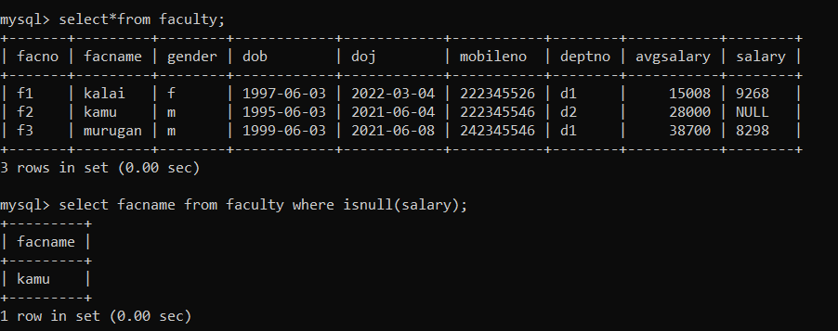

2. Display the salary of all the faculty. If null salary it should be displayed as 0.

Ans)

