1. Alter the table STUDENT with following structure.

|  |  |  |
| --- | --- | --- |
| S.No | Column | Constraints |
| 1 | RegNo | PRIMARY KEY |
| 2 | MobileNo | NotNull |

Ans:-

mysql> alter table student add primary key(regno);

Query OK, 0 rows affected (0.03 sec)

Records: 0 Duplicates: 0 Warnings: 0

mysql> alter table student modify mobileno varchar(10) not null;

Query OK, 0 rows affected (0.03 sec)

Records: 0 Duplicates: 0 Warnings: 0

mysql> desc student;

+----------+-------------+------+-----+---------+-------+

| Field | Type | Null | Key | Default | Extra |

+----------+-------------+------+-----+---------+-------+

| regno | int(3) | NO | PRI | 0 | |

| name | varchar(15) | YES | | NULL | |

| gender | char(1) | YES | | NULL | |

| dob | date | YES | | NULL | |

| mobileno | varchar(10) | NO | | NULL | |

| city | varchar(15) | YES | | NULL | |

+----------+-------------+------+-----+---------+-------+

6 rows in set (0.01 sec)

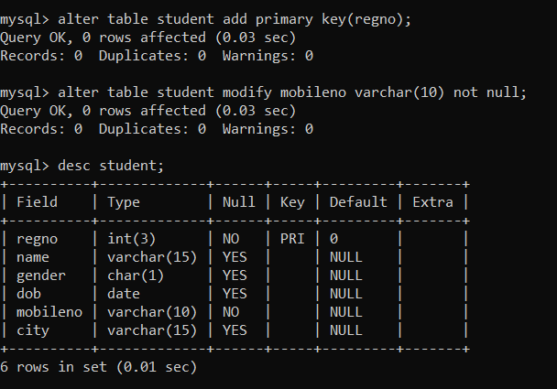

1. Alter the table name FACULTY with following structure. The DeptNo in this table refers the DeptNo in the DEPARTMENT table.

|  |  |  |
| --- | --- | --- |
| S.No | Column | Constraints |
| 1 | FacNo | PRIMARY KEY |
| 2 | Gender | Check ‘M’ or ‘F’ |

Ans:-

mysql> alter table faculty add primary key(facno);

Query OK, 0 rows affected (0.03 sec)

Records: 0 Duplicates: 0 Warnings: 0

mysql> alter table faculty add check(gender='M' or 'F');

Query OK, 0 rows affected (0.01 sec)

Records: 0 Duplicates: 0 Warnings: 0

mysql> desc faculty;

+----------+-------------+------+-----+---------+-------+

| Field | Type | Null | Key | Default | Extra |

+----------+-------------+------+-----+---------+-------+

| facno | varchar(4) | NO | PRI | | |

| facname | varchar(15) | YES | | NULL | |

| gender | char(1) | YES | | NULL | |

| dob | date | YES | | NULL | |

| doj | date | YES | | NULL | |

| mobileno | varchar(10) | YES | | NULL | |

+----------+-------------+------+-----+---------+-------+

6 rows in set (0.02 sec)

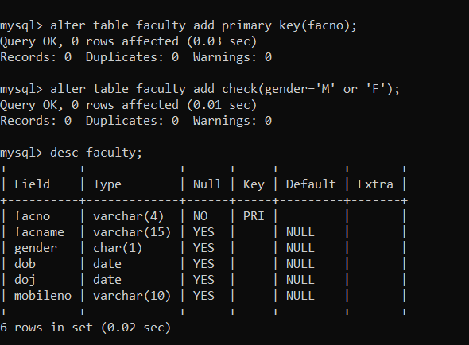

4)Alter the table name DEPARTMENT with following structure.

|  |  |  |
| --- | --- | --- |
| S.No | Column | Constraints |
| 1 | DeptNo | PRIMARY KEY |

Ans:-

mysql> alter table department add primary key(deptno);

Query OK, 0 rows affected (0.03 sec)

Records: 0 Duplicates: 0 Warnings: 0

mysql> desc department;

+----------+-------------+------+-----+---------+-------+

| Field | Type | Null | Key | Default | Extra |

+----------+-------------+------+-----+---------+-------+

| deptno | varchar(4) | NO | PRI | | |

| deptname | varchar(15) | YES | | NULL | |

| depthead | varchar(4) | YES | | NULL | |

+----------+-------------+------+-----+---------+-------+

3 rows in set (0.00 sec)

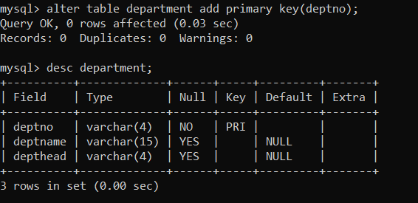

5). Alter the table name COURSE with following Structure

|  |  |  |
| --- | --- | --- |
| S.No | Column | Constraints |
| 1 | CourseNo | PRIMARY KEY |
| 2 | SemNo | 1 to 6 |
|  |  |  |

Ans:-

mysql> alter table course add primary key(courseno);

Query OK, 0 rows affected (0.05 sec)

Records: 0 Duplicates: 0 Warnings: 0

mysql> alter table course add check (semno between 1 and 6);

Query OK, 0 rows affected (0.03 sec)

Records: 0 Duplicates: 0 Warnings: 0

mysql> desc course;

+------------+-------------+------+-----+---------+-------+

| Field | Type | Null | Key | Default | Extra |

+------------+-------------+------+-----+---------+-------+

| courseno | varchar(3) | NO | PRI | | |

| coursedesc | varchar(14) | YES | | NULL | |

| coursetype | char(1) | YES | | NULL | |

| semno | char(1) | YES | | NULL | |

| hallno | varchar(4) | YES | | NULL | |

| facno | varchar(4) | YES | | NULL | |

+------------+-------------+------+-----+---------+-------+

