**Ex.No 24**

**Database Design using ER modeling, normalization and Implementation for any application**

**Aim:**

To design a database using ER modeling and Normalization for student portal and sports meet Application

**Problem Statement: ER Diagram**

* A College is conducting a sports meet.
* Teams from recognized colleges are allowed.
* A team should have the players of same college.
* A player can play for more than one team.
* Events occurs in various grounds in the college.
* Winning teams receive awards.
* A captain is a player of a team.
* A player is a student of a college.
* Many teams can play a game.
* A game takes place in a ground.
* A college can have many teams.
* Only first two teams are awarded.

**IDENTIFICATION OF ENTITY:**

* COLLEGE
* PLAYERS
* TEAMS
* GAMES
* GROUND
* AWARDS

**DESCRIPTION ABOUT ENTITY:**

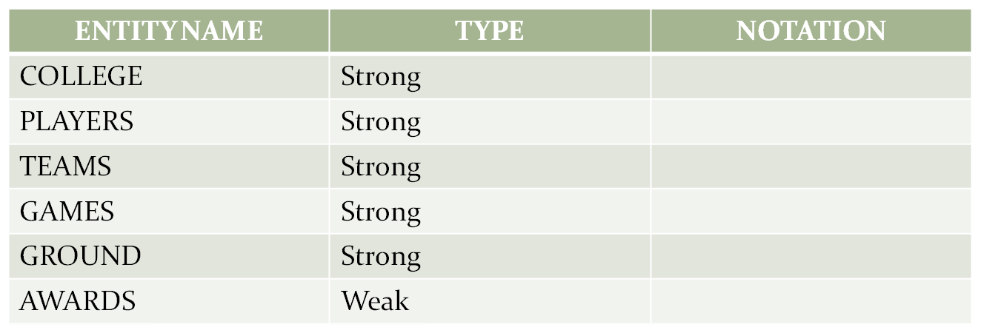

**ATTRIBUTES:**

* COLLEGE – CID, Name, Address line1, Address line2
* PLAYERS – FN, LN, POS, DOB, GENDER, PID
* TEAM - TID, Name, NOP, Rank, Team
* GAMES - GID, Name
* GROUND - ID, Name, Area
* AWARDS – Name, Position, Prize, Team

**DESCRIPTION ABOUT ATTRIBUTES:**

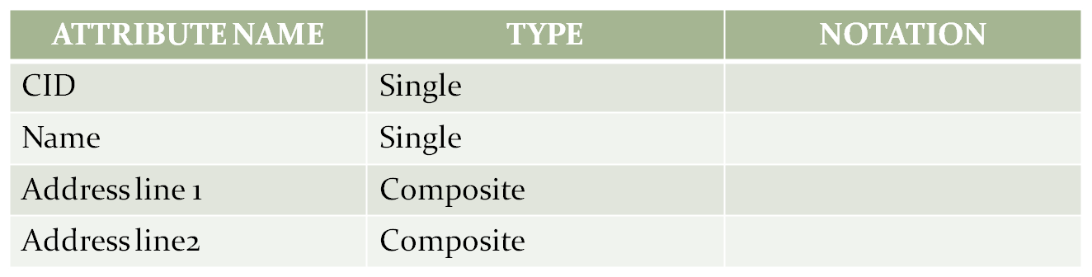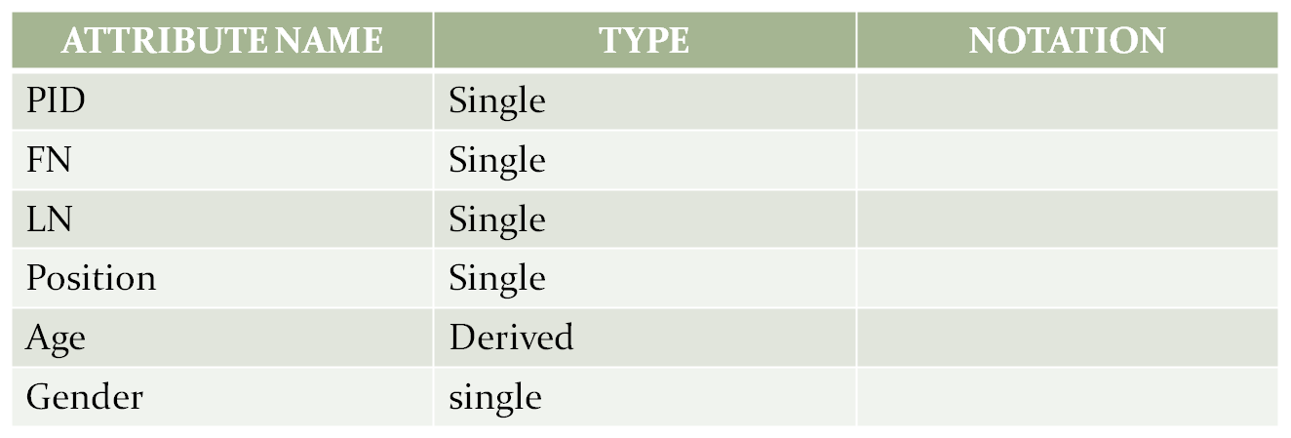

COLLEGE

PLAYERS

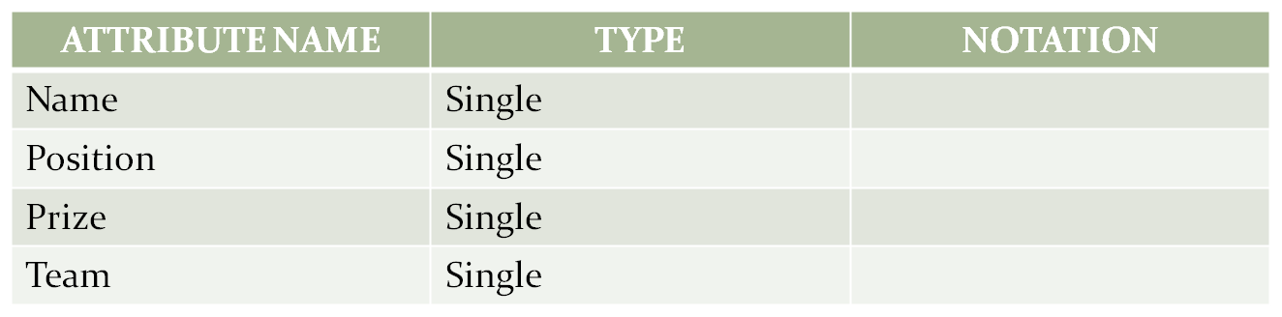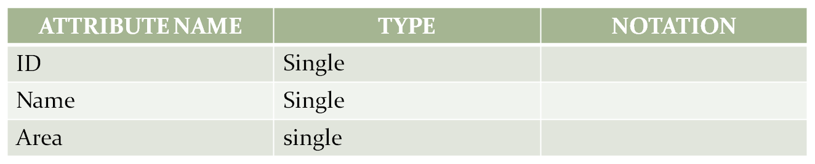

AWARDS

GROUND

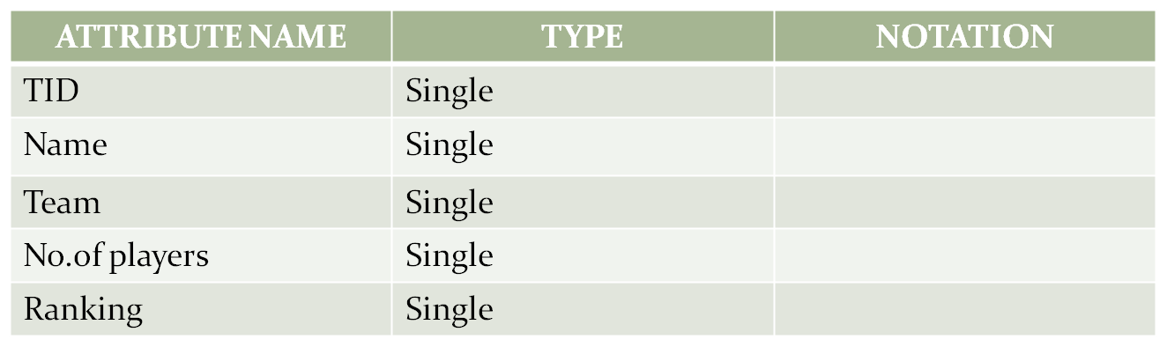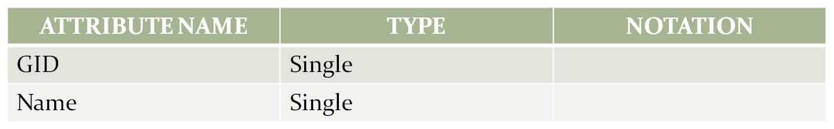

TEAMS

GAMES

**RELATIONSHIP:**

BINARY:

* + Plays
  + Has
  + Student of
  + Receives
  + Takes place

**ATTRIBUTES IN THE RELATIONSHIP:**

* Student of – CID, PID
* Has – TID, CID
* Plays – TID, GID
* Takes place – GID, ID
* Receives – TID, Position

**CARDINALITY AND RELATIONSHIP:**

* ONE TO ONE:Plays, Takes place
* MANY TO ONE:Student of
* ONE TO MANY:has

**CARDINALITY ABOUT RELATIONSHIP:**

* PLAYERS STUDENT OF COLLEGE.
* MANY TEAMS PLAY A GAME.
* A GAME TAKES PLACE IN A GROUND.
* A COLLEGE HAS MANY TEAMS.

**ER DIAGRAM:**

COLLEGE

PLAYERS

GAMES

TEAMS

CID

CONTACT NOS

PID

GID

NAME

LINE2

GENDER

AGE

NAME

ADDRESS

NAME

LINE1

NAME

GENDER

NO.OF PLAYERS

TID

RANKING

NAME

POSITION

CID

PRIZE

GROUND

TAKES PLACE

HAS

STUDENT OF

PLAYS

TID

AREA

NAME

ID

RECEIVES

AWARDS

GID

TID

GID

ID

TID

POSITION

CID

PID

1

1

1

1

1

N

N

1

FN

LN

CONTACT NOS

CAPTAIN

CAPID

N

1

**Problem Statement: Normalization**

Createacollegedatabasethatcontainsstudentid,studentname,studentcity,dateofbirth,course id, course name, duration of the course, marks and grade and their relationships. The requirements are listedbelow:

* A college can offer one or morecourses.
* A student can enroll in one or morecourses.
* Courses can be taken by one or morestudents.
* A student can have student_id, student_name, date _of _birth andstudent_city.
* A student belongs to onecity.
* A city can have one or morestudents.
* A course can have course_id, course_name andduration.
* When a student finishes the course, a grade and marks areawarded.
* Grades are calculated based on themarks

Below 45 – U, 45-50 – E, 50-60– D, 60-70 – C, 70-80 – B, 80-90 – A, 90-100 –S

### FIRST NORMAL FORM

A relation is said to be in first normal form if and only if

*All the attributes in the relation must be atomic in nature.

*No multivalued and composite attributes in the table

### In a given table there is no multivalued and composite attributes, so it is satisfying normal form1

**SECOND NORMAL FORM**

A relation is said to be in second normal form if and only if

*It is in the first normal form and

\***No partial dependencies** exist between non-key attributes and key attributes.

|  |  |  |  |  |  |  |  |  |
| --- | --- | --- | --- | --- | --- | --- | --- | --- |
| **STUDENT ID** | **STUDENT NAME** | **STUDENT CITY** | **DOB** | **COURSE ID** | **COURSE NAME** | **DURATION** | **MARKS** | **GRADE** |

**From Requirements: (studentid, courseid is Composite Primarykey)**



**studentid**,courseid studentname

**studentid**,courseid studentcity

**studentid**,courseid dob PartialFunctional dependencies.

studentid,**courseid** coursename

studentid,**courseid** duration

studentid,courseid marks

**studentid,coursed** grade Full Functionaldependencies

### After removing partial functional dependencies from above table

**STUDENT**

|  |  |  |  |
| --- | --- | --- | --- |
| **STUDENTID** | **STUDENTNAME** | **STUDENTCITY** | **DOB** |

**COURSE**

|  |  |  |
| --- | --- | --- |
| **COURSEID** | **COURSENAME** | **DURATION** |

**RESULT**

|  |  |  |  |
| --- | --- | --- | --- |
| **STUDENTID** | **COURSEID** | **MARKS** | **GRADE** |

**THIRD NORMAL FORM**

A relation is said to be in the third normal form if and only if

*it is in Second Normal Form

\***No transitive dependency** exists between non-key attributes and key attribute



**studentid,coursed** marks

**marks** grade Transitivedependency

**studentid,courseid** grade

After removing transitive dependency from above table

**STUDENT**

|  |  |  |  |
| --- | --- | --- | --- |
| **STUDENTID** | **STUDENTNAME** | **STUDENTCITY** | **DOB** |

**COURSE**

|  |  |  |
| --- | --- | --- |
| **COURSEID** | **COURSENAME** | **DURATION** |

**MARKS**

|  |  |  |
| --- | --- | --- |
| **MARKID** | **RANGE1** | **RANGE2** |

**RESULT**

|  |  |  |
| --- | --- | --- |
| **STUDENTID** | **COURSEID** | **MARKID** |

**Result:**

**Thus the database is designed and normalized**