Edulynk on the Azure Marketplace
How everything works together - from purchasing a subscription to daily use
Prepared for the Edulynk team • June 2026

1. What we are building
Edulynk (the Educ8e Connector product - school fees, billing, students and ERP sync) is being placed on the Microsoft Azure Marketplace so that schools can buy it as a subscription, the same way they buy Microsoft 365. To make that possible, Edulynk is being plugged into a ready-made 'SaaS platform' we already operate. The platform handles everything commercial and administrative (purchases, plans, sign-ups, user management, billing events from Microsoft), so the Edulynk product itself can focus on what it does best: managing students, fees and finances.
Think of it as a shopping mall: the platform is the mall - it handles the entrance, security, the rent and the tenant register. Edulynk is the store inside - it serves the customers.
2. The big picture
The diagram below shows the four layers of the combined system and how they connect.
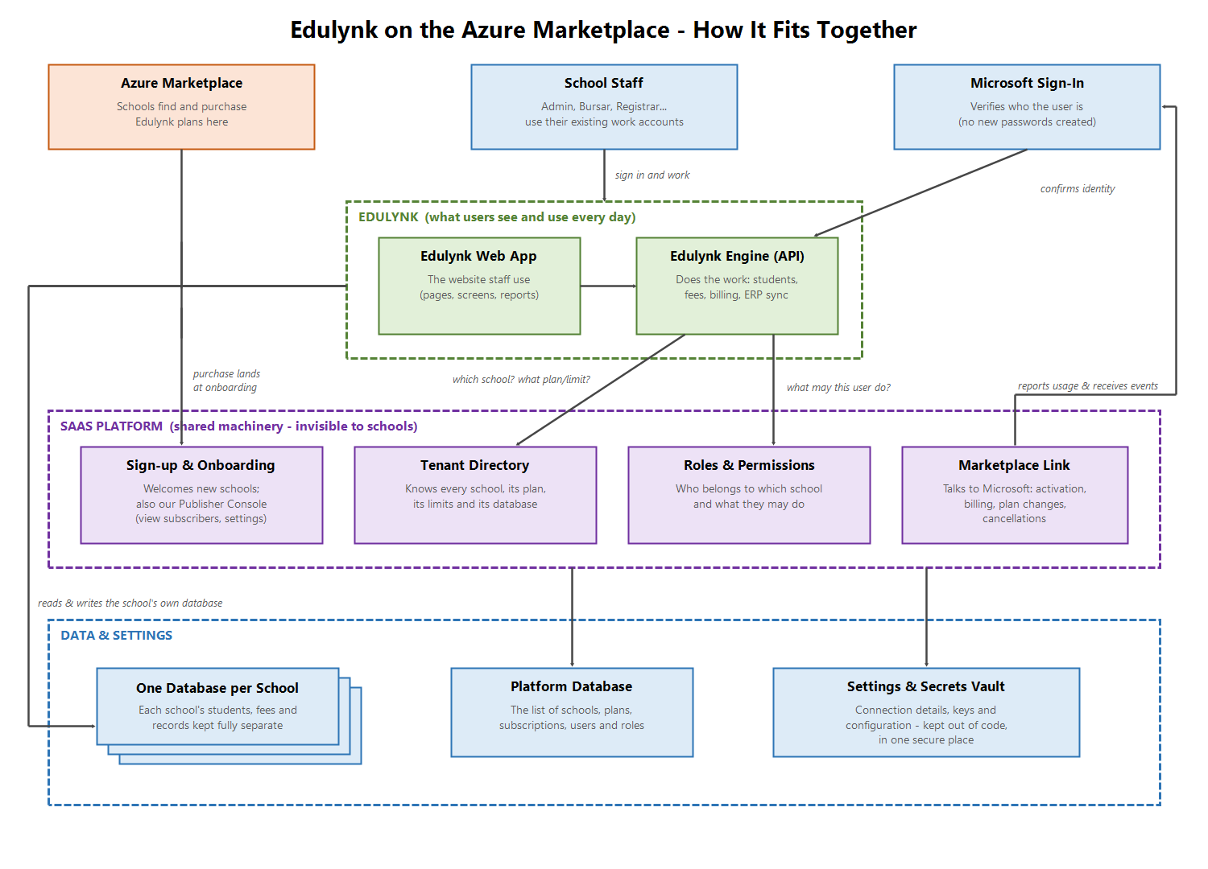
• The outside world (top): Schools discover Edulynk on the Azure Marketplace. Their staff sign in with the Microsoft work accounts they already use every day - we never create or store passwords.
• Edulynk (green): The product itself - the website school staff use, and the engine behind it that does the real work.
• The SaaS platform (purple): Shared machinery that schools never see. It keeps the register of schools (tenants), their plans and limits, who belongs to which school and what they are allowed to do, and it talks to Microsoft about purchases, plan changes and cancellations. It also gives us, the publisher, a console to view subscribers and manage notifications.
• Data and settings (bottom): Every school gets its own private database - one school's records can never mix with another's. Settings and secret keys live in a central secure vault instead of being written into code.

3. The journey: from purchase to daily use
Buying and getting started (day one)
1. The school finds Edulynk on the Azure Marketplace and picks a plan (for example Basic, Standard or Premium - each allows a different number of students).
2. Microsoft confirms the purchase and sends the buyer to our onboarding page.
3. The buyer signs in with their work account and completes a short setup wizard (school name, web address for their portal).
4. The platform creates the school's tenant. Behind the scenes it also: activates the subscription with Microsoft (billing starts only now), creates the school's own private database, prepares it with starter data, and records which plan and student limit apply.
5. The buyer automatically becomes the school's Administrator - the first user, with full rights inside their school.
6. We get notified. A new-subscriber email reaches us, and the school appears in our Publisher Console.
Setting up the team
7. The Administrator invites colleagues by email - the bursar, registrars, accountants. Invited people simply sign in with their existing work account; no new passwords are issued.
8. The Administrator assigns each person a role (for example Bursar or Registrar) from a predefined list. The role decides exactly what that person can see and do in Edulynk.
Daily use
9. Staff use Edulynk normally - students, fees, billing, reports. Every request quietly checks: which school is this? Is the subscription active? What is this user allowed to do?
10. Plan limits are enforced automatically. If a school on a 500-student plan tries to add student number 501, Edulynk politely refuses and suggests upgrading.
11. Plan changes and cancellations flow by themselves. If the school upgrades, downgrades or cancels in the Azure portal, Microsoft notifies our platform and the school's limits or access adjust automatically - no manual work.
4. People, sign-in and roles
Three simple rules govern identity:
• Everyone signs in with the Microsoft work account they already have. We never create logins or store passwords - Microsoft vouches for who the person is.
• Being able to sign in is not the same as having access. A person gets access to a school only when that school's Administrator invites them.
• What a person can do is decided by their role (Administrator, Bursar, Registrar...). Roles are assigned inside Edulynk by the school's Administrator and stored on our platform - not in the school's IT systems, so school IT departments don't need to do anything.

5. What a plan controls
Each marketplace plan sets a ceiling on the number of students a school can manage. The platform's tenant directory knows each school's plan and ceiling; Edulynk checks against it whenever students are added. Staff accounts are not the limited resource - schools can invite as many staff as they need.
Plan (example) | Student ceiling (example) | What happens at the limit
Basic | up to 500 | Adding student 501 is blocked with an upgrade prompt
Standard | up to 2,000 | Same - upgrade lifts the ceiling immediately
Premium | up to 10,000 | Same

(The exact plan names and numbers will be finalised in the marketplace offer; the mechanism is what matters here.)
6. Where each school's data lives
Every school gets its own dedicated database, created automatically the moment its subscription is activated. This was chosen deliberately:
• Privacy by construction: one school's students and financial records are physically separate from every other school's. There is no shared table where a software bug could leak data across schools.
• Easy housekeeping: backing up, restoring or (on cancellation) deleting one school touches only that school.
• Affordable: each database runs on the smallest Azure tier (about USD 5 per month per school) - a tiny fraction of a subscription - and can be enlarged for a big school individually.
• No passwords anywhere: Edulynk connects to these databases using its own managed Azure identity. There are no database passwords to store, leak or rotate.

7. Settings, keys and per-school customisation
Everything configurable lives in one of three places, by a simple rule:
Kind of value | Where it lives | Examples
Secrets | Azure Key Vault (secure vault) | Connection keys, signing keys, report-service credentials
Deployment settings | Azure App Configuration (central settings store) | Service addresses, feature switches
Per-school values | The database, managed inside the app | Each school's Power BI report identifiers, branding choices

The practical effect: nothing sensitive is written in source code or env files anymore (today some passwords are - they will be rotated and moved), and anything that differs per school is managed from within the product rather than by editing server settings.
8. What changes from today's Educ8e Connector
Today | After the integration
One customer, set up by hand | Any school can buy and onboard itself from the Azure Marketplace
Sign-in tied to our own company directory | Schools' staff sign in with their own organisations' Microsoft accounts
Roles configured in Azure by us, per user | Each school's Administrator invites staff and assigns roles inside Edulynk
One shared database | One private database per school, created automatically
No commercial machinery (no plans, no billing) | Plans, student limits, billing, upgrades and cancellations handled automatically with Microsoft
Settings and some passwords in code/env files | Secrets in a vault, settings in a central store, per-school values in the product

What does NOT change: the Edulynk screens and features staff use daily (the Next.js web app and the .NET engine stay), and the school-facing workflows for fees, billing and students.
9. Key decisions at a glance
• What is limited per plan: the number of students a school manages (not the number of staff logins).
• Who keeps the register of schools, plans and limits: the platform - one source of truth; Edulynk asks it.
• Where roles live: in the platform's permissions store, assigned by each school's Administrator inside the product.
• How people sign in: with their existing Microsoft work accounts, from any organisation (multi-tenant).
• Databases: one per school, smallest tier, created at activation, accessed without passwords.
• The product keeps its current shape: Next.js website (on Azure Static Web Apps) + .NET engine; the platform's placeholder demo app is retired.

10. Open items before go-live
• Rotate the database passwords currently written in the old code, and retire the old app registrations after cutover.
• Finalise plan names, prices and student ceilings for the marketplace offer.
• Provide the Exchange 365 mailbox credentials to finish the new-subscriber email notifications (feature is built, waiting on the mailbox).
• Confirm the sign-in flow on Azure Static Web Apps early in implementation (expected fine; verify first).

