How the BadgeMeUp App Works
A plain-English guide for newcomers
Built on Microsoft Azure + Entra External ID

1. What is this app, in one minute?
BadgeMeUp is a 'Software as a Service' (SaaS) application. That's just a fancy way of saying: it's software you use through a web browser, and many different organisations share the same app at the same time — without ever seeing each other's data.
Think of an apartment building. It's one building (one app), but each family has their own locked apartment (their own private space and data). In our app, each of those 'apartments' is called a tenant — usually a company or organisation, like a coffee shop called 'Sanni cafe'.
This project is a starter kit (originally Microsoft's 'Azure SaaS Dev Kit') that gives you all the hard parts already built: signing up, logging in, keeping each organisation separate, and controlling who is allowed to do what.

2. A few key words (no jargon, promise)
- Tenant — one organisation using the app (one 'apartment'). Example: Sanni cafe.
- User — a person who logs in. A user can belong to one or more tenants.
- Sign-up / Onboarding — the process of creating a brand-new organisation in the app.
- Identity provider — the trusted 'bouncer' that checks your email and password. We use Microsoft Entra External ID for this. The app itself never sees your password.
- Token (a 'digital pass') — after you log in, you're given a signed digital pass that proves who you are for the rest of your visit.
- Permissions — the list of things you're allowed to do (for example, 'Admin of Sanni cafe'). The app checks this before showing you sensitive pages.

3. The big picture: the moving parts
The app isn't one single program — it's a small team of programs that each do one job and talk to each other. Here's the whole team:
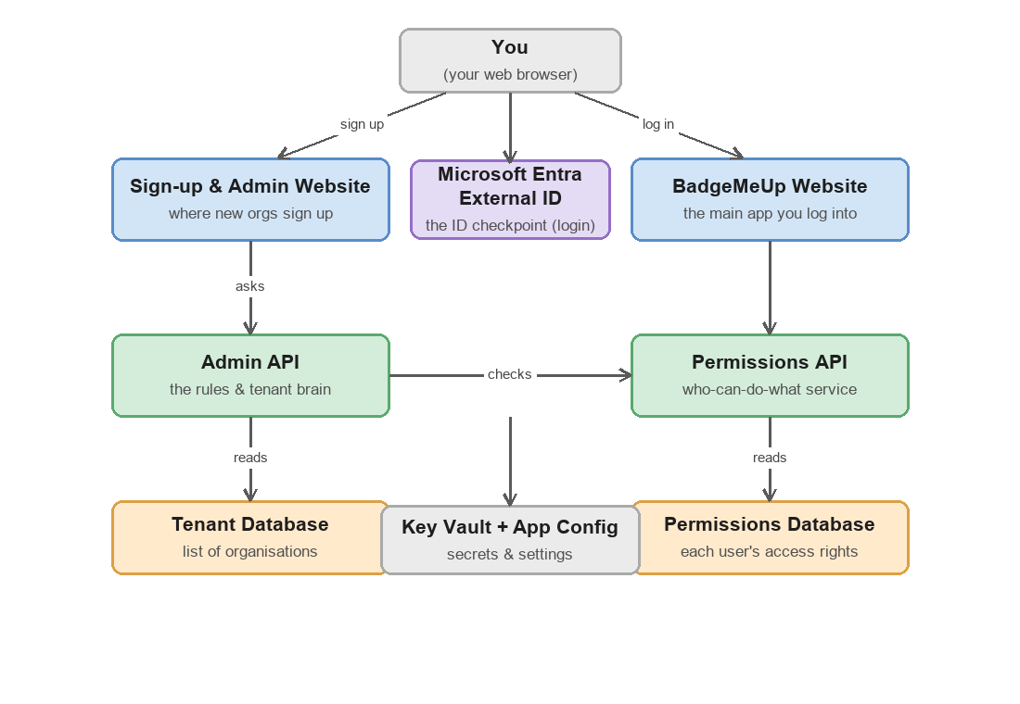
Figure 1 — How the pieces fit together.
In words:
- Sign-up & Admin Website — where a new organisation registers and where admins manage their organisation.
- BadgeMeUp Website — the main app that everyday users log into.
- Microsoft Entra External ID — the login checkpoint. It checks your identity and hands out the digital pass.
- Admin API — the 'brain'. The websites ask it questions like 'what is this tenant?' and 'is this person allowed?'.
- Permissions API — a specialist service that knows each user's access rights.
- Databases — one stores the list of organisations (tenants), another stores each user's permissions.
- Key Vault & App Configuration — secure lockboxes for passwords/secrets and for the app's settings, so secrets never sit in the code.

4. What happens when you log in
You never type your password into the app itself. Instead, the app sends you to Microsoft's secure login page. This is safer — the app only ever receives a signed 'pass' that says 'yes, this really is them'.
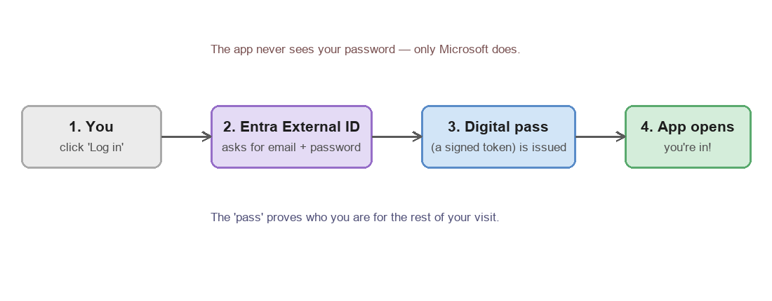
Figure 2 — Logging in, step by step.
That digital pass travels with you while you click around, so you don't have to log in again on every page.

5. How the app knows what you're allowed to do
Logging in proves who you are. It does not, by itself, say what you're allowed to do. Those are two different questions. When you open a sensitive page — say your organisation's page at /sannicafe — the app quietly checks your permissions first.
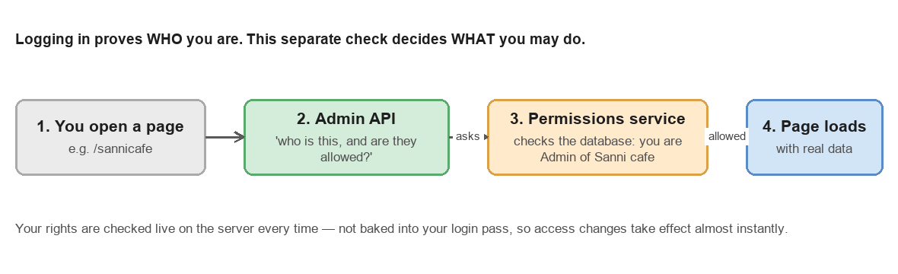
Figure 3 — Checking your access rights, live, on every request.
Important detail (and the heart of this project's recent work): your permissions are looked up fresh on the server every single time, rather than being stamped into your login pass. This is more secure — if your access is removed, it stops working almost immediately, and your rights never travel around inside the pass where they could leak or go stale.

6. Starting a brand-new organisation
When someone brings a new organisation to the app, they go through a short wizard. By the end, the system has carved out a private space for that organisation.
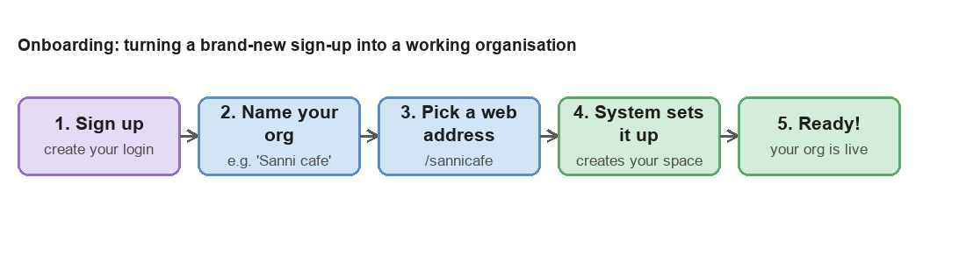
Figure 4 — From sign-up to a live organisation.

7. Where does all this actually run?
Everything lives in Microsoft Azure, the cloud platform. You don't need your own servers. Each of the websites and APIs runs as an 'App Service' (a managed place to run a web app). The databases are Azure SQL. Secrets live in Key Vault, settings in App Configuration, and logins are handled by Entra External ID.
When developers update the app, an automated pipeline (currently GitHub Actions) builds the new version and publishes it to Azure — no manual copying of files.

8. One recent behind-the-scenes change
This app used to use an older Microsoft login system called 'Azure AD B2C'. Microsoft stopped offering B2C to new customers, so the app was moved over to the newer 'Microsoft Entra External ID'. To you as a user, nothing looks different — you still just log in. Under the hood, the team rewired the login checkpoint and rebuilt the permissions check (Section 5) to work with the new system. That migration is now complete and working.

Glossary (quick reference)
- SaaS — Software you use over the internet, shared by many organisations.
- Tenant — One organisation's private space in the app.
- Entra External ID — Microsoft's modern login service used here.
- Token / pass — A signed proof of who you are, given out after login.
- API — A behind-the-scenes service that answers questions for the websites.
- Permissions — The list of actions you're allowed to perform.
- Key Vault — A secure lockbox in Azure for passwords and secrets.
- App Service — A managed home in Azure where a website or API runs.

