1. 1) Data Source: Utilize a dataset containing historical sales data, including features like date, product ID, store ID, and sales quantity.

import pandas as pd

import random

from datetime import datetime, timedelta

num_records = 1000

dates = []

product_ids = []

store_ids = []

sales_quantities = []

for _ in range(num_records):

start_date = datetime(2020, 1, 1)

end_date = datetime(2021, 12, 31)

random_date = start_date + timedelta(days=random.randint(0, (end_date - start_date).days)

product_id = random.randint(1, 100)

store_id = random.randint(1, 10)

sales_quantity = random.randint(1, 100)

dates.append(random_date)

product_ids.append(product_id)

store_ids.append(store_id)

sales_quantities.append(sales_quantity)

sales_data = pd.DataFrame({

'Date': dates,

'Product_ID': product_ids,

'Store_ID': store_ids,

'Sales_Quantity': sales_quantities

})

print(sales_data.head())

sales_data.to_csv('sales_data.csv', index=False)

2) Data Preprocessing: Clean and preprocess the data, handle missing values, and convert categorical features into numerical representations.

missing_values = sales_data.isnull().sum()

sales_data = sales_data.dropna()

sales_data['Sales_Quantity'].fillna(sales_data['Sales_Quantity'].mean(), inplace=True)

sales_data['Product_ID'].fillna('Unknown', inplace=True)

sales_data = pd.get_dummies(sales_data, columns=['Product_ID', 'Store_ID'])

from sklearn.preprocessing import LabelEncoder

label_encoder = LabelEncoder()

sales_data['Product_ID'] = label_encoder.fit_transform(sales_data['Product_ID'])

sales_data['Store_ID'] = label_encoder.fit_transform(sales_data['Store_ID'])

from sklearn.preprocessing import MinMaxScaler

scaler = MinMaxScaler()

sales_data['Sales_Quantity'] = scaler.fit_transform(sales_data[['Sales_Quantity']])

3) Feature Engineering: Create additional features that could enhance the predictive power of the model, such as time-based features (e.g., day of the week, month).

import pandas as pd

sales_data['Date'] = pd.to_datetime(sales_data['Date']

sales_data['Year'] = sales_data['Date'].dt.year

sales_data['Month'] = sales_data['Date'].dt.month

sales_data['Day'] = sales_data['Date'].dt.day

sales_data['Day_of_Week'] = sales_data['Date'].dt.dayofweek # Monday is 0, Sunday is 6

sales_data['Week_of_Year'] = sales_data['Date'].dt.weekofyear

sales_data['Quarter'] = sales_data['Date'].dt.quarter

sales_data['Is_Weekend'] = sales_data['Day_of_Week'].apply(lambda x: 1 if x >= 5 else 0)

1. 4) Model Selection: Choose suitable time series forecasting algorithms (e.g., ARIMA, Exponential Smoothing) for predicting future sales.

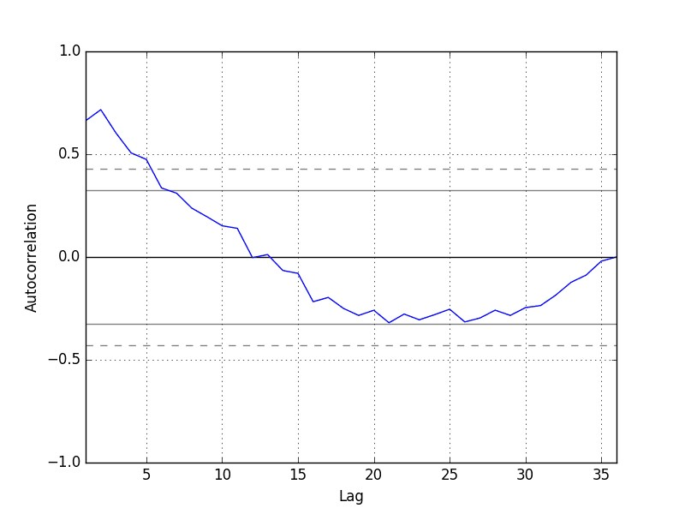

from pandas import read_csv

from pandas import datetime

from matplotlib import pyplot

from pandas.plotting import autocorrelation_plot

def parser(x):

return datetime.strptime('190'+x, '%Y-%m')

series = read_csv('shampoo-sales.csv', header=0, parse_dates=[0], index_col=0, squeeze=True, date_parser=parser)

autocorrelation_plot(series)

pyplot.show()

5

import numpy as np

actual = np.array([actual_values]) # Replace with your actual values

forecast = np.array([forecast_values]) # Replace with your forecasted values

mae = np.mean(np.abs(actual - forecast))

rmse = np.sqrt(np.mean((actual - forecast) ** 2))

print("MAE:", mae)

print("RMSE:", rmse)