Review on Drama

Weak Hero Class 1
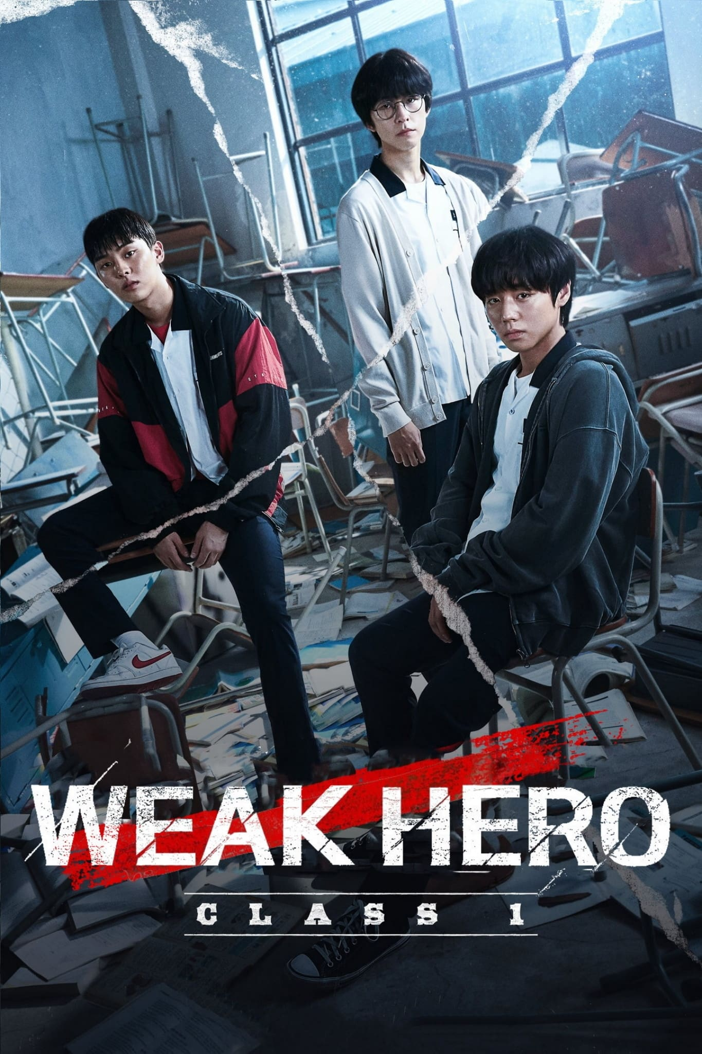

Released in 2022
Directed by: Yoo Soo-min
Written by: Yoo Soo-min
Produced by: Studio Wavve
Genre: Action, Thriller, Psychological Drama
IMDB Rating: 8.5/10

Introduction
Released in November 2022, *Weak Hero Class 1* is a South Korean action-thriller youth drama based on the webtoon *Weak Hero* by SeoPass and Kim Jin-seok. It tells the gripping story of Yeon Si-eun, a top student who uses strategic thinking and psychological tactics to fight against brutal bullying in his school. Set in a harshly realistic high school environment, the show dives deep into themes of loyalty, betrayal, emotional trauma, and mental strength. Beyond the action, it is a powerful commentary on how resilience and friendship shape identity and survival.

Analysis on Genre
• Action: Grounded, intense fight scenes based on clever tactics rather than brute force.
• Thriller: The suspense builds through betrayals, manipulation, and dark psychological turns.
• Drama: Deep emotional arcs and character-driven conflicts take center stage.
• Social Commentary: The series critiques school systems, bullying, and adult negligence.

About the Writer & Director
Yoo Soo-min is a rising director and screenwriter known for gritty, character-focused storytelling. In *Weak Hero Class 1*, he presents a raw and immersive view of school violence through a psychological lens, using minimal dialogue, tension-building scenes, and precise direction to engage viewers.

Series Premier
The series premiered on November 18, 2022 on Wavve and gained international popularity via streaming platforms like Viki. With only 8 episodes, it achieved high acclaim for storytelling, emotional impact, and unique characters.

Target Audience
Targeted at youth, teenagers, and fans of realistic psychological dramas, the series appeals to anyone interested in complex friendships, trauma recovery, and intelligent protagonists.

Main Cast & Characters
• Yeon Si-eun (Park Ji-hoon) – A top student who appears weak but is mentally powerful. He uses strategy, intelligence, and even classroom tools like pens, rulers, and chairs to defend himself. His favorite weapon is a pen, often modified into a striking tool.
• Ahn Su-ho (Choi Hyun-wook) – Loyal, physically strong, and dependable. He protects Si-eun and believes in justice.
• Oh Beom-seok (Hong Kyung) – A timid, unstable student with a traumatic past. He eventually betrays his friends due to jealousy and insecurity.
• Jeon Young-bin – A manipulative bully who initially targets Si-eun.
• Jung Chan – Young-bin's violent ally, known for his physical dominance.
• Han Tae-hoon – Another member of the bully trio, known for provoking Su-ho.
• Jo Ji-won (or Jiwan) – Young-bin’s cousin, a gang member involved in serious fights later in the series.
• Gil-soo – A gangster who represents the danger of external violence invading school life.

Driving Force Behind Its Success
Park Ji-hoon’s performance as Yeon Si-eun anchors the series. His restrained expression, sharp delivery, and internalized acting style portray a character who fights with his mind, not his fists. He often quotes principles from physics, geometry, or military tactics, such as:
“The Battle of Thermopylae. If you're fighting against many, you must make use of the surroundings.”
“The law of reflection—angle of incidence equals angle of reflection. 90% chance of success.”

Recurring Symbols and Tools
Pen: His favorite weapon — small, silent, precise.
Physics and History: He applies strategic knowledge from studies to real-life battles.
Silence: Si-eun rarely speaks, but his eyes and actions say everything.
Blood and Bandages: Physical scars as symbols of deeper emotional wounds.

Overview
Weak Hero Class 1 is an 8-episode South Korean drama that follows Yeon Si-eun, a top student who is physically weak but intellectually superior. Set in a violent, corrupt school environment, the story tracks his transformation from a quiet victim to a fearless strategist who uses his mind, not muscle, to fight back. It’s a psychological thriller, action drama, and emotional coming-of-age story all at once.

REVIEW OF ALL EPISODES

Episode 1: The Model Student

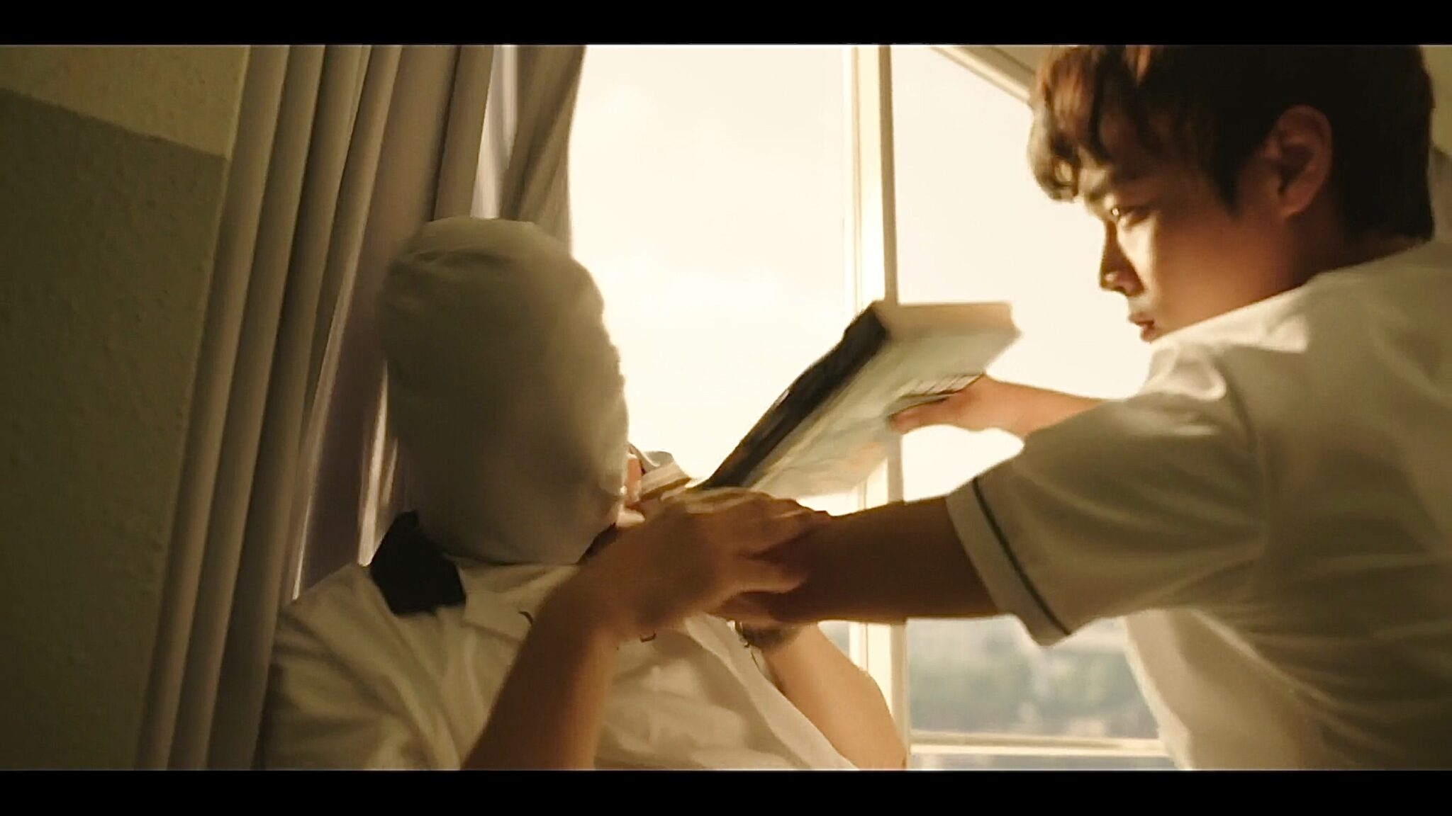
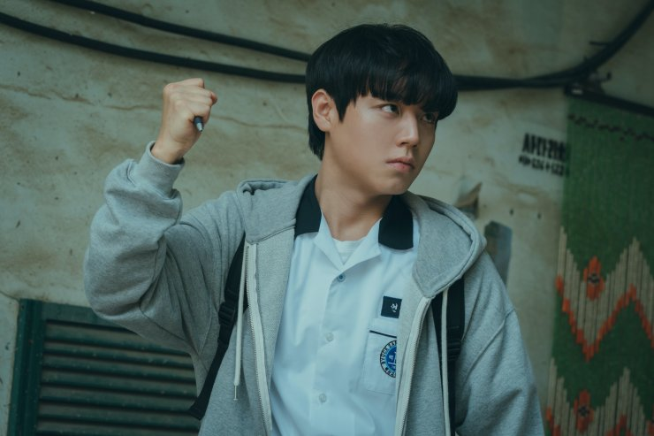
Yeon Si-eun is a loner and a top-ranking student who avoids people. He draws the attention of Jeon Young-bin, a class bully, simply because of his good grades and aloof nature. When Young-bin and his gang — Jung Chan and Han Tae-hoon — start tormenting him, Si-eun surprises everyone by fighting back.
Tactic used: Si-eun uses classroom items like a pen and a chair leg as weapons. He observes surroundings and body angles, quoting:
“The law of reflection. Based on the center of the billiard ball, the angle of incidence and reflection are the same…”
This fight, calculated and brutal, shocks the bullies. Si-eun earns respect and draws the attention of Ahn Su-ho, a tough but kind student.

Episode 2: Forming the Trio
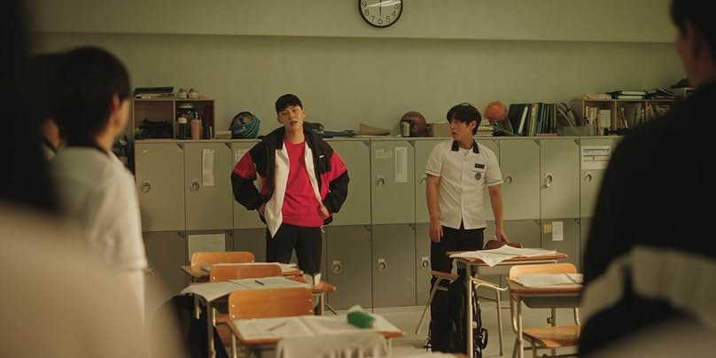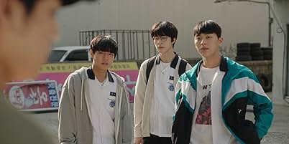
Su-ho offers to walk with Si-eun, slowly earning his trust. They become unlikely allies. Soon, they meet Oh Beom-seok, a new transfer student with a history of bullying and abuse.
The trio shares ramen, jokes, and friendship — but Beom-seok feels out of place between the strong Su-ho and brilliant Si-eun. He begins to develop deep emotional insecurity.
Meanwhile, the bullies escalate. Si-eun, although mentally sharp, knows that violence cannot be avoided. He prepares accordingly.

Episode 3: The Gang Trap

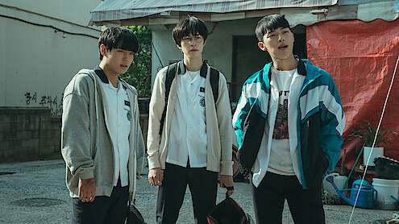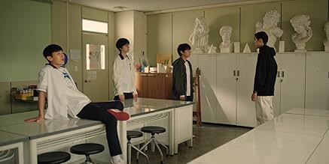
Young-bin and his cousin Ji-won trick the trio into a dangerous encounter with a local gangster named Gil-soo, who is brutal and threatening. Gil-soo demands money from Beom-seok in exchange for their safety.
Tactic used: Si-eun uses surveillance and street maps to track the gang’s location, silently planning a rescue.
This episode also highlights Si-eun’s empathy — despite his cold exterior, he risks everything for his friends.

Episode 4: The Rescue
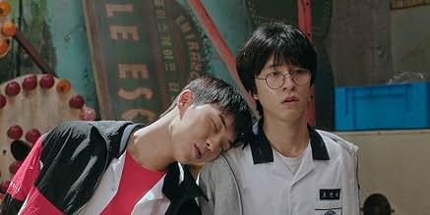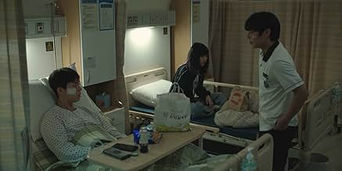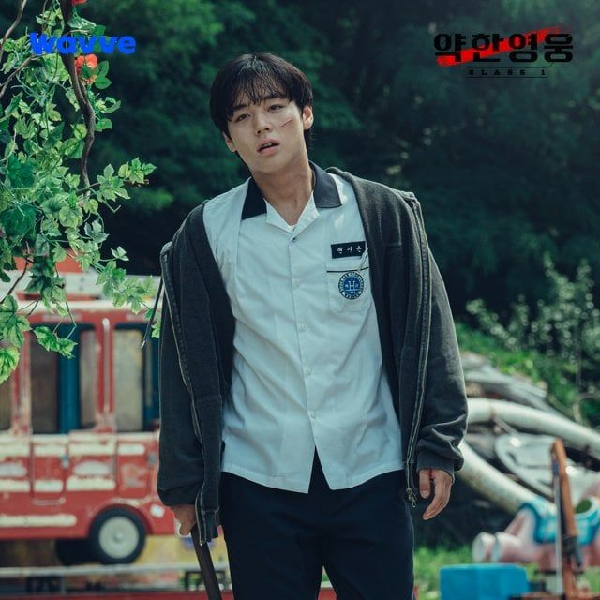
Su-ho and Beom-seok are kidnapped by Gil-soo’s gang. Si-eun finds an ally in Yeong-i, a tough runaway girl who helps him sneak into the gang’s hideout.
Quote:
“When you’re fighting many, make use of the surroundings.”
— a reference to the Battle of Thermopylae, which he studies.
He rescues his friends using ropes, lures, and distraction tactics. The trio emerges stronger than ever — but cracks are beginning to form, especially in Beom-seok.

Episode 5: The Cracks Deepen
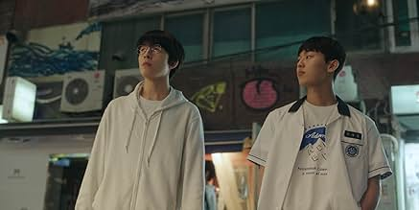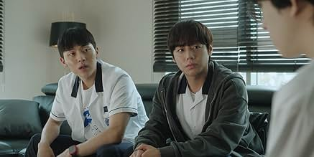
Beom-seok becomes increasingly jealous of the bond between Su-ho and Si-eun. When Su-ho posts a group picture but doesn’t follow Beom-seok back on Instagram, Beom-seok interprets it as rejection.
Psychological Turn:
Beom-seok starts talking to Ji-won and other bullies again, lying to them and playing the victim to gain sympathy and power.
Si-eun, unaware, tries to maintain the friendship, but emotional misunderstandings grow. Beom-seok feels invisible and powerless.

Episode 6: The Betrayal
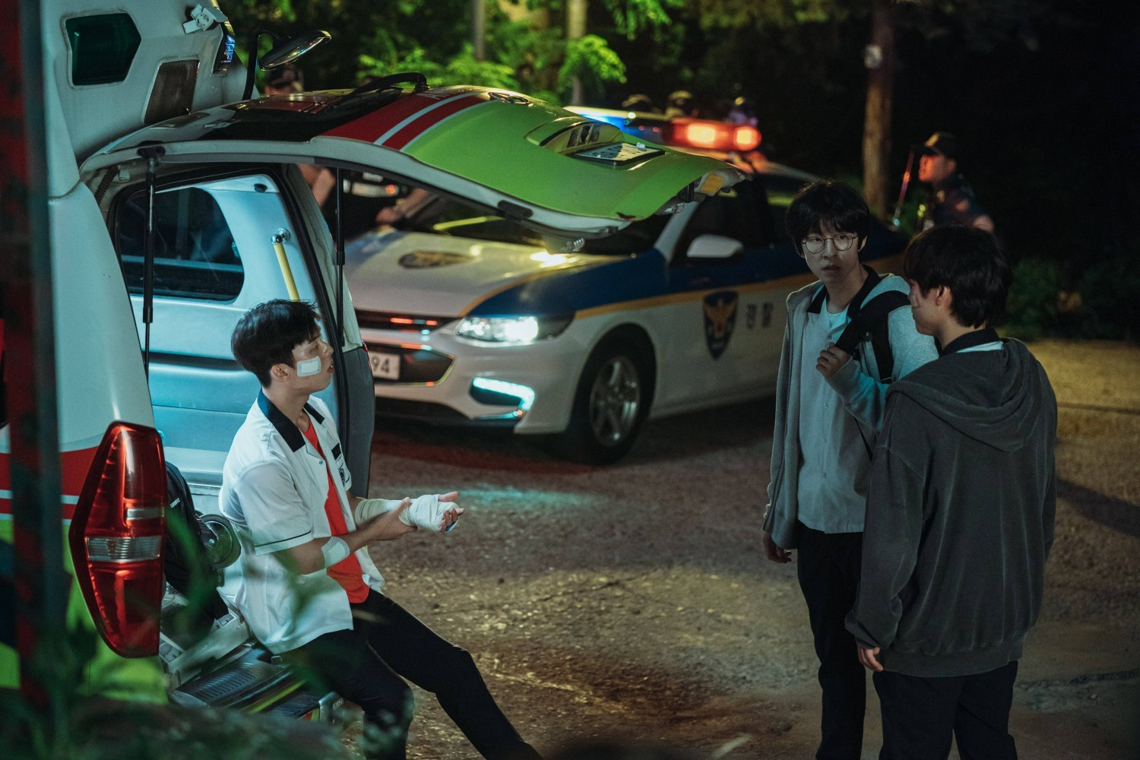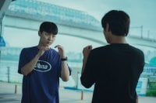

In a shocking twist, Beom-seok lures Su-ho into a trap where he’s ambushed and brutally beaten by Ji-won and his gang.
Symbolism:
Su-ho — the strongest character — is destroyed not by enemies but by a friend’s betrayal.
Si-eun finds Su-ho unconscious and bleeding. He is filled with guilt, rage, and sorrow. Beom-seok is now fully aligned with the gang, enjoying the power he never had.

Episode 7: Revenge Begins
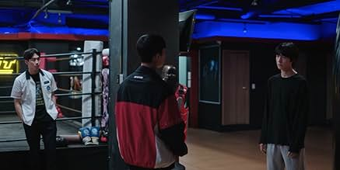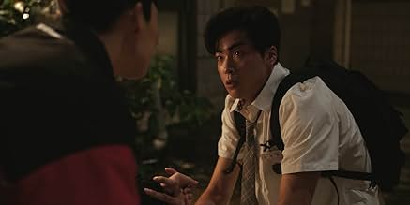
Si-eun snaps. Cold and methodical, he finds the gang members and beats them one by one using strategy, surprise, and tools like metal rods and wires.
Tactic used:
He sets traps in an abandoned building, uses blind spots, and even mimics gang behavior to confuse them.
But when he reaches Beom-seok, he stops. Despite everything, he can’t bring himself to hurt someone who was once his friend.
Quote:
“You disgust me. Don’t look at me.”
— Si-eun to Beom-seok, his voice trembling with pain.

Episode 8: The End — and a New Beginning
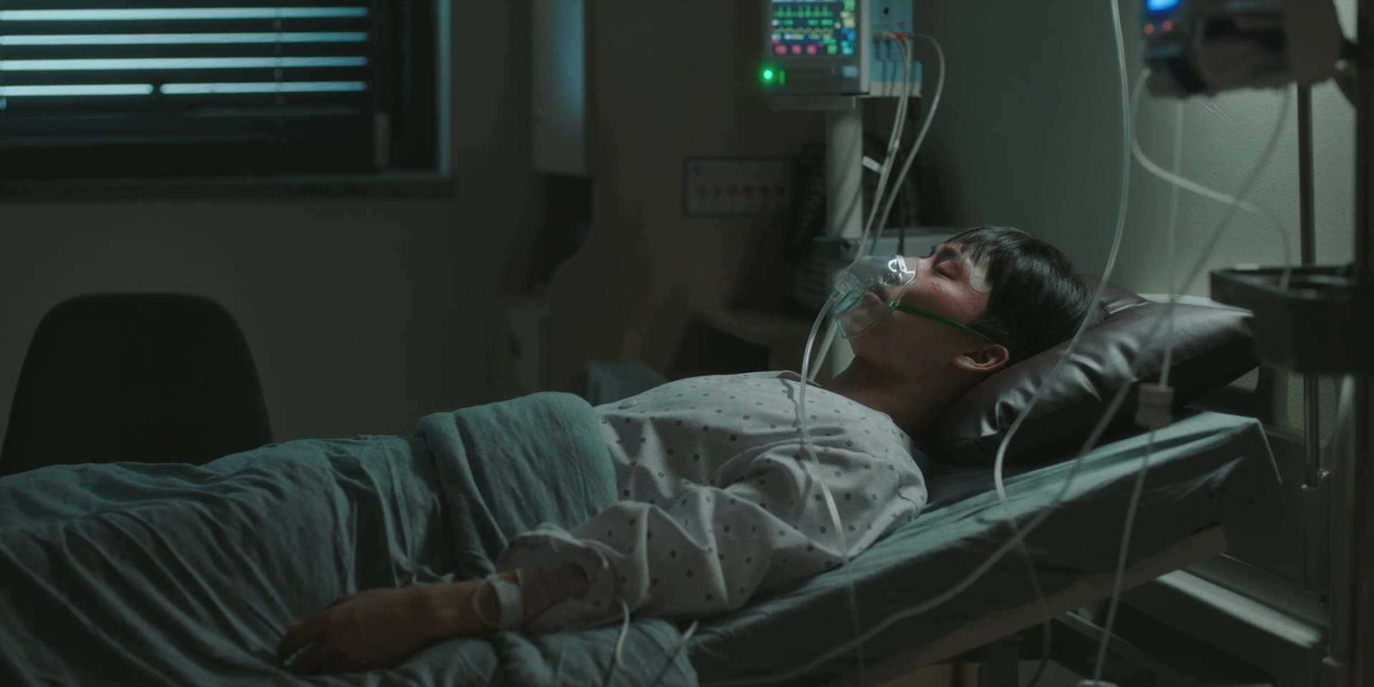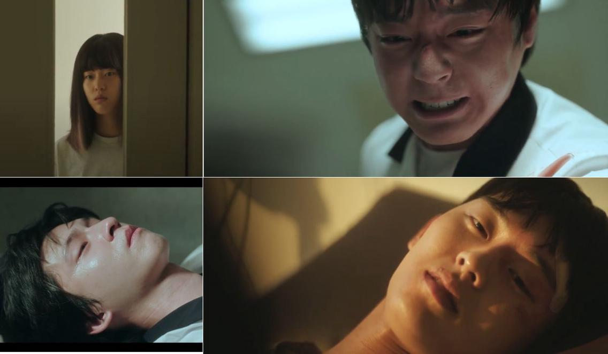
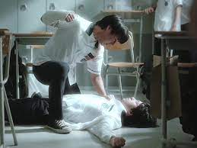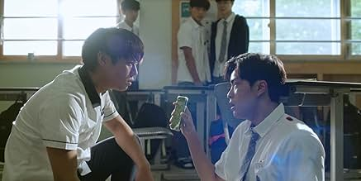
Su-ho is hospitalized, possibly unconscious for life. Si-eun walks through the school — a lone figure now. No friends. No gang. Just memories.
He transfers to a new school. The final scene mirrors the opening — a new bully targets Si-eun. But this time, Si-eun doesn’t hesitate. He looks him dead in the eye.
Final Message:
Si-eun will never back down again. He is no longer weak. He is a silent hero forged in pain.
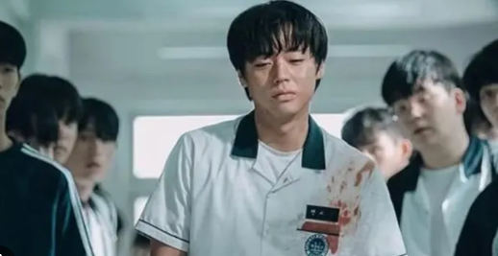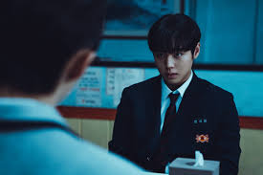

Summary
Weak Hero Class 1 follows the journey of Yeon Si-eun, a top-ranking high school student who, despite his frail appearance and quiet nature, possesses a brilliant mind. His life takes a drastic turn when he becomes the target of brutal school bullies—Jeon Young-bin, Jung Chan, and Han Tae-hoon. Refusing to back down, Si-eun uses intelligence, observation, and physics-based tactics to fight back. He weaponizes everyday objects like pens, rulers, and chair legs, turning them into tools of defense and survival.
Along the way, Si-eun befriends Ahn Su-ho, a strong, courageous classmate, and Oh Beom-seok, a timid and emotionally fragile new transfer student. Together, they form a tight trio and confront the violent school environment. However, cracks begin to form in their friendship as Beom-seok—who suffers from low self-worth and past abuse—grows increasingly jealous of Si-eun and Su-ho’s bond.
When the trio is manipulated into crossing paths with a dangerous gangster named Gil-soo, Si-eun shows his true strength. He tracks down the gang and rescues his friends using carefully laid traps and calculated strikes. His strategy-driven approach earns him a fearsome reputation, but also deepens Beom-seok’s feelings of inadequacy.
Beom-seok, desperate for validation and power, falls under the influence of Young-bin’s cousin, Jo Ji-won, a gang member. Misreading friendly gestures and social media as signs of exclusion, Beom-seok feels abandoned. His emotional breakdown leads him to betray his friends by orchestrating an ambush that leaves Su-ho hospitalized with life-threatening injuries.
Devastated and enraged, Si-eun unleashes his rage—not through brute force, but through meticulously planned vengeance. He tracks and defeats the gang members using the environment, physics, and surprise. However, when he finally confronts Beom-seok, Si-eun stops short of retaliation, saying only:
“Don’t look at me. You disgust me.”
In the final episode, Si-eun transfers to another school. Alone and emotionally scarred, he walks into a new classroom, only to face another bully. But this time, he doesn’t hesitate. His eyes are steady, his fear gone. The series ends where it began—but with a stronger, colder Si-eun ready to face anything.

Themes
• True Strength Lies in the Mind – Si-eun’s power comes from analysis, not violence.
• Friendship & Betrayal – How fragile bonds can be under pressure.
• School Violence & Psychological Trauma – A raw portrayal of bullying and neglect.
• Loneliness & Miscommunication – Unspoken pain and isolation can lead to disastrous outcomes.
• Redemption & Responsibility – Everyone makes choices, but not everyone seeks to heal.

Strengths
• Intelligent and Unique Lead – A rare protagonist who wins with brain over brawn.
• Emotional and Psychological Depth – Rich character arcs and realistic trauma.
• Intense, Smart Action – Strategic fights using physics, momentum, and environment.
• Strong Visual Storytelling – Silent moments and camera work speak louder than words.

Weaknesses
• Short Length – Only 8 episodes limits deeper character development.
• Female Characters Are Minor – Limited representation and relevance in the plot.
• Adults are Passive – Almost no adult steps in to stop the violence.
• Ambiguous Ending – Leaves emotional threads open.

Writing Style
The storytelling is compact, sharp, and emotionally charged. Dialogues are minimal but meaningful. The writing uses silence and visuals to convey emotion, creating a sense of realism and tension. Si-eun’s internal monologues and strategic thoughts add depth without needing loud action.

Character Development
- Yeon Si-eun evolves from a quiet victim into a calculating, emotionally complex fighter.
- Ahn Su-ho becomes the group’s moral compass—his loyalty and strength contrast with Si-eun’s logic.
- Oh Beom-seok undergoes the most tragic arc, consumed by his desire for acceptance and control.
- Villains remain mostly static, symbolizing systemic and personal cruelty.

Emotional Impact
The drama delivers a raw emotional punch. The betrayal of friendship, the silent suffering, and the consequences of violence are presented with honesty and sensitivity. Su-ho’s injury, Beom-seok’s breakdown, and Si-eun’s quiet pain leave a lasting impression.

Conclusion
*Weak Hero Class 1* is an emotionally powerful and sharply crafted drama that redefines heroism. It shows that courage is not about how hard you hit, but how deeply you endure and how smartly you act. It explores betrayal, friendship, trauma, and justice in a brutally honest way. With stunning performances, especially by Park Ji-hoon, and a story that balances tension with emotion, it’s a must-watch for anyone interested in youth dramas with real-world relevance.
Final Verdict: 9.5/10 — A short but unforgettable masterpiece.

