NATIONAL UNIVERSITY OF SCIENCES & TECHNOLOGY (NUST)
College of Electrical & Mechanical Engineering
ME-109 ENGINEERING DRAWING — Semester Project (DE-48)
Stage I: Project Proposal

Mars Rover Corner Wheel & Drive Module
3D Modeling, Assembly and Engineering Drawing Booklet using AutoCAD
Group No. | Group __
Syndicate | SYN __
Member Name | Registration No. | Primary Components
Member 1 | ______ | 01 Wheel Rim, 02 Spoke Plate; drawing template
Member 2 | ______ | 03 Drive Hub, 04 Axle, 09 Bearing Spacer
Member 3 | ______ | 05 Motor Housing, 06 Motor End Cap; sectional views
Member 4 | ______ | 07 Steering Bracket, 08 Steering Actuator Housing; assembly
Submitted to | Instructor name
Date | 12 November 2026

1. Project Title and Description
Title: Design, 3D Modeling and Engineering Drawing of a Mars Rover Corner Wheel & Drive Module

1.1 Introduction
NASA's Mars Science Laboratory rover Curiosity has driven over Martian terrain since 2012. It moves on six aluminium wheels, each about 0.5 m in diameter. Every wheel has its own drive motor, and the four corner wheels also have a steering actuator. As a result, each corner of the rover carries a self-contained wheel and drive module: a treaded wheel, an in-hub motor and gearbox, a supporting bracket, and a steering unit that rotates the whole wheel about a vertical axis.
No one can repair the rover on Mars, so this module has to carry the vehicle's weight, absorb shocks through flexible spokes, grip loose sand with its treads (grousers), and keep dust out of its bearings, all while staying as light as possible. This makes it a compact, realistic product with interesting geometry.
In this project our group will design a simplified, scaled version inspired by Curiosity's corner wheel module, using our own dimensions. We will model each component in 3D in AutoCAD, assemble them into the complete module, and produce a full engineering drawing booklet with orthographic, isometric, sectional, exploded and assembly drawings.

1.2 Objectives
- Model 9 distinct mechanical components in 3D using a range of AutoCAD solid-modeling operations.
- Assemble them into a working module with two rotation axes: wheel drive and steering.
- Produce dimensioned and toleranced drawings of every component on A4 paper-space layouts.
- Produce an exploded isometric view, the final assembly drawing, a full sectional view and the Bill of Materials.
- Apply standard engineering-drawing conventions: projection, line types, layers, title blocks, fits and tolerances.

1.3 Purpose and Applications
- Planetary exploration: Mars and lunar rovers (Curiosity, Perseverance, future lunar vehicles).
- Terrestrial robotics: all-terrain robots for search-and-rescue, bomb disposal, agriculture and mining inspection.
- Automotive and logistics: the same concept of an in-wheel motor with independent steering is used in electric vehicles, autonomous warehouse robots and omnidirectional platforms.
- Engineering relevance: the module brings together shafts, bearings, fits, keyed connections, bolted flanges and thin-walled structures, which are core topics in mechanical design.

2. Reference Images and Concept Sketch
We will use the following NASA/JPL images (public domain, courtesy NASA/JPL-Caltech) for visual reference only. All models and drawings will be the group's own work, with our own dimensions.
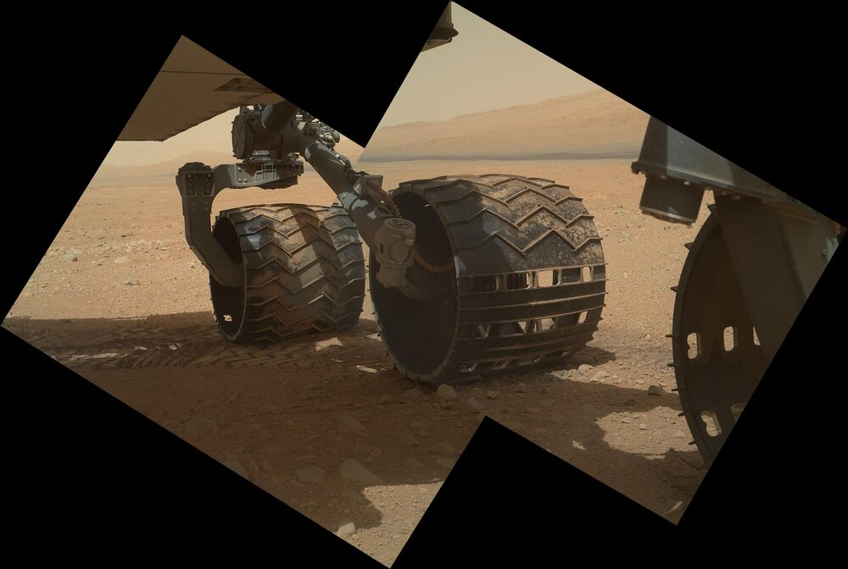  Fig. 1: Curiosity's wheels on Mars, showing chevron grousers, the corner steering bracket and the actuator (PIA16134) | 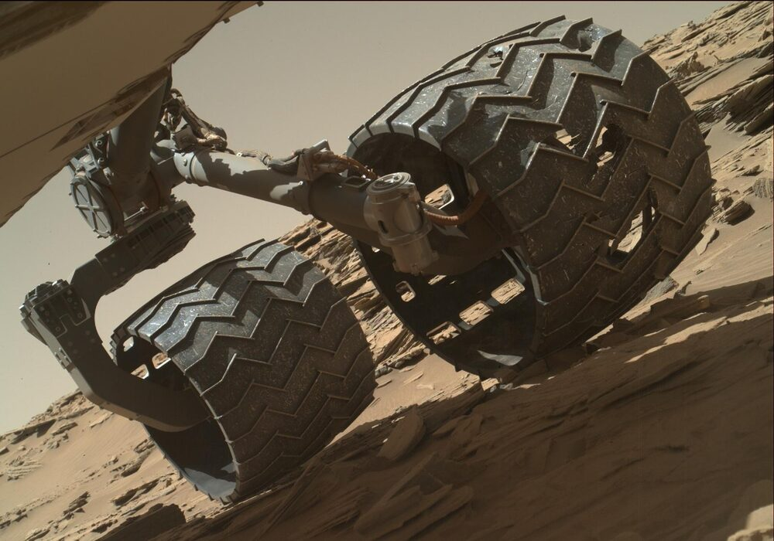  Fig. 2: Close-up of a wheel showing the thin rim skin and the grouser pattern (PIA20334)
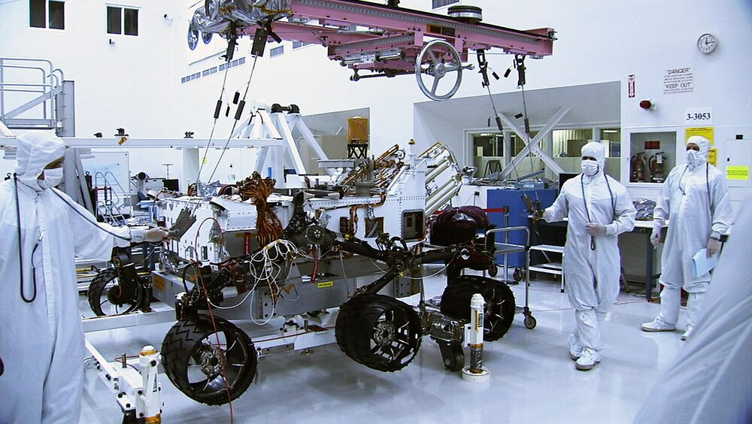  Fig. 3: Wheels before launch, showing the curved titanium spokes, the hub and the rim (PIA13237) | 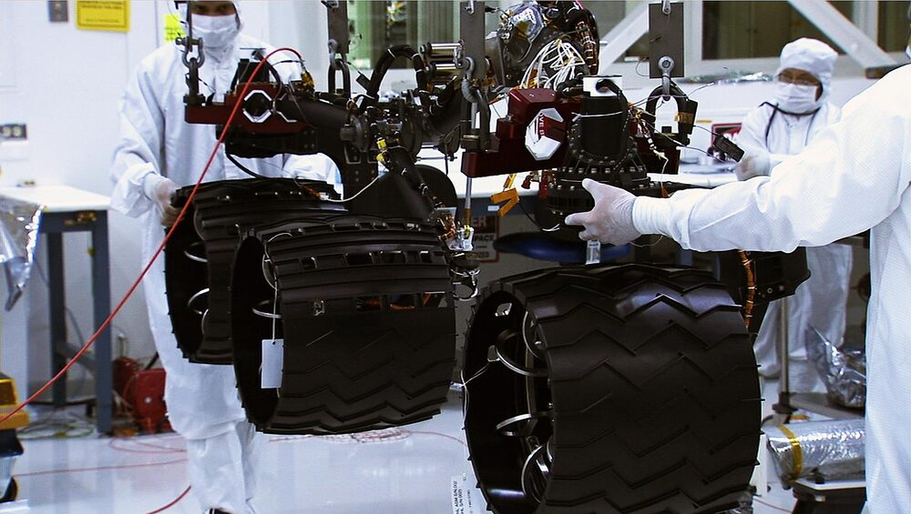  Fig. 4: Engineers installing a wheel module, which shows how the drive actuator and the bracket interface (PIA13236)
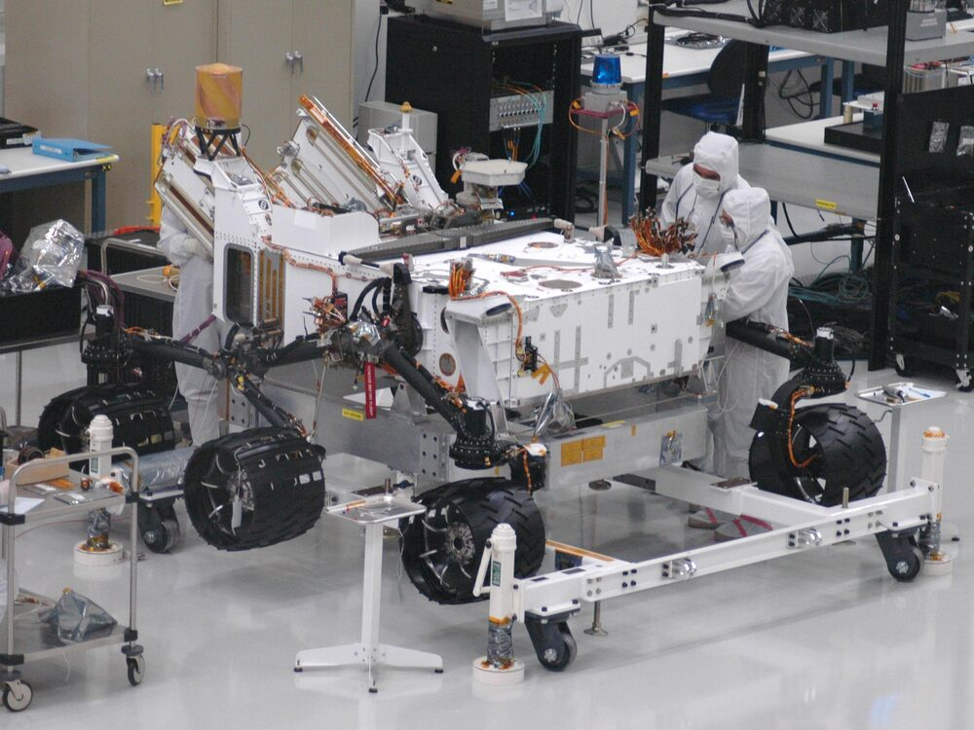  Fig. 5: Corner wheel modules mounted on the rover's suspension (PIA13235) | 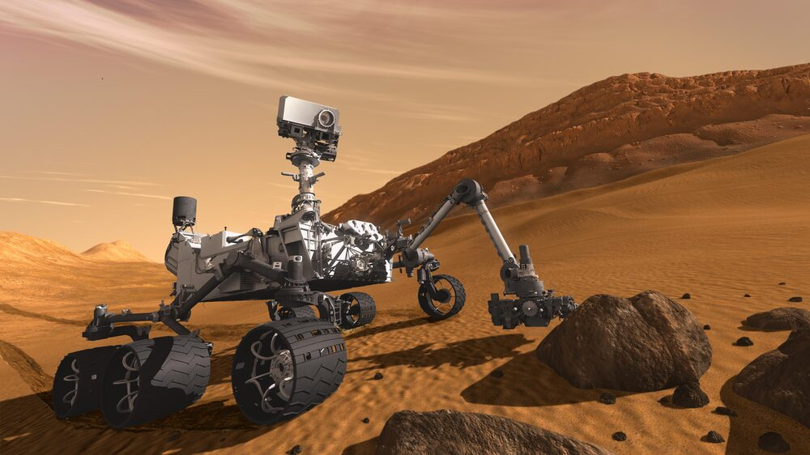  Fig. 6: Artist's concept of Curiosity on Mars, showing the six-wheel layout (PIA14156)
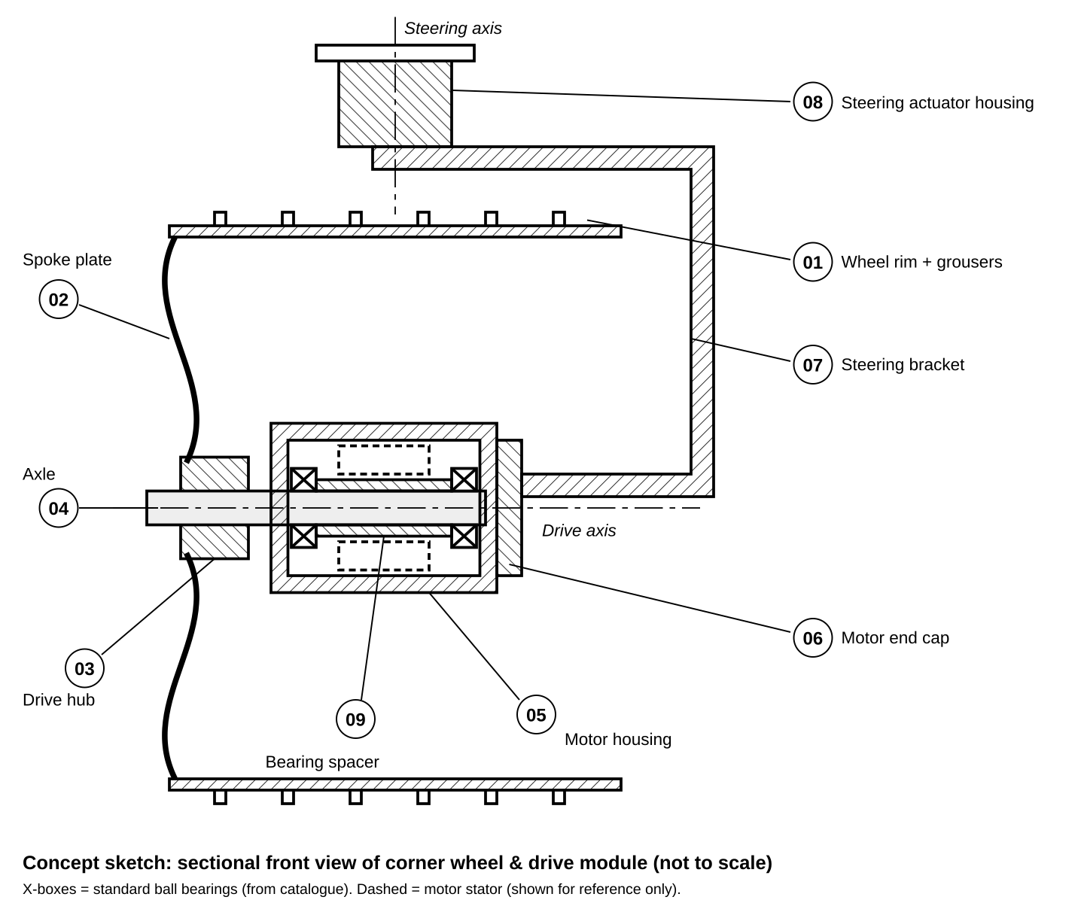
Fig. 7: Group concept sketch: sectional front view of the proposed module, with part numbers matching the component breakdown in Section 3.

3. Component Breakdown

3.1 Distinct Components (to be modeled)
No. | Component | Qty | Material (assumed) | Description / Key Geometry
01 | Wheel Rim (Drum) | 1 | Al 7075-T6 | Thin-walled cylindrical drum (Ø500 × 400 mm) with 24 chevron-shaped grousers arrayed around the circumference and an inner stiffening ring
02 | Spoke Plate | 1 | Ti-6Al-4V | Six curved, flexible spokes joining the rim to a central flange. The spokes act as suspension springs. Modeled by sweep and polar array.
03 | Drive Hub | 1 | Al 6061-T6 | Flanged hub with a 6-hole bolt circle, central bore and keyway; transmits torque from the axle to the spoke plate
04 | Axle (Output Shaft) | 1 | Steel AISI 4340 | Stepped shaft with two bearing seats, shoulders, a keyway, chamfers and a threaded end for the retaining nut
05 | Motor Housing | 1 | Al 6061-T6 | Cylindrical in-hub housing with a mounting flange, internal bearing bores, cooling fins and a tapped bolt circle
06 | Motor End Cap | 1 | Al 6061-T6 | Cover plate with a spigot locating diameter, a bolt circle, a cable port and a seal groove
07 | Steering Bracket (Yoke) | 1 | Al 7075-T6 | C-shaped bracket that carries the motor housing on one end and the steering pivot on the other; ribbed, filleted section
08 | Steering Actuator Housing | 1 | Al 6061-T6 | Vertical cylindrical housing with a mounting flange to the suspension arm and an internal bearing bore for the steering shaft
09 | Bearing Spacer | 1 | Steel | Precision sleeve that sets the axial distance between the two drive bearings

3.2 Standard Parts (in the BOM only, not counted as distinct parts)
Item | Specification (proposed) | Qty
Deep-groove ball bearing | 6007 (35 × 62 × 14) | 2 (drive) + 1 (steering)
Socket head cap screws | M8 × 20, M8 × 35, M5 × 16 (ISO 4762) | 18
Thin hex nut + washer | M24 × 2 (ISO 8675) + ISO 7089 washer | 1 + 1
Retaining ring (circlip) | DIN 471, 35 × 1.5 | 1
Parallel key | 8 × 7 × 50, DIN 6885-1 | 1
O-ring seal | Ø128 × 3, NBR | 1

3.3 Assembly Requirements and Sequence
- Press the two bearings into the motor housing (05), with the bearing spacer (09) between them.
- Insert the axle (04) through the bearings. Close the housing with the end cap (06), bolted on a bolt circle.
- Key the drive hub (03) onto the axle and secure it with the axle nut.
- Bolt the spoke plate (02) to the hub flange, then attach the wheel rim (01) to the spoke plate.
- Bolt the motor housing flange to the lower arm of the steering bracket (07).
- Mount the upper arm of the bracket on the steering actuator housing (08), which rotates the bracket about the vertical steering axis.
Mating interfaces needing tolerances:
- Bearing to axle: Ø35 k6
- Bearing to housing: Ø62 H7
- Hub to axle: Ø30 H7/k6 with key
- End-cap spigot: Ø136 H7/g6
- Steering bearing: Ø35 k6 / Ø62 H7

4. Key Preliminary Specifications
Parameter | Value (full details in the group dimension sheet)
Wheel outer diameter × width | Ø500 mm × 400 mm
Rim wall thickness / grouser height | 3 mm / 8 mm
Number of grousers / spokes | 24 chevrons / 6 curved spokes
Axle diameter (bearing seat) | Ø35 mm
Motor housing size | Ø150 mm × 210 mm (with flange)
Steering housing size | Ø120 mm × 150 mm
Motion axes | Wheel drive (horizontal) and steering (vertical, ±90°)
Projection method / sheet size | First-angle projection, A4 sheets, scales 1:1 to 1:5

5. Project Complexity

5.1 Modeling Complexity
Component | Main AutoCAD operations
01 Wheel Rim | REVOLVE, EXTRUDE (chevron profile), ARRAYPOLAR, UNION, SHELL
02 Spoke Plate | SWEEP along a curved spline path, ARRAYPOLAR, UNION, FILLET
03 Drive Hub | REVOLVE, bolt-circle holes (ARRAYPOLAR + SUBTRACT), keyway cut
04 Axle | REVOLVE stepped profile, CHAMFER, FILLET, keyway, cosmetic thread
05 Motor Housing | REVOLVE, SHELL, ARRAYPOLAR cooling fins, internal stepped bores
06 Motor End Cap | EXTRUDE, REVOLVE seal groove, bolt circle, cable port
07 Steering Bracket | Polyline outline EXTRUDE, ribs, LOFT transitions, FILLET, Boolean bosses
08 Steering Housing | REVOLVE, flange with bolt holes, internal bore
09 Bearing Spacer | Concentric CYLINDER + SUBTRACT, CHAMFER

5.2 Assembly Complexity
The module has two rotation axes, eleven or more mating interfaces, keyed and bolted joints, nested parts (the bearings and spacer sit inside the housing, which sits inside the wheel), and an offset C-bracket load path. We will check the assembly for clashes with the INTERFERE command.

5.3 Drawing Requirements (planned booklet)
Sheet | Content
00 | Cover page and drawing index
01–09 | One A4 sheet per component: front, top and side views, isometric view, dimensions, tolerances and notes
10 | Exploded isometric view with balloons
11 | Final assembly drawing (orthographic views) with the Bill of Materials
12 | Full sectional view through the drive axis (hub, axle, bearings, housing)
13 | Sectional and detail views of the steering pivot and the end-cap seal

6. Work Plan

6.1 Approach
- Dimension sheet: agree on all interface dimensions together, so that parts modeled by different members fit together.
- Shared template (.dwt): layers (Visible, Hidden, Center, Dimension, Hatch, Section, Title), line types and lineweights, text and dimension styles, and an A4 border with a title block.
- Modeling: each member models their own components in a separate DWG file.
- Assembly: combine the components into one file, align them, check for interference, and create the exploded view.
- Drawings: generate views in paper space (VIEWBASE / VIEWSECTION), then dimension, tolerance and annotate them.
- Compilation: peer-check every sheet, compile and print the booklet, and prepare the presentation and the ZIP submission.

6.2 Distribution of Responsibilities
Member | Modeling and drawing sheets | Additional responsibility
Member 1 | 01 Wheel Rim, 02 Spoke Plate | AutoCAD template, layer standards, cover page
Member 2 | 03 Drive Hub, 04 Axle, 09 Bearing Spacer | Tolerances and fits, BOM
Member 3 | 05 Motor Housing, 06 Motor End Cap | Sectional views (Sheets 12–13)
Member 4 | 07 Steering Bracket, 08 Steering Housing | 3D assembly, exploded view, presentation

6.3 Timeline
Week | Activity | Responsibility
10 | Proposal submission; dimension sheet | All members
11 | Shared template; start modeling components | Member 1 / all members
12 | Complete all component models | Each member
13 | Assembly, interference check, exploded view | Member 4 with all members
13–14 | Component sheets, sectional views, assembly drawing, BOM | Each member
14 | Peer review, booklet compilation, printing | All members
15 | Presentation, viva, ZIP submission (Group_XX_Mars_Rover_Wheel_Module.zip) | All members

7. Anticipated Challenges and Mitigation
Challenge | Planned solution
Curved spokes and chevron grousers | Use SWEEP along spline paths and ARRAYPOLAR; simplify the curvature if needed
Parts by different members not fitting | Use a shared dimension sheet and the same reference origin (drive axis at 0,0,0)
Representing threads and bearings | Show threads with the standard cosmetic convention; model bearings as simplified catalogue parts
Readable sectional views of nested parts | Use different hatch angles and spacing for adjacent parts, and do not hatch shafts or fasteners, as the convention requires
Large file sizes and slow regeneration | Keep one DWG per component and insert them into the assembly as blocks or external references

8. Expected Outcomes
- A complete 3D assembly of the corner wheel and drive module in AutoCAD (editable DWG files).
- A printed and PDF Engineering Drawing Booklet of about 14 A4 sheets.
- A group presentation covering what we designed, why it matters, how we built it, the challenges we faced and the final result, plus a live AutoCAD demonstration.

References
- NASA/JPL-Caltech Photojournal: PIA16134, PIA20334, PIA13235, PIA13236, PIA13237, PIA14156. https://photojournal.jpl.nasa.gov
- The Planetary Society, "Diagram of a Curiosity wheel." https://www.planetary.org/space-images/diagram-of-a-curiosity-wheel
- NASA Mars Science Laboratory mission overview. https://science.nasa.gov/mission/msl-curiosity/
- N.D. Bhatt, Machine Drawing, Charotar Publishing House.
- Autodesk, AutoCAD Help: 3D Modeling and Model Documentation. https://help.autodesk.com

