**Criterion B: Design of Solution**

A game of hangman works as follows:

1. The program selects a word from a pool of words from a specific difficulty level and displays it on the screen.
2. The user/player begins guessing letters. If the player guesses a letter that is in the word, then all instances of that letter are displayed at their corresponding positions in the word. Otherwise, the guess is incorrect. Every incorrect guess results in a body part of the stickman being drawn. At the first incorrect guess head and body is drawn. Then left leg, then the right leg and after the arms start forming starting with the left arm and lastly the right.
3. The game ends when either all letters in the word have been guessed or when the player has used 5 incorrect guesses and all stickman body parts are drawn with a pop up stating whether the player has won or lost.

**Main Menu Screen**

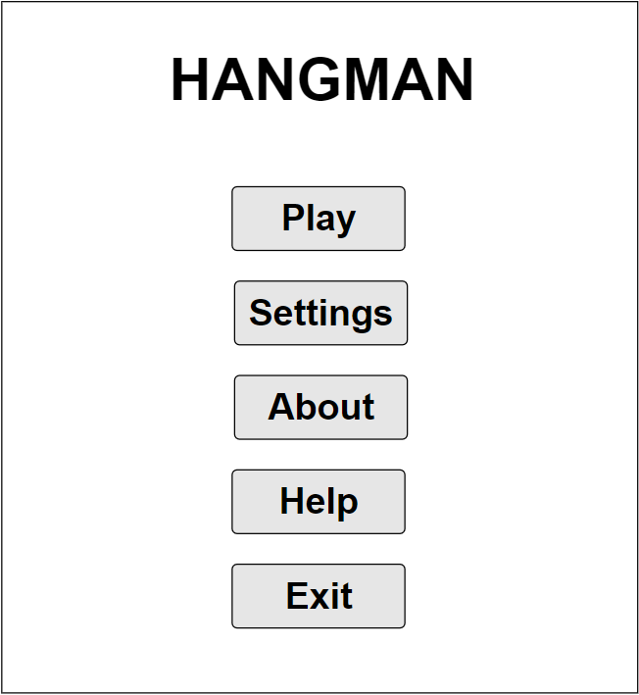

The screen would have 5 buttons when started, Play, Settings, About, Help, Exit. The Exit option simply just quits the game.

**About in Main Menu**

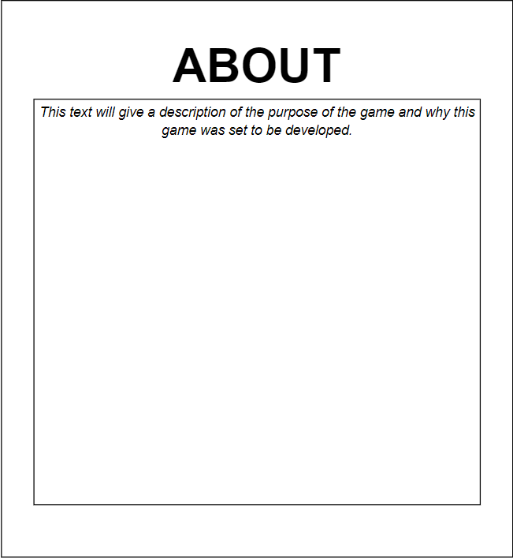

Once clicked should show a description of the “About” option

**Help in Main Menu**

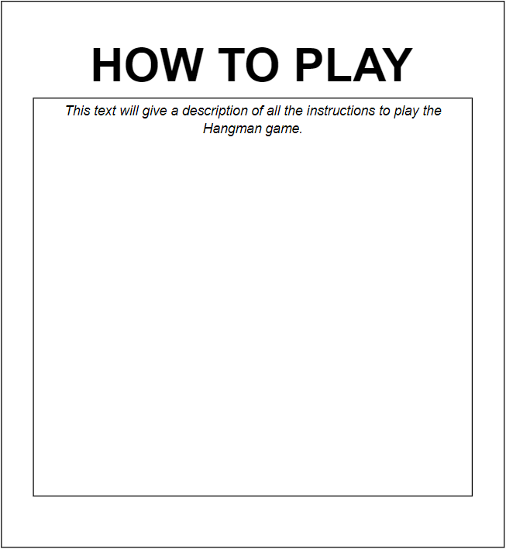  
Once clicked should show a description of the “Help” option

**Settings in Menu**

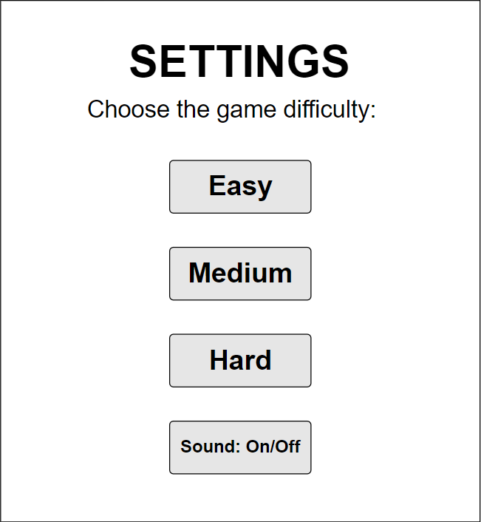

This settings screen shall be displayed upon pressing the settings option

It should consist of a list of all the difficulty levels Easy, Medium, Hard. By default, the game upon launch should be set at “Easy” difficulty. There should also be a button where once clicked would toggle sound on or off.

**Play (Game-Screen)**

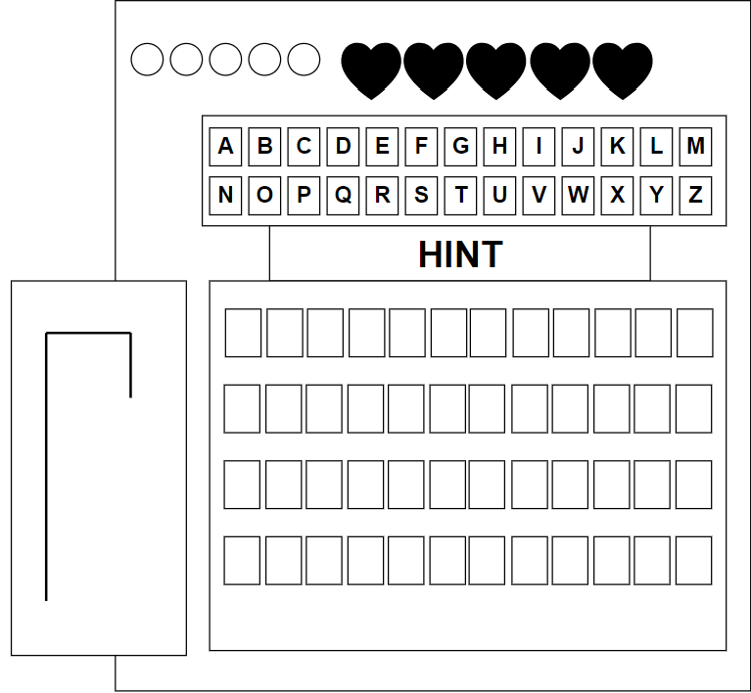

When user selects a new game from the menu they’ll be seeing an incomplete Hangman image on the left, text field of all the alphabets under it a hint for the vocabulary word along with a clear representation of how many lives they have left on the top of the text fields followed by the image formed on their left.

Under hint text field, the vocabulary word the user has to be guess will start to appear once the correct letters are selected, if the selected letter is incorrect it should disappear from the text field, deduct a life and apart of stickman image should be formed.

**Win or Lose Dialog**

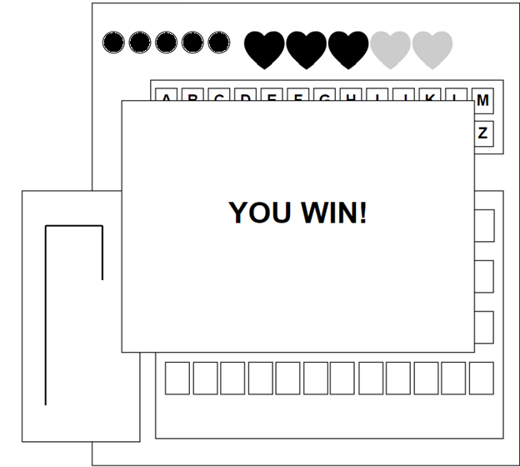

This dialog shall be displayed when the user has won a game after completing all 5 levels. If the user has lost, the message is displayed as “You Lose!” instead.

*All above images were made possible with the help of app.moqups.com*

**Test Plan**

|  |  |
| --- | --- |
| **Action to be tested** | **Test method** |
| All the graphical interfaces are doing their appropriate functions | Run the program multiple to test individual features linked to graphical elements with various inputs and check if they are performing the desired functions. |
| Check whether the audio button’s through settings functional or not | Launch the game and check through main menu if it cycles the filter easily or not. |
| During the game check if the results are shown correctly | Play the game, enter correct answer, then incorrect and see if results are displayed properly. |
| Check whether all the difficulty levels are functional and rightly placed (Should begin with Easy difficulty on first launch) | Run the program and see if start-up of the game matches with the vocabulary list for “Easy “difficulty and run it and check if it’s functional. |
| Check whether the stickman figure is formed linked with the 5 lives given for each level. | Making sure at each wrong letter selected a part of the stickman’s body is formed followed by the 5 lives given. |
| Check whether if when you have lost or won the game it returns to main menu or not. | Selecting wrong letters for a given hint of given word, at loss should bring you back to main menu same for when all 5 stages passed it takes you back. |