Smart Agriculture Management System
Intelligent Soil Telemetry and Automated Irrigation for Tamil Nadu Farmlands
Object Oriented Analysis and Software Engineering (OOASE)
Project Report

Submitted by:
Sanofar Fathima I
Register Number: 6113241041131
III B.E. CSE – Section C
Live project: https://smart-agri-frontend-rho.vercel.app

1. Introduction

1.1 Overview
The Smart Agriculture Management System is a web-based platform for the farmlands of Tamil Nadu. It brings live soil and land telemetry, irrigation-dam storage information, localised agronomic advice, a fertigation (fertiliser and water) calculator, government scheme information and market prices into one place, so that a farmer can take decisions from a phone or computer instead of depending on guesswork. The platform is organised around the seven agro-climatic zones of the State and the traditional Pattam (seasonal) calendar, and it is designed to work with low-cost field devices: multi-depth soil moisture probes, optical NPK sensors, solenoid drip valves and a LoRaWAN gateway.
Because farm details, land information and sensor controls are sensitive, the system uses role-based access with two kinds of signed-in users: farmers (customers) and the creator administrator. A visitor who has not signed in can read the public pages only. The application is deployed on Vercel and can be opened from any modern browser.
The system follows a client–server architecture. The responsive web front end talks to a Node.js and Express REST API, and the data (users, farms, readings, reviews, enquiries) is stored in a database. The project is documented using OOASE practices: requirements prepared in MS Word, seven UML diagrams, implementation in VS Code, API testing with Postman and version control with Git.

1.2 Problem Statement
Most small and marginal farmers in Tamil Nadu still manage water and fertiliser by experience and by the calendar alone. This leads to recurring problems:
- Erratic water supply – monsoon rainfall is uneven and Cauvery basin water is scarce, yet irrigation is started and stopped by hand.
- Over- and under-watering – without soil moisture data, crops such as paddy, coconut and turmeric receive too much or too little water.
- Unscientific fertiliser use – urea, DAP and potash are applied by habit rather than by soil nutrient levels, raising cost and damaging soil.
- No real-time soil information – nitrogen, phosphorus, potassium, pH and micronutrient status are known only after a laboratory test.
- Scattered advice – crop calendars, zone details, dam levels, market prices and subsidy schemes are spread across many offices and portals.
- Missed subsidies – eligible farmers often do not know about micro-irrigation, solar pump and crop-insurance schemes.
- Manual records – farmer details, landholdings and feedback are kept on paper and are hard to search or report.

1.3 Objectives
- Provide a live land report showing soil and field telemetry together with the storage, inflow and outflow of major irrigation dams.
- Let farmers register, sign in, maintain a profile with photo, district, landholding and primary crops, and accept the terms and conditions.
- Give crop-wise fertigation prescriptions (urea, DAP, MOP, bio-fertiliser, zinc sulphate, daily water and drip run-time) from crop, acreage, growth phase and soil texture.
- Publish an agri-tech guide covering IoT probe installation, drip rules, NPK and pH thresholds, agro-climatic zones, the Pattam calendar and the nutrient deficiency matrix.
- Present Tamil Nadu government welfare schemes and subsidies, and live market (AGMARKNET) prices for important crops.
- Collect farmer reviews and support enquiries, and show project revenue and the customer directory.
- Restrict administrative functions strictly to the creator administrator and secure the system with login, role-based access and encrypted passwords.
- Model the system with standard UML diagrams and implement it with a layered, maintainable code base.

1.4 Scope of the Project
The system covers the cycle from farmer registration to advisory: the farmer registers and signs in, views the live land report and market prices, studies the guide, runs the fertigation calculator, reads about schemes and subsidies, and submits reviews or support enquiries; the administrator reviews customers, revenue and platform telemetry.
Included: registration and login, role management, farmer profile with photo, live land report, dam storage radar, farmlands gallery, agri-tech guide, fertigation calculator, government schemes, market price ticker, project revenue, customer directory, reviews, support desk and administrator console.
Not included: fully commercial IoT hardware integration, real payment gateway for subscriptions, a native mobile application and multi-language (Tamil/English) switching (see Section 6.3).

1.5 Technologies Used
The project uses web technologies that are free, well documented and run on ordinary hardware. JavaScript is used on both client and server, which keeps the code base consistent.
Layer | Technology | Purpose
Frontend | HTML5, CSS3, JavaScript (ES6) | Responsive single-page interface with sections, tabs and pop-up dialogs
Backend | Node.js, Express.js | REST API, business logic, authentication and authorisation (runs on port 3000)
Database | MongoDB, Mongoose | Document storage of users, farms, readings, reviews and enquiries
Security | JWT, bcrypt, CORS, input validation | Token login, password hashing, origin control, safe input handling
Field layer (design) | LoRaWAN soil probes, optical NPK sensors, solenoid drip valves | Soil moisture, nutrient and irrigation actuation described by the platform
Hosting | Vercel, Git | Cloud deployment of the front end and version control
Requirements | MS Word | Requirement analysis document
Modelling | UML (use case, class, sequence, activity, state chart, component, deployment) | Analysis and design diagrams
Testing | Postman, browser testing | Collection-based API testing and manual scenarios
Tooling | VS Code, npm, Git | Code editing, packages and version control

1.6 Organisation of the Report
Section 2 presents the requirement analysis; Section 3 the seven UML diagrams; Section 4 the project code, architecture and testing; Section 5 the screens of the website; and Section 6 the conclusion, limitations, future enhancements and references.

2. Requirement Analysis

2.1 Approach
Requirements were analysed in the object-oriented style: actors were identified first, their goals were written as use cases, the real-world things they handle were identified as classes, and the connecting rules were captured as business rules. The requirements were refined by walking through the normal workflow: a farmer registers and accepts the terms, signs in, checks the live land report and market prices, uses the fertigation calculator to plan inputs, reads the guide and schemes, and gives feedback; the administrator monitors customers, revenue and sensor settings.

2.2 User Roles
Role | Description | Main responsibilities
Creator Administrator | Platform owner with full access through a separate administrative gate. | Views and manages customers, revenue, reviews and enquiries; sets global telemetry calibrations and emergency drought overrides.
Farmer (Customer) | Registered agriculturist. | Maintains profile, views live land report, uses calculator and guide, reads schemes, writes reviews, sends enquiries, overrides valves manually on own farm.
Visitor | Unregistered person. | Reads public sections (home, farmlands gallery, about); must register or sign in to use the dashboard.

2.3 Functional Requirements
ID | Requirement | Module
FR01 | Register a farmer account with name, e-mail, password, phone, date of birth, district, farm size and primary crops. | Authentication
FR02 | Sign in with e-mail and password; reject invalid credentials; offer quick demo accounts for evaluation. | Authentication
FR03 | Require acceptance of the Terms and Conditions during registration. | Authentication
FR04 | Issue a token on login and restrict each page and API call by the user role. | Authentication
FR05 | Provide a separate administrative gate that accepts the creator only and rejects farmer logins. | Administration
FR06 | Allow a farmer to upload a profile picture and edit profile details. | Profile
FR07 | Show the live land report with soil telemetry for agro-climatic zones. | Live report
FR08 | Show dam storage radar: level, percentage full, inflow and outflow for major dams (Mettur, Bhavanisagar, Vaigai, Aliyar). | Live report
FR09 | Display live market prices (AGMARKNET) with change indicators in a ticker. | Market
FR10 | Display a gallery of Tamil Nadu farmlands and agro-zones. | Gallery
FR11 | Provide the agri-tech guide with modules on probes, drip rules, NPK and pH thresholds and governance. | Guide
FR12 | Present the seven agro-climatic zones, the Pattam calendar and the soil NPK and micronutrient matrix. | Guide
FR13 | Present water budgeting, drip maintenance and energy management protocols. | Guide
FR14 | Present Tamil Nadu government schemes with department, subsidy percentage and benefits. | Schemes
FR15 | Generate a fertigation prescription from crop, acreage, growth phase and soil texture. | Calculator
FR16 | Show project revenue and commercial performance of deployed districts. | Revenue
FR17 | Show the customer directory with farmer details and landholdings. | Customers
FR18 | Let a farmer submit a review with rating, headline, feedback and avatar photo. | Reviews
FR19 | Let any user send a support or sensor-installation enquiry to the engineering desk. | Support
FR20 | Hold scheduled irrigation when heavy rain is forecast and shut valves when rainfall exceeds the limit. | Irrigation rules
FR21 | Give the administrator a command centre showing platform telemetry. | Administration
FR22 | Keep customer data and administrative actions inaccessible to farmers. | Security

2.4 Non-Functional Requirements
Attribute | Requirement
Security | Passwords stored only as hashes; token required for protected API calls; administrator gate restricted to the creator; secrets kept in environment variables; land coordinates and survey numbers protected.
Performance | Pages and sections load within about two seconds on a normal connection; images are compressed before upload for fast loading.
Usability | Clear section menu, high-contrast dark theme, quick demo logins, icons, and short guided modules suitable for farmers.
Reliability | Input is validated on client and server; safe defaults hold irrigation when rainfall is forecast; farmers can always override valves manually.
Maintainability | Server code separated into models, routes, middleware and services; client code into sections, scripts and styles.
Portability | Stateless REST API; runs in any modern browser; responsive layout for phone and desktop.
Availability | Hosted on Vercel; target probe-grid uptime shown to users is 99.98%.

2.5 Hardware and Software Requirements
Item | Minimum requirement
Processor, memory, storage | Dual-core processor, 4 GB RAM (8 GB recommended for development), 2 GB free disk space
Operating system / runtime | Windows 10 or later, Ubuntu 20.04 or later, or macOS; Node.js 18 or newer and npm
Database / browser | MongoDB 6.0 or newer (local server or Atlas); current Chrome, Edge, Firefox or Safari
Field devices (design) | LoRaWAN soil moisture probe, optical NPK sensor, solar battery node, solenoid valve and district gateway
Tools | VS Code, MongoDB Compass, Postman, MS Word, UML tool, Git

2.6 Data Requirements
Entity | Principal attributes | Description
User | userId, name, email, passwordHash, phone, dob, role, isActive | A person who can log in; the role decides what they may do.
Farmer profile | district, farmSizeAcres, primaryCrops, photo, termsAccepted | Agricultural details of a customer.
Farm | farmId, district, zone, soilType, areaAcres | A land holding owned by a farmer.
SensorReading | readingId, moisture, pH, N, P, K, temperature, takenAt | One telemetry record from a probe.
Dam | damId, name, basin, level, capacity, inflow, outflow | Irrigation dam storage record.
MarketPrice | crop, market, price, unit, changePercent | AGMARKNET price entry.
Prescription | crop, acres, phase, soilTexture, ureaKg, dapKg, mopKg, waterLitres | Output of the fertigation calculator.
Review | name, district, crops, rating, headline, feedback, avatar | Farmer testimonial.
Inquiry | name, email, phone, district, message, createdAt | Support or installation request.

2.7 Business Rules
- Only the creator administrator may use the administrative gate; farmer logins are rejected there and customers have no administrative privileges.
- A farmer must accept the Terms and Conditions before registration is complete.
- Farmers retain manual physical override rights on their farm valves at all times.
- An emergency shut-off is triggered automatically if rainfall exceeds 15 mm; scheduled cycles hold if more than 10 mm is forecast within 12 hours.
- Drip actuation follows soil texture: sandy loam starts below 55% moisture and stops at 82%; coconut rings start below 50% field capacity; acidic hill soil suppresses irrigation in morning mist or humidity above 85%.
- Fertigation quantities are calculated per acre of the selected crop and growth phase and scaled by the land area entered.
- Land coordinates and survey numbers are encrypted and not shared with unauthorised third parties.
- A deactivated user can no longer log in, but historical reviews and records are kept.

2.8 Feasibility Study
- Technical – all software is open source or free-tier, well documented and needs only JavaScript skills and ordinary hardware.
- Economic – there is no licence cost; Vercel free hosting and a local MongoDB or the Atlas free tier are enough.
- Operational – quick demo accounts and a one-click creator verification make evaluation easy for examiners.

2.9 Assumptions and Constraints
- A reliable network connection to the server, and each user has an individual account.
- Field telemetry shown in the demonstration is sample data; real sensors are connected through the gateway in a full deployment.
- Market prices and dam levels are shown as demonstration figures and are not official data in this version.
- Demo credentials are for testing only and must never be used in a deployed environment.

3. UML Diagrams

3.1 Overview
The Unified Modeling Language (UML) is a standard visual language for specifying and documenting software. The seven diagrams below describe the system from the viewpoint of its users (use case), its structure (class, component, deployment) and its behaviour (sequence, activity, state chart).

3.2 Diagrams and Descriptions
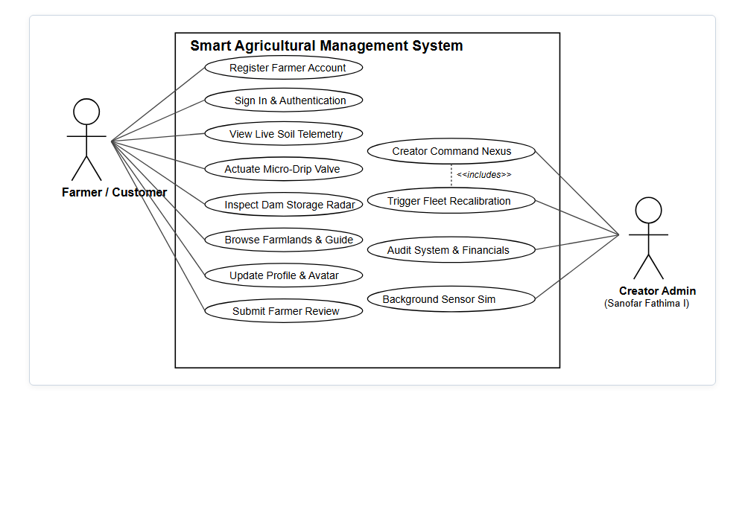
Figure 3.1: Use Case Diagram
Use case diagram. Two main actors use the system. The Farmer registers or signs in, views the live land report, reads the guide, uses the fertigation calculator, checks schemes and market prices, edits the profile, writes reviews and sends enquiries. The Creator Administrator signs in through the administrative gate, views customers and revenue, moderates reviews, answers enquiries and manages platform telemetry. The IoT gateway acts as a secondary actor that supplies sensor readings. A visitor who has not signed in can read public sections only.

3.3 Class Diagram
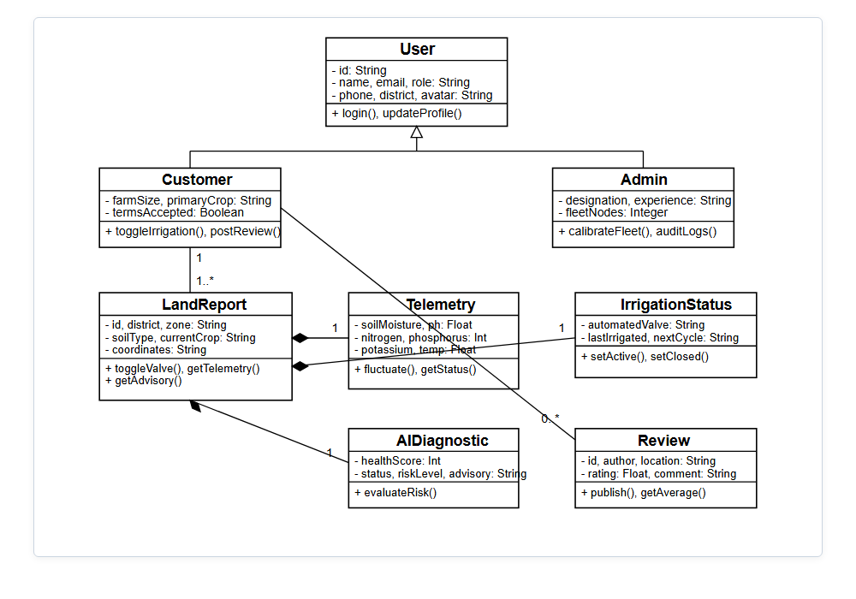
Figure 3.2: Class Diagram
Class diagram. User is the parent class; Admin and Farmer inherit from it. A Farmer owns one or more Farms; each Farm has SensorNodes that produce SensorReadings and IrrigationValves that are actuated by rules. A Farmer requests Prescriptions for a Crop, writes Reviews and sends Inquiries. Dam and MarketPrice are reference classes shown in the live report and ticker. Operations include register(), login(), calculatePrescription(), openValve(), closeValve() and submitReview().

3.4 Sequence Diagram
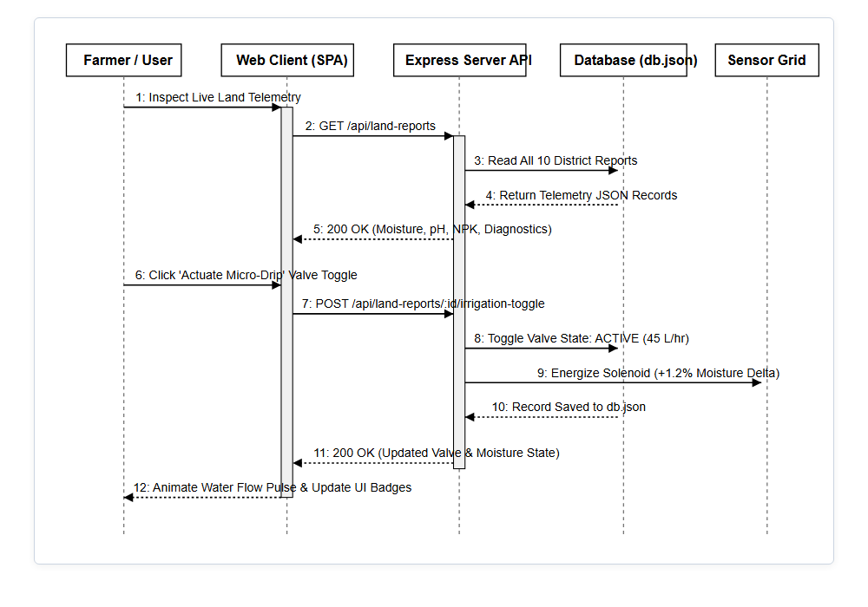
Figure 3.3: Sequence Diagram – Generate Fertigation Prescription
Sequence diagram. The farmer selects crop, area, growth phase and soil texture in the web app and presses the calculate button. The app calls the API with the token; the server verifies the token and role, loads the per-acre norms for the crop and phase, computes urea, DAP, MOP, bio-fertiliser, zinc sulphate, daily water and drip run-time, stores the prescription, and returns the result, which is displayed to the farmer. If a value is missing or invalid, an error is returned and nothing is stored.

3.5 Activity Diagram
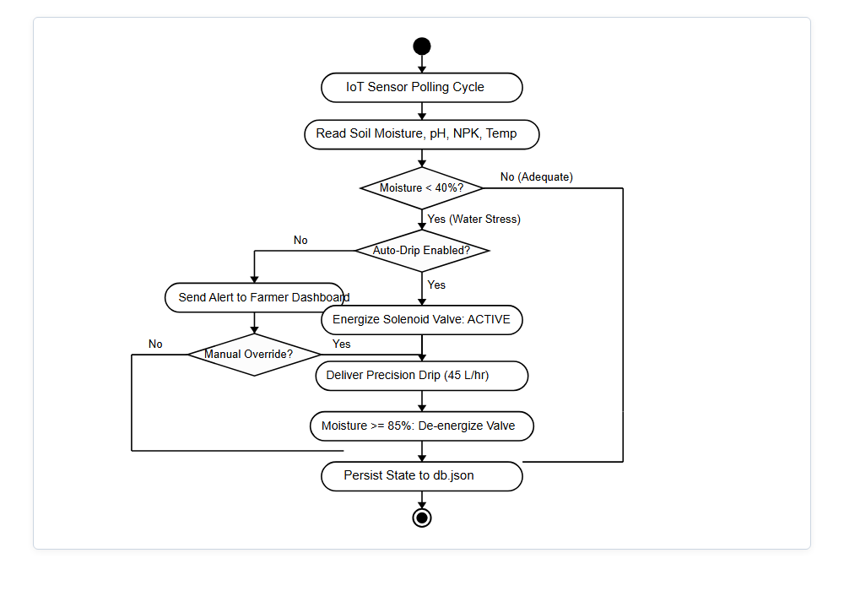
Figure 3.4: Activity Diagram – Register, Monitor and Irrigate
Activity diagram. The farmer registers, accepts the terms and signs in. The dashboard shows the live land report. If soil moisture is below the crop threshold and no heavy rain is forecast, the drip valve is opened and closed again at the upper limit; if rainfall exceeds the limit, the valve is shut and irrigation is held. The farmer may then run the calculator, read the guide and submit a review.

3.6 State Chart Diagram
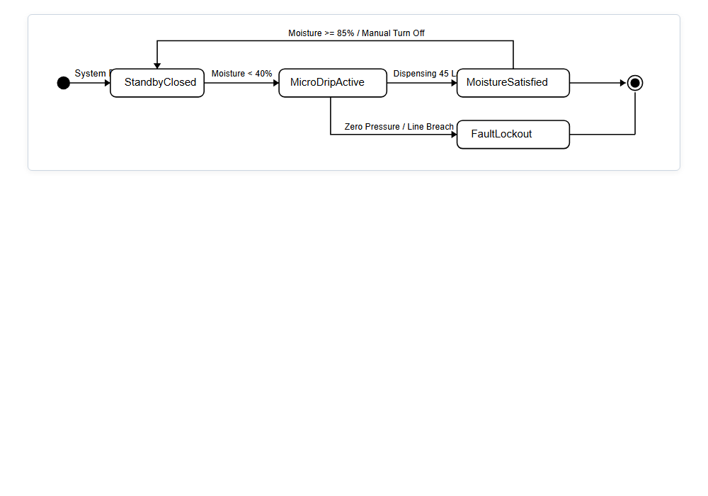
Figure 3.5: State Chart Diagram – Irrigation Valve and Farmer Account
State chart diagram. An irrigation valve starts Closed, becomes Open when soil moisture falls below the crop threshold, returns to Closed at the upper limit, moves to Held when heavy rain is forecast, and to Emergency Shut-off when rainfall exceeds the limit; a farmer may force Manual Override at any time. A farmer account is Registered after sign-up, Active after the terms are accepted and login succeeds, and Deactivated if the administrator disables it.

3.7 Component Diagram
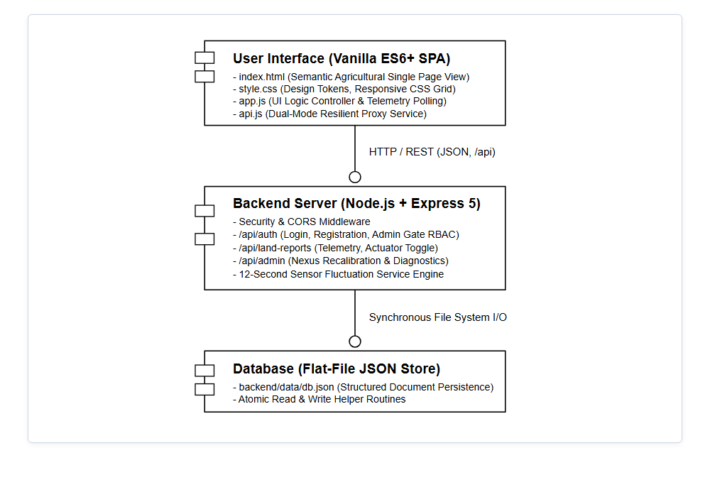
Figure 3.6: Component Diagram
Component diagram. The web user interface (sections, dialogs, calculator script) talks to the Node.js and Express backend over HTTP/REST using JSON. The backend contains security middleware, authentication, route modules and the fertigation and irrigation-rule services, and reads and writes the database through models. The IoT gateway posts sensor readings to the backend.

3.8 Deployment Diagram
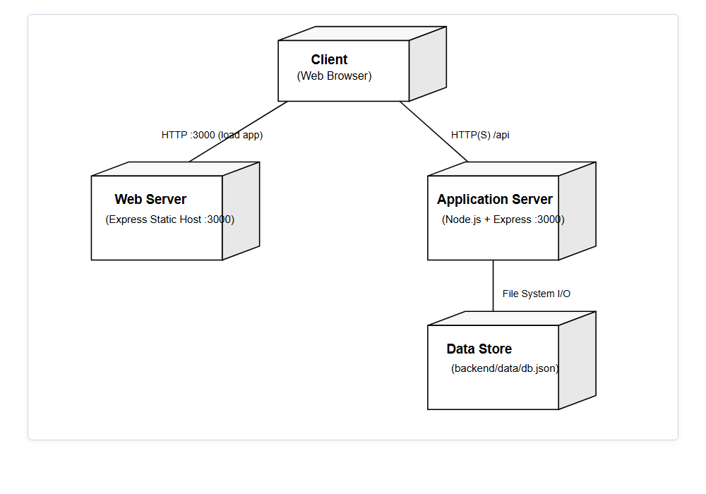
Figure 3.7: Deployment Diagram
Deployment diagram. The browser loads the application from the Vercel-hosted web server and calls the application server (Express, port 3000, path /api). The application server connects to the database server. The field devices connect through a LoRaWAN district gateway. In development all nodes run on localhost; in production HTTPS and a hosted database such as Atlas are used.

4. Project Coding

4.1 Architecture Overview
The system is a three-tier application. The presentation tier is the browser interface built with HTML, CSS and JavaScript; the application tier is a Node.js and Express REST API that validates requests and applies the business rules; the data tier is the database accessed through models. Client and server communicate only through JSON over HTTP.
A request flows as follows: the page calls the API and attaches the login token; Express applies the security middleware and routes the request to the matching route module; the authenticate middleware checks the token and role; the handler reads or writes the database; and the JSON result is rendered in the page.

4.2 Project Directory Structure
smart-agri-system
|-- frontend
|-- index.html, styles/, scripts/, assets/
|-- server
|-- src/ app.js, server.js, config/, middleware/,
|-- models/, routes/, controllers/, services/
|-- tests/ API tests
|-- .env.example (environment template), package.json
|-- diagrams/ UML diagrams
|-- docs/ requirement analysis document, test report
|-- postman/ API collection and environment
|-- package.json, README.md

4.3 Environment Configuration
Deployment-specific values are read from environment variables. The template .env.example is committed, each developer copies it to .env, and the real file is never committed, so the database address and token secret stay out of version control.
PORT=3000
MONGO_URI=mongodb://127.0.0.1:27017/smartagri
JWT_SECRET=replace-with-a-long-random-secret-before-deployment
JWT_EXPIRES_IN=7d
CREATOR_EMAIL=sanofar.fathima@smartagri.tn.gov.in
CLIENT_ORIGIN=https://smart-agri-frontend-rho.vercel.app
NODE_ENV=development

4.4 Server Entry Point (app.js)
server/src/app.js creates the Express application, applies the security middleware and mounts the routes; server.js connects to the database and starts the server.
const app = express();
app.use(cors({ origin: config.clientOrigin }));
app.use(express.json({ limit: '2mb' })); // profile photos are compressed
app.get('/api/health', (req, res) => res.json({ status: 'ok' }));
app.use('/api/auth', authRoutes);
app.use('/api/live', liveRoutes);
app.use('/api/guide', guideRoutes);
app.use('/api/reviews', reviewRoutes);
app.use('/api/inquiries', inquiryRoutes);
app.use('/api/prescriptions', authenticate, prescriptionRoutes);
app.use('/api/farmers', authenticate, farmerRoutes);
app.use('/api/admin', authenticate, authorize('admin'), adminRoutes);
app.use(notFound, errorHandler);
Public routes (health, register, login, live report, guide, reviews and enquiries) skip authentication; prescription and farmer routes call the authenticate middleware; every /api/admin route also calls authorize('admin'), which accepts only the creator account.

4.5 Data Models
Each collection is described by a schema in server/src/models, implementing the classes of the class diagram.
Model | Purpose | Class diagram entity
User | Name, e-mail, hashed password, phone, date of birth, role, active status, photo. | User, Admin, Farmer
Farm | District, zone, soil type, area, owner. | Farm
SensorReading | Moisture, pH, N, P, K, temperature and time stamp. | SensorReading
Dam | Name, basin, level, capacity, inflow and outflow. | Dam
Prescription | Crop, acres, phase, soil texture and computed quantities. | Prescription
Review | Rating, headline, feedback, crops and avatar of a farmer. | Review
Inquiry | Name, contact details, district and message. | Inquiry

4.6 REST API Routes
The API is served under /api (http://localhost:3000/api).
Method | Endpoint | Description | Access
GET | /health | API status. | Public
POST | /auth/register | Register a farmer account (201). | Public
POST | /auth/login | Authenticate and receive a token. | Public
POST | /auth/admin | Creator administrative sign-in. | Creator
GET | /live/dams | Dam storage radar data. | Public
GET | /live/readings | Soil telemetry by zone. | Farmer
GET | /live/prices | Market price ticker. | Public
POST | /prescriptions | Calculate and store a fertigation prescription. | Farmer
GET / PUT | /farmers/me | View or update own profile. | Farmer
GET / POST | /reviews | List or submit reviews. | Public / Farmer
POST | /inquiries | Send an enquiry to the support desk. | Public
GET | /admin/customers | Customer directory. | Creator
GET | /admin/revenue | Revenue and commercial metrics. | Creator
The key business logic is the fertigation service. Per-acre norms for the chosen crop and phase are multiplied by the land area; for example, for 5 acres of Samba/Kuruvai paddy in the vegetative stage the result is 275 kg urea, 200 kg DAP, 125 kg MOP, 20 bio-fertiliser packets and 57,500 litres of water per day with a 90-minute drip cycle.
function prescribe(crop, acres, phase, soil) {
const n = NORMS[crop][phase]; // per-acre norms
return {
ureaKg: n.urea * acres,
dapKg: n.dap * acres,
mopKg: n.mop * acres,
bioPackets: n.bio * acres,
zincKgPerAcre: n.zinc,
waterLitresPerDay: n.water[soil] * acres,
dripMinutes: n.runtime
};
}
The irrigation rule engine decides valve actions from soil moisture and rainfall:
function decide(reading, rule, rain) {
if (rain.mm > 15) return 'EMERGENCY_SHUTOFF';
if (rain.forecastMm12h > 10) return 'HOLD';
if (reading.moisture < rule.startBelow) return 'OPEN';
if (reading.moisture >= rule.stopAt) return 'CLOSE';
return 'NO_CHANGE';
}

4.7 Frontend Implementation
The front end is a responsive single-page website organised around a few reusable pieces:
- A top navigation lists the sections: Live Land Report, Farmlands Gallery, Agri-Tech Guide, Project Revenue, Customer Directory, Farmer Reviews, Creator and About & Support.
- A sign-in dialog with three tabs (Sign In, Sign Up as Farmer, Creator Admin) validates inputs, shows quick demo accounts and the administrative gate.
- A profile dialog lets a farmer edit details and upload a photo, which is compressed before it is sent.
- The guide uses tabs (core modules, zones, Pattam calendar, NPK matrix, water budgeting, schemes, calculator) and tables for quick reading.
- A calculator form collects crop, area, phase and soil and displays the prescription instantly.
- The market ticker, dam radar and statistic counters are reusable components fed by the API.
- A dark obsidian and cobalt-blue theme gives high contrast for outdoor screens.

4.8 API Testing with Postman
Every endpoint group was tested with Postman. The collection defines the variable baseUrl (http://localhost:3000/api) together with the tokens needed to chain requests (farmerToken, adminToken). Each request carries test scripts (for example, health returns 200 and register returns 201), so the whole collection can run in sequence against a fresh database.

4.9 Test Scenarios
Scenario | Expected result
Sign in with correct e-mail and password | The farmer is authenticated and a token is returned.
Sign in with a wrong password | The request is rejected and no token is issued.
Register without accepting the terms | Registration is blocked with a validation message.
Farmer signs in at the creator gate | Access is denied and the farmer is returned to the dashboard.
Open a protected route without a token | The request is rejected as unauthorised.
Calculate prescription for 5 acres paddy (vegetative) | Urea 275 kg, DAP 200 kg, MOP 125 kg, 20 packets, 57,500 L/day, 90 minutes.
Submit calculator with empty area | Validation error; nothing is stored.
Rainfall above 15 mm | Valve action is Emergency Shut-off.
Forecast above 10 mm in 12 hours | Scheduled irrigation is held.
Upload a large profile photo | The photo is compressed and saved.
Submit a review and an enquiry | Both are saved and the review appears in the live feed.

4.10 Deployment and Version Control
The source code is managed with Git. The front end is deployed to Vercel, which builds and publishes the site on every push and provides the public address https://smart-agri-frontend-rho.vercel.app. The API runs as a Node.js service and its allowed origin is set through the CLIENT_ORIGIN variable. Environment secrets are configured in the hosting dashboard and never stored in the repository.

5. Website Screenshots

5.1 Overview
The screens below show the Smart Agriculture Management System running at https://smart-agri-frontend-rho.vercel.app. The public site shares one layout with a top menu; signed-in farmers see the dashboard sections and the creator uses the administrative gate.

5.2 Application Screens
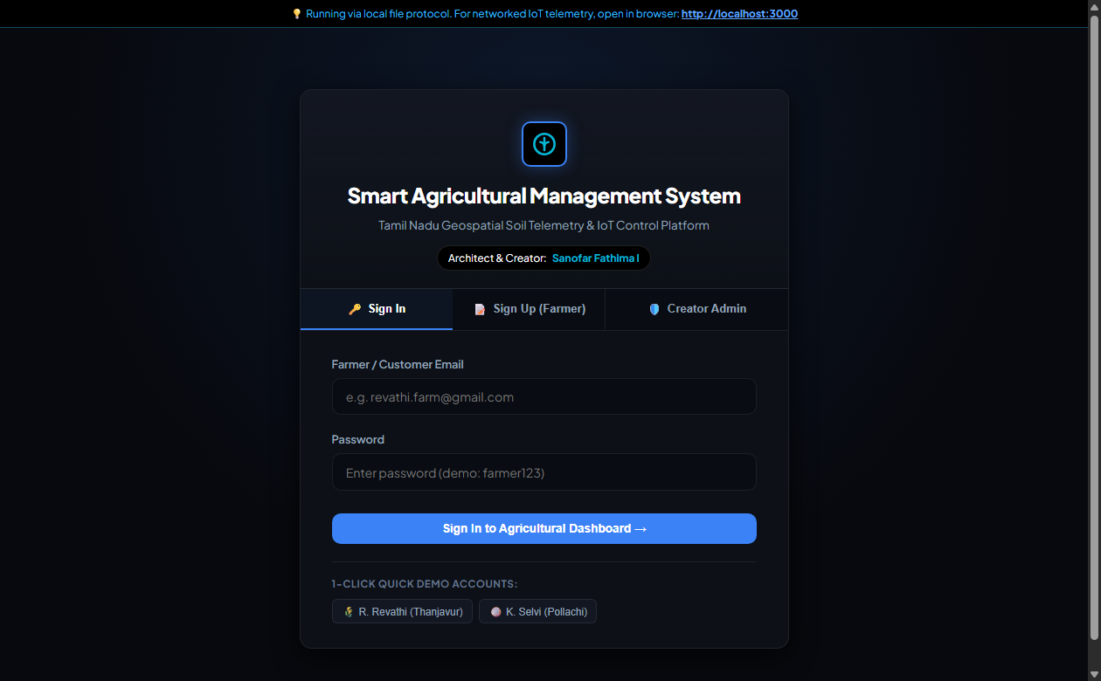
Figure 5.1: Sign In page
Sign In page. Farmers sign in with e-mail and password. Quick demo accounts (for example R. Revathi of Thanjavur and K. Selvi of Pollachi) fill in credentials for evaluation.
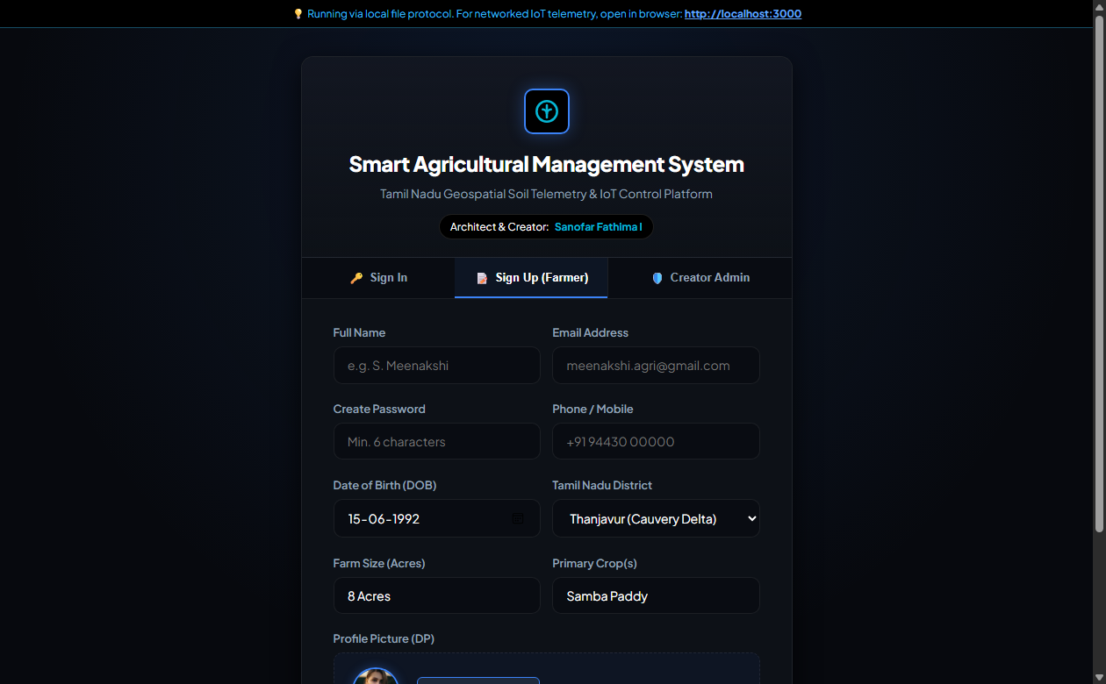
Figure 5.2: Farmer Sign Up
Sign Up page. A new farmer enters name, e-mail, password, phone, date of birth, district, farm size, primary crops and profile photo, and must accept the Terms and Conditions.
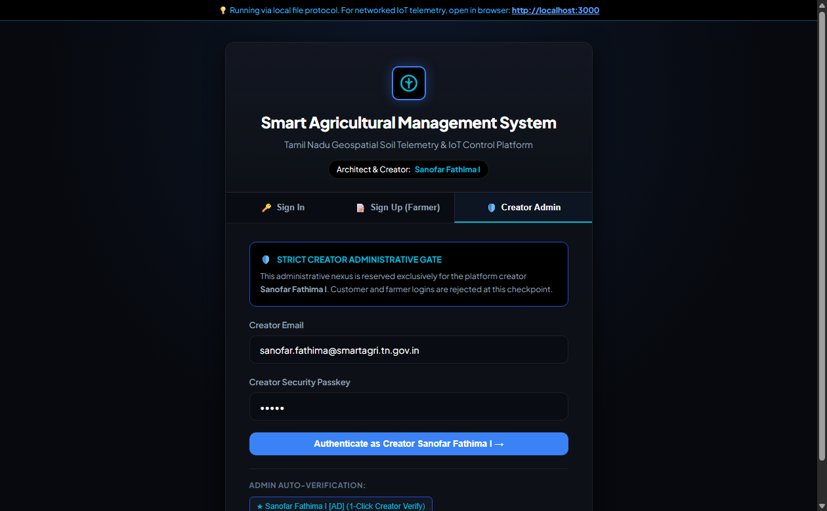
Figure 5.3: Creator Admin gate
Creator administrative gate. This gate accepts only the creator; farmer logins are rejected. A one-click verification button is provided for demonstration.
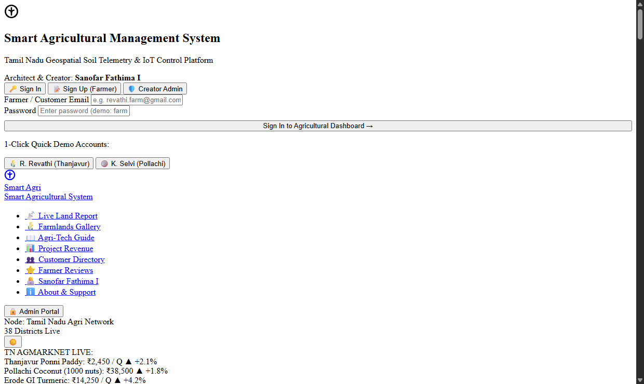
Figure 5.4: Home page and market ticker
Home page. The hero section shows the platform title, key figures (acres monitored, water conserved, probe-grid uptime), the AGMARKNET price ticker and links to the live report and guide.
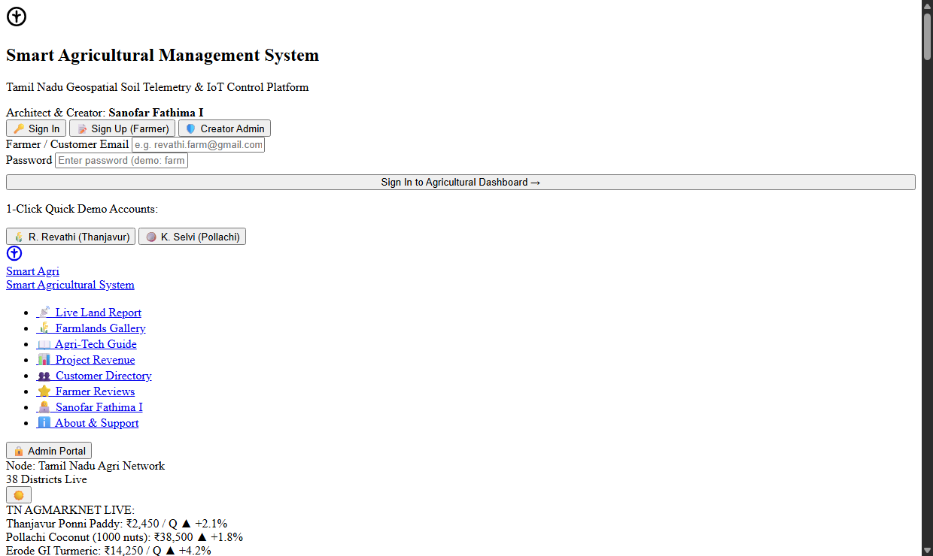
Figure 5.5: Live Land Report and dam radar
Live Land Report. Soil telemetry across agro-climatic zones is shown with the dam storage radar for Mettur, Bhavanisagar, Vaigai and Aliyar, including level, percentage full, inflow and outflow.
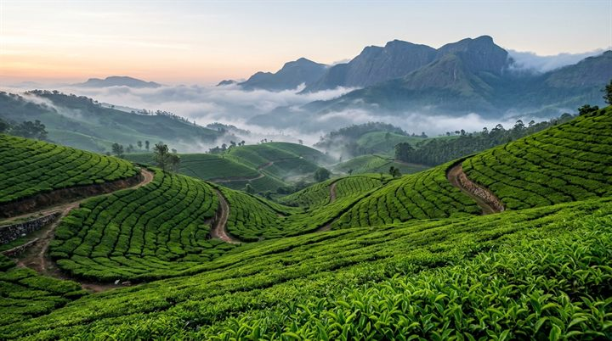
Figure 5.6: Farmlands gallery
Farmlands gallery. Photographs of the Tamil Nadu agro-zones are shown in a responsive grid.
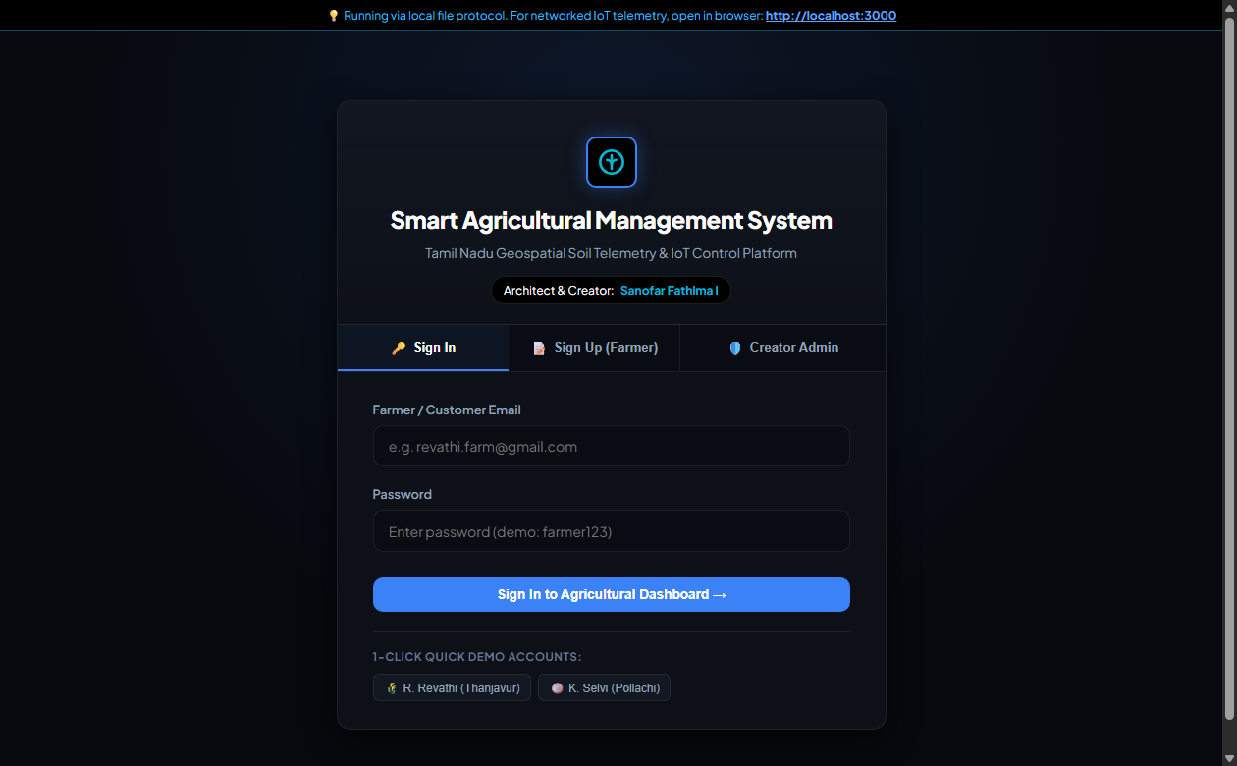
Figure 5.7: Agri-Tech Guide
Agri-Tech Guide. Tabs present core modules, agro-climatic zones, the Pattam calendar, the NPK deficiency matrix, water budgeting and government schemes.
Figure 5.8: Precision Fertigation Calculator
Fertigation calculator. After choosing crop, area, phase and soil texture, the farmer receives fertiliser weights, bio-inoculant packets, daily water and drip run-time with an agronomist note.
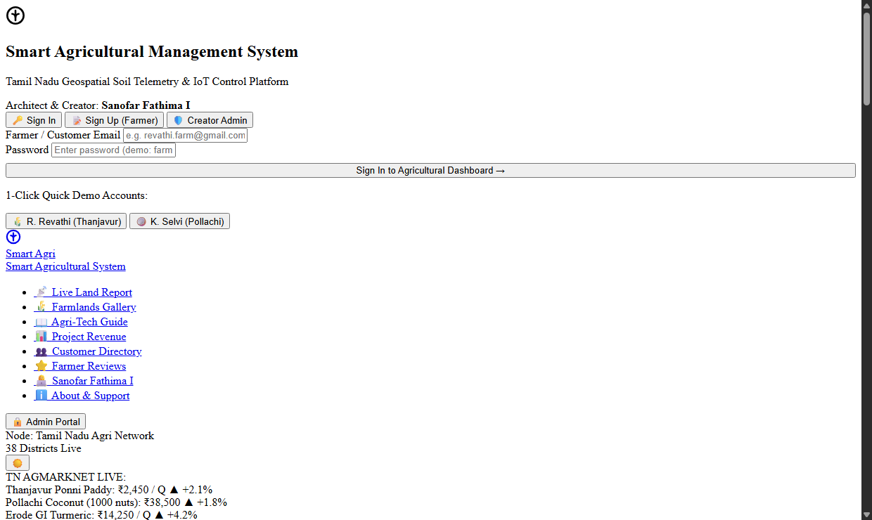
Figure 5.9: Project Revenue and Customer Directory
Revenue and customers. The revenue section shows commercial performance of deployed districts; the directory lists verified farmers with landholding and primary crops.
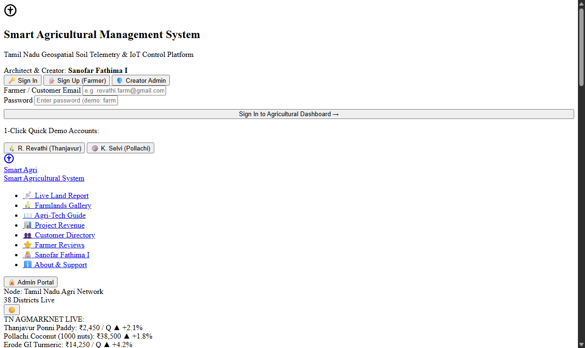
Figure 5.10: Reviews, Creator and Support desk
Reviews and support. Farmers submit ratings and feedback; the creator section describes the architecture and vision; the support form sends sensor installation enquiries.

6. Conclusion and References

6.1 Conclusion
The Smart Agriculture Management System shows how object-oriented analysis and modern web technology can support farmers of Tamil Nadu. The requirement analysis identified the user roles and a set of functional and non-functional requirements; the UML diagrams translated them into a clear design (use case for functions, class for data, sequence, activity and state chart for behaviour, component and deployment for architecture); and the design was implemented as a responsive web front end, a Node.js and Express REST API and a database.
The finished system lets farmers view live land and dam information, plan fertiliser and water with the fertigation calculator, learn from the guide, discover subsidies and share feedback, while the creator administrator controls the platform through a restricted gate. Security rests on hashed passwords, token authentication, role-based access and origin control, and the work was verified with Postman and test scenarios. The project also gave practical experience of the complete software engineering cycle.

6.2 Limitations
- Sensor data, dam levels and market prices are demonstration values; no live integration with official sources or hardware in this version.
- No online payment for subscriptions.
- The interface is a responsive web application; there is no native mobile app.
- Notifications are shown in the application only; SMS alerts for motor trips and dry runs are designed but not implemented.
- The interface language is English only.

6.3 Future Enhancements
- Live integration with LoRaWAN sensors, solenoid valves and satellite NDVI crop-health maps.
- Official data feeds for dams (PWD) and market prices (AGMARKNET).
- Tamil and English language switching and voice support for farmers.
- SMS and WhatsApp alerts for irrigation, rainfall and pump faults.
- Mobile application with offline support for fields with weak networks.
- Machine-learning yield prediction and pest-disease detection from photographs.

6.4 References
1. Booch, G., Rumbaugh, J. and Jacobson, I., The Unified Modeling Language User Guide, Addison-Wesley.
2. Sommerville, I., Software Engineering, Pearson.
3. Pressman, R. S., Software Engineering: A Practitioner's Approach, McGraw-Hill.
4. Tamil Nadu Agricultural University (TNAU) Agritech Portal. https://agritech.tnau.ac.in
5. Tamil Nadu Agriculture Department. https://www.tn.gov.in
6. Agmarknet – Agricultural Marketing Information Network. https://agmarknet.gov.in
7. Node.js Documentation. https://nodejs.org/en/docs
8. Express.js Documentation. https://expressjs.com
9. MongoDB Documentation. https://www.mongodb.com/docs
10. Mongoose Documentation. https://mongoosejs.com/docs
11. Vercel Documentation. https://vercel.com/docs
12. Postman Learning Center. https://learning.postman.com
13. Jones, M., Bradley, J. and Sakimura, N., JSON Web Token (JWT), RFC 7519, IETF.
14. OWASP Foundation, OWASP Top Ten Web Application Security Risks. https://owasp.org/www-project-top-ten

