Install Newtonsoft.Json dll (for JSON parser) in GAC:

Open VS command prompt in admin mode and run below GAC command

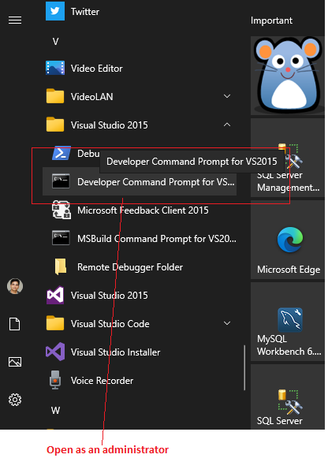

**gacutil /i "C:\All Files\Learning\SSIS\open.gsa.gov\open.gsa.gov\lib\Newtonsoft.Json.dll"**

*Change highlighted path to location on your machine*

Execute script from folder **\open.gsa.gov\sql**

It will create tables and stored procedures

Change parameters in SSIS package

1. API URL
2. API Key
3. DB connection string

