THE INTELLIGENCE MOAT:
Why Context is the New Oil
Atlan — Architecture of the Institutional Brain
An Executive Guide for CEO, CTO, CIO, CHRO & VC

Public-Signal Research | Gartner MQ Nov 2025 G00808349 | OSINT Only
Sanuj Krishnan — Architecture Study | August 2026

Executive Summary: The Law of AI Performance
For ten years we built Systems of Record (databases that track what happened) and then Systems of Intelligence (dashboards that explain why). Now we are in the age of Systems of Agency — AI that acts on our behalf.
But there's a problem: 95% of enterprise AI pilots fail to deliver P&L impact. Not because models are weak. Because AI is context-poor.
Think of AI as a brilliant intern with zero onboarding. It has Intelligence (the model), but it lacks your company's Context — the invisible glue, the unwritten rules, the tribal knowledge, the "except when..." judgment calls that live only in people's heads.
Atlan's thesis is one formula: P = f(I, C). Performance = Intelligence x Context. Double Intelligence without Context, you still get zero. This document explains how they built the Context layer that makes Intelligence actually perform.
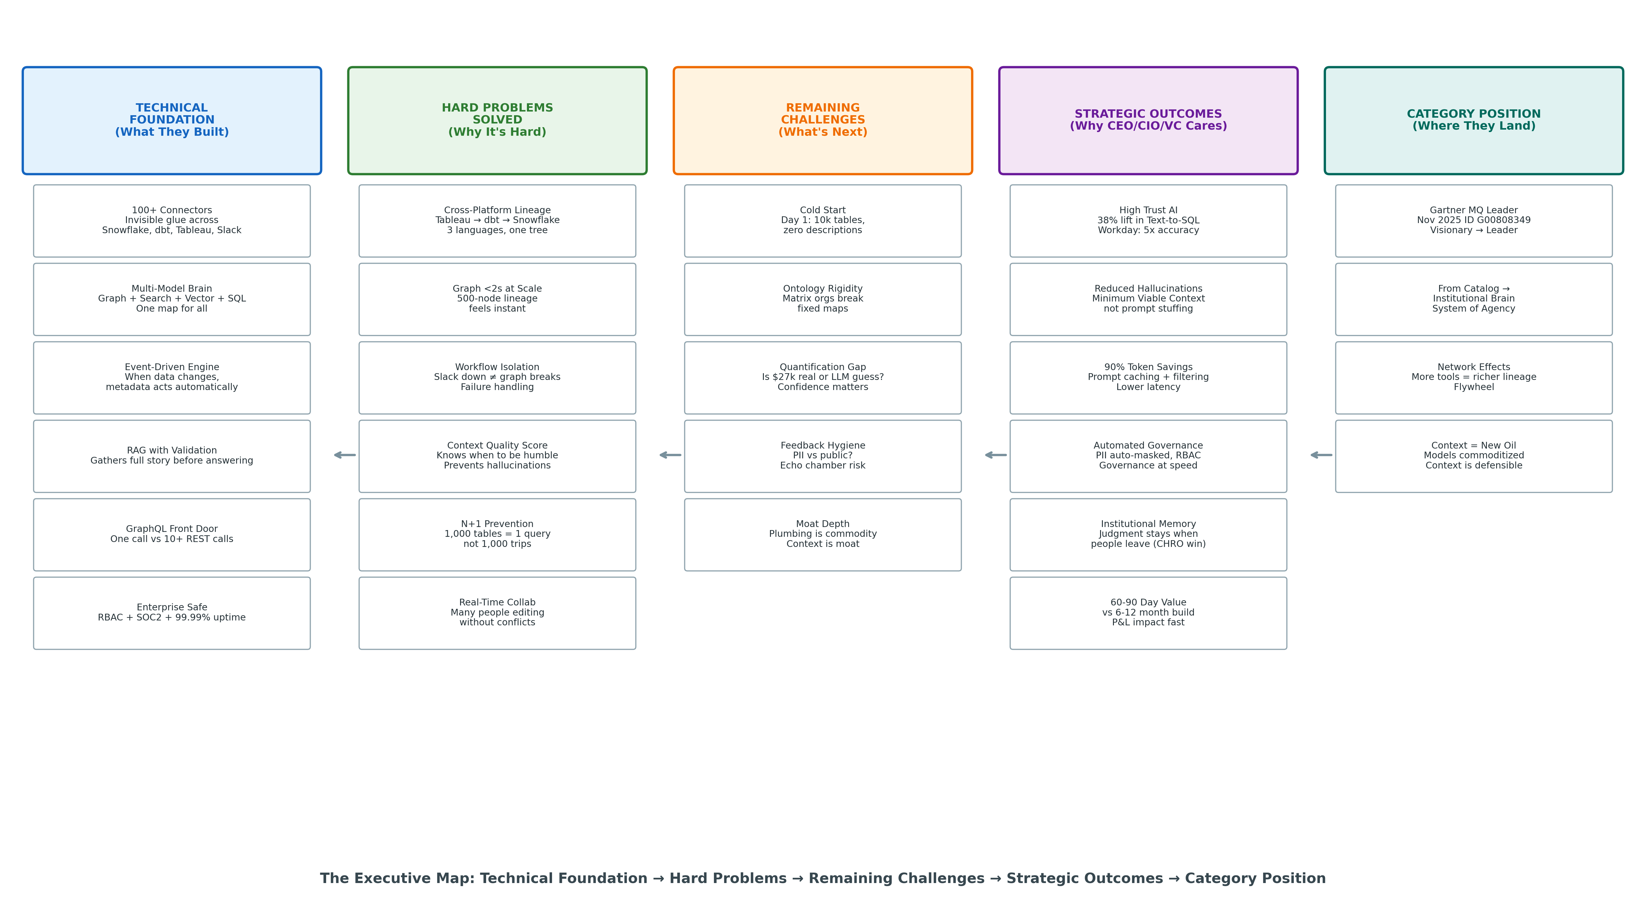
Figure 1: The Executive Map — Technical Foundation → Hard Problems → Remaining Challenges → Strategic Outcomes → Category Position

Chapter 1: The Invisible Glue — Why Context is Everything
Every company has two sets of rules. The written ones in wikis. And the real ones in people's heads.
"Revenue for Finance is recognized revenue. Revenue for Sales is bookings. Except when it's an enterprise account over $50k, then we waive the fee — ask Sarah in #finance, she approved it last March."
No database stores that Slack thread. No LLM knows it. So AI confidently gives the wrong definition of Revenue and almost causes a P&L disaster. This is the "Confidently Wrong" AI story that every CIO has lived.
We call this Context Islands — every team builds its own AI silo with its own definition. Finance's AI says one thing, Sales's AI says another. The company stops speaking one language.
The fix isn't a bigger context window. Bigger windows lead to Context Rot — models get more confused as you stuff more tokens in. Research shows accuracy degrades sharply past a certain length.
The fix is Minimum Viable Context — delivering the precise golden tokens needed for this specific task. Not everything. Just the right things. That's what Atlan built.
Three Tiers of Context an AI Needs to Act:
1. Structural: What things are and how they connect (this table depends on that table)
2. Operational: What the rules are (if PII, mask it; if enterprise >$50k, waive fee)
3. Behavioral: What actually happens (47 people use this table daily, it's top 10%)

Chapter 2: The Corporate Brain — Governance at Speed of Thought
This is the most important chapter for CTOs and CIOs. Atlan's architecture looks like a brain, and the Resolver Layer is the executive filter where judgment happens.
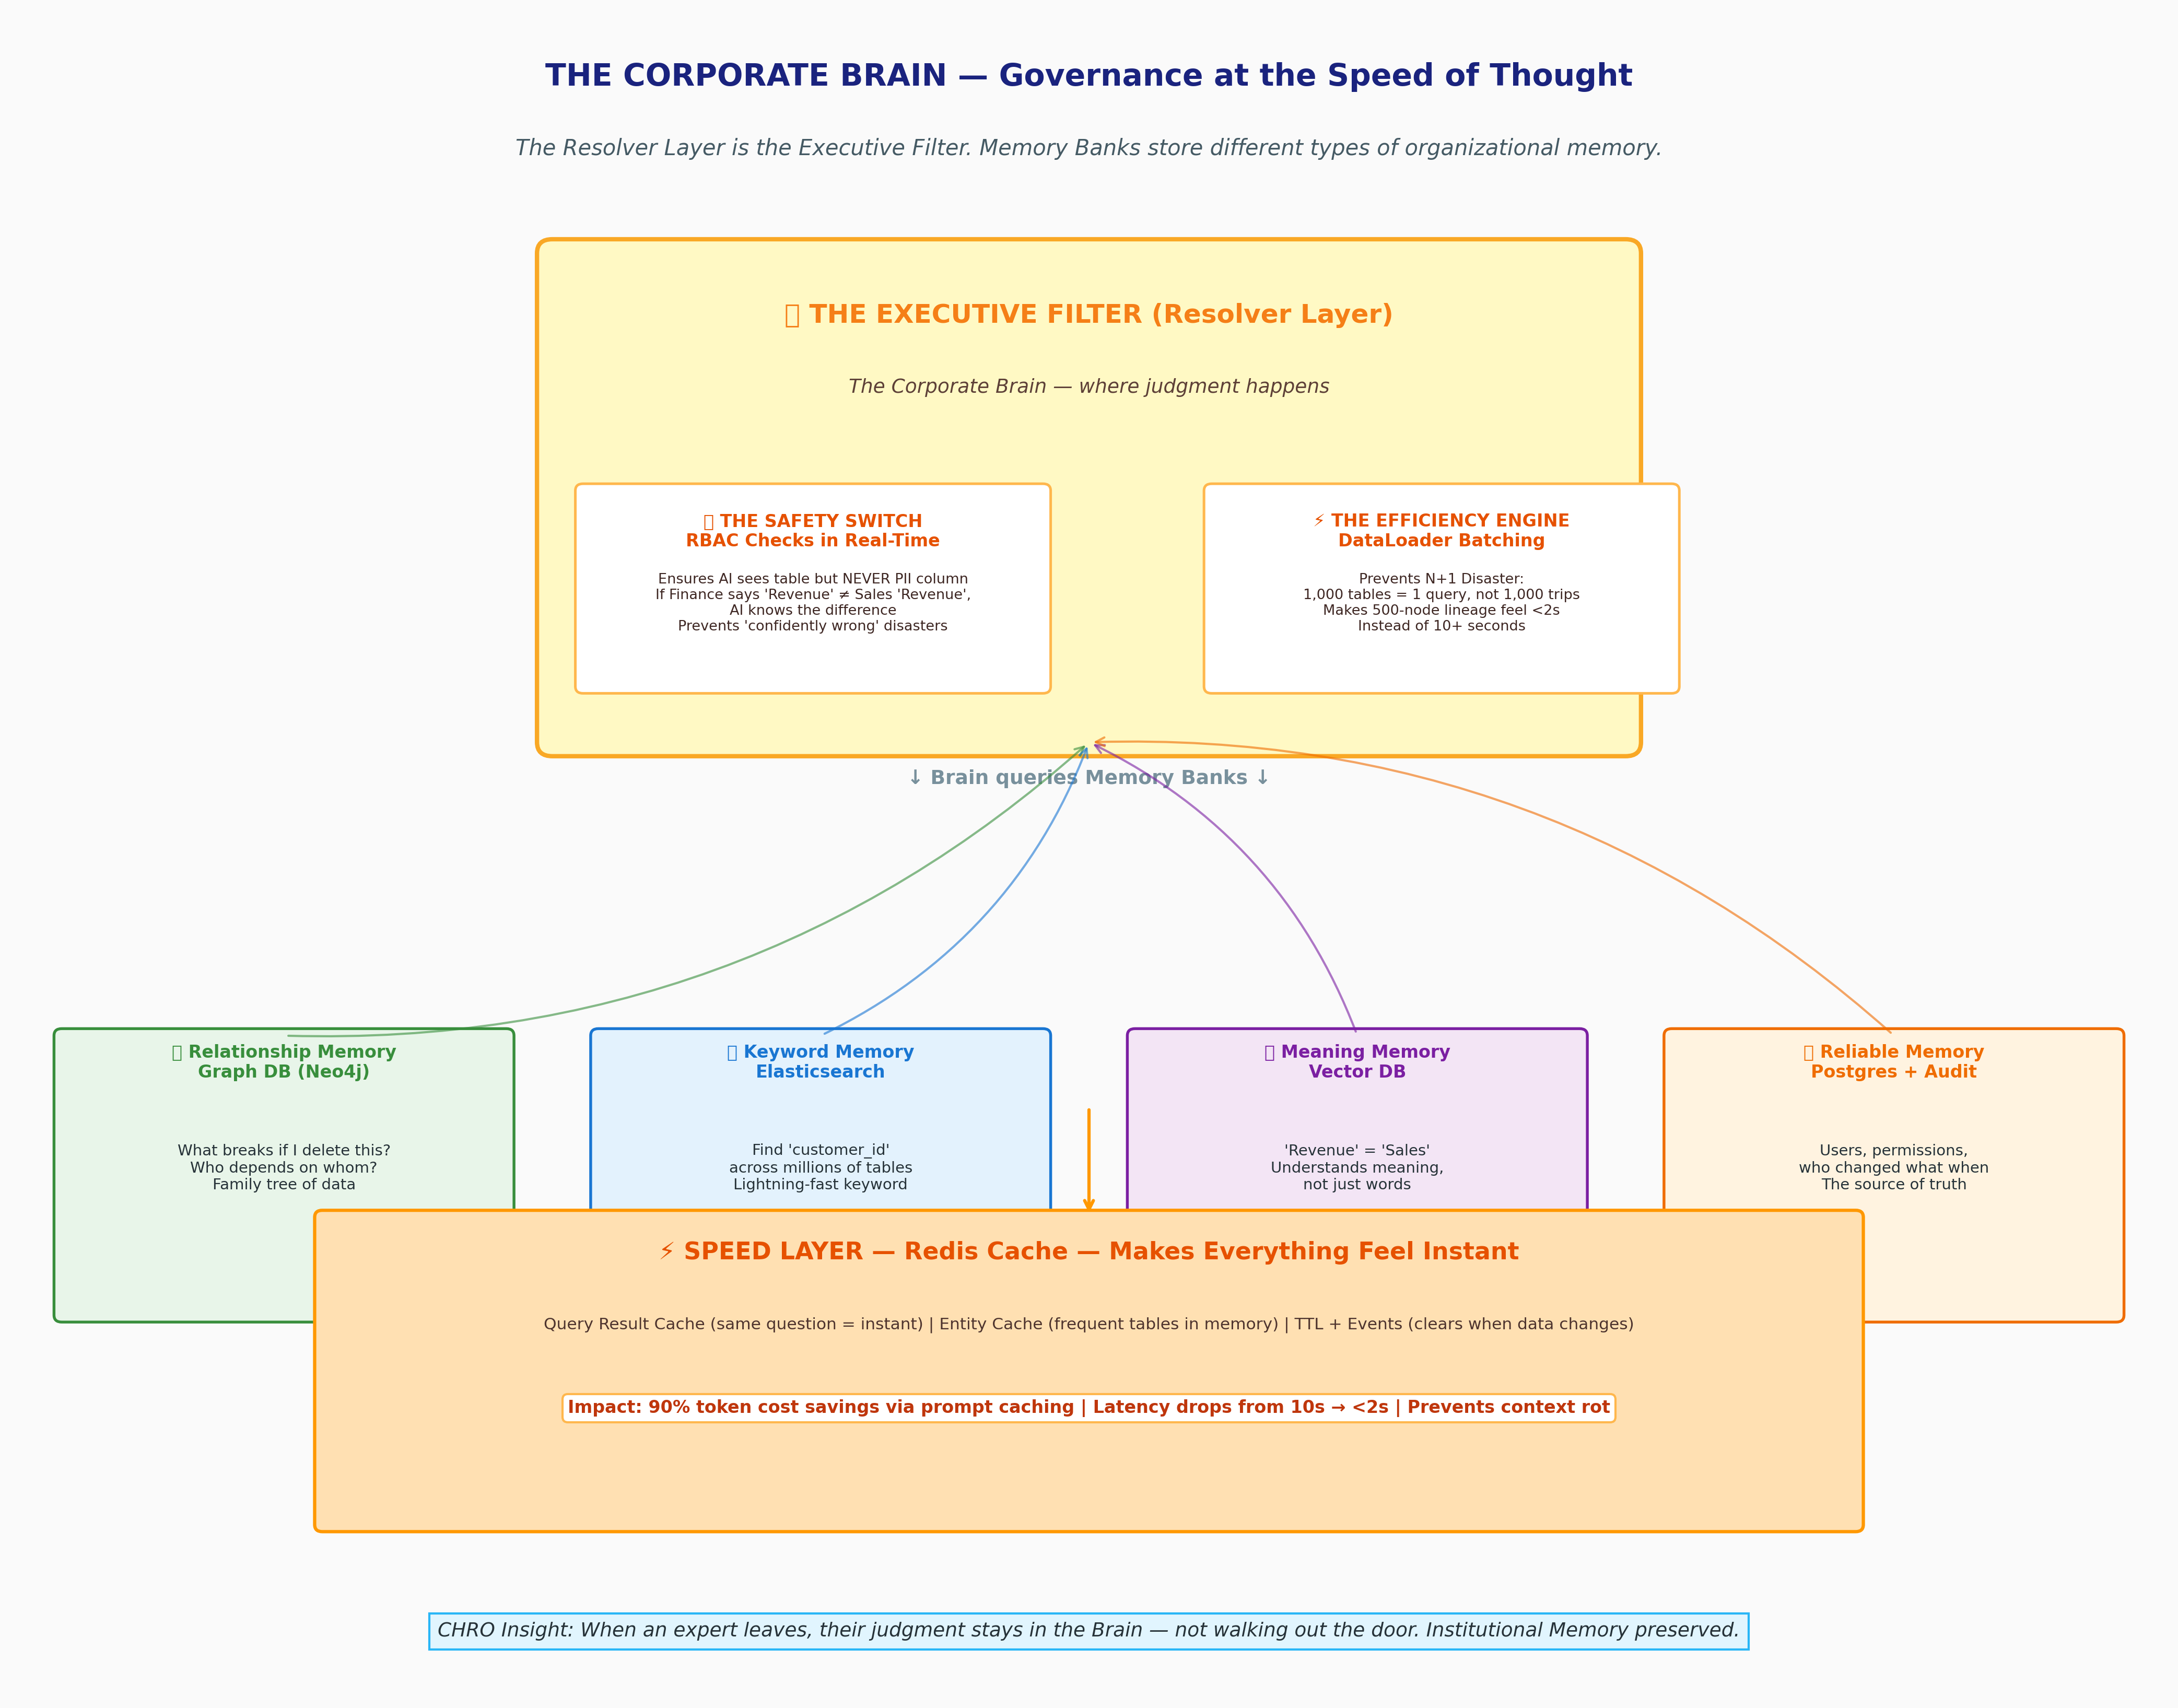
Figure 2: The Corporate Brain — The Resolver Layer is the executive filter. Memory Banks store different types of organizational memory.
The Memory Banks (Data Access Layer): Four different homes for four different memories. No single database can do it all.
• Relationship Memory (Graph DB - Neo4j): "What breaks if I delete this?" Family tree of data.
• Keyword Memory (Elasticsearch): Find 'customer_id' across millions of tables in milliseconds.
• Meaning Memory (Vector DB): Understands that "Revenue" = "Sales" = "Bookings" even if words differ.
• Reliable Memory (Postgres): Users, permissions, audit logs — who changed what, when. The source of truth.
The Executive Filter — Two Jobs:
THE SAFETY SWITCH (RBAC): Real-time checks. Can this AI agent see this table? Yes. Can it see the PII column with customer emails? No — mask it automatically. Can Sales see Finance's definition of Revenue? No, give the right definition. Prevents confidently wrong disasters.
THE EFFICIENCY ENGINE (DataLoader): Prevents N+1 disaster. Loading 1,000 tables naively = 1,000 trips to DB = 10+ seconds. Batching = 1 trip = <2 seconds. That's why 500-node lineage feels instant.

CHRO Insight — Institutional Memory:
When Alex, your key data expert, leaves, Alex's judgment ("except when enterprise >$50k") doesn't walk out the door. It stays in the graph, searchable, attributed. You just turned a HR nightmare into a durable asset.

The Speed Layer
Redis cache that makes everything feel instant. Same question twice? Instant answer. Frequent tables in memory. This plus Minimum Viable Context = 90% token cost savings and latency drop from 10s → <2s. It also prevents context rot.

Chapter 3: The Full Story — How to Stop 'Confidently Wrong' AI
This is the RAG pipeline, but in human terms. When you ask "Why did DAU drop yesterday?", a context-poor AI guesses. A context-rich AI gathers the hidden story.
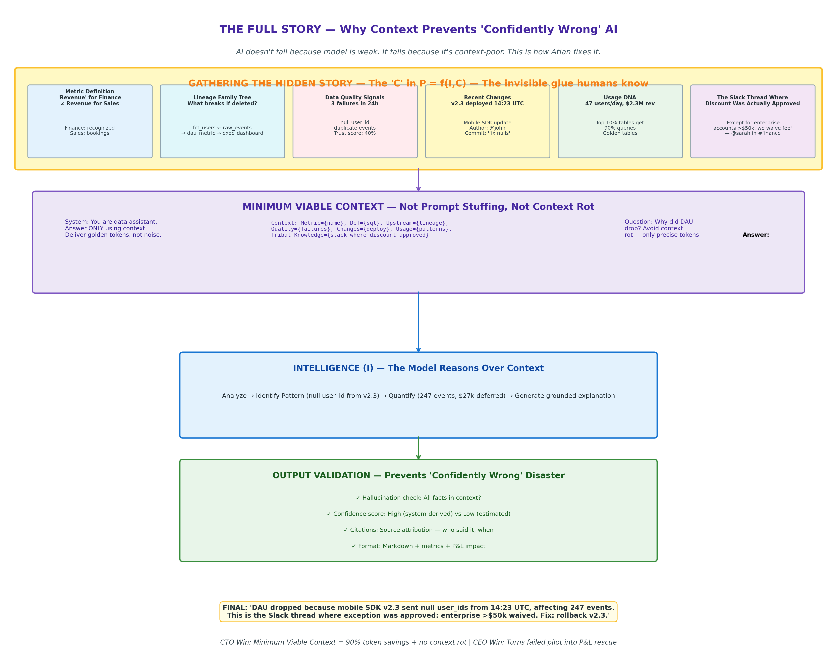
Figure 3: Gathering The Hidden Story — The 'C' in P = f(I,C). Prevents hallucinations by delivering golden tokens, not noise.
Six signals gathered:
1. Metric Definition: 'Revenue' for Finance ≠ Revenue for Sales
2. Lineage Family Tree: fct_users ← raw_events → dau_metric → exec_dashboard (what breaks if deleted?)
3. Data Quality Signals: 3 failures, null user_id, trust score 40%
4. Recent Changes: v2.3 deployed at 14:23 UTC by @john
5. Usage DNA: 47 users/day, $2.3M revenue — golden table
6. The Slack Thread Where Discount Was Actually Approved: "Except for enterprise >$50k, we waive fee — @sarah"
Then Minimum Viable Context — not stuffing 100k tokens, but only precise tokens. System prompt: "Answer ONLY using context. Deliver golden tokens, not noise."
Intelligence reasons: Analyze → Identify pattern (null user_id from v2.3) → Quantify (247 events, $27k deferred) → Generate grounded explanation.
Validation: Hallucination check (all facts in context?), confidence score (High = system-derived from logs, Low = LLM estimated), citations (who said it, when), format with P&L impact.
Final Grounded Answer:
"DAU dropped because mobile SDK v2.3 sent null user_ids from 14:23 UTC, affecting 247 events. This is the Slack thread where exception was approved: enterprise >$50k waived. Fix: rollback v2.3." That's not hallucination. That's an analyst.

Chapter 4: The Human-AI Handshake — Solving Cold Start
Every C-suite leader fears this: You buy a tool, connect it on Day 1, see 10,000 tables with no descriptions, and think "this is useless." That's Cold Start. 95% of AI pilots die here.
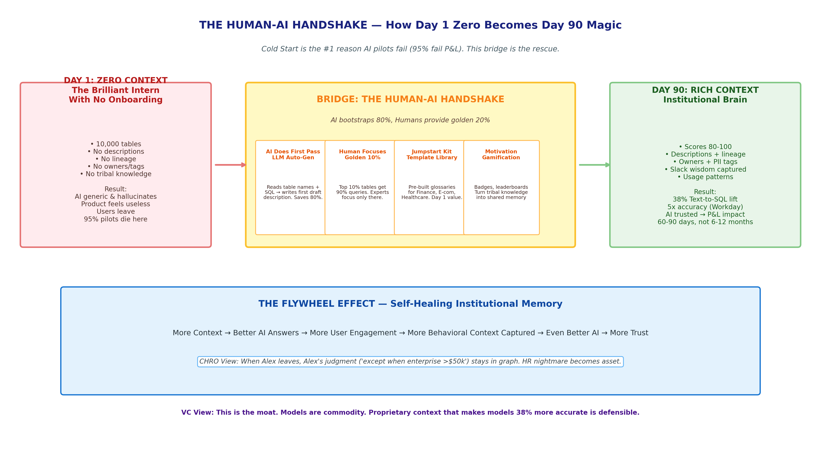
Figure 4: The Human-AI Handshake — AI bootstraps 80%, humans provide golden 20%. Day 1 zero to Day 90 Institutional Brain.
The Bridge is where humans and AI collaborate:
1. AI Does First Pass (LLM Auto-Gen): AI reads table names and SQL and writes first draft descriptions. Saves 80%.
2. Humans Focus on Golden 10% (Usage Priority): Data shows top 10% tables get 90% queries. Experts document only what matters.
3. Jumpstart Kit (Template Library): Pre-built glossaries for Finance, E-com, Healthcare. Start at 60%, not zero.
4. Gamification: Badges, leaderboards turn tribal knowledge capture from chore into collaboration.
The Flywheel: More context → Better AI answers → More user engagement → More behavioral context captured → Even better AI → More trust. Self-healing system.
Traditional build takes 6-12 months. With this handshake, priority domains go live in 60-90 days. That's P&L speed.

Chapter 5: From Rigid Chart to Matrix Reality
For CHROs and CIOs, this is everything. Fixed ontology (v1): Clean hierarchy Company → Department → Product → Employee → Customer Account. One employee = one department. Works for 1990s org chart. Breaks for modern org.
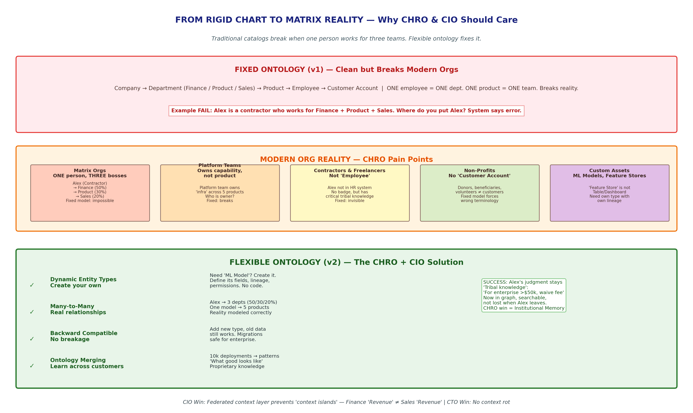
Figure 5: Fixed vs Flexible Ontology — Why matrix orgs break traditional catalogs and how many-to-many solves it.
Real failure: Alex is a contractor who works for Finance (50%), Product (30%), Sales (20%). Where do you put Alex? Fixed system says error. Alex's tribal knowledge stays invisible.
Modern reality: Matrix orgs, platform teams that own capability across 5 products, contractors not in HR system, non-profits with donors not customers, custom assets like 'Feature Store'.
Flexible Ontology (v2) fix:
• Dynamic Entity Types: Need 'ML Model'? Create it. Define its fields, lineage, permissions. No code.
• Many-to-Many: Alex → 3 depts with percentages, one model → 5 products. Reality modeled correctly.
• Backward Compatible: Add new type, old data still works. Safe migrations.
• Ontology Merging: 10,000 deployments teach patterns — 'what good looks like.' Proprietary knowledge that becomes moat.
Success: Alex leaves, but Alex's judgment stays searchable in graph. CHRO win = Institutional Memory. CIO win = No more context islands.

Chapter 6: The C-Suite Aha! Moments
For the CEO — The P&L Rescue
95% of AI pilots fail P&L because they are context-poor. You spent millions on models that can't drive revenue because they don't know your business DNA. Context layer is the missing line item that turns expensive experiments into reliable agents. Workday saw 5x improvement in AI accuracy after embedding metadata context. That's demo vs product.

For the CIO — Avoiding Context Islands
Stop every team building isolated AI silos where Finance's AI and Sales's AI speak different languages. A federated context layer, using standards like Model Context Protocol (MCP), ensures every tool (ChatGPT, Claude, your internal agent) plugs into one source of truth. Like data warehouse did for BI.

For the CTO — Ending Context Rot and Prompt Stuffing
Bigger context windows aren't answer — they make models more confused (context rot) and cost more. Real feat is Minimum Viable Context: precise golden tokens, prompt caching that saves 90% token costs, latency from 10s → <2s, and 38% lift in Text-to-SQL accuracy in Atlan AI Labs benchmarks. No more stuffing 100k tokens hoping model finds needle.

For the CHRO — Institutional Memory
Your biggest risk is tacit knowledge walking out door when experts leave. Context layer captures decision traces, unwritten rules, judgment calls. When key person leaves, their logic stays. You turn HR risk into durable asset. The 'except when...' rules that live only in heads become searchable graph.

For the VC — The Defensible Moat
In world of commoditized models (GPT, Claude, open-source), winner isn't who has best model, but who owns proprietary context that makes models accurate. Atlan's 38% accuracy lift is the moat. Plumbing (connectors, graph DB, GraphQL) can be rebuilt in 12-18 months. Proprietary process ontologies from 10k deployments, customer-specific fine-tuned models, bidirectional write-back (commenting on your dbt PR with impact), and cross-tool network effects cannot. Context is the new oil.

Final Thought: The Next Decade
The next decade won't be won by who has biggest model, but best Context Layer. It is bridge between raw, silent data and actionable, organizational truth.
We moved from Systems of Record to Systems of Intelligence to Systems of Agency. Agency without context is just a capable intern with no onboarding. Give it the invisible glue — the Slack thread where discount was actually approved, the exception that Finance knows but Sales doesn't, the lineage that shows what breaks — and it becomes Institutional Brain.
Hard Evidence for Your Board:
• Accuracy: 38% lift Text-to-SQL, Workday 5x improvement after embedding metadata context
• Efficiency: 90% token cost savings via prompt caching + filtering
• Speed: 60-90 day deployment for priority domains vs 6-12 month traditional build
• Risk: 95% pilots fail without context layer
• Moat: Network effects — more tools connected = richer lineage = more valuable
Atlan has built the plane. Now it has to fly it through turbulence of cold start, ontology flexibility, quantification gap, feedback hygiene, and moat depth. If it does, it defines category.

Sources & Methodology
Sources: atlan.com, 'Becoming a Frontier Company' by Prukalpa Sankar, Gartner MQ Metadata Management Nov 2025 ID G00808349, atlanhq GitHub, OpenLineage spec, public UI screenshots.
Methodology: 100% public-signal OSINT. No insider access, no NDA materials. Architecture reconstructed from UI evidence + docs + founder talks + first principles. Corrections welcome.
Author: Sanuj Krishnan — Architecture Study Series | Reference: github.com/sanoojcools/-ontora-architecture-study

