Conversion Baseline and Data Architecture: One-Page Summary
Oct 2, 2026 · @Sanookiezz

Purpose
Sarah wants a course-by-course conversion baseline in Excel, so each course knows how many applications and offers it needs to fill its places. It supports the College Transformation Framework (CTF) for two reasons:
- Credits: the college must deliver 79,000 credits, about 45,000 from full-time courses, and loses about 10% through under-enrolment.
- Workload: recruitment is very manual, with student admin constantly opening and closing applications and sending waiting-list offers.
The data architecture map you assigned is the foundation: it shows where every conversion number comes from and where it can go wrong.

Key idea
Replace the single 200% applications / 120% offers rule with targets based on each course's own conversion over the last 3 years. Today a 20-place course aims for 40 applications and 24 offers, yet sometimes only 12 of those 24 people turn up.
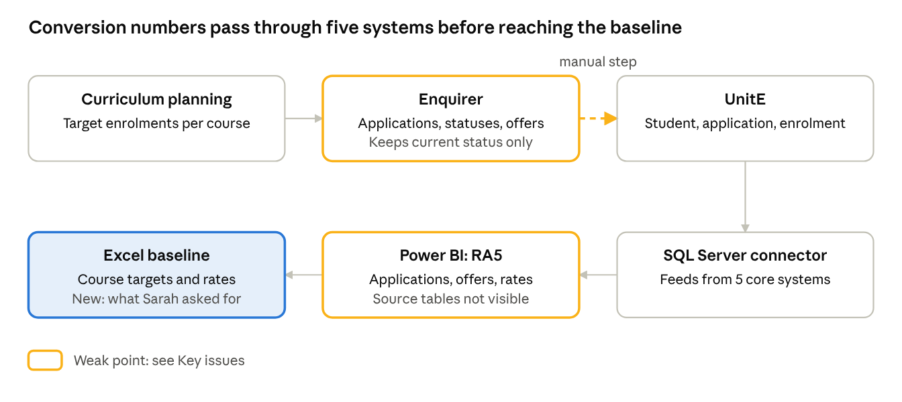
recruitment data path · from the data architecture map
The data map shows the path every conversion number takes. The amber points are where counts can be lost or changed.

Key issues
The numbers we have today overstate conversion, and the systems cannot yet give a clean 3-year history.
Issue | What we found | Proposed fix
Power BI rate matches nothing we can calculate | YCCJ/AL: 36 offers ÷ 116 applications = 31.0%, ÷ 66 live = 54.5%, but RA5 shows 37.9% | Lesley to confirm which application count the measure uses
Only this year is visible | RA5 shows only the 2026 session, still in progress | Ask Lesley for final data for 2023/24 to 2025/26
No status history | Enquirer keeps only each application's current status, so past offer counts cannot be rebuilt | Use final status for past years; start weekly snapshots now
Manual steps on the recruitment path | Applications move from Enquirer into UnitE by hand; 23 of 98 system connections are manual | Flag these in the data map; look at automating later
Source of RA5 not visible | Lineage shows semantic model → report, but not the database behind it | Kevin to confirm which tables feed the model
Offers and day-one enrolment inflate the picture | Waiting-list offers (36 offers for 14 places on YCCJ/AL); credits are claimed at about 6 weeks | Use live applications and enrolment at the 6-week claim point

Progress and next steps
Done: meeting summary and plan; student system data map (209 systems, 98 connections), aligned with Kevin; plan and data request sent to Lyndsay; RA5 exploration started.
Next: build a construction pilot (3 years, live applications, course targets compared with the 200% / 120% rule), review first findings with Lyndsay and you after the October break, then deliver the full baseline before Christmas.
Waiting on:
- Lesley: the conversion measure, past-year data, and which enrolment statuses count for credits
- Lyndsay: target enrolments and capacities per course, the credits report, how the waiting list works
- Kevin: which database tables feed the RA5 semantic model

