# 1 06demo

06demo test: the max width 640px

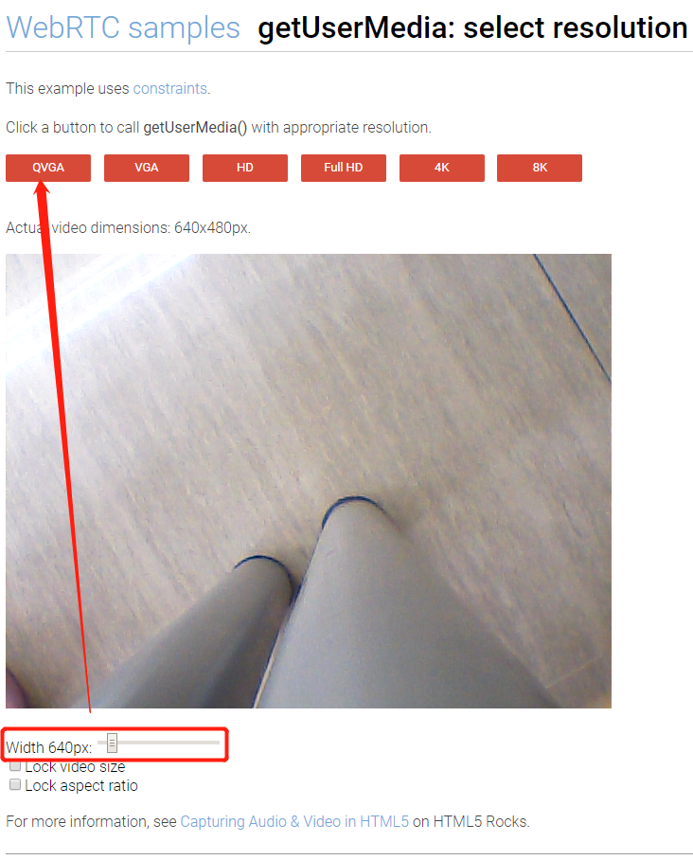

if you set it 641px，as follow:

