# Hibernate Annotations

# Connecting to DB, Creating a table and inserting values using Hibernate Annotations

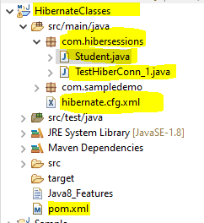

pom.xml:

<?xml version=*"1.0"* encoding=*"UTF-8"*?>

<project xmlns=*"http://maven.apache.org/POM/4.0.0"*

xmlns:xsi=*"http://www.w3.org/2001/XMLSchema-instance"*

xsi:schemaLocation=*"http://maven.apache.org/POM/4.0.0 http://maven.apache.org/xsd/maven-4.0.0.xsd"*>

<modelVersion>4.0.0</modelVersion>

<groupId>com</groupId>

<artifactId>sampledemo</artifactId>

<version>0.0.1-SNAPSHOT</version>

<packaging>jar</packaging>

<name>sampledemo</name>

<url>http://www.example.com</url>

<properties>

<project.build.sourceEncoding>UTF-8</project.build.sourceEncoding>

<maven.compiler.source>1.8</maven.compiler.source>

<maven.compiler.target>1.8</maven.compiler.target>

</properties>

<dependencies>

<dependency>

<groupId>org.junit.jupiter</groupId>

<artifactId>junit-jupiter-engine</artifactId>

<version>5.7.1</version>

<scope>test</scope>

</dependency>

<dependency>

<groupId>org.junit.jupiter</groupId>

<artifactId>junit-jupiter-params</artifactId>

<version>5.7.1</version>

<scope>test</scope>

</dependency>

<!-- https://mvnrepository.com/artifact/mysql/mysql-connector-java -->

<dependency>

<groupId>mysql</groupId>

<artifactId>mysql-connector-java</artifactId>

<version>8.0.12</version>

</dependency>

<!-- https://mvnrepository.com/artifact/org.hibernate/hibernate-core -->

<dependency>

<groupId>org.hibernate</groupId>

<artifactId>hibernate-core</artifactId>

<version>5.6.15.Final</version>

</dependency>

</dependencies>

<build>

<plugins>

<plugin>

<groupId>org.apache.maven.plugins</groupId>

<artifactId>maven-surefire-plugin</artifactId>

<version>3.0.0-M5</version>

</plugin>

</plugins>

</build>

</project>

Hibernate.cfg.xml:

<?xml version = *"1.0"* encoding = *"utf-8"*?>

<!DOCTYPE hibernate-configuration SYSTEM

"http://www.hibernate.org/dtd/hibernate-configuration-3.0.dtd">

<hibernate-configuration>

<session-factory>

<property name=*"connection.driver_class"*>com.mysql.cj.jdbc.Driver</property>

<property name=*"connection.url"*>jdbc:mysql://localhost:3306/empdb?useSSL=false</property>

<property name=*"connection.username"*>root</property>

<property name=*"connection.password"*>root</property>

<property name=*"dialect"*>org.hibernate.dialect.MySQL5Dialect</property>

<property name=*"hbm2ddl.auto"*>update</property>

<property name=*"show_sql"*>true</property>

<!-- tag added to create a new table from the class. -->

<mapping class=*"com.hibersessions.Student"* />

</session-factory>

</hibernate-configuration>

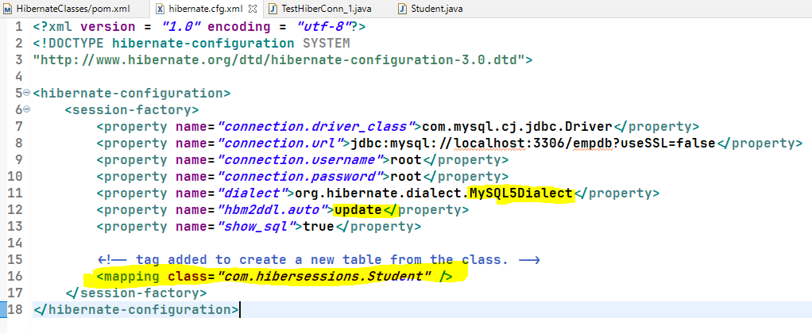

Student.java (POJO class):

**package** com.hibersessions;

**import** javax.persistence.Entity;

**import** javax.persistence.Id;

//@Entity: Is an annotation which creates or updates the table in the database. Takes class name as table name by default.

//@Entity(name = "student_details") : Entity with table name

//@Id: To make that variable as primary key column.

@Entity(name = "student_details")

**public** **class** Student {

@Id

**private** **int** stuId;

**private** String stuName;

**private** **int** marks;

**public** **int** getStuId() {

**return** stuId;

}

**public** **void** setStuId(**int** stuId) {

**this**.stuId = stuId;

}

**public** String getStuName() {

**return** stuName;

}

**public** **void** setStuName(String stuName) {

**this**.stuName = stuName;

}

**public** **int** getMarks() {

**return** marks;

}

**public** **void** setMarks(**int** marks) {

**this**.marks = marks;

}

}

Main Class:

**package** com.hibersessions;

**import** javax.transaction.HeuristicMixedException;

**import** javax.transaction.HeuristicRollbackException;

**import** javax.transaction.RollbackException;

**import** javax.transaction.SystemException;

**import** org.hibernate.Session;

**import** org.hibernate.SessionFactory;

**import** org.hibernate.Transaction;

**import** org.hibernate.cfg.Configuration;

**public** **class** TestHiberConn_1 {

**public** **static** **void** main(String[] args) **throws** SecurityException, RollbackException, HeuristicMixedException,

HeuristicRollbackException, SystemException {

SessionFactory factory = **new** Configuration().configure("hibernate.cfg.xml").buildSessionFactory();

System.***out***.println(factory);

// Storing the Student class data in database.

Student st = **new** Student();

st.setStuId(1011);

st.setStuName("SaiChandra");

st.setMarks(980);

// Triggering the session

Session session = factory.openSession();

Transaction tx = session.beginTransaction();

session.save(st);

tx.commit();

session.close();

}

}

Output:

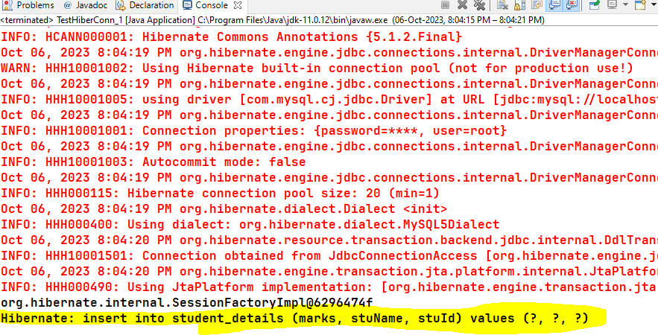

Output from Database:

