OS LAB-6
Sanskar Sehgal 180905486 Roll Number:58 14/12/2020

Q1:
//Receiver

#include <stdlib.h>
#include <stdio.h>
#include <string.h>
#include <errno.h>
#include <unistd.h>
#include <sys/types.h>
#include <sys/ipc.h>
#include <sys/msg.h>
struct my_msg{
long int msg_type;
int number;
};

int palin(int n){
int arr[10],i=0;
while(n>0){
arr[i++]=n%10;
n=n/10;
}
n=i;
for(int i=0;i<n;i++){
if(arr[i]!=arr[n-1-i])
return 0;
}
return 1;
}
int main(){
int running=1;
int msgid;
struct my_msg data;
long int msg_rcv;
msgid=msgget((key_t)1234,0666|IPC_CREAT);
if(msgid==-1){
printf("msgget failed\n");
return 0;
}
while(running){
if(msgrcv(msgid,(void*)&data,sizeof(int),msg_rcv,0)==-1){
printf("msgrcv failed %m\n");
return 0;
}
if(data.number==-1)
return 0;
if (palin(data.number))
printf("%d is Palindrome\n",data.number);
else
printf("%d is not a Palindrome\n",data.number);
}
return 0;
}

//Sender

#include<stdio.h>
#include <stdlib.h>
#include <errno.h>
#include <unistd.h>
#include <sys/types.h>
#include <sys/ipc.h>
#include <sys/msg.h>

struct my_msg{
long int msg_type;
int number;
};
int main(){
int run=1;
struct my_msg data;
int msgid;
msgid=msgget((key_t)1234,0666|IPC_CREAT);
if(msgid==-1){
printf("Msgget failed %m\n");
return 0;
}
while(run){
int n;
printf("Enter the number to be checked,To quit enter -1:\n");
scanf("%d",&n);
data.msg_type=1;
data.number=n;
if(msgsnd(msgid,(void*)&data,sizeof(int),0)==-1){
printf("Message failed\n");
return 0;
}
if(n==-1)
run=0;
}
return 0;
}

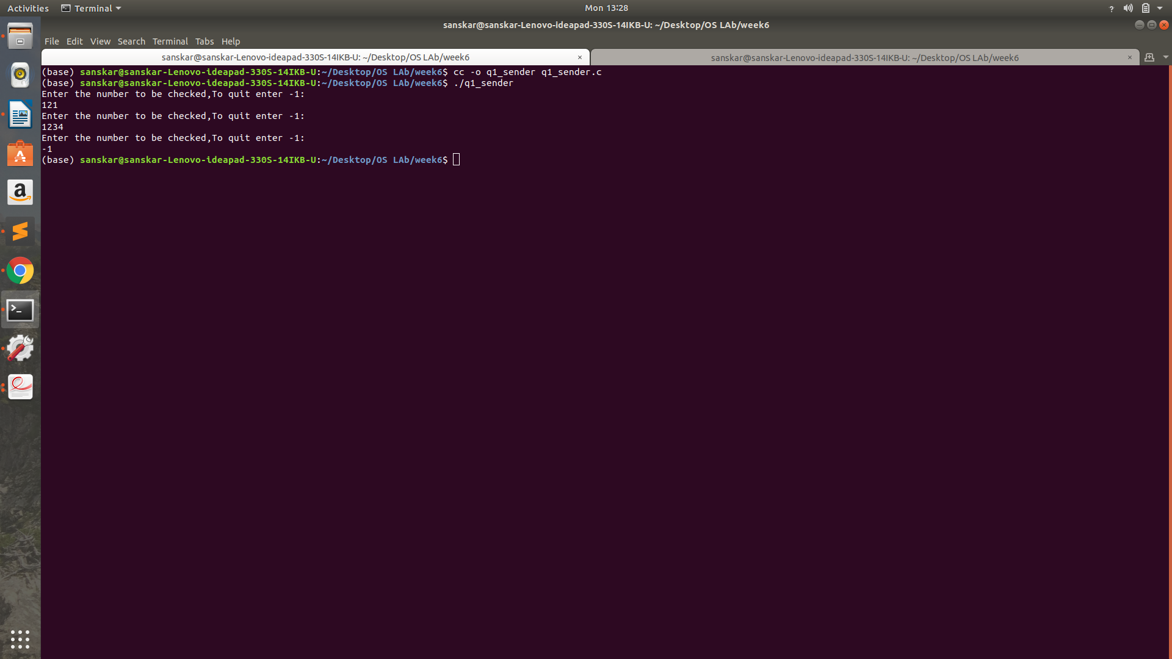

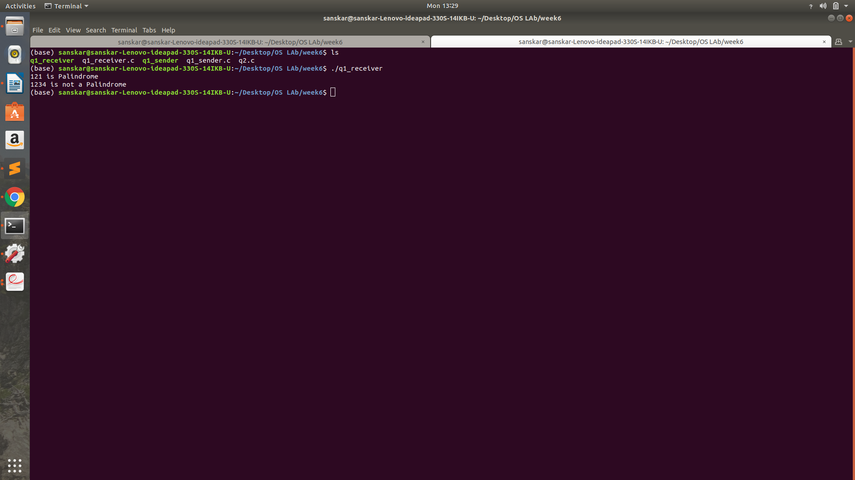

Q2:

#include <stdlib.h>
#include <stdio.h>
#include <string.h>
#include <errno.h>
#include <unistd.h>
#include <sys/types.h>
#include <sys/ipc.h>
#include <sys/shm.h>
#include <sys/wait.h>
struct shared_use
{
char c;
char next_char;
};
int main()
{
void *shared_memory = (void *)0;
int shmid;
struct shared_use *stuff;
char buffer;
pid_t p;
p = fork();
if (p == -1)
{
fprintf(stderr,"fork failed!!\n");
exit(EXIT_FAILURE);
}
else if (p == 0)
{
shmid = shmget((key_t)1234,sizeof(struct shared_use),0666|IPC_CREAT);
if(shmid==-1)
{
fprintf(stderr,"shmget failed!!\n");
exit(EXIT_FAILURE);
}
shared_memory = shmat(shmid,(void *)0,0);
if(shared_memory == (void *)-1)
{
fprintf(stderr, "shmat failed\n");
exit(EXIT_FAILURE);
}
stuff = (struct shared_use *)shared_memory;
sleep(10);
printf("current char: %c\n",stuff->c);
stuff->c++;
if(shmdt(shared_memory)==-1)
{
fprintf(stderr, "shmdt failed\n");
exit(EXIT_FAILURE);
}
if(shmctl(shmid,IPC_RMID,0)==-1)
{
fprintf(stderr, "shmctl(IP_RMID) failed\n");
exit(EXIT_FAILURE);
}
exit(EXIT_SUCCESS);}
else
{
shmid = shmget((key_t)1234,sizeof(struct shared_use),0666|IPC_CREAT);
if(shmid==-1)
{
fprintf(stderr,"shmget failed!!\n");
exit(EXIT_FAILURE);
}
shared_memory = shmat(shmid,(void *)0,0);
if(shared_memory == (void *)-1)
{
fprintf(stderr, "shmat failed\n");
exit(EXIT_FAILURE);
}
stuff = (struct shared_use *)shared_memory;
char ch;
printf("Enter a character: \n");
scanf("%c",&ch);
stuff->c = ch;
printf("current char: %c\n",stuff->c);
printf("Waiting for child process to change...\n");
wait(NULL);
printf("new char: %c\n",stuff->c);
if(shmdt(shared_memory)==-1)
{
fprintf(stderr, "shmdt failed\n");
exit(EXIT_FAILURE);
}
exit(EXIT_SUCCESS);
}
}

