OS LAB-7
Sanskar Sehgal 180905486 Roll Number 58
Q1:
#include <stdio.h>
#include <pthread.h>
#include <semaphore.h>
#include <unistd.h>
int buf[10],f,r;
sem_t mutex,full,empty;
void *produce(void *arg)
{
int i;
for (i = 0; i < 50; i++)
{
sem_wait(&empty);
sem_wait(&mutex);
printf("produced item is %d\n", i);
buf[(++r)%10] = i;
sleep(1);
sem_post(&mutex);
sem_post(&full);
}
}
void *consume(void *arg)
{
int item,i;
for (i = 0; i < 50; i++)
{
sem_wait(&full);
sem_wait(&mutex);
item = buf[(++f)%10];
printf("consumed item is %d\n", item);
sleep(1);
sem_post(&mutex);
sem_post(&empty);
}
}
int main()
{
pthread_t tid1,tid2;
sem_init(&mutex,0,1);
sem_init(&full,0,2);
sem_init(&empty,0,5);
pthread_create(&tid1,NULL,produce,NULL);
pthread_create(&tid2,NULL,consume,NULL);
pthread_join(tid1,NULL);
pthread_join(tid2,NULL);
return 0;
}

Output:

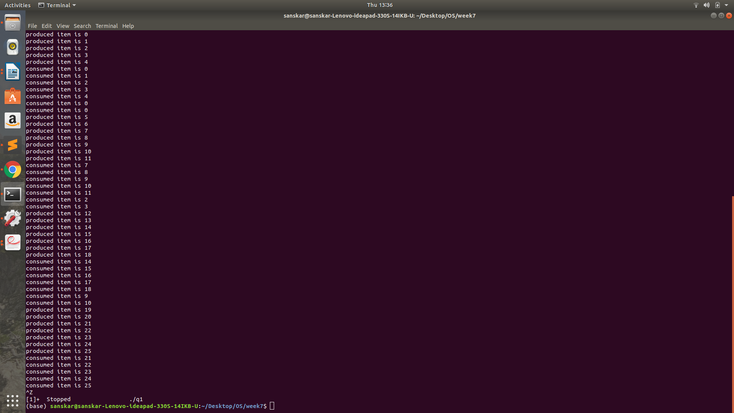
Q2:

#include <pthread.h>
#include <semaphore.h>
#include <stdio.h>
sem_t wrt;
pthread_mutex_t mutex;
int cnt = 1;
int numreader = 0;
void *writer(void *wno)
{
sem_wait(&wrt);
cnt = cnt*2;
printf("Writer %d modified cnt to %d\n",(*((int *)wno)),cnt);
sem_post(&wrt);
}
void *reader(void *rno)
{
pthread_mutex_lock(&mutex);
numreader++;
if(numreader == 1)
sem_wait(&wrt);
pthread_mutex_unlock(&mutex);
printf("Reader %d: read cnt as %d\n",*((int *)rno),cnt);
pthread_mutex_lock(&mutex);
numreader--;
if(numreader == 0)
sem_post(&wrt);
pthread_mutex_unlock(&mutex);
}
int main()
{
pthread_t read[10],write[5];
pthread_mutex_init(&mutex, NULL);
sem_init(&wrt,0,1);
int a[10] = {1,2,3,4,5,6,7,8,9,10};
for(int i = 0; i < 10; i++)
pthread_create(&read[i], NULL, (void *)reader, (void *)&a[i]);
for(int i = 0; i < 5; i++)
pthread_create(&write[i], NULL, (void *)writer, (void *)&a[i]);
for(int i = 0; i < 10; i++)
pthread_join(read[i], NULL);
for(int i = 0; i < 5; i++)
pthread_join(write[i], NULL);
pthread_mutex_destroy(&mutex);
sem_destroy(&wrt);
return 0;
}
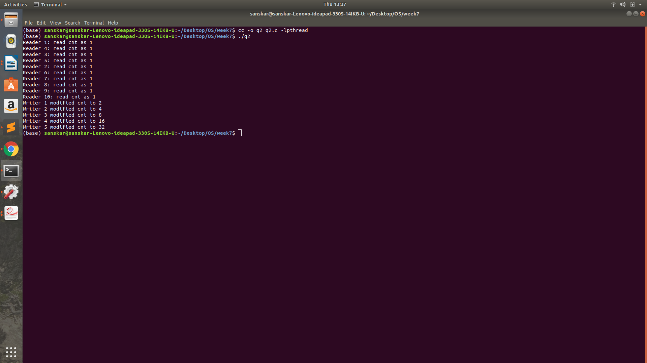
Output:

Q3:

#include <stdio.h>
#include <pthread.h>
#include <semaphore.h>
#include <unistd.h>
int num;
sem_t mutex1,mutex2;
void *A(void *arg)
{
sem_wait(&mutex1);
sem_wait(&mutex2);
num = 2;
printf("function a executing\nnum = %d\n",num);
sem_post(&mutex2);
sem_post(&mutex1);
}
void *B(void *arg)
{
sem_wait(&mutex2);
sem_wait(&mutex1);
num = 1;
printf("function b executing\nnum = %d\n",num);
sem_post(&mutex1);
sem_post(&mutex2);
}
int main()
{
pthread_t tid1,tid2;
sem_init(&mutex1,0,1);
sem_init(&mutex2,0,1);
pthread_create(&tid1,NULL,A,NULL);
pthread_create(&tid2,NULL,B,NULL);
pthread_join(tid1,NULL);
pthread_join(tid2,NULL);
return 0;
}

Output:

NO OUTPUT ON TERMINAL DUE TO DEADLOCK

Q4:

#define _REENTRANT
#include <stdio.h>
#include <unistd.h>
#include <stdlib.h>
#include <pthread.h>
#include <semaphore.h>
#define MAX_CUSTOMERS 25
void *customer(void *num);
void *barber(void *);
void randwait(int secs);
sem_t waitingRoom;
sem_t barberChair;
sem_t barberPillow;
sem_t seatBelt;
int allDone = 0;
int main(int argc, char *argv[])
{
pthread_t btid;
pthread_t tid[MAX_CUSTOMERS];
long RandSeed;
int i, numCustomers, numChairs;
int Number[MAX_CUSTOMERS];
if (argc != 4)
{
printf("Use: SleepBarber <Num Customers> <Num Chairs> <rand seed>\n");
exit(-1);
}
numCustomers = atoi(argv[1]);
numChairs = atoi(argv[2]);
RandSeed = atol(argv[3]);
if (numCustomers > MAX_CUSTOMERS)
{
printf("The maximum number of Customers is %d.\n", MAX_CUSTOMERS);
exit(-1);
}
printf("A solution to the sleeping barber problem using semaphores.\n");
srand48(RandSeed);
for (i=0; i<MAX_CUSTOMERS; i++)
Number[i] = i;
sem_init(&waitingRoom, 0, numChairs);
sem_init(&barberChair, 0, 1);
sem_init(&barberPillow, 0, 0);
sem_init(&seatBelt, 0, 0);
pthread_create(&btid, NULL, barber, NULL);
for (i=0; i<numCustomers; i++)
pthread_create(&tid[i], NULL, customer, (void *)&Number[i]);
for (i=0; i<numCustomers; i++)
pthread_join(tid[i],NULL);
allDone = 1;
sem_post(&barberPillow);
pthread_join(btid,NULL);
}
void *customer(void *number){
int num = *(int *)number;
printf("Customer %d leaving for barber shop.\n", num);
randwait(5);
printf("Customer %d arrived at barber shop.\n", num);
sem_wait(&waitingRoom);
printf("Customer %d entering waiting room.\n", num);
sem_wait(&barberChair);
sem_post(&waitingRoom);
printf("Customer %d waking the barber.\n", num);
sem_post(&barberPillow);
sem_wait(&seatBelt);
sem_post(&barberChair);
printf("Customer %d leaving barber shop.\n", num);
}
void *barber(void *junk)
{
while (!allDone)
{
printf("The barber is sleeping\n");
sem_wait(&barberPillow);
if (!allDone)
{
printf("The barber is cutting hair\n");
randwait(3);
printf("The barber has finished cutting hair.\n");
sem_post(&seatBelt);
}
else
printf("The barber is going home for the day.\n");
}
}
void randwait(int secs)
{
int len;
len = (int) ((drand48() * secs) + 1);
sleep(len);
}

Output:

