OS LAB 8
Sanskar Sehgal 180905486 Roll Number:58
Q1:
#include <stdlib.h>
#include <stdio.h>
#include <pthread.h>
#include <string.h>

void *thread_code(void* param) {
int n = *((int*)param);

int arr[n];
arr[0] = 0;
arr[1] = 1;

for (int i = 2; i < n; i++)
arr[i] = arr[i - 2] + arr[i - 1];

int *sol = (int *)calloc(n, sizeof(int));
memcpy(sol, arr, sizeof(int) * n);

return sol;
}

void main() {
pthread_t thread;

int n;
printf("Enter no. of terms: ");
scanf("%d", &n);

void *arr;
pthread_create(&thread, 0, &thread_code, (void*)&n);

printf("Thread created and working\n");
pthread_join(thread, &arr);

int *arr2 = arr;

for (int i = 0; i < n; i++)
printf("%d ", (int)arr2[i]);

printf("\n");
}

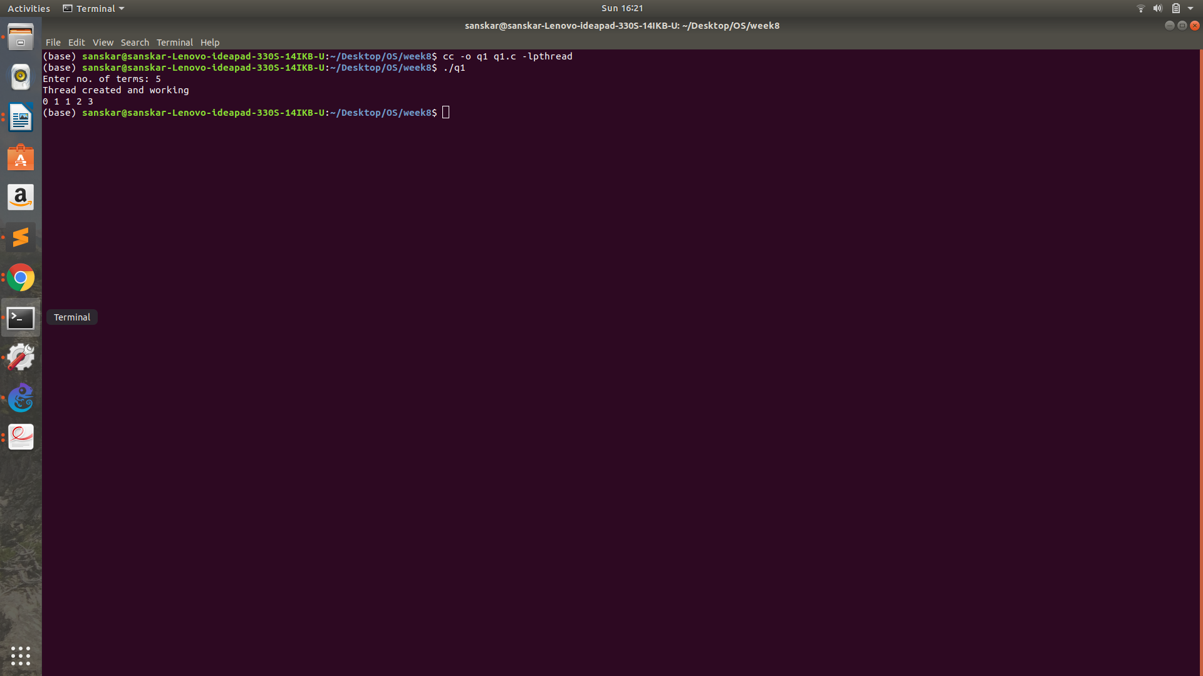

Q2:

#include <stdlib.h>
#include <stdio.h>
#include <pthread.h>
#include <string.h>

void* thread_code(void* n) {
printf("Thread running....\n");

int sum = 0;
int limit = *((int*)n);

for (int i = 1; i <= limit; i++)
sum += i;

*((int*)n) = sum;
}

void main() {
pthread_t thread;

int n;
printf("No. of elements?\n>> ");
scanf("%d", &n);

int ans;
pthread_create(&thread, 0, &thread_code, (void*)&n);

pthread_join(thread, NULL);
printf("Ans is %d\n", n);
}

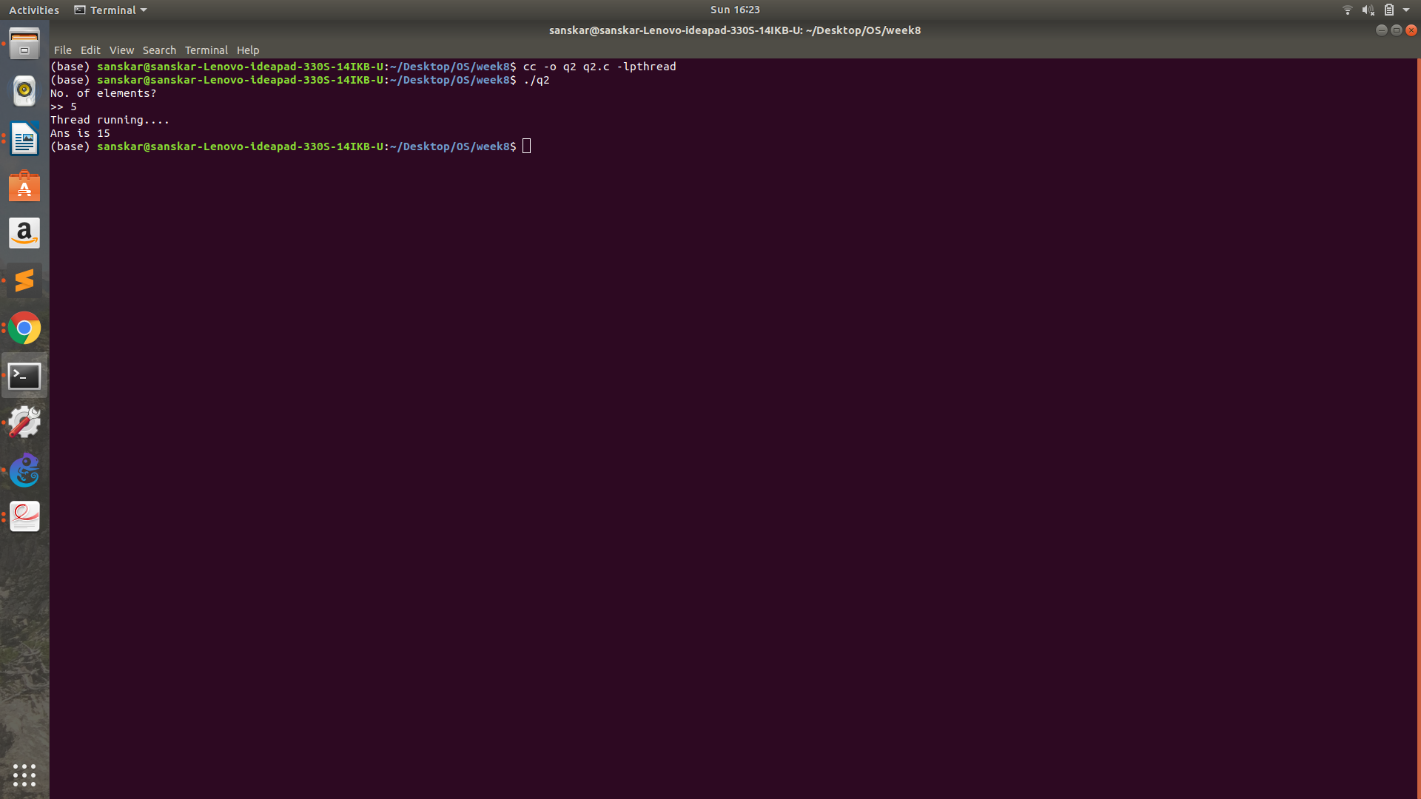

Q3:

#include <stdlib.h>
#include <stdio.h>
#include <pthread.h>
#include <string.h>

void *prime(void* arr) {
int low = *((int*)arr);
int high = *(((int*)(arr + sizeof(int))));

printf("Prime numbers: ");

for (int i = low; i <= high; i++) {
int flag = 0;
for (int j = 2; j <= i / 2; j++) {
if ((i % j) == 0) {
flag = 1;
break;
}
}

if (flag == 0)
printf("%d ", i);
}

printf("\n");
}

int main() {
pthread_t thread;

printf("Enter the limits:\n>> ");
int arr[2];
scanf("%d %d", &arr[0], &arr[1]);

pthread_create(&thread, 0, &prime, (void*)arr);

pthread_join(thread, NULL);
}

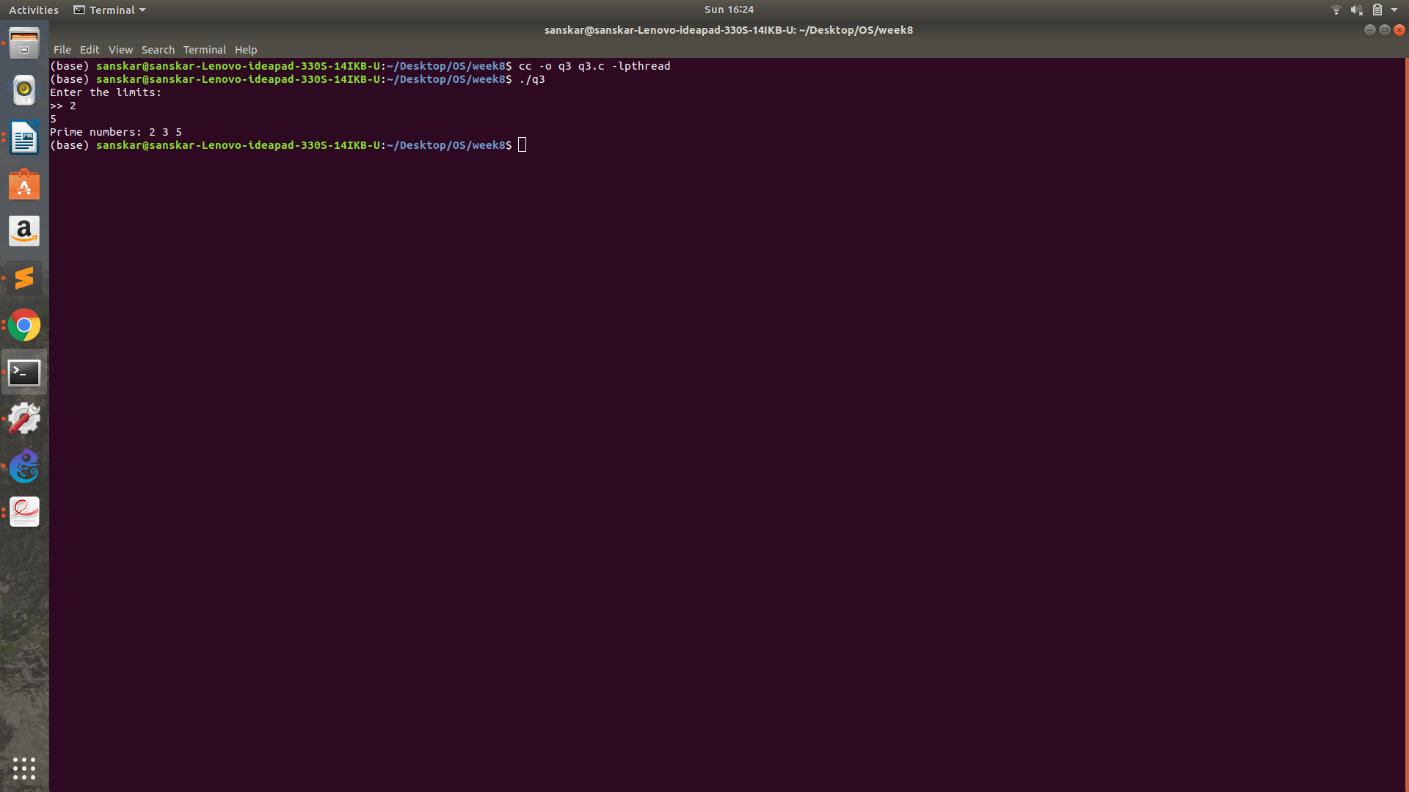

Q4:

#include <stdlib.h>
#include <stdio.h>
#include <pthread.h>
#include <string.h>

void *even(void *arr) {
int *arr2 = (int*)arr;
int size = arr2[0];

int sum = 0;
for (int i = 1; i <= size; i++)
if (arr2[i] % 2 == 0)
sum += arr2[i];

return (void*) sum;
}

void *odd(void *arr) {
int *arr2 = (int*)arr;
int size = arr2[0];
int sum = 0;

for (int i = 1; i <= size; i++)
if (arr2[i] % 2 != 0)
sum += arr2[i];

return (void*) sum;
}

int main() {
int n;
printf("Enter size of array:\n>> ");
scanf("%d", &n);

int arr[n + 1];
arr[0] = n;

printf("Enter elements:\n>> ");

for (int i = 1; i <= n; i++)
scanf("%d", &arr[i]);

pthread_t t1, t2;
pthread_create(&t1, 0, &even, (void *)arr);
pthread_create(&t2, 0, &odd, (void *)arr);

int e, o;

pthread_join(t1, (void*) &e);
pthread_join(t2, (void*) &o);
printf("Sum of even numbers = %d\n", (int)e);
printf("Sum of odd numbers = %d\n", (int)o);
}

