**TODO APP**

TODO App has been created for you to comfortably write and note down tasks which are important for you to remember.

* To get started with the app,First of all you are supposed to install the application in your device. Then you will be able to see a splash screen that will be welcoming you to the application.



* After that you will be directed into the login screen where you are supposed to enter your username and password in order to get logged in. if you don’t have a account already than you can simply click on the register here button which will redirect you towards the registration page where you are supposed to input your desired username, password and email address and create an account.

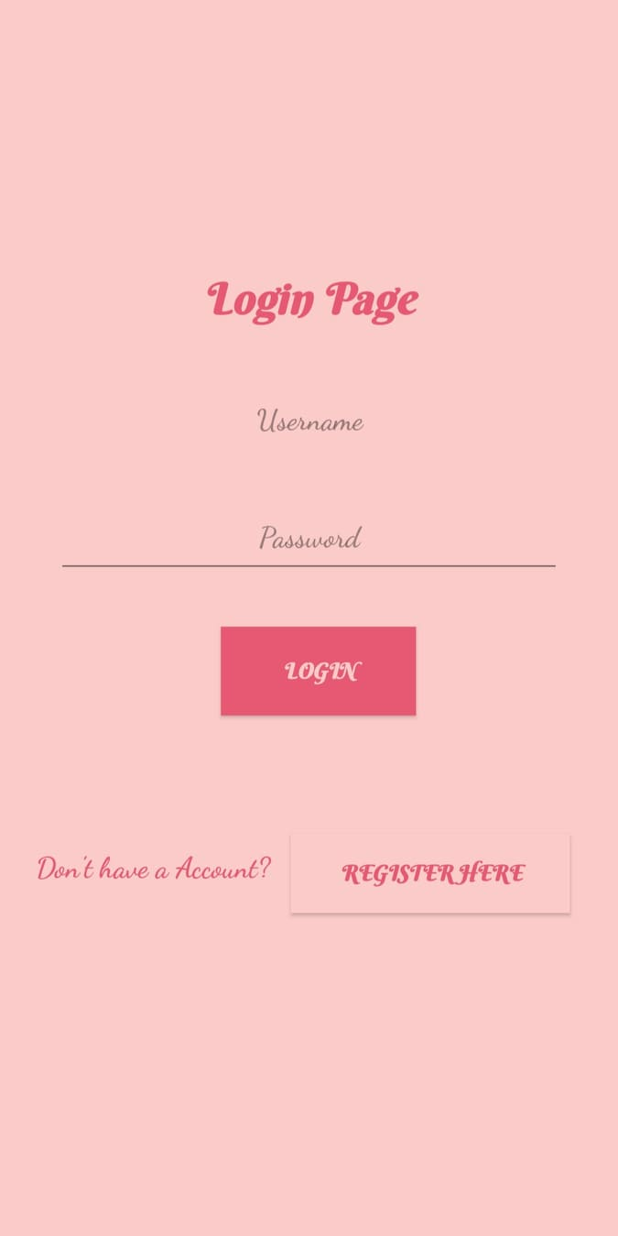 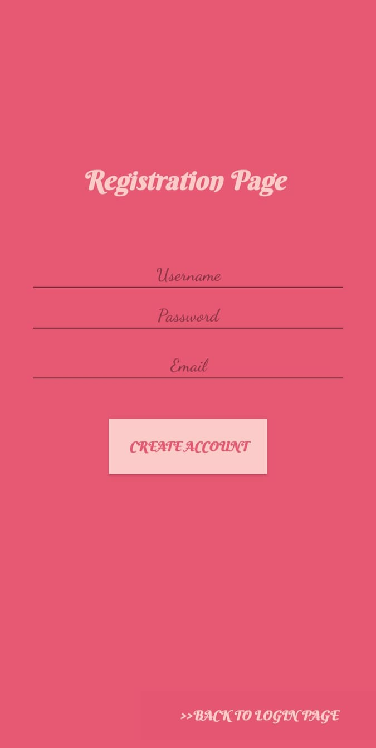

* Then you will be logged in. after being logged in you can see a page with a + icon at the end of the page which is supposed to be clicked in order to add a new todo in your list. By clicking on the icon you can see a page which holds information to be included in your todo like the title, description, date, priority and also holds the completion status for it.

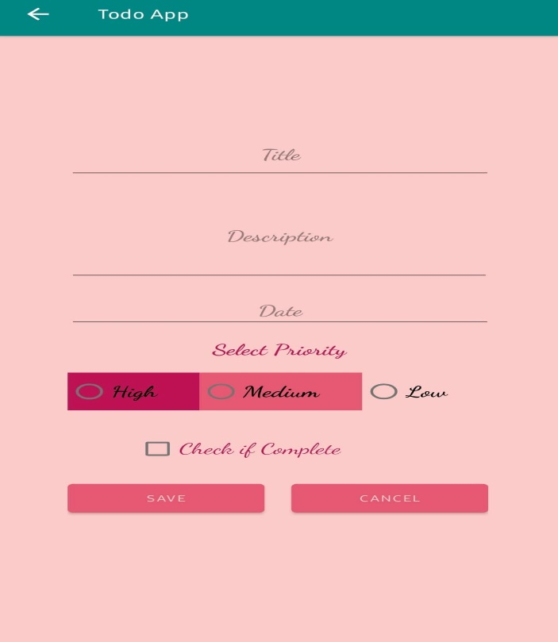

* Then by clicking on the save button your todo will be saved. After returning on your previous page you will find all your saved todos in a listed form. From there you can delete/update the todo as well as set complete or not complete status for your todos. Through the menu you can also delete either all of your todos or only the completed ones.

