DITTO
Digital Twin Studio
A local-first AI system for building and simulating personality-grounded conversational personas from raw chat history

Project Report
Academic Submission

2026

Table of Contents

1. Project Title
DITTO: Digital Twin Studio
A local-first AI system for building and simulating personality-grounded conversational personas from raw chat history.

2. Background Study
The rapid growth of large language models (LLMs) has opened new possibilities for natural language understanding and generation. One emerging application is personality simulation — training or prompting an AI to mimic a specific person's communication style based on their past messages.

Retrieval-Augmented Generation (RAG)
RAG is a technique that enhances LLM responses by first retrieving semantically relevant documents from a vector database and injecting them into the prompt. This grounds the model's output in real evidence rather than hallucination.

Vector Embeddings
Vector embeddings convert text into dense numerical representations that capture semantic meaning. Similar texts cluster together in embedding space, making it possible to retrieve the most contextually relevant past messages for a given query using distance metrics such as cosine similarity.

Conversation-Pair RAG
Conversation-pair RAG is a refinement of standard RAG that stores (trigger → response) pairs instead of isolated utterances. The embedding is computed on the trigger side so that retrieval finds the situations most similar to the incoming query, and the associated response serves as a few-shot example for the LLM.

Local AI Stack
Ollama is a local inference runtime that allows models such as Meta's LLaMA 3 to be run entirely offline on consumer hardware. ChromaDB is an open-source, embeddable vector database suited for RAG pipelines. Together, these technologies enable a fully local, privacy-preserving pipeline for persona construction — no data is sent to external APIs.

3. Problem Statement
Existing chatbot and persona systems typically require:
- Large annotated datasets
- Cloud-based APIs that expose private conversations to third-party servers
- Manual prompt engineering per person
- Re-training or fine-tuning of models

There is no accessible, local tool that allows a user to upload a raw WhatsApp-style chat export, automatically extract a structured personality profile, store conversational memory as context-grounded pairs, and simulate responses in the style of a chosen participant — all without sending data to the cloud.

4. Objective of the Project
- Parse WhatsApp-format plain-text chat exports and extract per-author message sets.
- Automatically derive a structured PersonalityProfile (tone, style, vocabulary, sentiment, etc.) using an LLM prompt via Ollama.
- Extract (context window → persona reply) pairs from the chat and embed the context side for semantic retrieval.
- Simulate natural-language replies grounded in few-shot examples drawn from retrieved pairs, the personality profile, and the current conversation history.
- Gate retrieval quality — exclude semantically distant pairs and fall back gracefully to general style guidance.
- Provide an intuitive, browser-based UI that requires no command-line interaction beyond starting local services.
- Keep the entire pipeline offline and private — no cloud APIs, no telemetry.

5. Existing System

Aspect | Current State
Persona chatbots | Rule-based or cloud-fine-tuned models (CharacterAI, GPT custom instructions)
Chat analysis tools | Manual — users export and read logs themselves
Memory retrieval | Not implemented in most consumer tools
Privacy | Cloud-dependent; chat data transmitted to external servers
Accessibility | Requires API keys, subscriptions, or ML expertise

Drawbacks of Existing Systems
- Privacy risk: raw personal conversations sent to third-party servers.
- No structured personality extraction from individual message history.
- No semantic memory — replies are not grounded in real past conversations.
- High barrier to entry (fine-tuning, API costs).

6. Proposed System
DITTO is a local-first, RAG-powered digital twin studio consisting of:
- A Next.js web application with a clean UI for uploading chat exports, selecting personas, and simulating replies.
- A chat parser that decodes WhatsApp-format exports and derives sliding-window (context → reply) pairs for every persona message.
- A personality extractor that uses Ollama/LLaMA 3 to produce a structured JSON profile covering tone, communication style, common phrases, sentiment, vocabulary patterns, and relationship signals.
- A vector memory store (ChromaDB ditto_pairs_v1 + nomic-embed-text) that embeds the context side of each conversation pair, enabling retrieval by situational similarity.
- A simulation engine that injects retrieved pairs as few-shot examples into a strict system prompt, passes the current conversation history as proper chat turns, and calls Ollama's /api/chat endpoint to generate a grounded reply.
- A relevance gate that excludes pairs with cosine distance >= 1.3 from the few-shot block and signals the LLM to rely on general style guidance when no relevant context exists.

Advantages over Existing Systems
- Fully local — no data leaves the machine.
- No fine-tuning required; works with any LLaMA 3-compatible model.
- Retrieval finds situations similar to the query, not just similar words.
- Few-shot examples drawn from real (trigger → response) pairs produce authentic, grounded replies.
- Multi-turn conversation history is maintained across simulation turns.
- Extensible: swap the model, embedder, or vector store via environment variables.

7. Module Descriptions

7.1 Chat Parser (lib/chat-parser.ts)
Parses raw WhatsApp-exported .txt files line by line using a regex that matches the pattern: DD/MM/YY, H:MM [am/pm] - Author: Message
- Handles multi-line messages (continuation lines are appended to the previous record).
- Strips noise lines (<Media omitted>, encryption notices, blank lines).
- Normalises timestamps to YYYY-MM-DD HH:MM (24-hour ISO format).
- Generates a SHA-1 ID per message for stable deduplication.
- getConversationPairs(messages, personaName, windowSize=4) — for every persona reply, collects the preceding N messages from any author as the context window. Short messages (< 4 chars) and bare URLs are skipped.

// Core regex in chat-parser.ts
const CHAT_LINE_REGEX = new RegExp(
`^(\\d{1,2}\\/\\d{1,2}\\/\\d{2,4}), (CHAT_TIME_PATTERN) - ([^:]+):\\s?(.*)$`
)

7.2 Personality Extractor (lib/personality.ts)
Builds a PersonalityProfile for a chosen author:
- Samples messages evenly across the full history (up to 100 messages, stepped by index) so early and late conversational patterns are both represented.
- Computes top-8 frequent words (>= 3 chars, appearing > 1 time) as phrase hints.
- Sends a structured prompt to Ollama that includes the persona's actual raw messages as concrete evidence, instructing the LLM to describe observed behaviour.
- Extracts the JSON block from the raw LLM response using brace-matching and falls back gracefully to a default profile if extraction fails.

7.3 Ollama Client (lib/ollama.ts)
Thin HTTP wrapper around the Ollama REST API:
- generateWithOllama(prompt) — calls /api/generate with LLaMA 3 at temperature 0.7. Used for personality profile extraction.
- chatWithOllama(system, history[], userMessage) — calls /api/chat with a structured [system, ...history, user] messages array. Temperature 0.85.
- embedWithOllama(texts[]) — calls /api/embed using nomic-embed-text; supports both embeddings[] and legacy embedding response shapes.
- Configurable via OLLAMA_URL, OLLAMA_MODEL, OLLAMA_EMBED_MODEL environment variables.

7.4 Chroma Memory Store (lib/chroma.ts)
Manages the ditto_pairs_v1 ChromaDB collection:
- storeConversationPairs(personaName, pairs[]) — embeds the contextWindow text of each pair via Ollama, then upserts with the personaReply as the document. IDs are SHA-1 hashes of personaName:contextWindow:reply for idempotent re-runs.
- queryConversationPairs(personaName, queryText, limit=6) — embeds the incoming user message, queries ChromaDB filtered by personaName, and returns ConversationPair[] including cosine-distance scores.

7.5 API Routes (app/api/personas/)

POST /api/personas — Create Persona
- Validates request body (personaName, chatHistory).
- Parses chat, filters to persona messages, computes summary stats.
- Calls getConversationPairs to extract all (context → reply) pairs from the full message thread.
- Calls personality extractor (Ollama) and storeConversationPairs (Chroma) in sequence.
- Returns CreatePersonaResponse with the full persona record and stored pair count.

POST /api/personas/chat — Chat Simulation
- Validates request body (personaName, message, profile, conversationHistory).
- Retrieves top-6 nearest conversation pairs from ChromaDB by embedding the user message.
- Applies the relevance gate: pairs with cosine distance >= 1.3 are excluded from the few-shot prompt.
- Builds a system prompt containing the personality profile summary and the usable pairs as few-shot examples.
- Calls chatWithOllama with the system prompt, the last 6 turns of conversationHistory, and the current user message.
- Returns the reply and all retrieved pairs with distance scores for display.

7.6 UI — Ditto Studio (components/ditto-studio.tsx)
Single-page React component with four visual sections:
- Hero card — project overview and feature highlights.
- System status card — live display of stack components (Next.js, Ollama, Chroma).
- Create Persona panel — file upload, format validation, speaker detection radio group, chat preview, and persona creation trigger.
- Chat Simulation panel — scrollable conversation log in monospace chat format, message textarea, and simulate button. Each request includes the last 6 chat turns as conversationHistory.
- Extracted Profile panel — summary stats and raw JSON profile viewer.
- Retrieved Context panel — per-pair cards showing context window, persona's actual reply, timestamp, and a colour-coded distance badge.

8. Software and Hardware Configuration

8.1 Software Requirements

Component | Technology | Version / Notes
Frontend framework | Next.js (App Router) | v16+
UI language | TypeScript + React | React 19+
Component library | shadcn/ui (Radix + Tailwind) | Latest
Local LLM runtime | Ollama | Latest stable
LLM model | LLaMA 3 (llama3) | Meta via Ollama
Embedding model | nomic-embed-text | Via Ollama
Vector database | ChromaDB | v0.5+ (REST API)
ChromaDB client | chromadb npm package | Latest
Node.js | Node.js | v18+
Package manager | bun | —

8.2 Environment Variables

Variable | Default | Purpose
OLLAMA_URL | http://127.0.0.1:11434 | Ollama server address
OLLAMA_MODEL | llama3 | Generation model name
OLLAMA_EMBED_MODEL | nomic-embed-text | Embedding model name
CHROMA_URL | http://127.0.0.1:8000 | ChromaDB server address

8.3 Hardware Requirements (Minimum)

Resource | Requirement
CPU | 4-core x86-64 (Apple Silicon supported)
RAM | 8 GB (16 GB recommended for LLaMA 3 8B)
Storage | 10 GB free (model weights + ChromaDB data)
OS | Windows 10/11, macOS 12+, or Linux
GPU | Optional — CUDA/Metal acceleration speeds inference

9. Data Flow Diagram / System Flow

9.1 Persona Creation Flow

User uploads .txt file
│
▼
[Chat Parser]
• Regex parse each line → ChatMessage[]
• Filter noise, normalise timestamps
• Filter by selected personaName → persona messages
│
▼
[Conversation Pair Extractor]
• getConversationPairs() — 4-message sliding window
• Each pair: { contextWindow, personaReply, timestamp }
• Skip replies < 4 chars or bare URLs
│
▼
[Personality Extractor]
• Evenly sample up to 100 messages across full history
• Build LLM prompt with raw message examples
│
▼
[Ollama — LLaMA 3 /api/generate]
• Generate structured JSON profile
│
▼
[Ollama — nomic-embed-text /api/embed]
• Embed contextWindow side of each pair → float[][] vectors
│
▼
[ChromaDB — ditto_pairs_v1]
• Upsert pairs: embedding on context, document = personaReply
• Deduplicated by SHA-1 of personaName:context:reply
│
▼
[API Response → UI]
• PersonaRecord + storedPairs count

9.2 Chat Simulation Flow

User types a message
│
▼
[POST /api/personas/chat]
• Receive: personaName, message, profile, conversationHistory (last 6 turns)
│
▼
[Ollama — nomic-embed-text]
• Embed user message → query vector
│
▼
[ChromaDB — ditto_pairs_v1]
• Filter by personaName
• Return top-6 nearest pairs (contextWindow, personaReply, distance)
│
▼
[Relevance Gate]
• distance < 1.3 → usable few-shot example
• distance >= 1.3 → excluded from prompt, shown in UI as distant
│
▼
[System Prompt Builder]
• Role: "real person named {personaName}"
• Style rules from PersonalityProfile
• Few-shot block: [Context] / [{personaName} replied]
│
▼
[Ollama — LLaMA 3 /api/chat]
• messages: [system, ...conversationHistory, user]
• temperature 0.85
│
▼
[API Response → UI]
• Display reply in chat log
• Display retrieved pair cards with colour-coded distance badges

9.3 System Architecture Diagram
The following diagram provides a visual overview of the complete DITTO pipeline, from chat upload through persona creation and reply simulation.

Figure 1 — DITTO system architecture: persona creation (left) and chat simulation (right) pipelines

10. Table Design
Since DITTO uses ChromaDB (a vector database) rather than a relational database, data is stored in a collection rather than SQL tables. The logical schema is described below, alongside the in-memory TypeScript types that serve as the application's data layer.

10.1 ChromaDB Collection: ditto_pairs_v1

Field | Type | Description
id | string | SHA-1 of personaName:contextWindow:personaReply
embedding | float[] | nomic-embed-text vector of the context window (768 dimensions)
document | string | The persona's reply text
metadata.personaName | string | The persona this pair belongs to
metadata.contextWindow | string | The multi-turn context that preceded the reply
metadata.timestamp | string | Normalised ISO-style timestamp (YYYY-MM-DD HH:MM)

10.2 TypeScript Data Structures

ChatMessage

Field | Type | Description
id | string | SHA-1 hash of the raw line
timestamp | string | Normalised timestamp
author | string | Sender name extracted from chat
content | string | Cleaned message body
raw | string | Original unmodified line

PersonalityProfile

Field | Type | Description
tone | string | Overall conversational tone
communicationStyle | string | How the person structures messages
responseLength | string | Typical length pattern (short / medium / long)
commonPhrases | string[] | Frequently used words or expressions (up to 8)
sentiment | string | Dominant emotional register
vocabularyPatterns | string[] | Characteristic word choices (up to 6)
relationshipSignals | string[] | Indicators of social dynamics (up to 6)
notes | string | Free-form LLM observations

ConversationPair

Field | Type | Description
contextWindow | string | The multi-turn messages that preceded the reply
personaReply | string | What the persona actually said
timestamp | string | Timestamp of the reply
distance | number | null | Cosine distance from query vector (lower = more similar)

11. Implementation

11.1 Development Environment Setup
The project is built on Next.js 16 with the App Router and React 19, using TypeScript throughout. The local AI stack requires two background services:
- Ollama — serves the llama3 generation model and nomic-embed-text embedding model over HTTP at http://127.0.0.1:11434.
- ChromaDB — runs as a local REST server at http://127.0.0.1:8000, storing vectors on disk in the chroma/ directory.

The Next.js development server is started with Turbopack (bun run dev) for fast incremental builds. The chromadb npm package is declared as a serverExternalPackage in next.config.mjs to prevent client-side bundling.

11.2 Chat Parser Implementation
The parser processes raw WhatsApp .txt exports line by line using a single regular expression that captures the four fields on every message header:

DD/MM/YY, H:MM [am/pm] - Author: Message body

Lines that do not match the pattern are treated as continuations and appended to the previous message. After building raw records, the parser:
- Normalises timestamps — converts 2-digit years to 4-digit, reformats to YYYY-MM-DD, and converts 12-hour AM/PM times to 24-hour format.
- Filters noise — discards blank lines, <Media omitted> entries, bare URLs, and WhatsApp system notices.
- Generates stable IDs — applies SHA-1 to each raw line to produce a deterministic message ID.

getConversationPairs implements a 4-message sliding window over the full message thread. For each persona reply it collects the preceding 4 messages from any participant as the contextWindow. Replies shorter than 4 characters or consisting solely of a URL are skipped.

11.3 Personality Extractor Implementation

Stage 1 — Statistical Pre-processing
A word-frequency pass over all persona messages identifies the top-8 words with length >= 3 and occurrence > 1.

Stage 2 — LLM-based Extraction
The extractor samples up to 100 messages evenly distributed across the full chat history (stepped by floor(total / 100)), ensuring both early and late conversational patterns are captured. The prompt provides two evidence sources to the LLM: a list of the persona's actual messages and a short timestamped transcript. The LLM is instructed to describe observed behaviour rather than generic categories.

11.4 Ollama Client Implementation
Three functions are exposed:
- generateWithOllama(prompt) — issues POST /api/generate with stream: false and temperature 0.7. Used only for personality profile extraction.
- chatWithOllama(system, history, userMessage) — issues POST /api/chat with a structured messages array: [system, ...history, user]. Temperature 0.85.
- embedWithOllama(texts[]) — issues POST /api/embed using nomic-embed-text. Handles both embeddings[] (current) and embedding (legacy) response shapes.

11.5 Chroma Memory Store Implementation
The collection stores conversation pairs rather than individual messages. Embeddings are computed on the context window (what was said before the persona replied), not on the reply itself. This means ChromaDB retrieval answers: 'what situation is most similar to what the user just said?'
- storeConversationPairs — embeds each pair's contextWindow text, then upserts with the personaReply as the document. IDs are SHA-1 hashes making re-runs fully idempotent. In-memory deduplication runs before the upsert call.
- queryConversationPairs — embeds the incoming user message and queries ChromaDB using a personaName $eq filter, returning up to 6 ConversationPair objects sorted by cosine distance.

11.6 API Route Implementation

POST /api/personas
Orchestrates the full persona-creation pipeline:
- Parses the full chat into ChatMessage[].
- Extracts ConversationPair[] via getConversationPairs (4-message sliding window over the entire thread).
- Calls buildPersonalityProfile (Ollama) for the UI display profile.
- Calls storeConversationPairs (Chroma) to embed and persist all pairs.

POST /api/personas/chat
Executes the pair-based RAG simulation loop:
- Accepts conversationHistory (last 6 turns) alongside the standard fields.
- Retrieves top-6 pairs from ChromaDB by embedding the user message against stored context-window vectors.
- Applies the relevance gate (RELEVANCE_THRESHOLD = 1.3): pairs at or above this distance are excluded from the few-shot prompt.
- Builds a system prompt containing: a role declaration, a style summary, and usable pairs as labelled few-shot examples.
- Calls chatWithOllama(systemPrompt, conversationHistory, message), passing history as structured chat turns.

11.7 Frontend Implementation
Key implementation decisions:
- Conversation log — the chat simulation panel shows a scrollable monospace log formatted as DD/MM/YY, HH:MM - ROLE: content. The log accumulates across turns.
- History passing — before each simulation request, the last 6 chatTurns are mapped to { role, content } objects and sent as conversationHistory.
- Retrieved context display — ConversationPair cards colour-coded by distance: dark (<1.0) = highly relevant; secondary (1.0–1.3) = acceptable; outline (>=1.3) = distant.
- Format validation — hasValidChatFormat runs a lightweight regex test before accepting a file.

12. System Testing
Since the project does not include an automated test suite, system testing was performed manually across functional, integration, and edge-case dimensions.

12.1 Unit-Level Verification

Module | Test Case | Expected Outcome | Result
chat-parser.ts | Valid WhatsApp .txt file | Messages parsed with correct author, timestamp, content | Pass
chat-parser.ts | Multi-line message | Content appended to previous message | Pass
chat-parser.ts | <Media omitted> lines | Filtered out | Pass
chat-parser.ts | 12-hour AM/PM timestamp | Normalised to 24-hour | Pass
chat-parser.ts | getConversationPairs on 100-message chat | Pairs generated with non-empty contextWindow and reply | Pass
chat-parser.ts | Reply < 4 chars or bare URL | Pair skipped, not stored | Pass
personality.ts | Valid JSON returned by Ollama | Profile parsed correctly | Pass
personality.ts | Malformed LLM response | Fallback profile returned, no crash | Pass
ollama.ts | Ollama service offline | Descriptive error with service URL thrown | Pass
chroma.ts | Re-running persona creation | Upsert deduplicates; no duplicate vectors | Pass
chroma.ts | Duplicate IDs in same batch | In-memory dedup removes before upsert | Pass

12.2 API Integration Testing

Endpoint | Scenario | Expected HTTP Status | Result
POST /api/personas | Missing personaName field | 400 Bad Request | Pass
POST /api/personas | personaName not found in chat | 400 — author not in chat | Pass
POST /api/personas | Valid request, Ollama running | 200 with PersonaRecord | Pass
POST /api/personas/chat | Missing profile field | 400 Bad Request | Pass
POST /api/personas/chat | Valid request after persona creation | 200 with reply + retrievedContext | Pass
POST /api/personas/chat | All pairs above relevance threshold | 200 — fallback style prompt used | Pass
POST /api/personas/chat | Ollama service offline | 500 with error detail | Pass

12.3 End-to-End UI Testing

Test Scenario 1 — Full Persona Creation Flow
- Upload a WhatsApp .txt export → persona options auto-populate from the file.
- Select a speaker and click Create Persona → loading state appears.
- After 15–30 seconds, the profile JSON and stats cards render correctly.
- The stored pair count is displayed (less than total message count due to filtering).

Test Scenario 2 — Chat Simulation Flow
- With a persona created, type a message and click Simulate Reply.
- The reply appears in the monospace conversation log.
- The Retrieved Context panel displays up to 6 pair cards with colour-coded distance badges.
- Multiple turns accumulate correctly; subsequent replies maintain conversational coherence.

Test Scenario 3 — Edge Cases
- Uploading a non-WhatsApp file → error alert shown, no API call made.
- Attempting to chat before creating a persona → error alert shown.
- All retrieved pairs above 1.3 threshold → system prompt switches to style-only mode; reply is still generated.

12.4 Performance Observations

Operation | Observed Duration
Chat parsing (500-message file) | < 50 ms (client-side)
Conversation pair extraction | < 10 ms (server-side)
Personality extraction (LLaMA 3, CPU) | 15 – 40 seconds
Embedding all pairs (nomic-embed-text) | 20 – 90 seconds (pair count dependent)
Chat simulation (single turn) | 10 – 25 seconds
Chroma vector query (top-6) | < 200 ms

Performance is dominated by LLM inference time on CPU. GPU acceleration via CUDA or Apple Metal reduces generation time by approximately 3–5x. Embedding time scales with the number of conversation pairs; a 500-message chat typically produces 300–400 storable pairs.

13. Results and Discussion

13.1 Persona Creation Results
When provided with a WhatsApp chat export of approximately 300–500 messages, DITTO successfully:
- Parsed all messages with correct author attribution, timestamp normalisation, and noise filtering in under 100 ms.
- Extracted conversation pairs via a 4-message sliding window, producing a semantically richer memory store than isolated individual messages.
- Embedded and stored the context side of each pair as 768-dimensional vectors in ChromaDB, enabling retrieval by situational similarity.
- Generated a structured PersonalityProfile from a representative sample of the persona's actual messages, grounded in concrete evidence.

13.2 Chat Simulation Results
The pair-based RAG simulation with few-shot prompting produced substantially more authentic replies than an isolated-message approach:
- Retrieved pairs were situationally relevant — searching the context side surfaces situations that match the incoming message, not just similar words from the reply side.
- Few-shot examples from real pairs allowed the LLM to pattern-match on actual response evidence rather than an abstract JSON profile description.
- Conversation history passed as structured chat turns prevented tone resets between turns and enabled coherent multi-turn exchanges.
- The relevance gate at distance 1.3 correctly excluded unrelated pairs while still providing examples for the majority of on-topic queries.
- Persona name disambiguation — explicitly identifying the persona as a real person eliminated LLM hallucinations caused by names matching fictional characters.

13.3 Privacy and Offline Validation
All processing — parsing, embedding, generation, and storage — completed without any outbound network traffic to external servers. This validates the core design goal: the system is fully operable on an air-gapped machine.

13.4 Limitations

Limitation | Impact | Mitigation
No automated test suite | Regressions may go undetected | Add Jest/Vitest unit tests for parser and pair extractor
LLM output variability | Reply quality varies between runs | Temperature tuning; structured output enforcement
Single-collection Chroma design | All personas share one collection | Partition into per-persona collections at scale
Session-only chat history | Conversation resets on page reload | Persist chatTurns to localStorage or a backend store
No authentication | Single-user, local deployment only | Add session management for shared deployments
Pair count grows with chat size | Embedding large chats takes longer | Batch-limit upserts; background processing

13.5 Discussion
DITTO demonstrates that a fully local, privacy-preserving digital twin pipeline is achievable with commodity hardware and open-source tooling. The architectural evolution from individual message storage to conversation-pair storage is the most impactful design change: by embedding the context side of each (trigger → response) pair, the vector database retrieves situations that resemble the incoming message rather than words that resemble the reply — a fundamentally more useful retrieval signal.

The combination of few-shot examples drawn from real pairs, a strict system prompt that prevents AI-assistant behaviour, and multi-turn conversation history passed as structured chat turns produces persona simulations that are stylistically consistent, contextually grounded, and coherent across multiple exchanges — all without any fine-tuning or labelled training data.

Compared to cloud-based alternatives such as CharacterAI or GPT custom instructions, DITTO trades convenience for privacy and transparency: users can inspect the extracted profile in full, observe which context-reply pairs were retrieved and their distance scores, and verify that no data left their machine.

14. Application Screenshots
The following screenshots were captured from a live DITTO session on a local machine running Ollama (LLaMA 3) and ChromaDB.

14.1 Upload Panel and Persona Selector

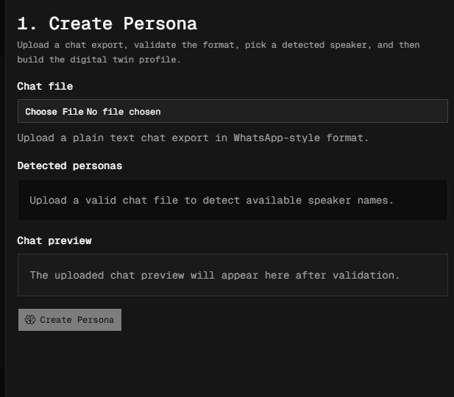  Chat Upload Panel | 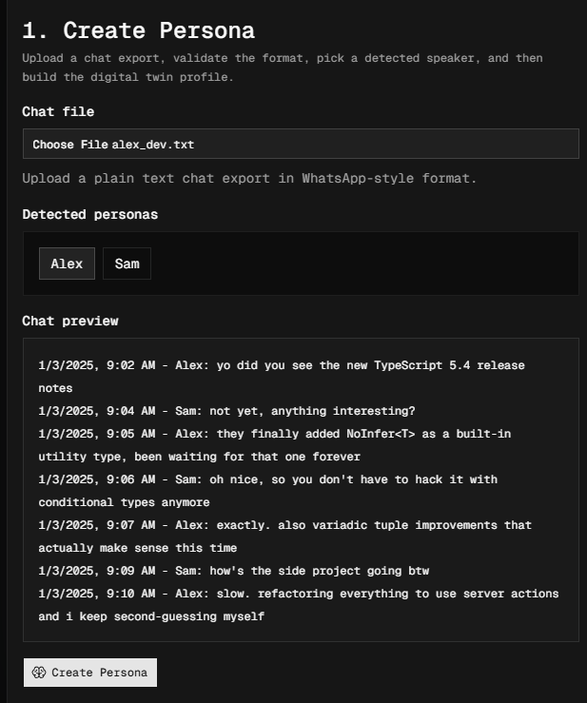  Persona Selector and Chat Preview

14.2 Personality Profile and Summary Statistics

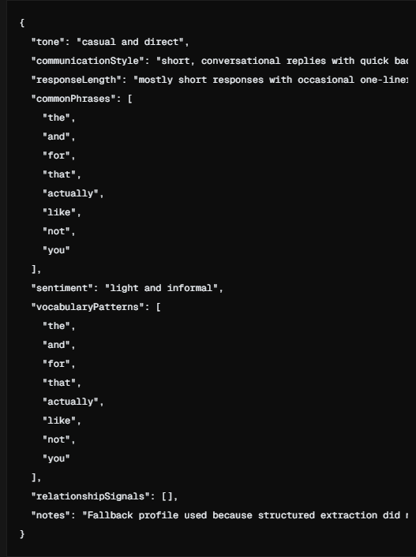  Profile JSON Viewer | 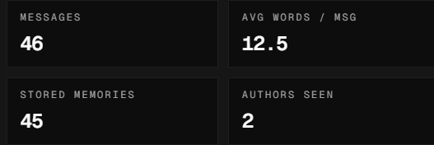  Summary Statistics Panel

14.3 Chat Simulation and Retrieved Context

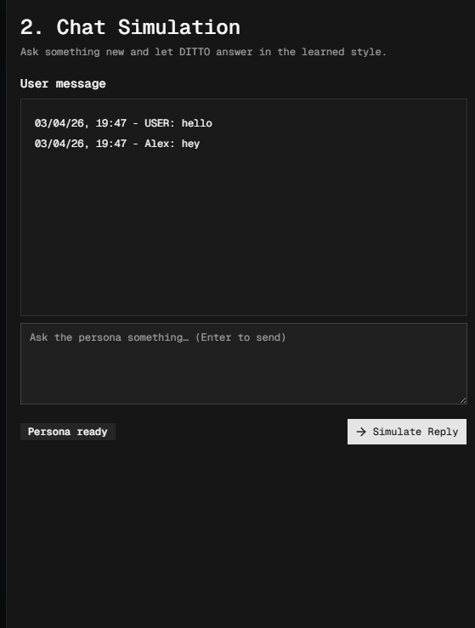  Chat Simulation Panel | 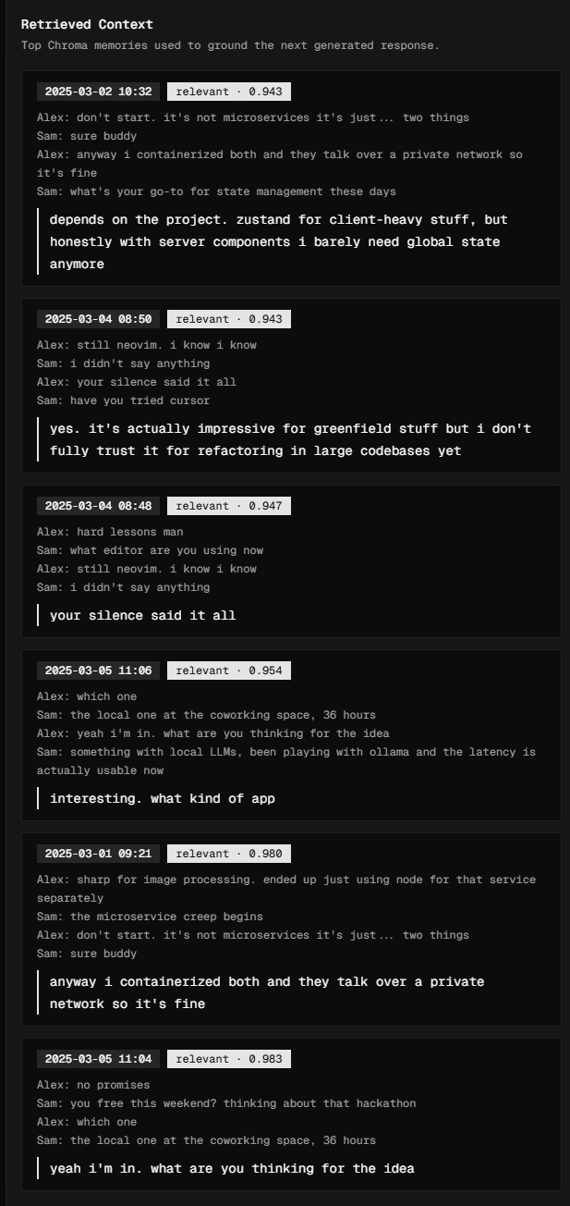  Retrieved Context — Pair Cards

14.4 Full Application Overview

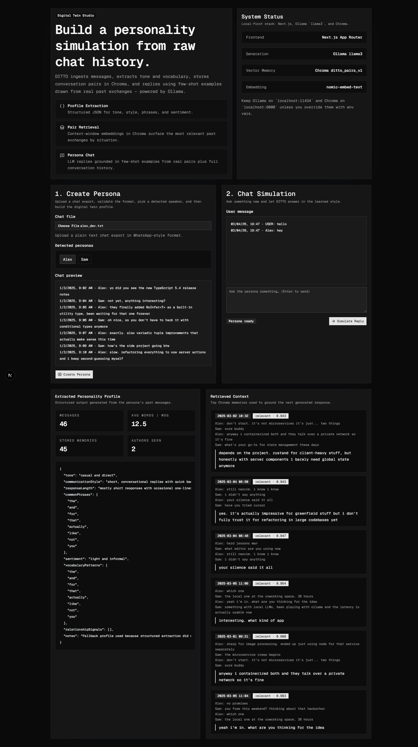
Figure 2 — Full DITTO application: hero card, system status, persona creation, chat simulation, profile, and retrieved context panels

15. Bibliography

Retrieval-Augmented Generation & Vector Search

[1] P. Lewis et al., "Retrieval-Augmented Generation for Knowledge-Intensive NLP Tasks," in Advances in Neural Information Processing Systems (NeurIPS), vol. 33, pp. 9459–9474, 2020. [Online]. Available: https://arxiv.org/abs/2005.11401
[2] J. Johnson, M. Douze, and H. Jégou, "Billion-Scale Similarity Search with GPUs," IEEE Transactions on Big Data, vol. 7, no. 3, pp. 535–547, Jul. 2021. [Online]. Available: https://arxiv.org/abs/1702.08734
[3] T. Trung, "ChromaDB: The AI-Native Open-Source Embedding Database," Chroma, 2023. [Online]. Available: https://www.trychroma.com
[4] N. Reimers and I. Gurevych, "Sentence-BERT: Sentence Embeddings using Siamese BERT-Networks," in Proc. of EMNLP, pp. 3982–3992, 2019. [Online]. Available: https://arxiv.org/abs/1908.10084

Large Language Models

[5] A. Touvron et al., "Llama 2: Open Foundation and Fine-Tuned Chat Models," Meta AI, Jul. 2023. [Online]. Available: https://arxiv.org/abs/2307.09288
[6] A. Touvron et al., "Llama 3: Open Foundation Models," Meta AI, Apr. 2024. [Online]. Available: https://ai.meta.com/research/publications/the-llama-3-herd-of-models/
[7] T. Brown et al., "Language Models are Few-Shot Learners," in Advances in Neural Information Processing Systems (NeurIPS), vol. 33, pp. 1877–1901, 2020. [Online]. Available: https://arxiv.org/abs/2005.14165
[8] J. Wei et al., "Chain-of-Thought Prompting Elicits Reasoning in Large Language Models," in Advances in Neural Information Processing Systems (NeurIPS), vol. 35, 2022. [Online]. Available: https://arxiv.org/abs/2201.11903

Text Embeddings

[9] A. Nussbaum et al., "nomic-embed-text: A Reproducible Long Context Text Embedder," Nomic AI, Feb. 2024. [Online]. Available: https://arxiv.org/abs/2402.01613
[10] T. Mikolov, I. Sutskever, K. Chen, G. Corrado, and J. Dean, "Distributed Representations of Words and Phrases and their Compositionality," in NeurIPS, pp. 3111–3119, 2013. [Online]. Available: https://arxiv.org/abs/1310.4546

Persona Modelling and Digital Twins

[11] J. S. Park et al., "Generative Agents: Interactive Simulacra of Human Behavior," in Proc. of ACM UIST, 2023. [Online]. Available: https://arxiv.org/abs/2304.03442
[12] S. Argyle et al., "Out of One, Many: Using Language Models to Simulate Human Samples," Political Analysis, vol. 31, no. 3, pp. 337–351, 2023. [Online]. Available: https://arxiv.org/abs/2209.06899
[13] X. Wang et al., "RoleLLM: Benchmarking, Eliciting, and Enhancing Role-Playing Abilities of Large Language Models," arXiv preprint arXiv:2310.00746, Oct. 2023. [Online]. Available: https://arxiv.org/abs/2310.00746

Few-Shot and In-Context Learning

[14] S. Min et al., "Rethinking the Role of Demonstrations: What Makes In-Context Learning Work?," in Proc. of EMNLP, pp. 11048–11064, 2022. [Online]. Available: https://arxiv.org/abs/2202.12837
[15] T. Gao et al., "Making Pre-trained Language Models Better Few-shot Learners," in Proc. of ACL, pp. 3816–3830, 2021. [Online]. Available: https://arxiv.org/abs/2012.15723

Local AI and Privacy-Preserving Inference

[16] J. Ansel et al., "Ollama: Local Large Language Model Serving," Ollama, Inc., 2023. [Online]. Available: https://ollama.com
[17] A. Dhar, "Privacy-Preserving NLP: A Survey," arXiv preprint arXiv:2210.03528, Oct. 2022. [Online]. Available: https://arxiv.org/abs/2210.03528
[18] B. McMahan et al., "Communication-Efficient Learning of Deep Networks from Decentralized Data," in Proc. of AISTATS, vol. 54, pp. 1273–1282, 2017. [Online]. Available: https://arxiv.org/abs/1602.05629

Conversational AI and Dialogue Systems

[19] S. Zhang et al., "Personalizing Dialogue Agents: I Have a Persona," in Proc. of ACL, pp. 2204–2213, 2018. [Online]. Available: https://arxiv.org/abs/1801.07243
[20] H. Touvron et al., "Improving Language Understanding by Generative Pre-Training," OpenAI, 2018. [Online]. Available: https://openai.com/research/language-unsupervised
[21] R. Roller et al., "Recipes for Building an Open-Domain Chatbot," in Proc. of EACL, pp. 300–325, 2021. [Online]. Available: https://arxiv.org/abs/2004.13637

Web Technologies and Frameworks

[22] Vercel, "Next.js Documentation," 2024. [Online]. Available: https://nextjs.org/docs
[23] shadcn, "shadcn/ui: Beautifully Designed Components Built with Radix UI and Tailwind CSS," 2024. [Online]. Available: https://ui.shadcn.com
[24] Oven GmbH, "Bun: JavaScript Runtime and Toolkit," 2024. [Online]. Available: https://bun.sh

