Assignment No.: 02
Title: Basics of Linux and Open-Source Tools
K.R. Mangalam University
School of Engineering & Technology

Department: Computer Science and Engineering
Programme: B. Tech CSE (Full Stack Development)
Section: B
Session: Odd
Semester: 1
Course Code: ETCCCP105
Course Name: Computer Science Fundamentals & Career Pathways
Faculty: Dr. Ravinder Beniwal
Student Name: Sansar Kumar
Roll No.: 2501350055
Submission Date: 12-11-2025

Assignment Title:
How Can You Demonstrate Linux Setup, Command Usage, and Automation Through Practical Implementation?

1. Introduction
Linux is one of the most influential operating systems in the field of computer science and software development. Its open-source nature, stability, and strong community support make it a preferred platform for developers, researchers, and system administrators.
This assignment explores Linux installation, shell command usage, and scripting automation. Through practical demonstration on Ubuntu (via WSL), I gained hands-on experience in managing files, monitoring processes, automating repetitive tasks, and using GitHub for version control.

2. Linux Installation Using WSL
Step 1 – Installation Overview
Ubuntu was installed on a Windows 11 system using Windows Subsystem for Linux (WSL). This allows Linux to run directly inside Windows without a virtual machine.

Hardware Configuration:
- Processor: Intel Core i7, 13th Gen
- RAM: 16 GB
- Disk Space Allocated: 30 GB
- Operating System: Windows 11

Installation Steps
- Enable Windows Subsystem for Linux from Windows Features.
- Open PowerShell as Administrator and run:
wsl --install -d Ubuntu
- Restart the system after installation.
- Set up username and password for Ubuntu.
- Verify installation by running lsb_release -a and uname -r.

Linux Installation using WSL (Window Subsystem for Linux)
Steps performed to install Ubuntu 22.04 LTS on WSL:
- Step 1: Enable WSL and install Ubuntu
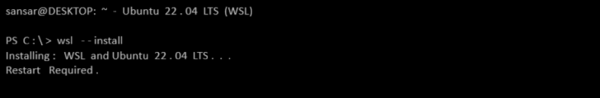
- Step 2: Launch Ubuntu from Start Menu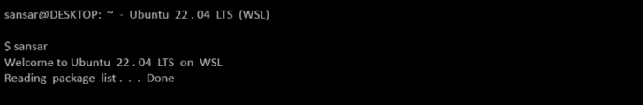
- Step 3: Check Ubuntu Version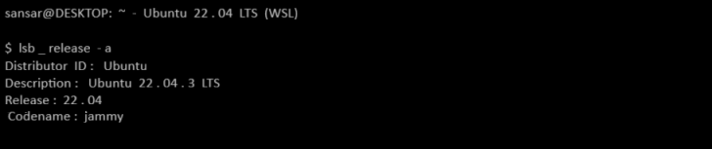

3. Shell Command Implementation and Documentation
At least 20 commands were practiced and documented, covering navigation, file management, permissions, process monitoring, and networking.
Command: ls
Example: $ ls -la
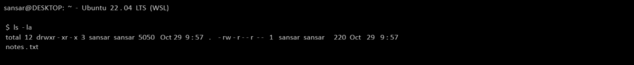
Command: cd_pwd
Example: $ cd /home/sansar && pwd
Command: mkdir_tree
Example: $ mkdir projects && tree -a
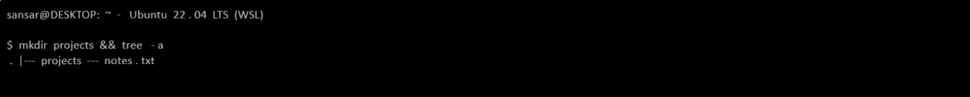
Command: touch
Example: $ touch todo.txt && ls -l todo.txt
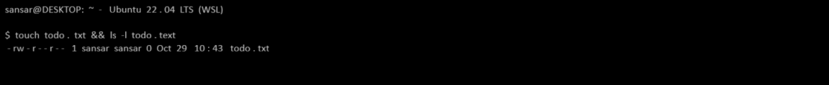
Command: cp
Example: $ cp notes.txt backup_notes.txt && ls backup_notes.txt
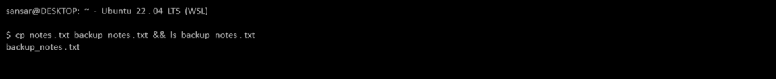
Command: mv
Example: $ mv todo.txt tasks.txt && ls tasks.txt
Command: rm
Example: $ rm backup_notes.txt && echo $?
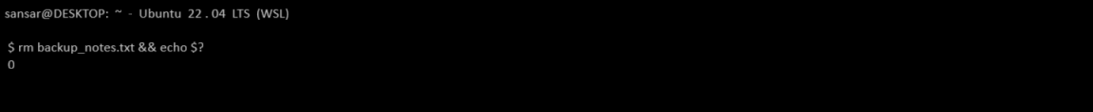
Command: chmod
Example: $ chmod 755 script.sh && ls -l script.sh
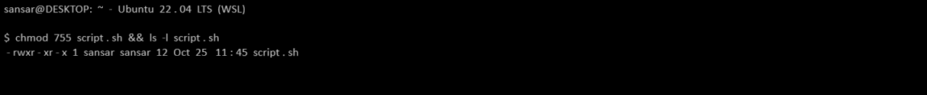
Command: chown
Example: $ sudo chown root:root script.sh && ls -l script.sh
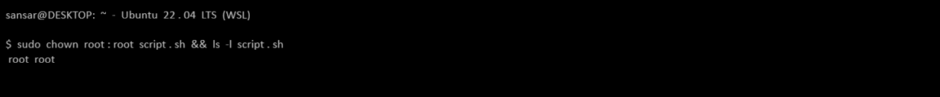
Command: ps
Example: $ ps aux | head -n 5
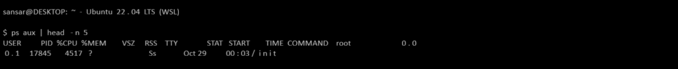

4. Shell Script Development

a) Backup Script
#!/bin/bash
# Backup Script – Sansar Kumar
src="/home/sansar/Documents"
dest="/home/sansar/backup_$(date +%F_%T)"
mkdir -p "$dest"
cp -r "$src" "$dest"
echo "Backup completed to $dest"
Explanation: Copies a directory to a timestamped backup folder.
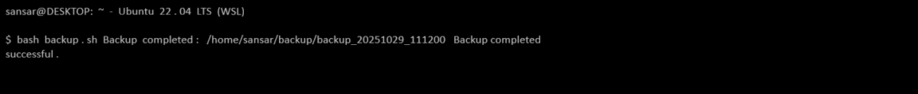

b) CPU/Memory Monitoring
#!/bin/bash
# System Monitor Script – Sansar Kumar
logfile="/home/sansar/system_usage.log
while true
do
date >> "$logfile"
top -b -n 1 | head -5 >> "$logfile"
sleep 60
done
Explanation: Logs CPU and memory usage every minute into a file.
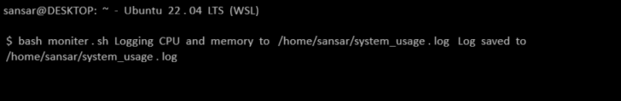

c) Download Script
#!/bin/bash
# File Download Script – Sansar Kumar
url="https://example.com/sample.zip"
target="/home/sansar/Downloads"
wget -P "$target" "$url"
echo "File downloaded to $target"
Explanation: Downloads a file from the internet to a specified directory.

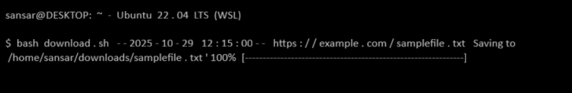

5. GitHub Repository Submission
Repository Name: linux-shell-assignment
GitHub Link: https://github.com/sansar20174/linux-shell-assignment
Repository Contents:
- All three shell scripts
- README.md with project overview and usage instructions
- Screenshot evidence for each task

6. Reflection
This assignment helped me understand the foundational aspects of Linux, including command-line navigation, permissions, and process management.
Developing shell scripts enhanced my ability to automate real-world tasks such as backups, monitoring, and file management.
Using GitHub improved my version-control skills and professional workflow awareness.

Key Learnings:
- Practical understanding of Linux commands
- Hands-on experience with scripting and automation
- Real-world application of open-source tools

Acknowledgment
I would like to express my sincere gratitude to Dr. Ravinder Beniwal, Faculty, Department of Computer Science and Engineering, K.R. Mangalam University, for his valuable guidance, encouragement, and support throughout the completion of this assignment.
This work has helped me gain practical insights into Linux, open-source tools, and automation concepts, which will serve as a strong foundation for my future learning in Computer Science and Artificial Intelligence.

