# Group access plugin for Atlassian Confluence

The plugin can be found under the „Confluence Admin“ view.

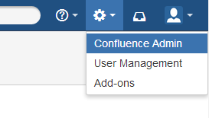

The link to the plugin appeares on the left sided menu under „GROUP ACCESS PLUGIN“

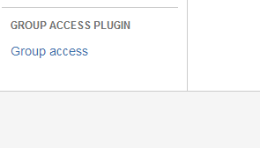

The plugins interface looks like this

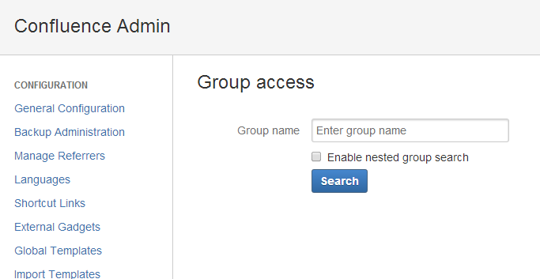

Input of the group name is done with an autocomplete field

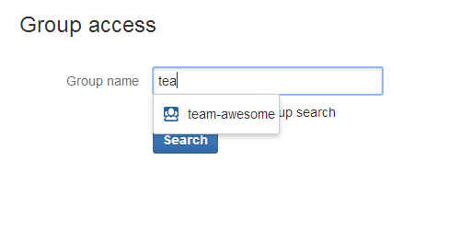

Performing a search displays the list of spaces this group has access/permissions to

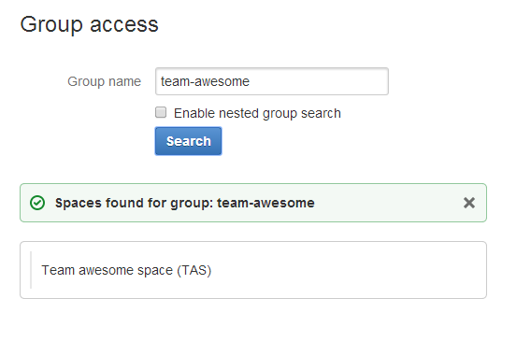

A search with the „Enable nested group search“ checked, performes a search that also cosiders the groups parent groups and their access/permission on a space

