STUDENT PERFORMANCE PREDICTION SYSTEM
Machine Learning Capstone Project
End-to-End Academic Analytics, Prediction & Recommendation Platform

1. Project Overview
The Student Performance Prediction System is a machine learning application designed to analyze student academic data, predict performance outcomes, identify factors affecting performance, and generate improvement insights. The implementation follows the supplied capstone brief and keeps the scope focused on a clean, functional prediction system.

2. Project Objectives
- Analyze student academic data
- Predict High, Average, and Low performance levels
- Identify key factors affecting performance
- Generate performance insights and recommendations
- Visualize student analytics through a dashboard

3. Industry Relevance
The solution is aligned with educational technology use cases such as EdTech platforms, learning management systems, academic analytics platforms, and online learning applications. It demonstrates how machine learning can support educational decision-making without attempting a large-scale platform.

4. Dataset
A self-created academic dataset of 1,003 raw records was used. Three duplicate rows and a small number of missing values were deliberately included so that the preprocessing pipeline can demonstrate duplicate removal and missing-value handling. The cleaned dataset contains 1,000 records.
Feature | Type | Purpose
Attendance | Numeric | Regularity of attendance
Study hours | Numeric | Average daily study time
Internal marks | Numeric | Internal academic assessment
Participation | Numeric | Class participation score
Previous score | Numeric | Prior academic performance
Assignment completion | Numeric | Completion percentage
Weak subjects | Numeric | Number of subjects needing attention
Gender / Study mode / Subject | Categorical | Student context
Final score | Target | Predicted academic score
Performance level | Target | High / Average / Low

5. Module 1 — Data Collection & Preprocessing
- Imported the student dataset using Pandas
- Removed duplicate records
- Handled missing numeric values with median imputation
- Handled missing categorical values with most-frequent imputation
- Encoded categorical variables using one-hot encoding
- Normalized numeric features using StandardScaler

6. Module 2 — Exploratory Data Analysis
The analysis examines attendance, study hours, internal marks, participation, previous academic performance and assignment completion. Charts were created for performance distribution, score differences across performance levels, and feature relationships with final score.
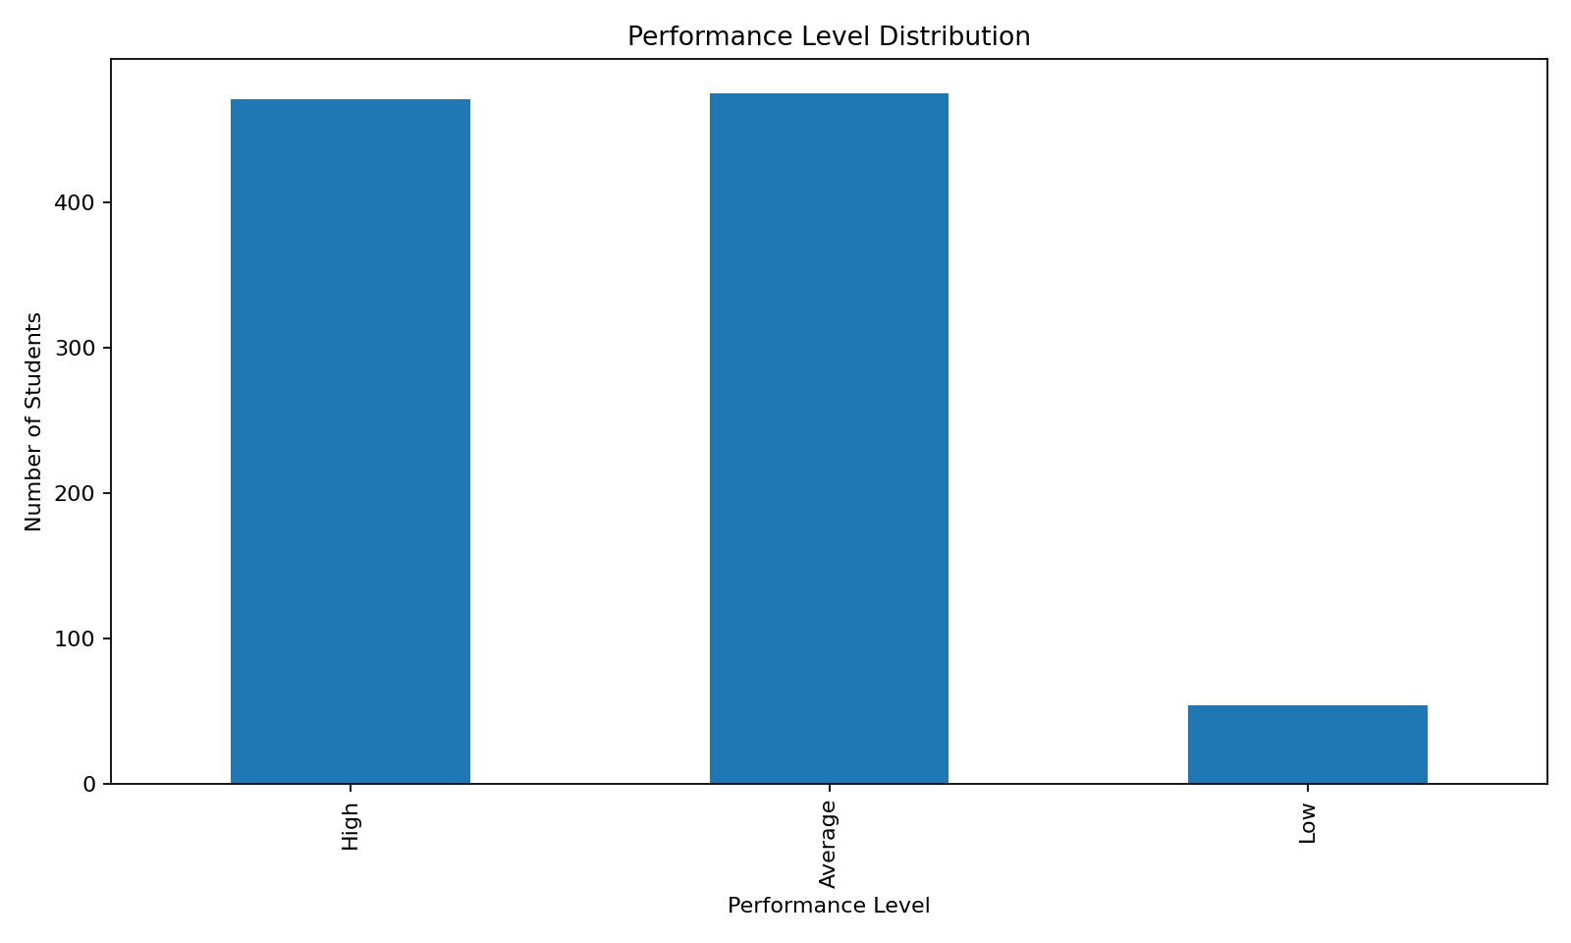
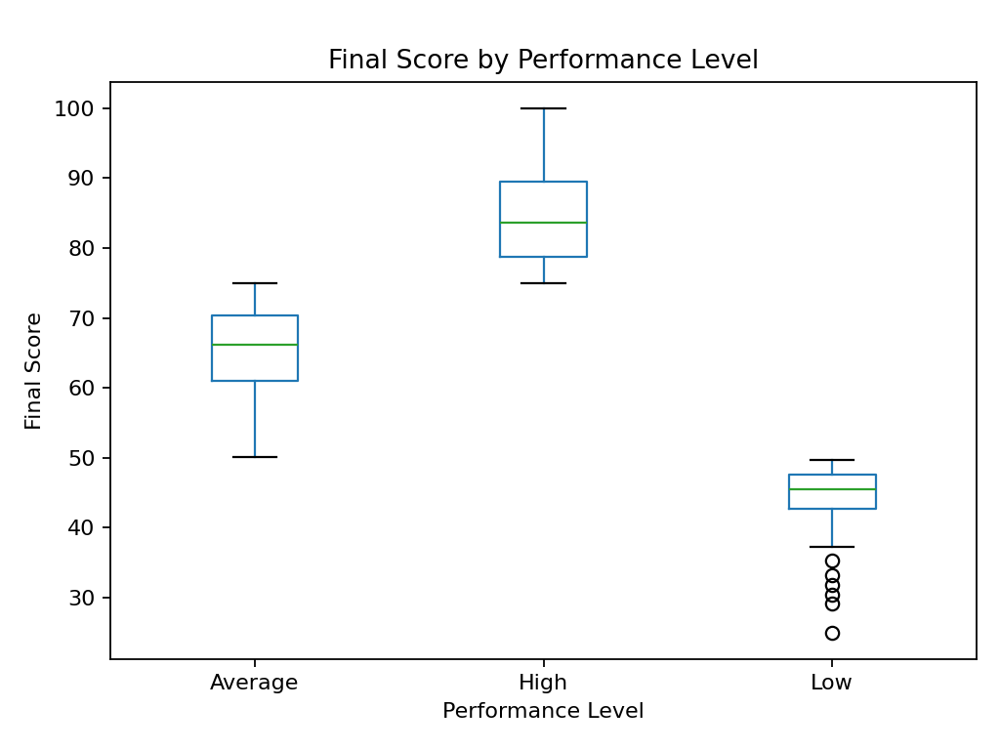
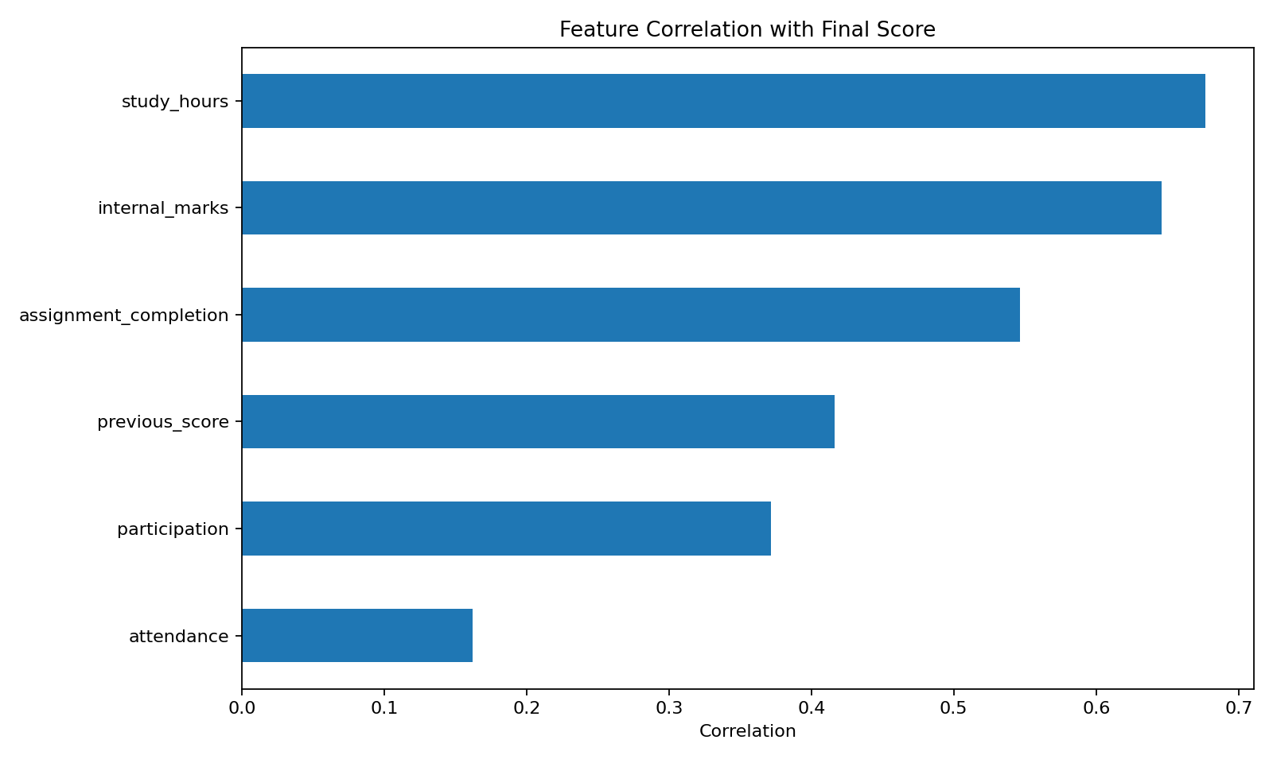

7. Module 3 — Performance Prediction Model
Two prediction tasks are implemented. First, a Random Forest classifier predicts High, Average, or Low performance. A Decision Tree classifier is included as a comparison model. Second, Linear Regression predicts a numerical final score; a Random Forest regressor is included as an additional regression comparison.
Model | Task | Evaluation
Random Forest Classifier | Performance level | Accuracy
Decision Tree Classifier | Performance level | Accuracy
Linear Regression | Final score | MAE, R²
Random Forest Regressor | Final score | MAE, R²

8. Model Results
Random Forest classification accuracy: 0.760. Decision Tree classification accuracy: 0.675. Linear Regression MAE: 4.46, R²: 0.815. Random Forest regression MAE: 5.05, R²: 0.767. These results are based on a fixed random 80/20 train-test split.

9. Module 4 — Performance Dashboard
The Streamlit dashboard accepts student inputs and displays predicted score, predicted performance level, attendance, student profile, recommendations, performance distribution, feature relationships and group-level student comparisons.
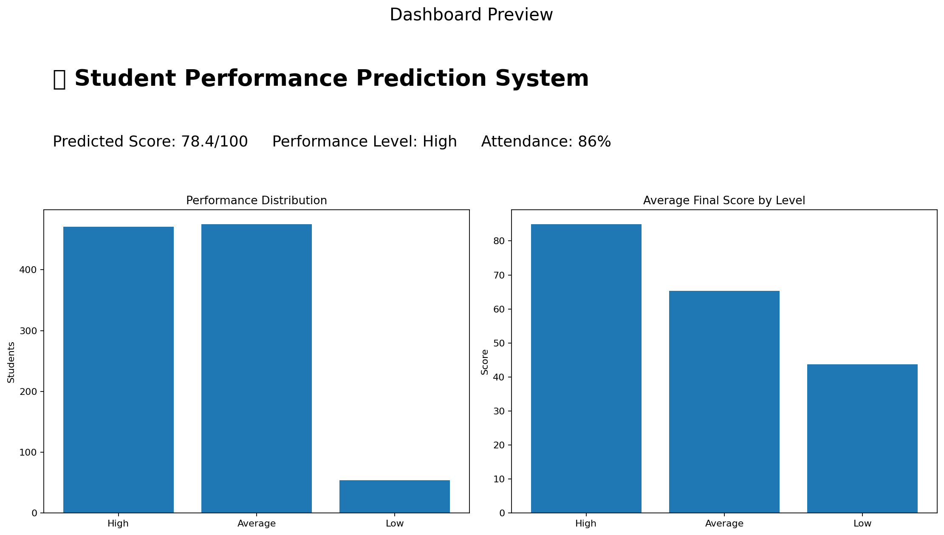

10. Module 5 — Recommendation System
- Increase study hours when daily study time is low
- Improve attendance when attendance falls below the target threshold
- Focus on internal assessments when internal marks are weak
- Attend practice sessions and participate more actively
- Complete assignments on time
- Focus on weak subjects when multiple subjects need attention
- Maintain the current routine when no major risk condition is detected

11. Project Workflow
- Dataset Collection
- Data Cleaning
- Exploratory Data Analysis
- Model Development
- Prediction Generation
- Dashboard Visualization
- Recommendation Generation

12. Technology Stack
Programming: Python. Libraries: Pandas, NumPy, Scikit-learn, Matplotlib, Seaborn. Dashboard: Streamlit. Model persistence: Joblib. The project can be deployed using Streamlit Cloud or Render.

13. Scope Limitations
The project intentionally avoids deep learning models, real-time student monitoring, large-scale educational platforms, and complex AI architectures, matching the supplied brief.

14. Testing
A basic automated test validates the recommendation engine for a low-performing student profile. The dashboard is structured to load trained models from the models directory and can be run locally with Streamlit.

15. 25-Day Project Plan
Days | Tasks
Day 1–3 | Requirement analysis and dataset collection
Day 4–7 | Data cleaning and preprocessing
Day 8–12 | Exploratory data analysis
Day 13–17 | Machine learning model development
Day 18–21 | Dashboard development
Day 22–23 | Recommendation system
Day 24 | Testing and bug fixing
Day 25 | Deployment and final presentation

16. Evaluation Criteria Alignment
Criteria | Weightage
Functionality | 30%
Data Analysis | 20%
Machine Learning Model | 20%
Dashboard/UI | 15%
Deployment | 10%
Documentation | 5%

17. Deliverables
- Source Code — included in project package
- Project Report — this document
- PPT Presentation — included
- GitHub Repository — folder is GitHub-ready
- Dashboard Screenshots — included
- Deployment Link — not fabricated; requires hosting account
- Demo Video — not fabricated; can be recorded from the running dashboard

18. Final Outcome
The final system is an end-to-end Student Performance Prediction platform capable of analyzing academic data, predicting student outcomes, and generating performance improvement insights. It implements the requested modules while remaining within the capstone scope.

