**Opening Screen**: 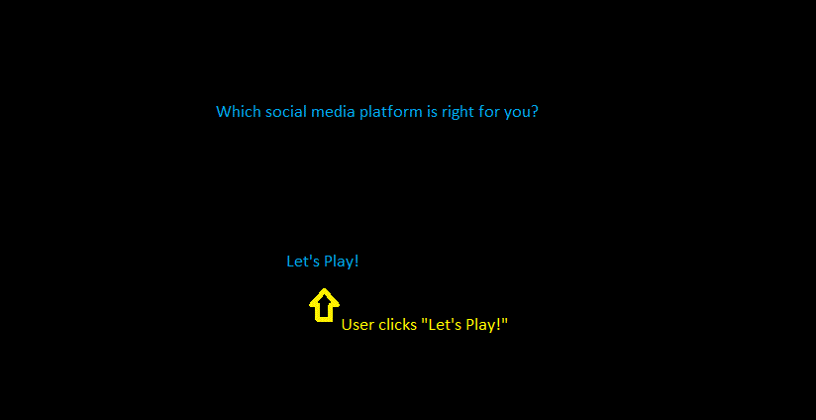

**Next screen**: User is asked one question at a time with Yes/No answers.

**Questions**:

Do you want to know the latest celebrity news?

* +1 Twitter
* +1 Instagram
* 0 Facebook
* 0 Tumblr
* 0 Snapchat
* 0 Youtube
* 0 Pinterest

Do you want to update people about big events in your life?

* 0 Twitter
* +1 Instagram
* +1 Facebook
* 0 Tumblr
* +1 Snapchat
* 0 Youtube
* 0 Pinterest

Do you want to update people about your day?

* +1 Twitter
* +1 Instagram
* +1 Facebook
* 0 Tumblr
* +1 Snapchat
* 0 Youtube
* 0 Pinterest

Do you want to learn things like new recipes, crafts, or DIY (do it yourself) projects?

* 0 Twitter
* 0 Instagram
* 0 Facebook
* 0 Tumblr
* 0 Snapchat
* +1 Youtube
* +1 Pinterest

Do you want to play games?

* 0 Twitter
* 0 Instagram
* +1 Facebook
* 0 Tumblr
* 0 Snapchat
* 0 Youtube
* 0 Pinterest

Do you want to text message people?

* 0 Twitter
* +1 Instagram
* +1 Facebook
* +1 Tumblr
* +1 Snapchat
* 0 Youtube
* 0 Pinterest

Do you want to picture message people?

* 0 Twitter
* +1 Instagram
* 0 Facebook
* 0 Tumblr
* +1 Snapchat
* 0 Youtube
* 0 Pinterest

Do you want to video message people?

* 0 Twitter
* 0 Instagram
* +1 Facebook
* 0 Tumblr
* +1 Snapchat
* +1 Youtube
* 0 Pinterest

Do you want to blog (blogging is sharing what you think by writing, taking pictures, or sharing videos)?

* 0 Twitter
* +1 Instagram
* 0 Facebook
* +1 Tumblr
* 0 Snapchat
* +1 Youtube
* 0 Pinterest

**Running Tally**: In the background the program needs to keep a running tally of all platforms. The scores with each question is how that particular question will affect the scoring. If a user selects no, every social media platform gets a 0.

For example, after question two the running tally should like this, because it’s a combination of question 1+2s scoring:

1 Twitter

2 Instagram

1 Facebook

0 Tumblr

1 Snapchat

0 Youtube

0 Pinterest

**The End**: 