PROJECT 2: WHERE IS MY DRONE?
Reconstructing a 3-D Drone Trajectory from IMU and Barometer Data
Course: System Modelling, Analysis and Stories-1 (SMAS-1) | Indian Institute of Technology Jammu
1. Problem and Objective
In many real-world flight environments—such as indoor warehouses, underground tunnels, or dense urban canyons—a drone cannot rely on external positioning systems like GPS, Ultra-Wideband (UWB) beacons, or optical motion-capture cameras. In this project, our challenge is to figure out where a quadcopter has flown and where it finally landed using only its onboard Inertial Measurement Unit (IMU) and a barometric altitude sensor.
We are provided with a 25.0-second flight log sampled at regular intervals of Δt = 0.1 s (a 10 Hz sampling rate, giving 251 total rows of data). At each time step, the dataset records three channels of linear acceleration from a 3-axis accelerometer (acc_x_mps2, acc_y_mps2, acc_z_mps2), three channels of angular velocity from a 3-axis gyroscope (gyro_x_rads, gyro_y_rads, gyro_z_rads), and an independent vertical height measurement from a barometer (baro_alt_m).
Our main objective is to build a step-by-step dead-reckoning navigation pipeline from scratch. First, we use the initial stationary period (0.0 s to 4.9 s) to calibrate the sensors and remove their constant static biases. Next, we integrate the yaw angular rate to track which direction the drone is pointing at every moment. Using a 2-D rotation matrix, we transform the drone's local body-frame accelerations into fixed ground coordinates (the World frame), subtract Earth's gravity from the vertical axis, and numerically integrate twice to reconstruct the drone's 3-D velocity and position over time. Finally, we compare our IMU-derived altitude against the barometer readings to see how well our reconstruction worked and to understand how tiny sensor errors accumulate into drift.
2. Coordinate Frames, Assumptions, and Sensor Model
To track the drone properly, we have to clearly separate the ground's fixed coordinate system from the moving coordinate system attached to the drone itself.
Question 1 (World and Body Coordinate Frames): The World frame is our fixed reference frame anchored to the ground at the takeoff spot. In this frame, +X points East, +Y points North, and +Z points straight Up away from the ground. The Body frame is attached directly to the drone's chassis and moves and rotates along with it. In the Body frame, +x points straight forward (along the drone's nose), +y points to the left side of the drone, and +z points straight up through the top of the frame.
Question 2 (Physical Meaning of Each IMU Measurement): An IMU contains two different types of sensors that measure motion relative to the drone's Body frame. The 3-axis accelerometer measures proper acceleration (specific force) along the drone's x, y, and z axes in units of m/s². Rather than measuring pure coordinate acceleration directly, it measures the physical push acting on the sensor's internal proof mass—which includes both the drone's thrust and the upward normal reaction force resisting Earth's gravity (+9.81 m/s² when sitting flat on the ground). For example, when the drone takes off vertically between 5.0 s and 6.0 s, the motors push harder than gravity so acc_z jumps up to about 11.86 m/s², and between 6.0 s and 7.0 s the motors ease off below gravity (around 7.86 m/s²) to slow the upward climb to a stop. Similarly, the 3-axis gyroscope measures the angular rate (rotational velocity) in rad/s—telling us how fast the drone is tilting or spinning around its body x-axis (roll rate), body y-axis (pitch rate), and body z-axis (yaw rate).
To simplify the 3-D math, our model makes four practical assumptions based on the known flight conditions:
1. Stationary Calibration Window: From t = 0.0 s to t = 4.9 s (the first 50 samples), the drone is sitting completely still and level on the ground.
2. Known Initial Conditions: At t = 0.0 s, the drone starts at the origin with position p₀ = [0, 0, 0]ᵀ m, velocity v₀ = [0, 0, 0]ᵀ m/s, and yaw heading ψ₀ = 0 rad (facing due East).
3. Uniform Gravity: Earth's gravitational acceleration is constant at g = 9.81 m/s² pointing straight down along the World -Z axis.
4. Small-Roll and Small-Pitch Assumption: Roll and pitch tilt angles are small enough throughout the flight that we can neglect them and use only the yaw angle ψ(t) for the body-to-world rotation.
Question 9 (How Well the Small-Roll/Small-Pitch Assumption Held): The small-roll/small-pitch assumption held up very well across the entire 25-second mission. When we inspect the raw gyroscope channels in Plot P2, the roll rate (gyro_x_rads) stays within a tiny band of -0.0026 to +0.0066 rad/s (with a mean of just 0.0018 rad/s), and the pitch rate (gyro_y_rads) stays within -0.0067 to +0.0023 rad/s (mean of -0.0012 rad/s). These values are practically zero and just represent normal background sensor noise. By contrast, when the drone actually rotates its heading between 13.0 s and 14.9 s, gyro_z_rads jumps sharply to ~0.79 rad/s—more than 100 times larger than the activity on gyro_x or gyro_y. Because the drone never banked or pitched aggressively, treating the rotation as a pure 2-D yaw turn around the vertical axis is a very safe and accurate simplification.
3. Calibration and Least-Squares Bias Estimation
Before we can integrate any sensor signals, we first inspect the raw data (Plots P1 and P2) and remove the constant sensor offsets (biases) using the stationary calibration window from t = 0.0 s to t = 4.9 s.
Question 3 (Why Sensor-Bias Estimation is an Overdetermined Least-Squares Problem): During the stationary window from 0.0 s to 4.9 s, we have N = 50 separate time samples (t = 0.0, 0.1, ..., 4.9 s) where we know the drone's true motion is zero. For each sensor channel, we are trying to find just 1 unknown constant parameter (the static bias b), which gives us a linear system of 50 equations of the form y_i = b + ε_i (where ε_i is random measurement noise) for only 1 unknown. Having 50 equations for 1 unknown makes the system heavily overdetermined. Because random noise fluctuates slightly from sample to sample, no single constant b can satisfy all 50 equations with zero residual. By minimizing the sum of squared residuals Σ(y_i - b)², calculus gives the ordinary least-squares (best-fit) solution as the sample mean (average) of the 50 stationary readings. Averaging all 50 points cancels out the random high-frequency noise and gives us a clean estimate of the constant offset.
Question 4 (Six Estimated Sensor Biases with Units): For the x-accelerometer, y-accelerometer, and all three gyroscopes, the true stationary reading should be 0, so the bias is simply the mean of the first 50 readings. For the z-accelerometer, a stationary level sensor should read +9.81 m/s² due to gravity, so we subtract 9.81 m/s² from its stationary mean (9.864203 - 9.81 = 0.054203 m/s²). Table 1 lists the six estimated sensor biases.
Sensor Channel | Expected True Value (0–4.9 s) | Raw Stationary Mean | Estimated Bias | Units
acc_x_mps2 | 0.000000 | 0.035021 | +0.035021 | m/s²
acc_y_mps2 | 0.000000 | -0.031018 | -0.031018 | m/s²
acc_z_mps2 | +9.810000 | 9.864203 | +0.054203 | m/s²
gyro_x_rads | 0.000000 | 0.001807 | +0.001807 | rad/s
gyro_y_rads | 0.000000 | -0.001184 | -0.001184 | rad/s
gyro_z_rads | 0.000000 | 0.003062 | +0.003062 | rad/s
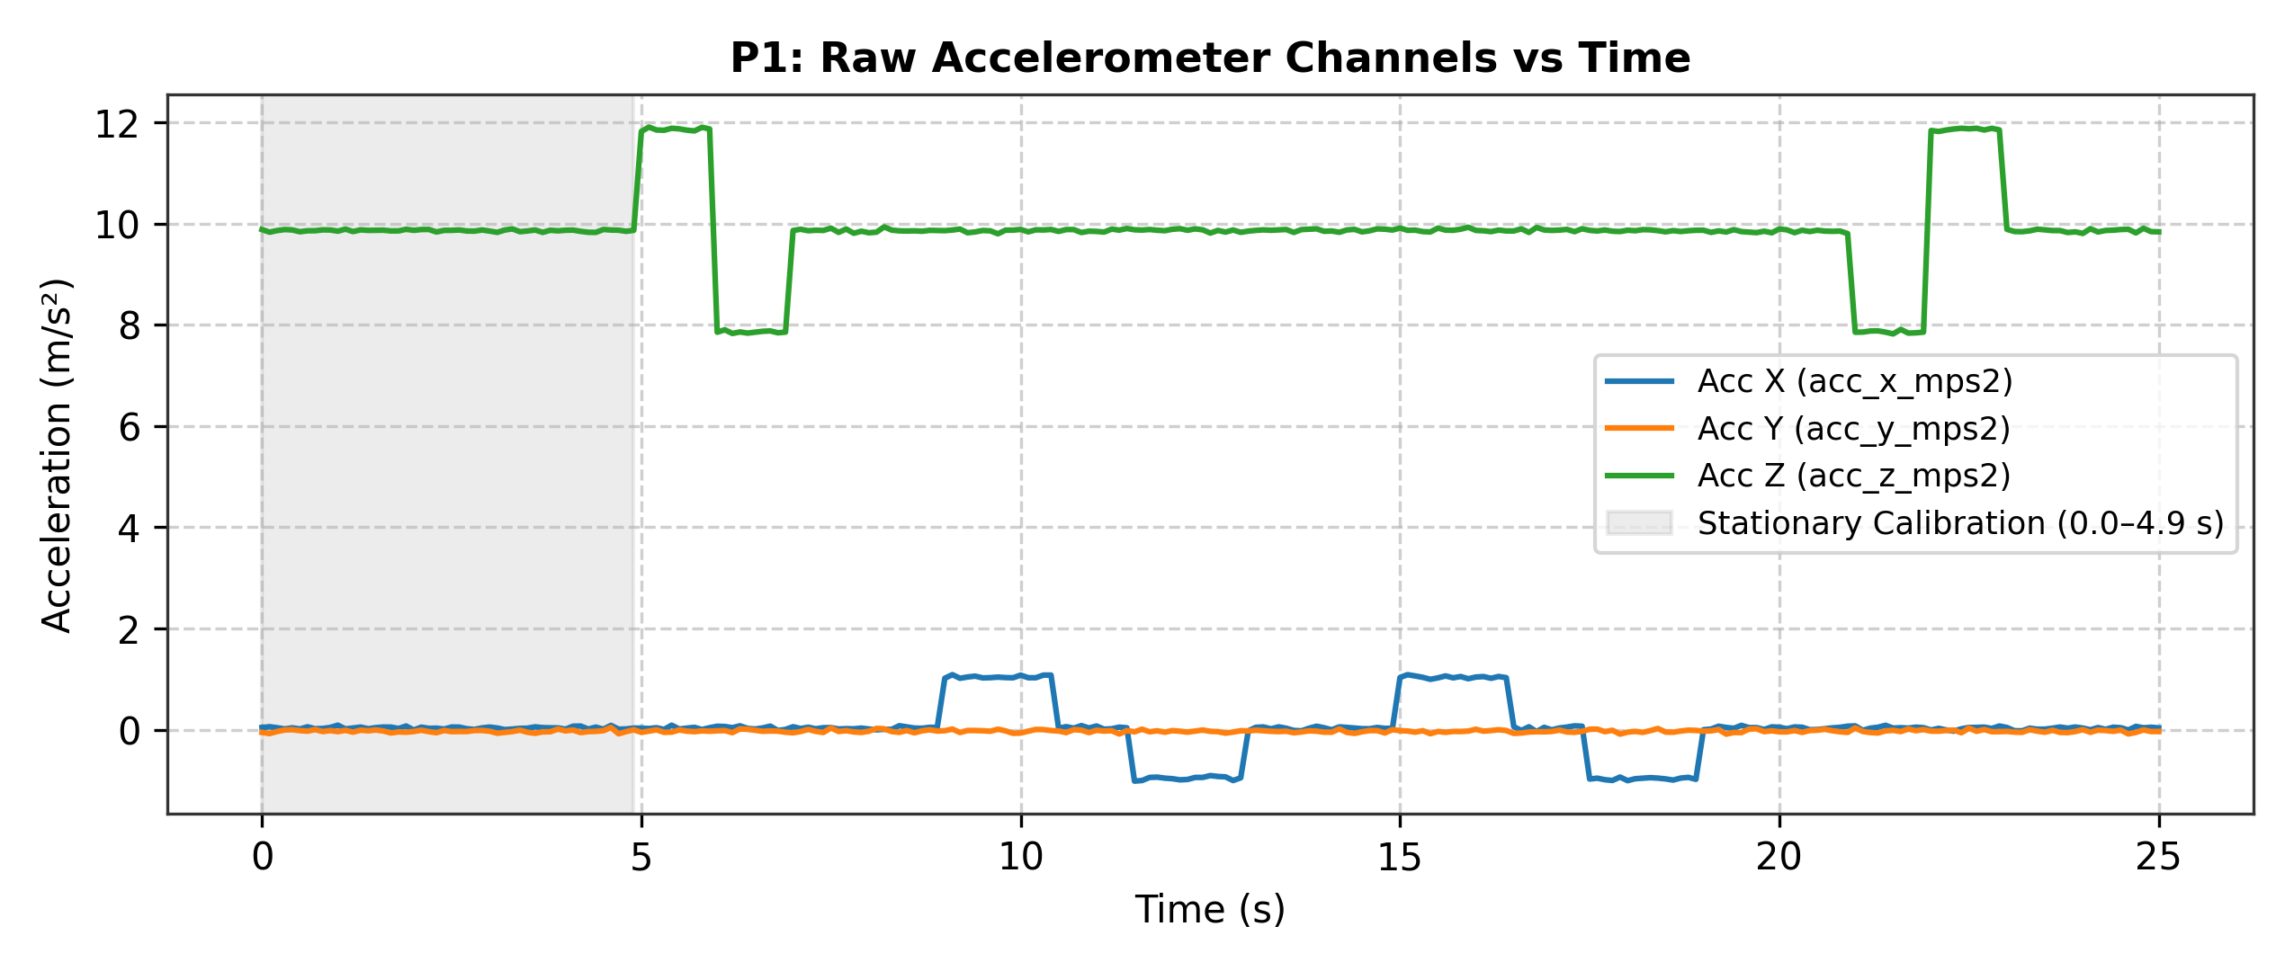
Figure 1 (Plot P1): Raw accelerometer channels versus time, showing the 0.0–4.9 s calibration window.
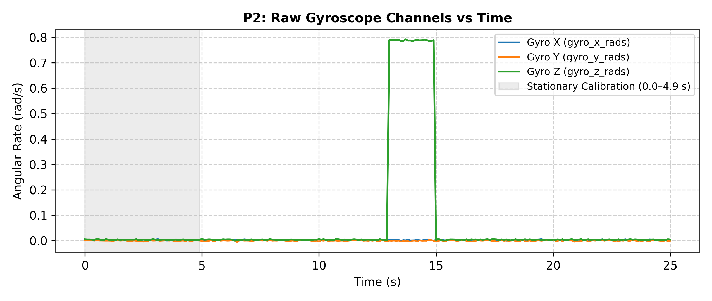
Figure 2 (Plot P2): Raw gyroscope channels versus time, showing near-zero roll/pitch and the yaw turn at 13.0–14.9 s.
4. Yaw and Body-to-World Transformation
After subtracting the static bias (+0.003062 rad/s) from the raw gyro_z_rads channel, we integrate the corrected yaw angular rate ω_z(t) over time using the trapezoidal rule (scipy.integrate.cumulative_trapezoid) starting from ψ(0) = 0 rad:
ψ(t) = ∫₀ᵗ ω_z,corrected(τ) dτ
As shown in Plot P3, the drone's heading stays right at 0 rad (facing due East) from t = 0.0 s until t = 13.0 s. Between t = 13.0 s and t = 14.9 s, the drone spins counter-clockwise at roughly 0.786 rad/s for 2.0 seconds, bringing its cumulative yaw angle to ψ = 1.5732 rad (about 90.14°, or facing nearly due North), where it stays for the rest of the flight.
Question 5 (Rotation Matrix Used in Code and What It Transforms): Because the onboard accelerometers only measure forces along the drone's moving nose (+x) and left side (+y), we have to rotate those measurements into the fixed World frame (+X East, +Y North, +Z Up) before we can track where the drone is moving over the ground. In our code, we use the standard 3×3 rotation matrix around the Z-axis, R_z(ψ):
R_z(ψ) = [ cos(ψ) -sin(ψ) 0 ]
[ sin(ψ) cos(ψ) 0 ]
[ 0 0 1 ]
Multiplying R_z(ψ) by the 3×1 bias-corrected body acceleration vector a_body = [a_x,corr, a_y,corr, a_z,corr]ᵀ transforms the drone's local body-frame accelerations into fixed global World-frame coordinates: a_world_raw = R_z(ψ) · a_body. This explains why, between 15.0 s and 19.0 s, a forward pulse on the drone's nose accelerometer (acc_x_mps2) gets properly mapped into northward World acceleration (a_Y): since ψ ≈ 90°, cos(90°) ≈ 0 and sin(90°) ≈ 1, so body +x maps directly onto World +Y (North).
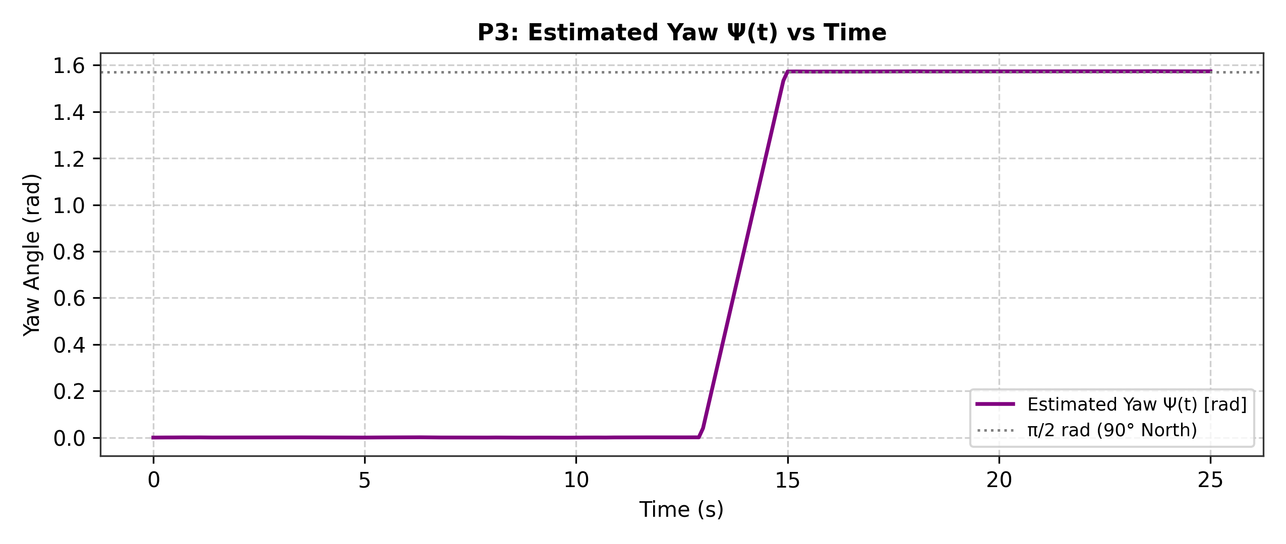
Figure 3 (Plot P3): Estimated yaw angle Ψ(t) versus time, showing the 90° counter-clockwise turn from East to North.
5. Acceleration → Velocity → Position Reconstruction
Once we rotate the bias-corrected acceleration vector into the World frame, we have to remove Earth's gravity from the vertical channel before integrating:
a_X(t) = a_world,X(t), a_Y(t) = a_world,Y(t), a_Z(t) = a_world,Z(t) - 9.81
Question 6 (Why Gravity Must Be Removed After Transforming to the World Frame): An accelerometer sitting still on the ground or hovering at a constant altitude continuously reads about +9.81 m/s² along the vertical axis because it senses the upward normal reaction force (or rotor thrust) supporting the drone against gravity. If we forgot to subtract 9.81 m/s² after transforming to the World frame, our numerical integration math would assume the drone is accelerating straight upward like a rocket at an extra 9.81 m/s² for the entire 25-second mission. Over 25 seconds, that unremoved gravity offset would create a fake upward velocity of v_Z = 9.81 × 25 = 245.25 m/s and a massive fake altitude of z = ½(9.81)(25)² ≈ 3,065.6 m, completely swamping the real 2-meter flight!
Why do we subtract gravity after rotating to the World frame rather than before? In general 3-D flight, gravity always acts straight down along the World Z-axis—not necessarily along the drone's tilted body z-axis. Transforming to the World frame first ensures that the gravity vector is aligned with the global vertical axis when we subtract [0, 0, 9.81]ᵀ m/s².
With pure translational World accelerations a_X(t), a_Y(t), and a_Z(t) in hand (Plot P4), we integrate once with respect to time using cumulative_trapezoid (with initial velocity v₀ = [0, 0, 0]ᵀ m/s) to get World velocity v_X(t), v_Y(t), and v_Z(t) (Plot P5), and then integrate velocity a second time (with initial position p₀ = [0, 0, 0]ᵀ m) to reconstruct the 3-D position x(t), y(t), and z(t) (Plot P6).
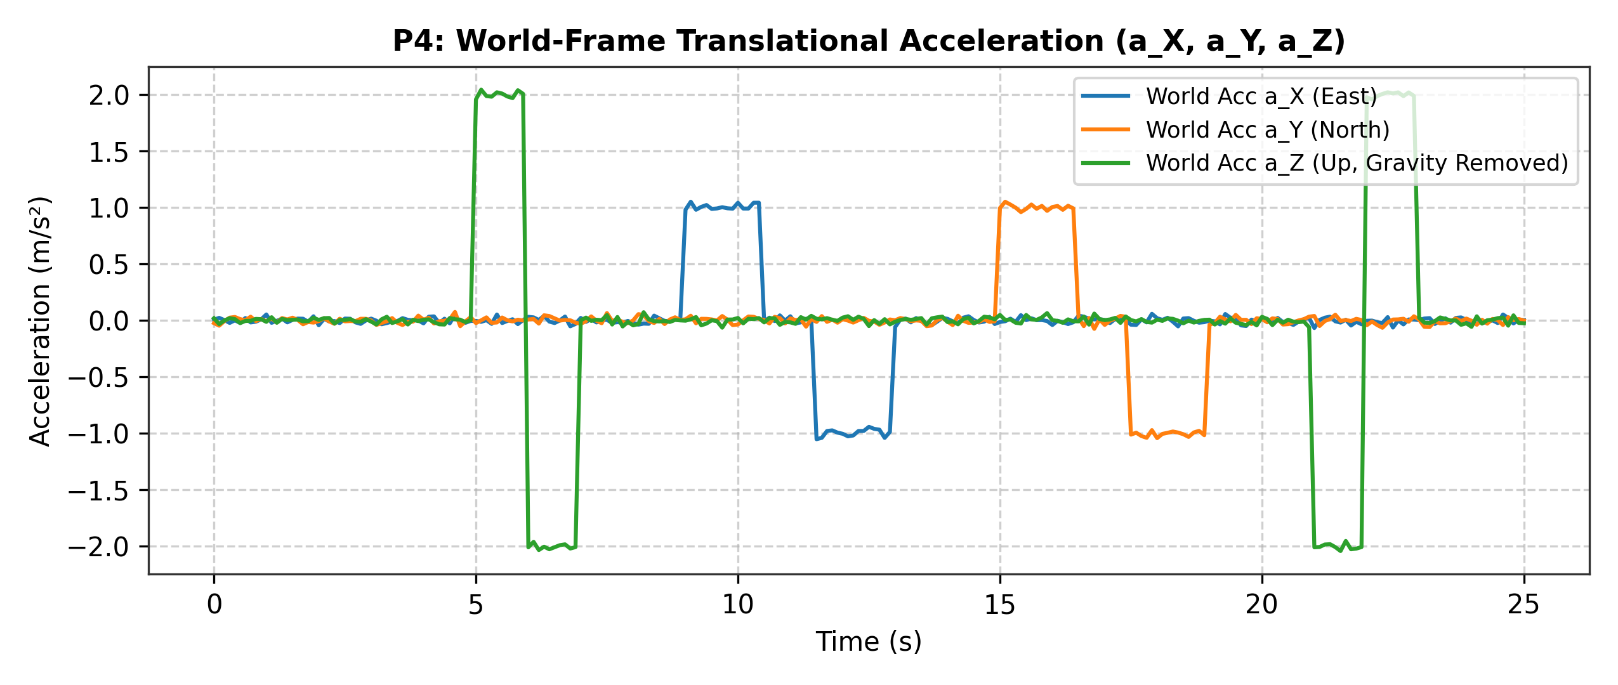
Figure 4 (Plot P4): World-frame translational acceleration (a_X, a_Y, a_Z) after gravity removal.
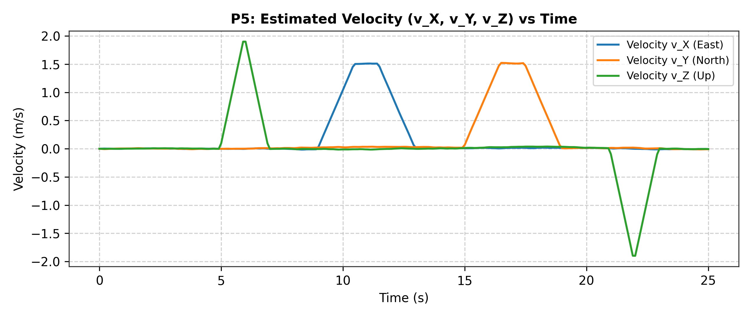
Figure 5 (Plot P5): Estimated World-frame velocity components (v_X, v_Y, v_Z) versus time.
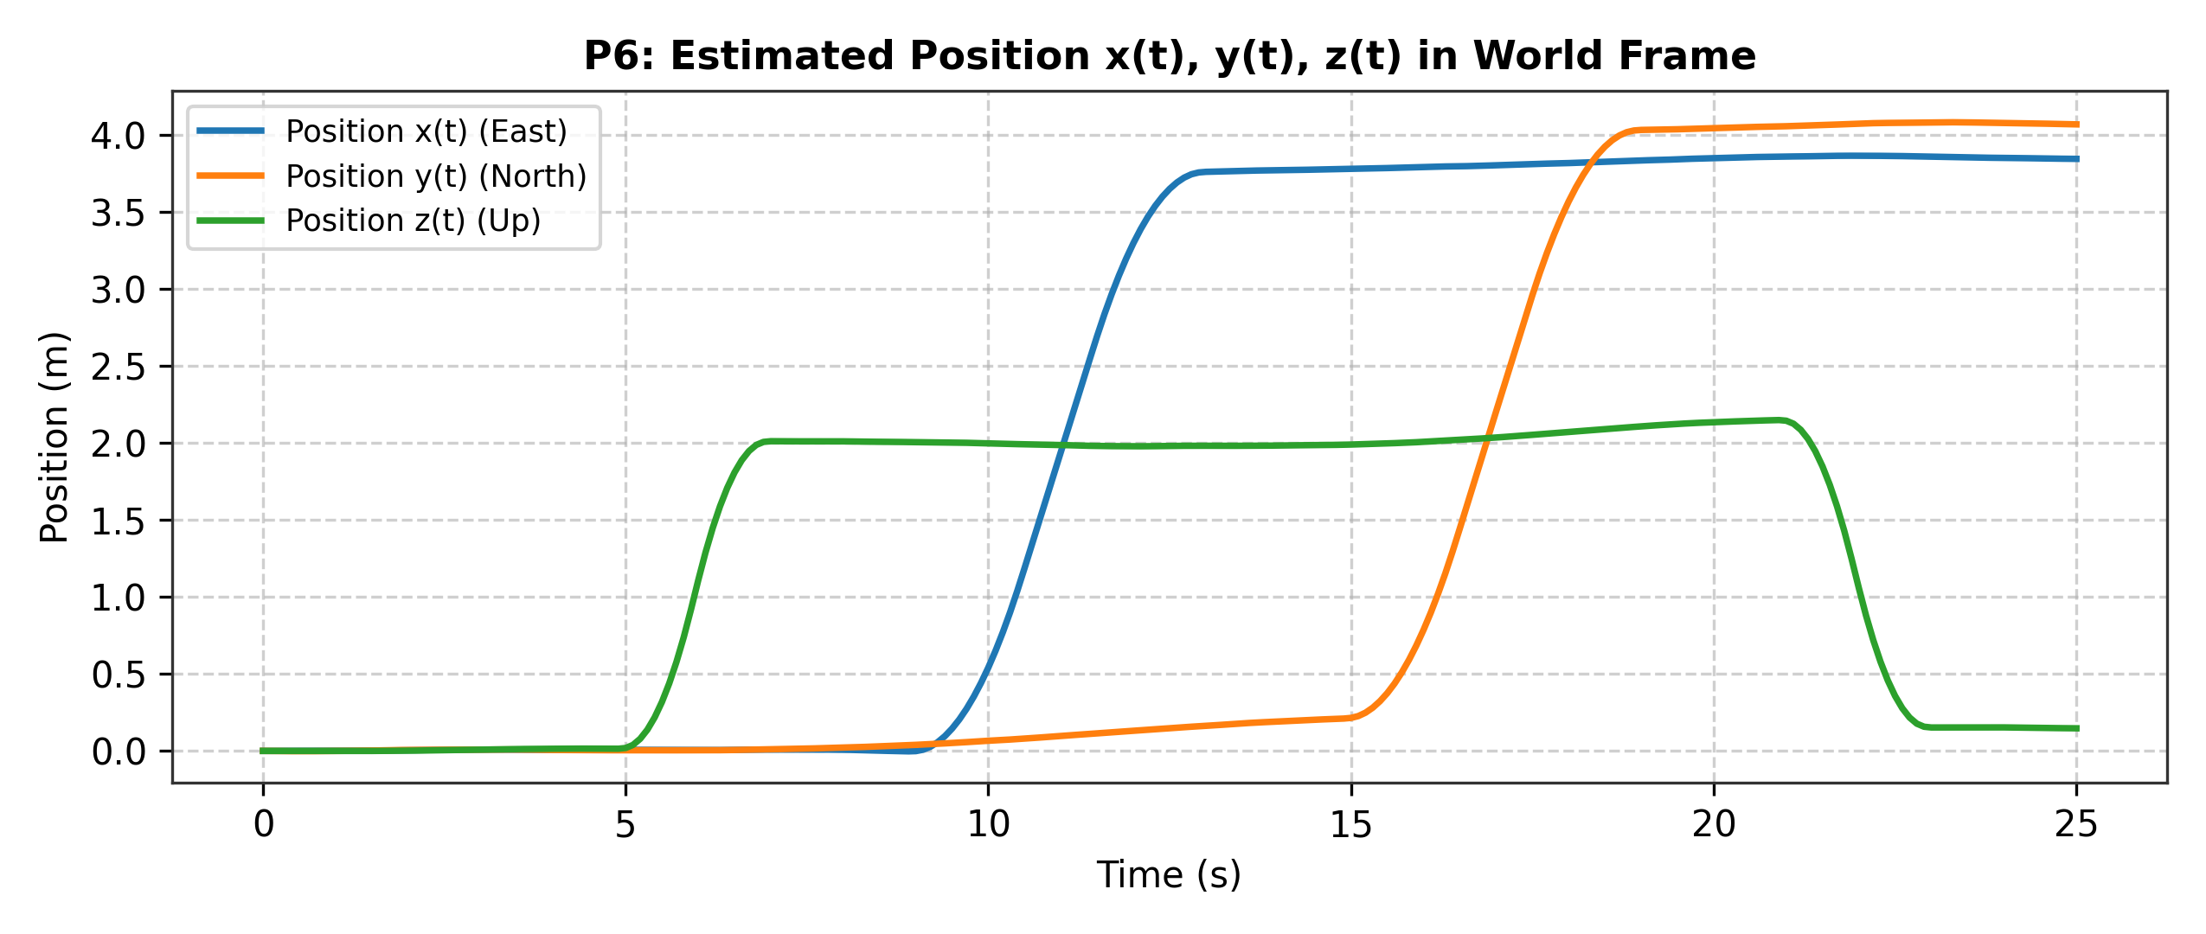
Figure 6 (Plot P6): Estimated World-frame position coordinates x(t), y(t), z(t) versus time.
6. Results and Required Plots
Putting our x(t), y(t), and z(t) coordinates together gives us the complete 3-D flight path of the drone, shown in Plot P7. Looking at the velocity and position curves alongside the 3-D trajectory, we can clearly tell the story of what the drone did during the 25-second flight:
• 0.0 s – 4.9 s (Ground Calibration): The drone sits stationary and level at the origin (0, 0, 0) m facing East (ψ = 0 rad).
• 5.0 s – 6.9 s (Vertical Takeoff): The drone accelerates upward at ~2.0 m/s² for 1 second (reaching a peak climb speed of ~1.90 m/s) and then decelerates at ~-2.0 m/s² for 1 second, leveling off in a hover at an altitude of about 2.01 m.
• 7.0 s – 8.9 s (Hover): The drone holds its hover at z ≈ 2.01 m above the takeoff point.
• 9.0 s – 12.9 s (Eastward Translation): While facing East, the drone pitches forward slightly to accelerate at ~1.0 m/s² from 9.0 to 10.4 s, cruises East at ~1.51 m/s, and brakes at ~-1.0 m/s² from 11.5 to 12.9 s, coming to a stop at x ≈ 3.76 m East.
• 13.0 s – 14.9 s (90° Counter-Clockwise Yaw Turn): While hovering at (x ≈ 3.78 m, y ≈ 0.20 m, z ≈ 1.98 m), the drone rotates 90.14° counter-clockwise (ψ = 1.5732 rad) so its nose points due North (+Y).
• 15.0 s – 18.9 s (Northward Translation): Now facing North, the drone accelerates forward along its body x-axis (which is World +Y) from 15.0 to 16.4 s, cruises North at ~1.52 m/s, and brakes to a stop between 17.5 and 18.9 s, reaching y ≈ 4.03 m North.
• 19.0 s – 20.9 s (Pre-Landing Hover): The drone hovers briefly over its destination.
• 21.0 s – 22.9 s (Controlled Vertical Landing): The drone descends by accelerating downward at ~-2.0 m/s² from 21.0 to 21.9 s (peak descent rate of -1.90 m/s) and braking at +2.0 m/s² from 22.0 to 22.9 s to touch down.
• 23.0 s – 25.0 s (Stationary on Ground): The drone rests on the ground at its landing spot.
Question 7 (Final Estimated Yaw, Velocity, and Position at t = 25.0 s): At the end of the flight (t = 25.0 s), our estimated state values using trapezoidal integration (with rectangular Euler integration shown in parentheses for reference) are summarized in Table 2.
State Variable | Trapezoidal Integration | Rectangular (Euler) Integration | Units
Final Yaw Angle ψ(25) | 1.5732 (90.14°) | 1.5734 (90.15°) | rad (deg)
Final Velocity v_X(25) | -0.0047 | -0.0036 | m/s
Final Velocity v_Y(25) | -0.0089 | -0.0103 | m/s
Final Velocity v_Z(25) | -0.0058 | -0.0061 | m/s
Final Position x(25) [East] | 3.8428 | 3.8567 | m
Final Position y(25) [North] | 4.0668 | 4.0344 | m
Final Position z(25) [Up] | 0.1469 | 0.1709 | m
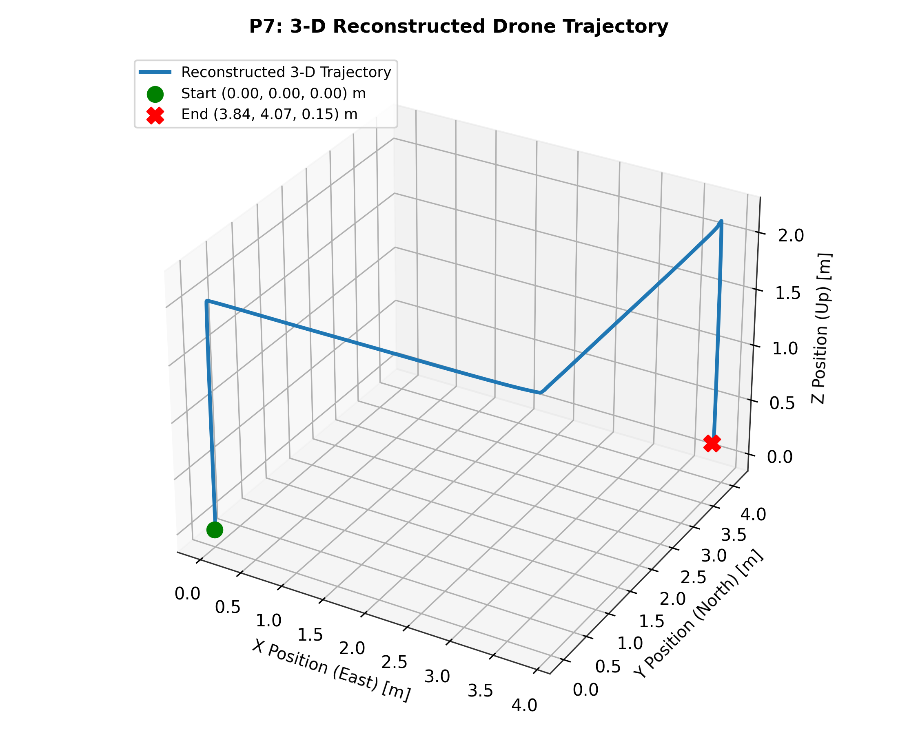
Figure 7 (Plot P7): 3-D reconstructed drone trajectory with Start and End positions marked.
7. Validation with Barometer
To check the accuracy of our vertical double-integration, we plotted our IMU-derived altitude z_IMU(t) directly against the independent barometer reading baro_alt_m in Plot P8.
Question 8 (Maximum Height According to IMU Integration vs. Barometer): According to our IMU double-integration, the maximum height reached by the drone is 2.1476 m (occurring at t = 20.4 s, right before the landing descent; or 2.1689 m using rectangular Euler integration). According to the raw barometer data (baro_alt_m), the maximum height recorded is 2.1820 m (at t = 11.0 s). While the barometer signal has more point-to-point high-frequency noise (fluctuating around a hover mean of ~2.07 m between 7 s and 21 s), it does not suffer from integration drift. The two curves match very closely in overall shape—both showing the climb at 5–7 s, the ~2 m cruise altitude from 7–21 s, and the landing at 21–23 s.
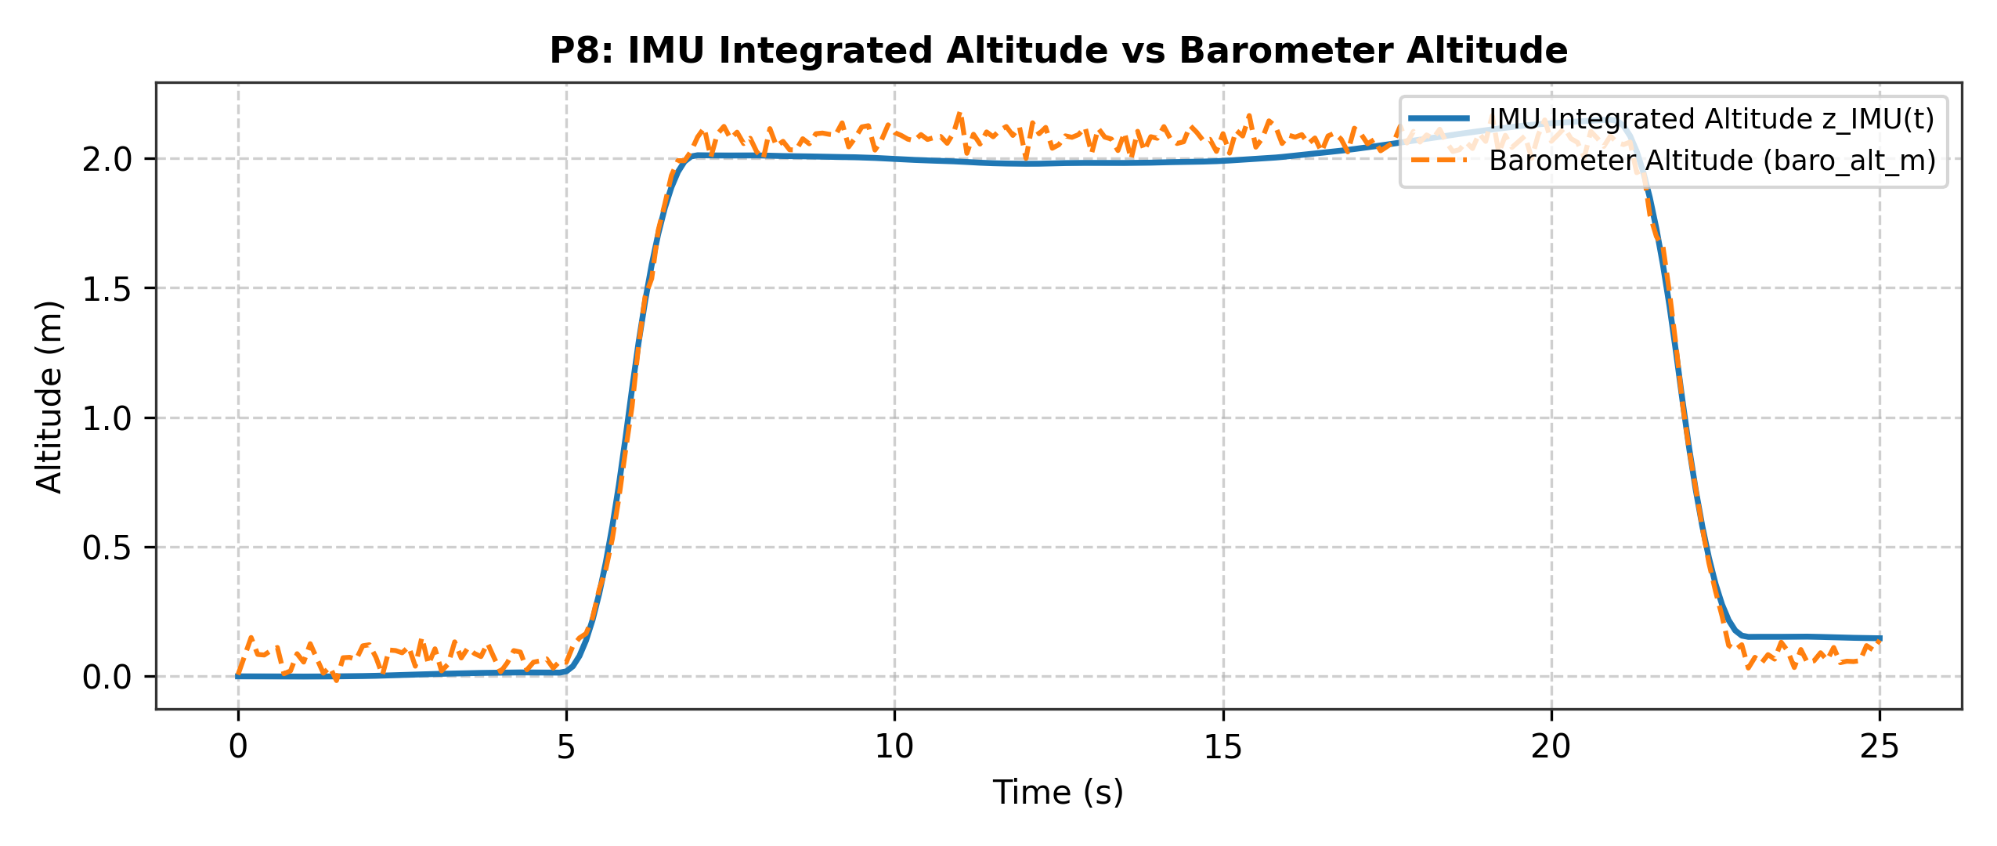
Figure 8 (Plot P8): Comparison of IMU double-integrated altitude z_IMU(t) versus barometer altitude.
8. Error/Drift Analysis and Limitations
Even though we carefully calibrated our sensors using the first 50 samples, a 50-sample average still has a tiny statistical uncertainty (standard error of the mean, σ/√50) and cannot account for biases that shift slightly during flight.
Question 10 (Where Drift Appears and Which Mathematical Operation Causes Error Accumulation): We can clearly see drift in our results in three places: (1) in Plot P8 between t = 14 s and t = 21 s, where the IMU altitude z_IMU(t) slowly curves upward from 1.98 m to 2.15 m even though the drone is supposed to be hovering at a constant height; (2) after touchdown at t = 23–25 s, where the drone is resting back on the ground (z ≈ 0 m) but our IMU altitude settles at a permanent offset of z = 0.1469 m; and (3) in Plot P6 between t = 7 s and t = 15 s, where the North position y(t) slowly creeps up from 0.00 m to 0.21 m before the northward flight even begins. The mathematical operation that causes these tiny measurement errors to accumulate is numerical integration (specifically double integration for position). If a residual acceleration bias error δa remains after calibration, integrating once produces a velocity error that grows linearly with time (δv(t) = δa · t), and integrating a second time produces a position error that grows quadratically with time (δp(t) = ½ δa · t²). In addition, integrating random white noise produces a random-walk drift whose variance grows rapidly with time (∝ t³ for double-integrated white noise).
Question 11 (Best Single Sensor to Add for Absolute Position and Why): If we could add one sensor to improve absolute position accuracy, we would choose a GPS receiver (specifically an RTK-GPS for outdoor flight, or an Ultra-Wideband / optical motion-capture positioning sensor if flying indoors). An IMU only measures relative changes in motion (accelerations and rotation rates), which means any dead-reckoning error is locked in forever unless an external reference corrects it. A GPS receiver directly measures absolute X, Y, Z position coordinates in the World frame with bounded error that does not grow over time. By fusing the fast, smooth IMU readings with periodic absolute position updates from GPS (for example, using a complementary or Kalman filter), we could continuously reset the accumulated velocity and position drift.
Question 12 (Single Most Important LimitatTion of Our Model): There are two major limitations in our model that are worth highlighting. First, from a system-architecture perspective, our model relies on pure open-loop dead-reckoning (double integration of IMU data without any closed-loop position correction), which guarantees that position errors grow unboundedly over time (∝ t²). Second, from a kinematic modeling perspective, our model relies on the 2-D small-roll/small-pitch assumption (assuming roll φ = 0 and pitch θ = 0). In real quadcopter physics, a drone must tilt (pitch or roll) to generate horizontal thrust. When a drone tilts by an angle θ, a component of Earth's 9.81 m/s² gravity vector (g · sin θ) projects directly onto the horizontal body accelerometers. Because our 2-D model ignores roll and pitch, any real tilt during aggressive flight would cause gravity to leak into the horizontal axes and be mistakenly double-integrated as huge horizontal acceleration.
9. Final Answer: Where Is My Drone?
Based on our complete kinematic reconstruction, the drone took off vertically to an altitude of ~2.0 m, flew ~3.8 m East, executed a 90° counter-clockwise turn to face North, flew ~4.0 m North, and performed a controlled vertical landing back to the ground. At the end of the 25.0-second recording, our estimated final state of the drone is:
• Final Position (x, y, z): [3.84, 4.07, 0.15] m in the World frame (3.84 m East, 4.07 m North, and 0.15 m Up).
• Final Velocity (v_X, v_Y, v_Z): [-0.005, -0.009, -0.006] m/s (essentially 0 m/s, confirming the drone is stationary on the ground).
• Final Yaw Heading (ψ): 1.573 rad (90.14° counter-clockwise from East, facing due North).
Confidence Level Discussion: We have high confidence in the overall L-shaped geometry of the trajectory and our final heading (~90° North), because the yaw angle only requires a single integration of a very clean gyroscope signal. For the final 3-D position coordinates, we have moderate confidence, with an estimated positional uncertainty of roughly ±0.15 m to ±0.25 m on each axis. We know from our barometer comparison (Plot P8) that the drone actually landed back on the ground (z ≈ 0.08 m barometric mean after 23 s), whereas our IMU double-integration drifted by about +0.15 m vertically over the 25-second mission. Since the X and Y accelerometers have similar noise levels to the Z accelerometer (and we observed a ~0.20 m drift in Y prior to the turn), the true landing spot of the drone is very close to (3.8 m East, 3.9–4.0 m North, 0.0 m Up).
10. Team Contribution Statement

