**Abstract**:-

Electric vehicles (EVs) are emerging as a promising solution to address environmental concerns and reduce reliance on fossil fuels in the transportation sector. However, the widespread adoption of EVs in India faces several challenges, including high prices, limited charging infrastructure, and range anxiety. To overcome these obstacles and promote the growth of the EV market in India, it is crucial to gain a comprehensive understanding of the different segments within the market.

This study aims to categorize and analyze the various segments in the Indian EV market while comprehending their distinct traits, preferences, and behaviors. By employing a combination of qualitative and quantitative research techniques, including surveys, interviews, and secondary data analysis, the study identifies and delineates the primary consumer segments in the Indian EV market.

Based on the research findings, the study identifies four main consumer segments: early adopters, value seekers, eco-conscious consumers, and convenience-oriented buyers. These segments are characterized by their unique demographics, psychographics, and behavioral characteristics.

Early adopters are driven by their enthusiasm for new technologies and their desire to be at the forefront of trends. They are more willing to pay a premium for EVs and value the environmental benefits they offer. Value seekers, on the other hand, prioritize cost-effectiveness and are more price-sensitive. They are motivated by the potential long-term savings on fuel and maintenance costs.

Eco-conscious consumers are deeply committed to environmental sustainability and are willing to make conscious choices to reduce their carbon footprint. They are attracted to EVs for their zero-emission nature and align their purchase decisions with their environmental values. Convenience-oriented buyers prioritize the ease and convenience of owning an EV. They value features such as fast-charging capabilities, ample range, and a well-developed charging infrastructure.

The study provides valuable insights into the characteristics and preferences of each segment, enabling EV manufacturers and marketers to tailor their marketing strategies to effectively target and engage each group. By understanding the diverse needs and motivations of these segments, industry stakeholders can develop compelling value propositions, address specific concerns, and create targeted communication campaigns.

The findings of this study underscore the significance of recognizing and addressing the different segments within the Indian EV market. By adapting marketing approaches and product offerings to cater to the unique requirements of each segment, EV manufacturers and policymakers can accelerate the adoption of EVs in India and contribute to a more sustainable and greener future for transportation.

**Introduction**:-

The electric vehicle (EV) market in India is still in its nascent stage, but it is growing

rapidly. The Indian government has set a target of achieving 30% electric vehicle

penetration by 2030, and several initiatives have been taken to promote the adoption of

EVs in the country. Market size: According to a report by Niti Aayog, the EV market in

India is projected to reach 30% of total vehicle sales by 2030. However, the market size is

currently quite small, with only a few thousand EVs sold each year. the EV market in

India has a lot of potential for growth, and the government is taking steps to promote the

adoption of EVs. However, there are still several challenges that need to be addressed,

such as the lack of charging infrastructure and consumer awareness, before the market

can reach its full potential.

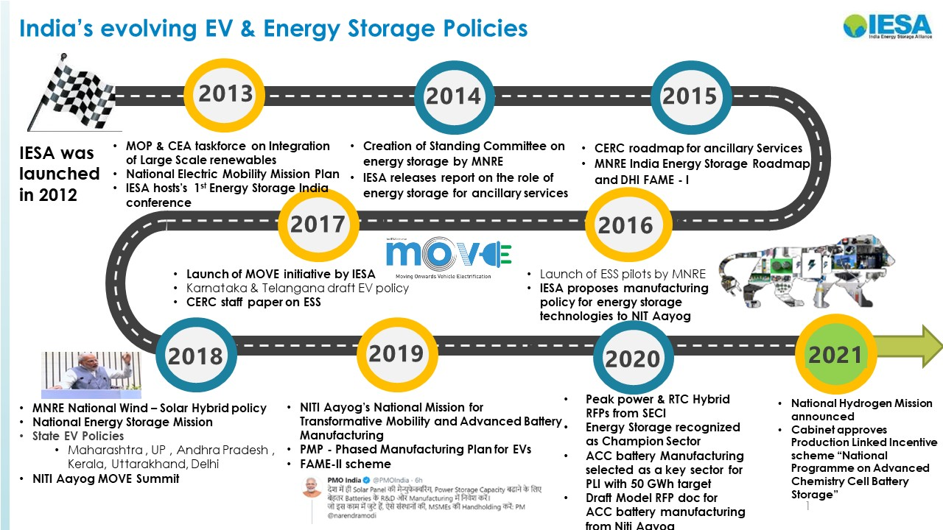

Market segmentation is the process of dividing a market into smaller groups of

consumers with similar needs or characteristics. This approach helps businesses tailor

their marketing strategies and products to specific target audiences. The market

segmentation of electric vehicles (EVs) is an important consideration for automakers and

other stakeholders in the EV industry. There are several ways to segment the market for

EVs. One common approach is to divide the market based on consumer preferences, such

as vehicle size, range, and price. For example, some consumers may be interested in

purchasing a smaller,more expensive EV with a longer range for family trips.

Another way to segment the EV market is by geographic location. EV adoption rates can

vary greatly depending on the region, with factors such as government incentives,

charging infrastructure, and climate affecting consumer demand. For example, EVs may

be more popular in areas with high gasoline prices, strict emissions regulations, or

abundant renewable energy resources. Additionally, the EV market can be segmented by

consumer demographics, such as age, income, and lifestyle. For instance, younger

consumers may be more likely to adopt EVs due to their interest in sustainable living and

technology, while wealthier consumers may be more attracted to premium EV models.

**PROBLEM STATEMENTS**

As part of an Electric Vehicle Startup team, our task is to analyze the Indian Electric

Vehicle market using segmentation analysis and devise a viable market entry strategy that

focuses on the segments with the highest potential for Electric vehicle usage. The Startup

is currently exploring the various vehicle and customer spaces to develop its EVs.

As part of an Online Vehicle Booking Product Startup team, your task is to analyze the

Indian Vehicle market using segmentation analysis and devise a viable market entry

strategy that focuses on segments with the potential to generate early traction and

revenue. The Startup is exploring alternative segments due to stiff competition in the Cab

booking space from Ola and Uber in India. Your goal is to identify segments with profit

potential for offering vehicle booking services.

Any problem statement can be broken down into:

1. Who: A team working under an Electric Vehicle Startup

2. What: Analyze the Electric Vehicle market in India using Segmentation analysis

3. Why: To come up with a feasible strategy to enter the market

4. How: By targeting the segments most likely to use Electric vehicles

5. Additional information: The startup is still deciding in which vehicle/customer

space it will develop its EVs.

**MARKET CHALLENGES**

● Despite the rapid surge in demand for electric vehicles (EVs) in India, sales

figures do not reflect the market hype. This discrepancy can be attributed to

several factors, including limited options in the passenger car segment, driving

range limitations, affordability issues, and a lack of charging infrastructure.

● The primary consideration for a majority of vehicle buyers in India is the cost of

the vehicle, which unfortunately makes EVs out of reach for a significant portion

of the population. Affordability is a major hurdle in the growth of the EV market

in India, particularly in a price-sensitive country like India.

● In addition to affordability issues, the charging infrastructure for EVs in India is

still in its nascent phase compared to developed nations, where well-established

charging stations are easily accessible for EV owners. Developing a reliable

charging infrastructure is essential for creating a conducive ecosystem for EV

growth in India.

● Furthermore, only a few EV models currently available in the market can provide

a driving range of over 150 km per charge, which further limits their appeal to

potential buyers.

**COMPETITIVE LANDSCAPE**

1. Electric Vehicles (EVs) in India face competition from various sources, including conventional gasoline and diesel vehicles, as well as hybrid vehicles. Furthermore, the Indian market is witnessing the entry of numerous new EV manufacturers, intensifying the competitive landscape.

2. Gasoline and diesel vehicles are the primary competitors to EVs in India. Despite the increasing environmental concerns and growing awareness about the negative impact of fossil fuels, these conventional vehicles remain popular among buyers due to their affordability, well-established infrastructure, and convenience.

3. Hybrid vehicles, which combine gasoline or diesel engines with electric motors, are also gaining popularity in India. They offer improved fuel efficiency and lower emissions compared to traditional gasoline and diesel vehicles, making them an appealing choice for environmentally conscious buyers.

4. In addition, several renowned global automobile manufacturers are entering the Indian EV market, including Tata Motors, Mahindra & Mahindra, and Hyundai Motors. These companies possess significant advantages in terms of brand recognition, manufacturing capabilities, and well-established sales and distribution networks.

**SITUATION ANALYSIS**

Conducting a situational analysis is an essential step in understanding the market segmentation of electric vehicles (EVs) in India. This process involves assessing both internal and external factors that influence the EV market in the country.

External factors encompass various elements, including political, economic, social, technological, environmental, and legal aspects, which significantly impact the growth of the EV industry in India. For example, the Indian government's ambitious target of achieving full electrification of Indian roads by 2030, along with incentives and subsidies for EVs, has resulted in a notable increase in the number of EVs in the country. Moreover, factors such as growing environmental awareness, escalating fuel prices, and the demand for sustainable transportation are driving the growth of the EV market in India.

On the other hand, internal factors involve conducting a strengths, weaknesses, opportunities, and threats (SWOT) analysis specific to the EV industry in India. The strengths of the EV industry in India include the presence of diverse domestic and international EV manufacturers, a burgeoning market for EVs, and a supportive regulatory framework. However, there are also weaknesses to consider, such as the inadequate charging infrastructure and the high initial costs of EVs, which may impede potential customers' entry into the market.

In conclusion, conducting a situational analysis aids in comprehending the market segmentation of EVs in India by examining both external and internal factors. By considering political, economic, social, technological, environmental, and legal aspects, as well as the industry's strengths, weaknesses, opportunities, and threats, stakeholders can gain valuable insights and make informed decisions to navigate the evolving landscape of the EV market in India.

Data Sources:-

<https://www.eai.in/india-ev-database>

<https://www.kaggle.com/datasets/kkhandekar/cheapest-electric-cars>

<https://www.kaggle.com/datasets/vishalturare/ev-cars-available-in-india-till-oct2021>

**Market Segment Analysis** :-

1. Based on Age

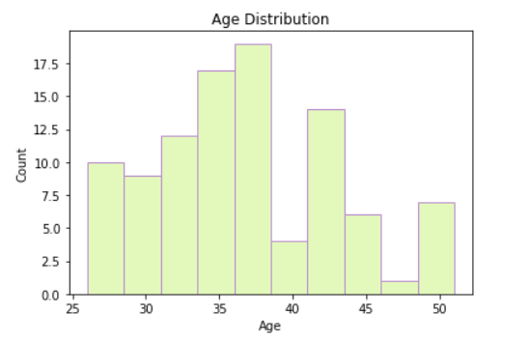

From the above Graph we can interpret that middle aged people are more concerned about the environment than the younger generation.

1. Based on Marital Status

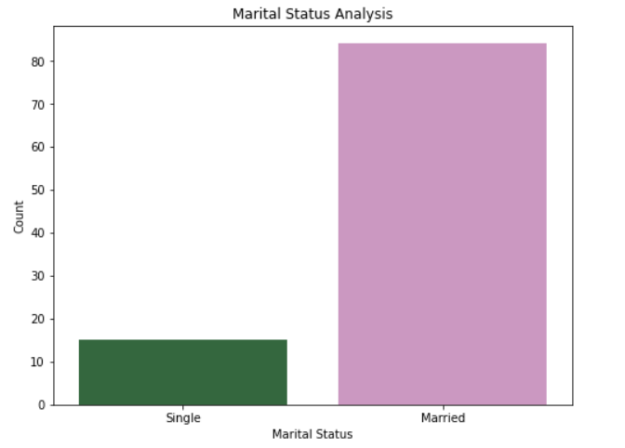

1. Base on Salary

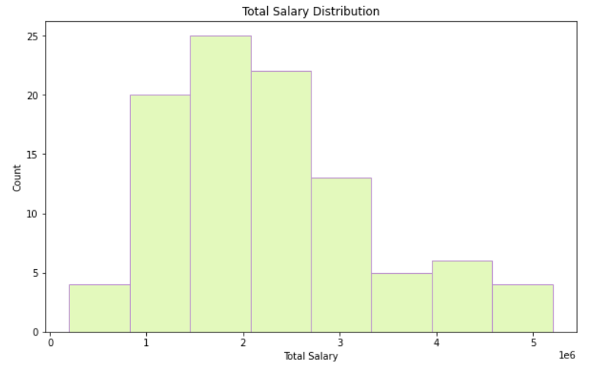

This shows that the Higher salaried people are opting for EVs, we see from later data analysis that usually EVs are more expensive than normal vehicles.

1. Car spending analysis:-

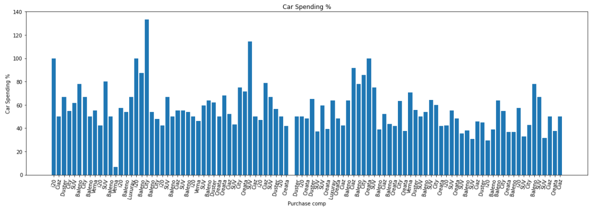

We can see cars like **Honda City and Baleno** are quite popular

1. Geographic Analysis:-

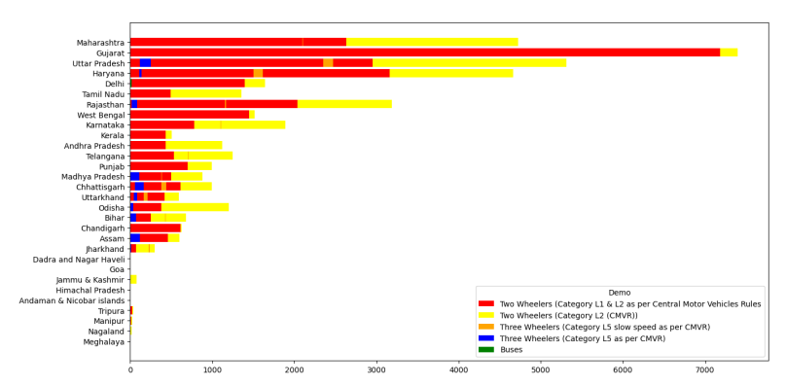

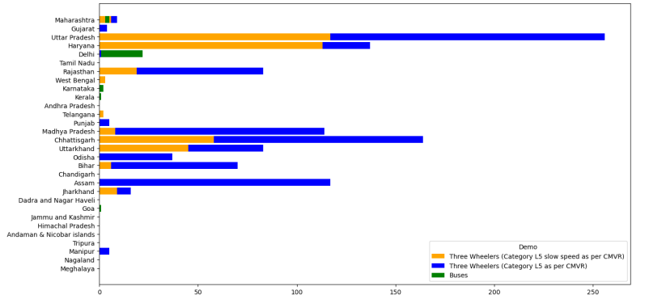

* Although Maharashtra leads in the total number of EV sales, most of the sales are

in the passenger car segment.

* Gujarat has the highest proportion of two-wheeler (category L1 and L2) EV sales

compared to the total sales in the state.

* Uttar Pradesh has the highest percentage of sales in two-wheelers (with maximum

power not exceeding 250 watts) EVs of the total sales in the state.

* Similar observations can be made for other segments based on the percentage of

sales.

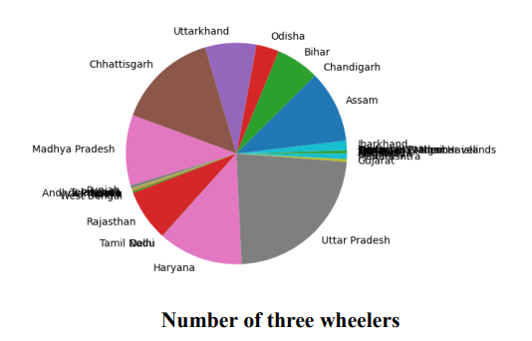

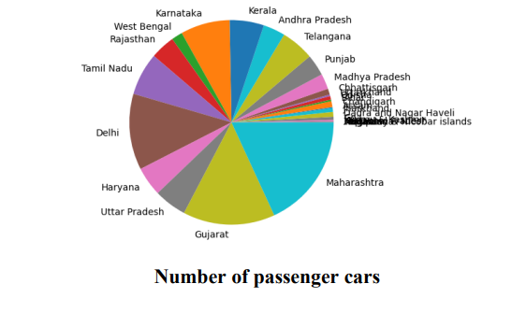

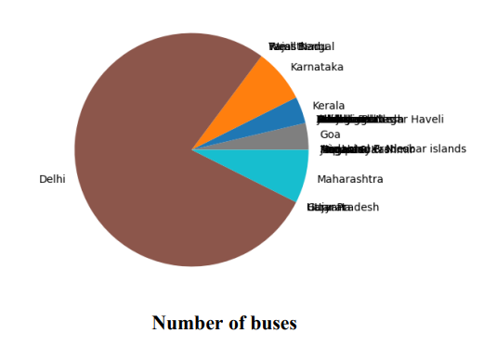

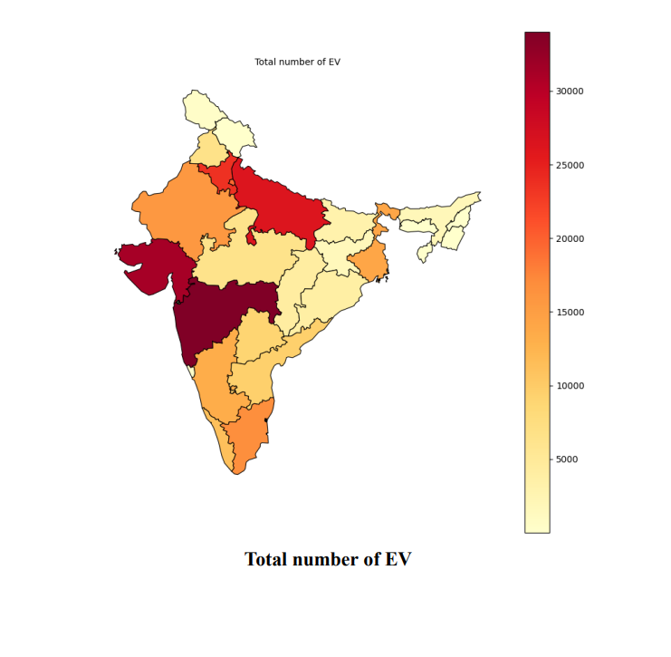

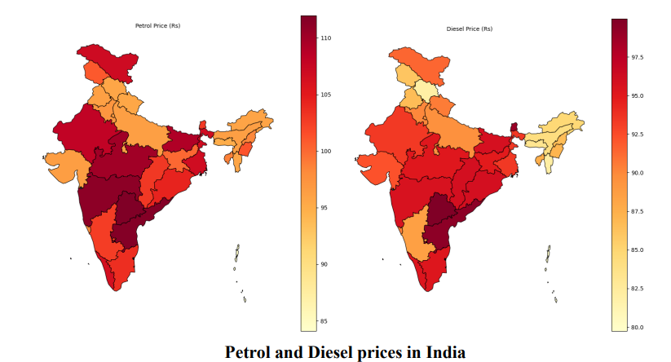

With rising petrol and diesel prices, electric vehicles are becoming a more cost-effective option compared to traditional petrol or diesel vehicles.. As the price of petrol continues to increase, electric vehicles become even more appealing to consumers as they provide long-term cost savings and can reduce the consumer's dependence on traditional fuels.

**Behavioral Analysis of different Electric Vehicle Brands**

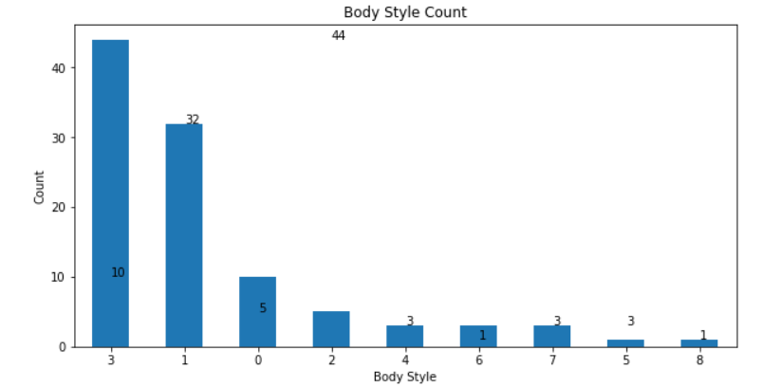

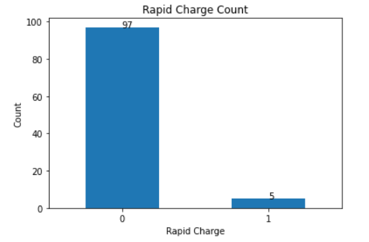

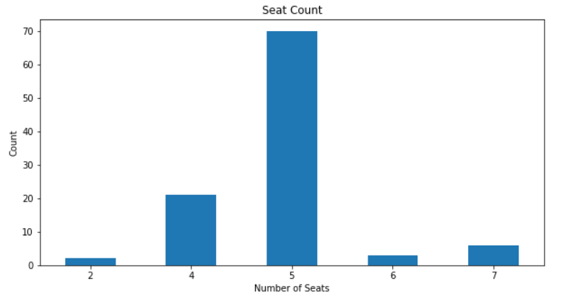

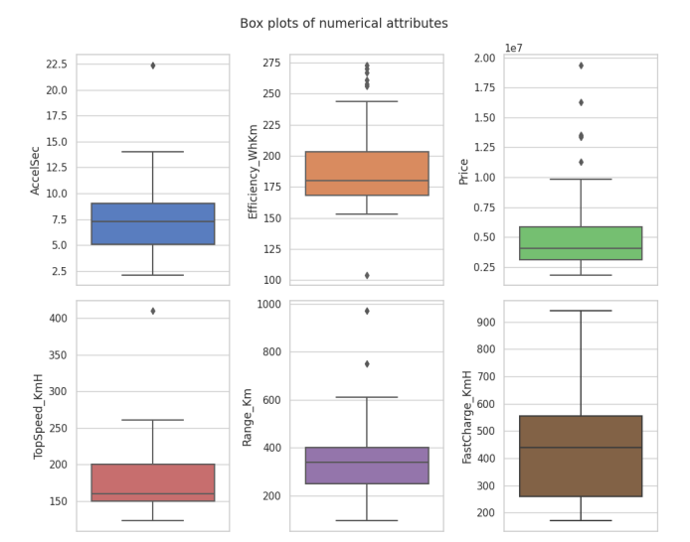

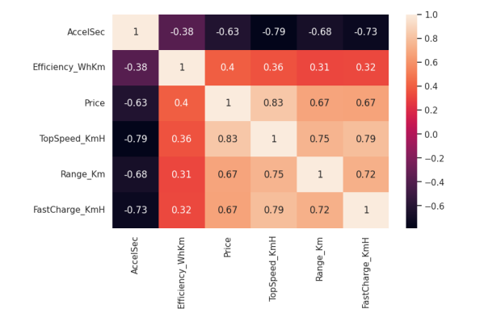

**So the major conclusions are:-**

➢ The younger the consumer, the more likely they are to purchase a less expensive car.

➢ Consumers with more dependents tend to buy cars with more seats, which makes SUVs a popular choice.

➢ The average salary of consumers tends to align with the price range of the cars they purchase, creating a direct relationship between the two variables.

**Marketing Mix:-**

The marketing mix consists of a range of strategies, including product, price, promotion, and place, that businesses employ to effectively target their intended market segments.

Drawing from the earlier discussed segmentation of the Indian electric vehicle (EV) market, here is an illustrative example of a marketing mix:

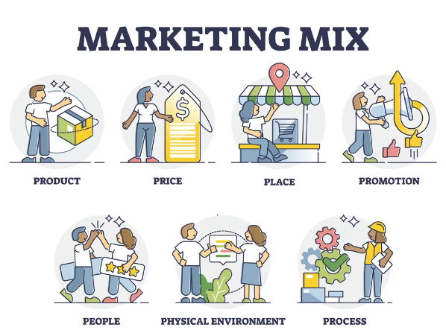

1. Product: EV manufacturers should offer a diverse range of products to appeal to different psychographic segments. This entails providing luxury EVs for high-income individuals, practical and affordable EVs for value-conscious consumers, and eco-friendly EVs for those who prioritize sustainability.

2. Price: The pricing strategy for EV manufacturers should take into account the affordability and value preferences of various market segments. This may involve offering financing options, incentives, and segment-specific discounts to make EVs more accessible to different consumer groups.

3. Promotion: To effectively promote their EV products, manufacturers should tailor their promotional activities to align with the interests and preferences of distinct segments. This could entail implementing targeted social media campaigns, leveraging influencer marketing, and organizing events that cater to specific psychographic segments. For example, sponsoring environmental events for eco-conscious consumers, participating in tech fairs for tech-savvy buyers, or showcasing at auto shows to attract early adopters.

4. Place: A well-designed distribution strategy is essential for reaching the desired psychographic segments. EV manufacturers can establish partnerships with dealerships, develop charging infrastructure in urban areas, and offer home charging solutions to cater to convenience-oriented segments.

To succeed in the Indian EV market, companies need a comprehensive understanding of the unique requirements, preferences, and motivations of diverse psychographic segments. This understanding informs the development of an effective marketing mix that tailors product offerings, pricing strategies, promotional activities, and distribution channels to cater to the specific needs of each segment. By doing so, companies can successfully engage their target audience and drive widespread adoption of EVs in India.