Week 2 EDA Deliverables

01_Comprehensive_EDA_Tables.txt
This table summarizes key insights obtained from the dataset, including monthly application counts, top opportunity programs, and the most common student majors. It serves as the foundation for the visualizations.

02_Monthly_Application_Trends.png
This chart shows how the number of applications changed over time, helping identify growth patterns and seasonal variations.
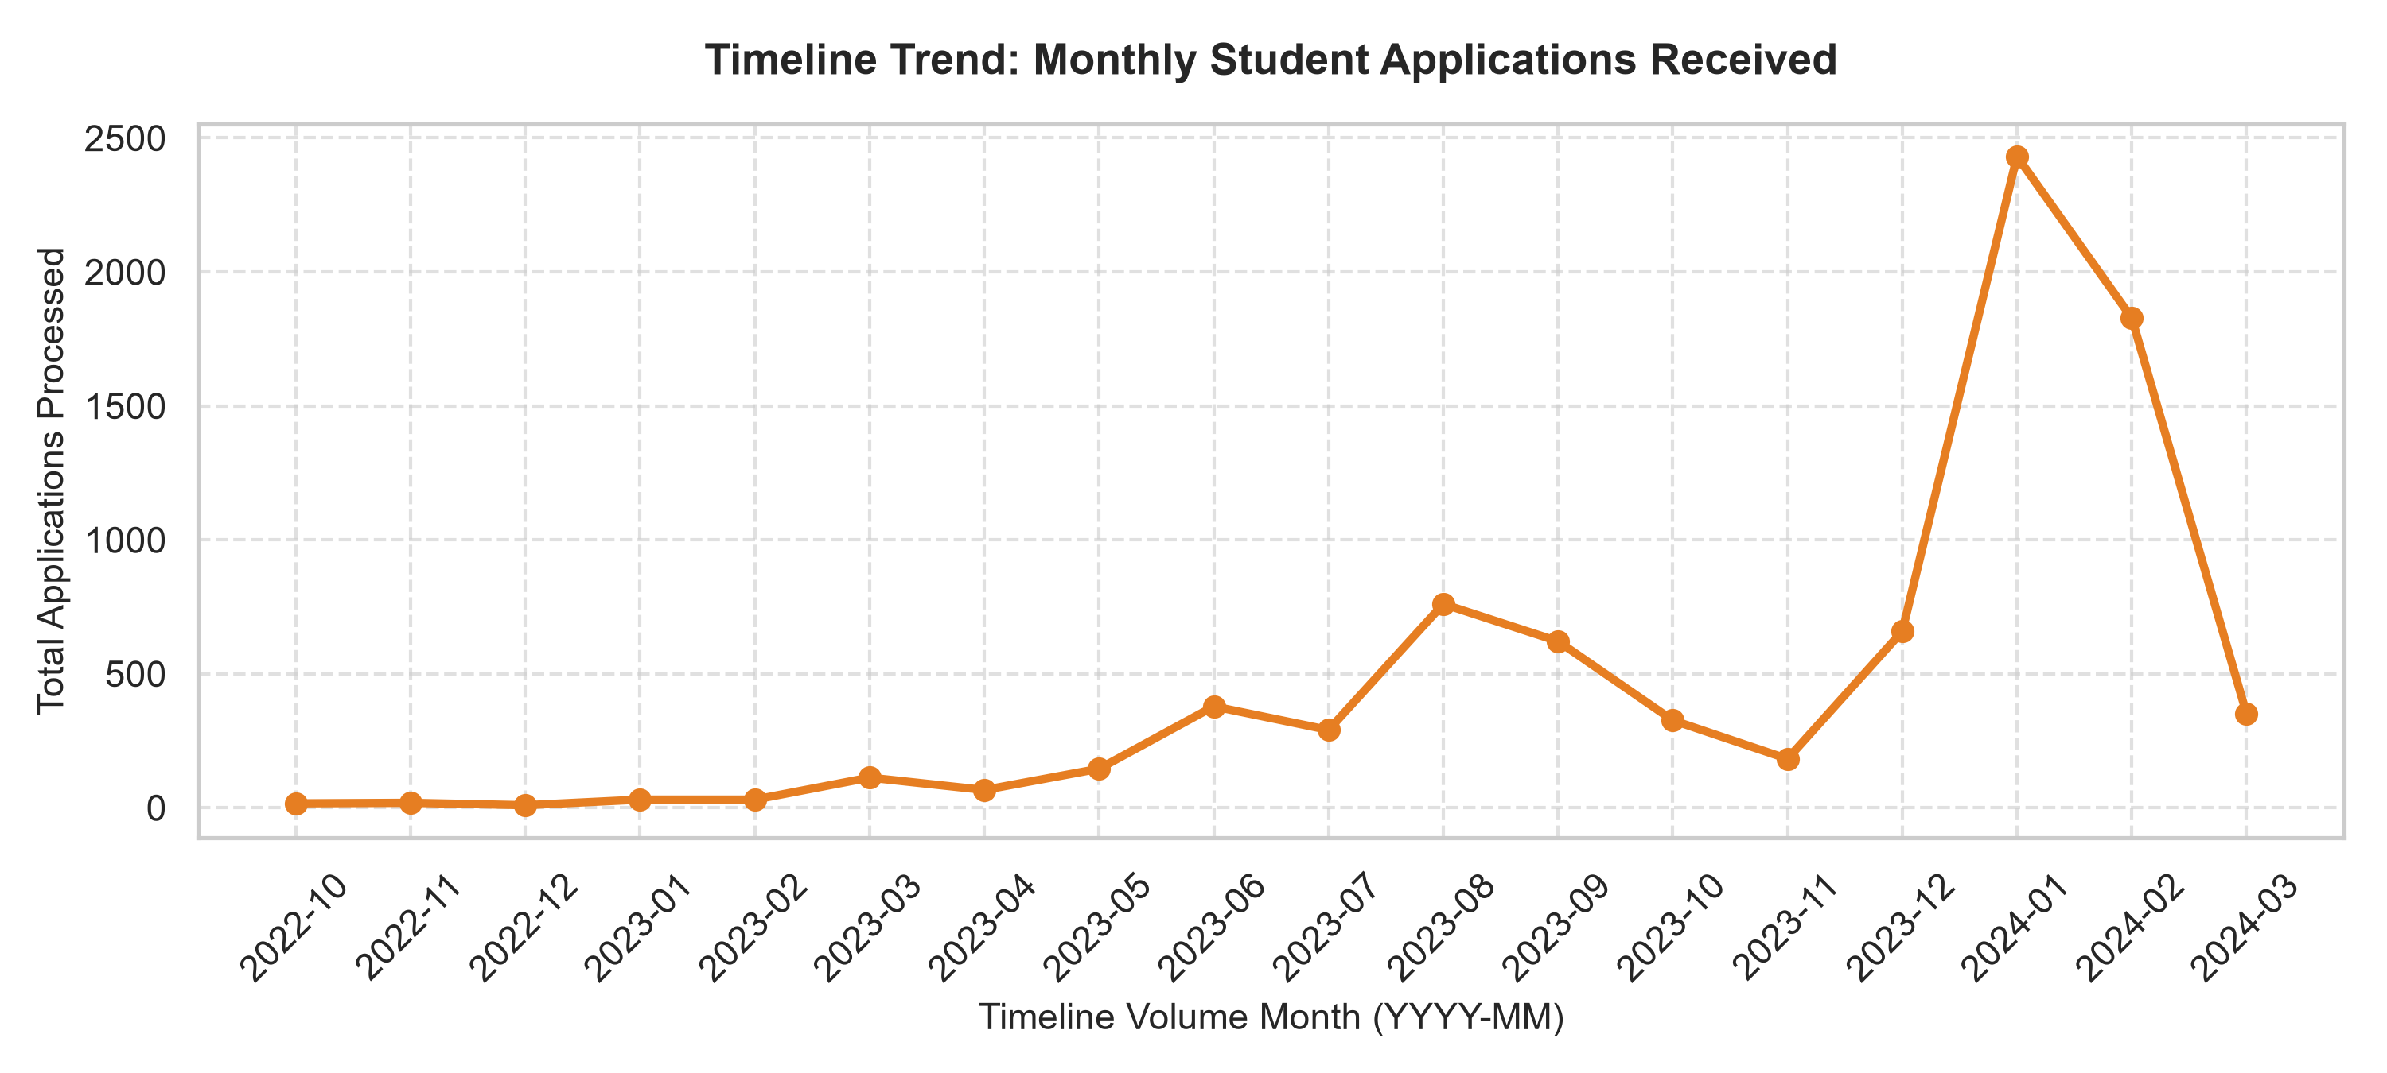

03_Monthly_Trends_By_Category.png
This visualization compares application trends across opportunity categories.
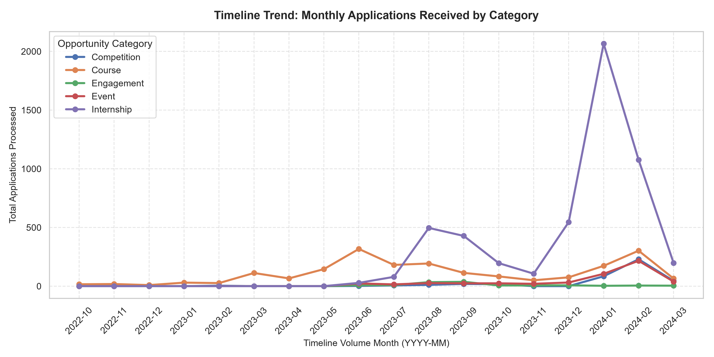

04_Opportunity_Categories_Distribution.png
This pie chart illustrates the proportion of applications across opportunity categories.
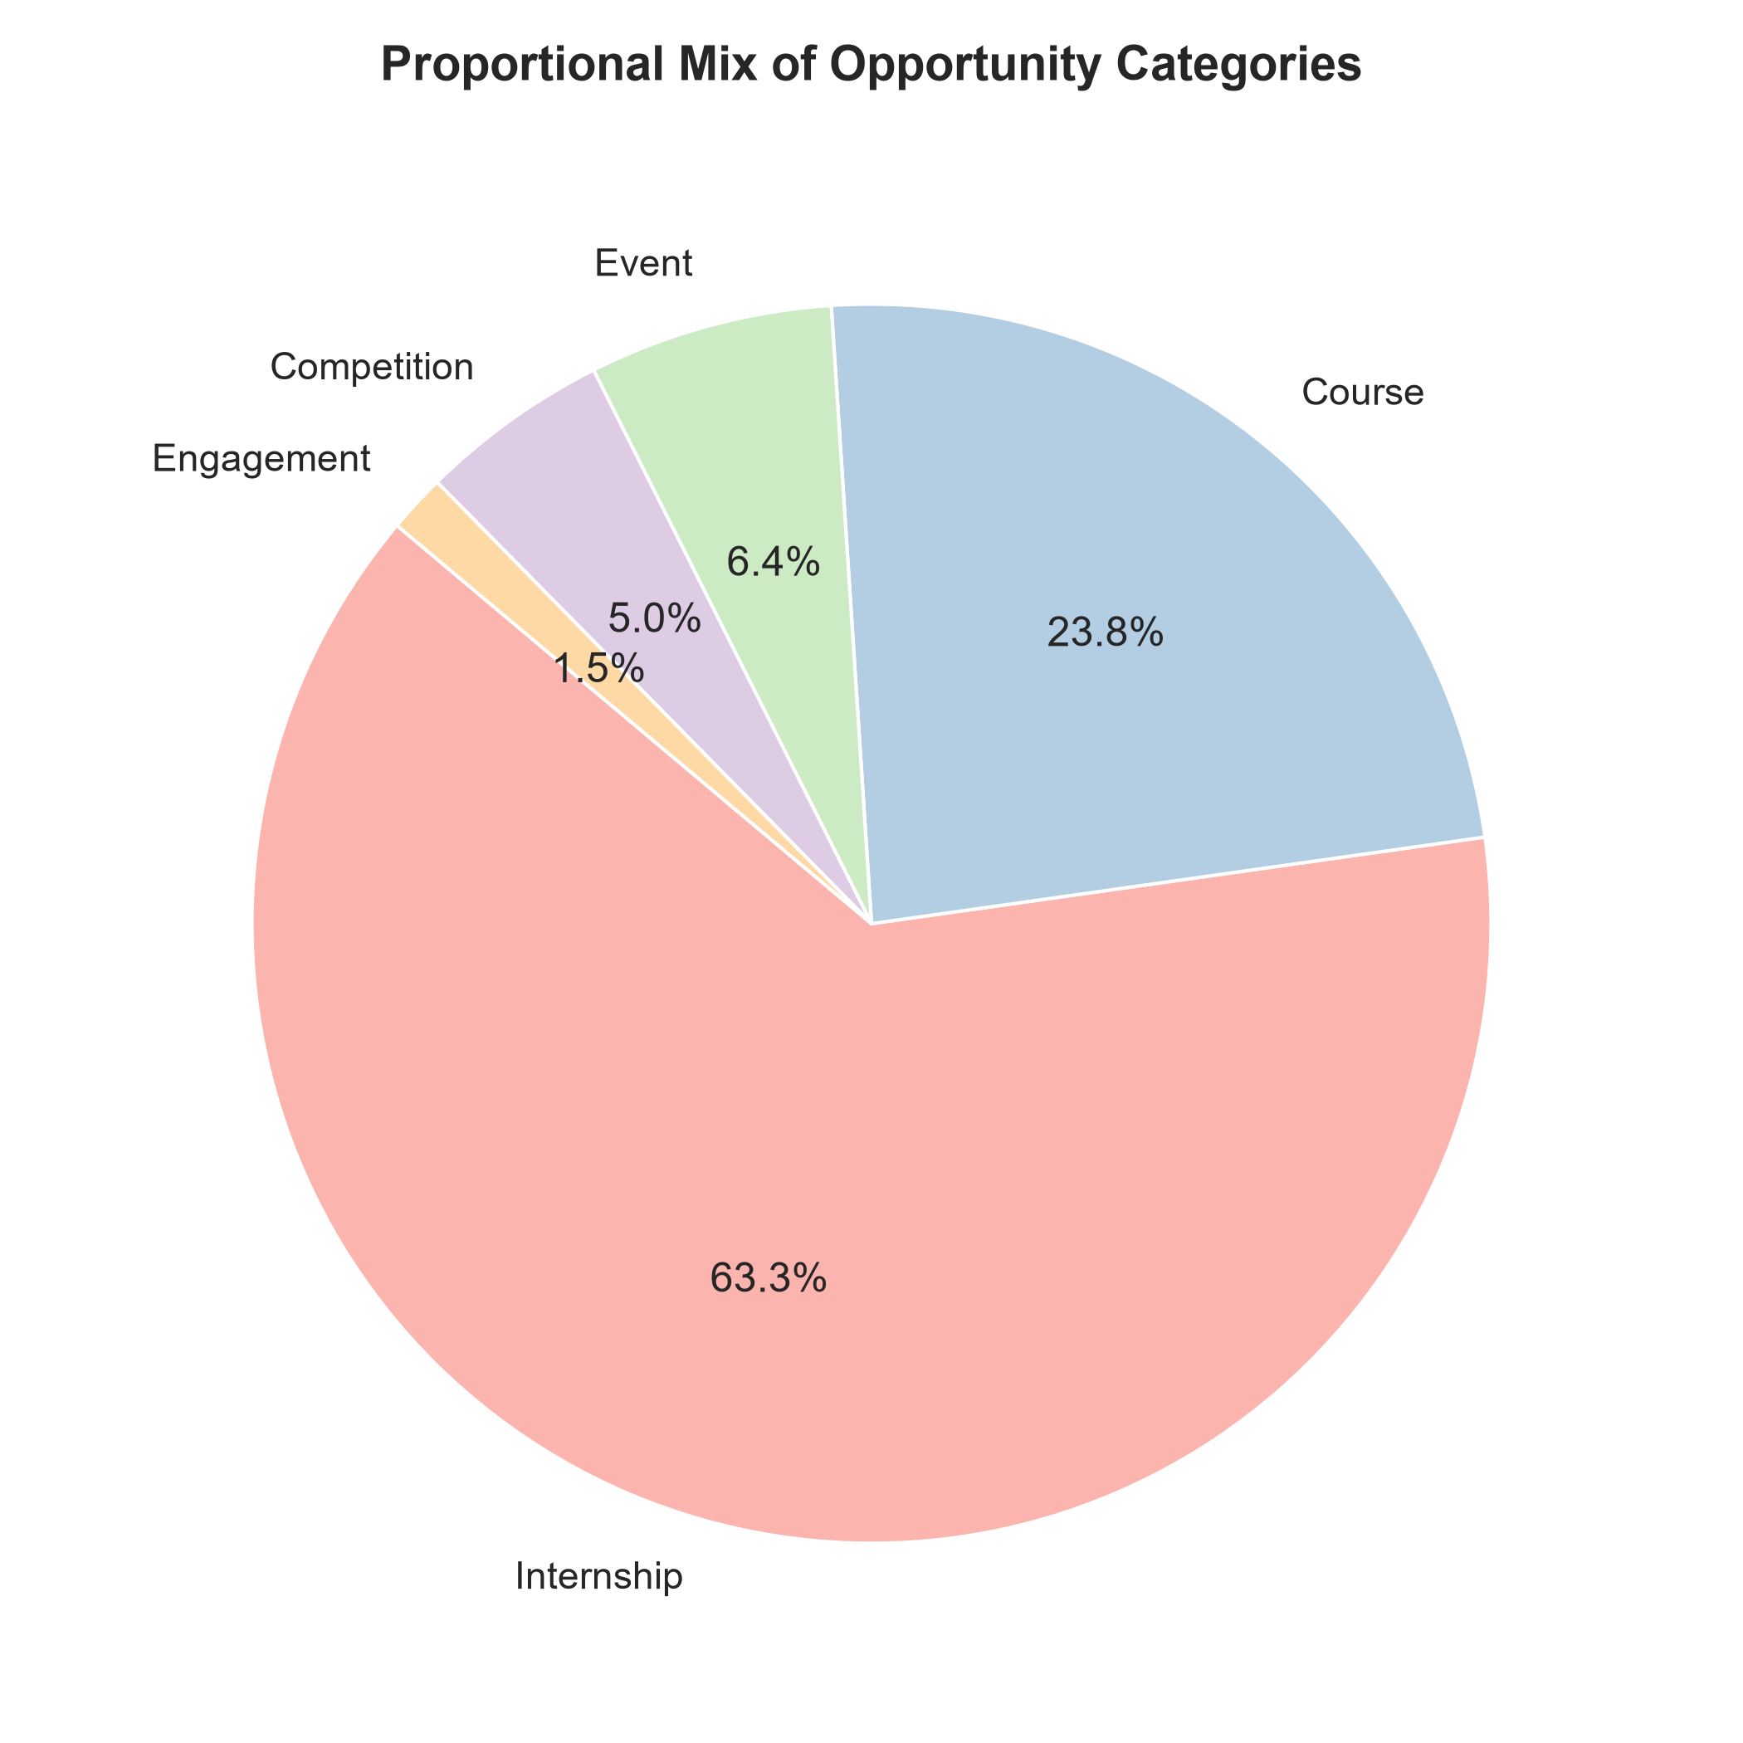

05_Gender_Distribution_Donut.png
This donut chart represents the gender distribution of applicants.
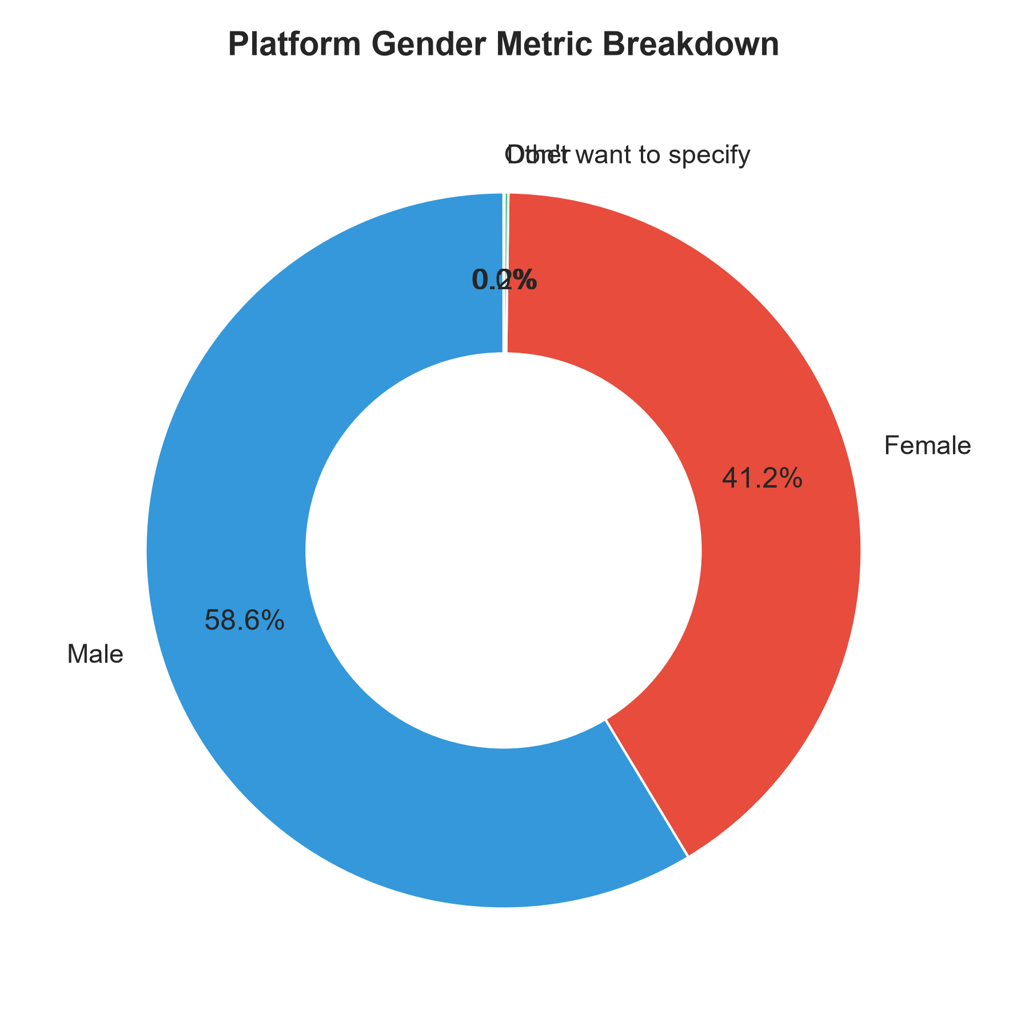

06_Top_10_Academic_Majors.png
This chart displays the ten most common academic majors of applicants.
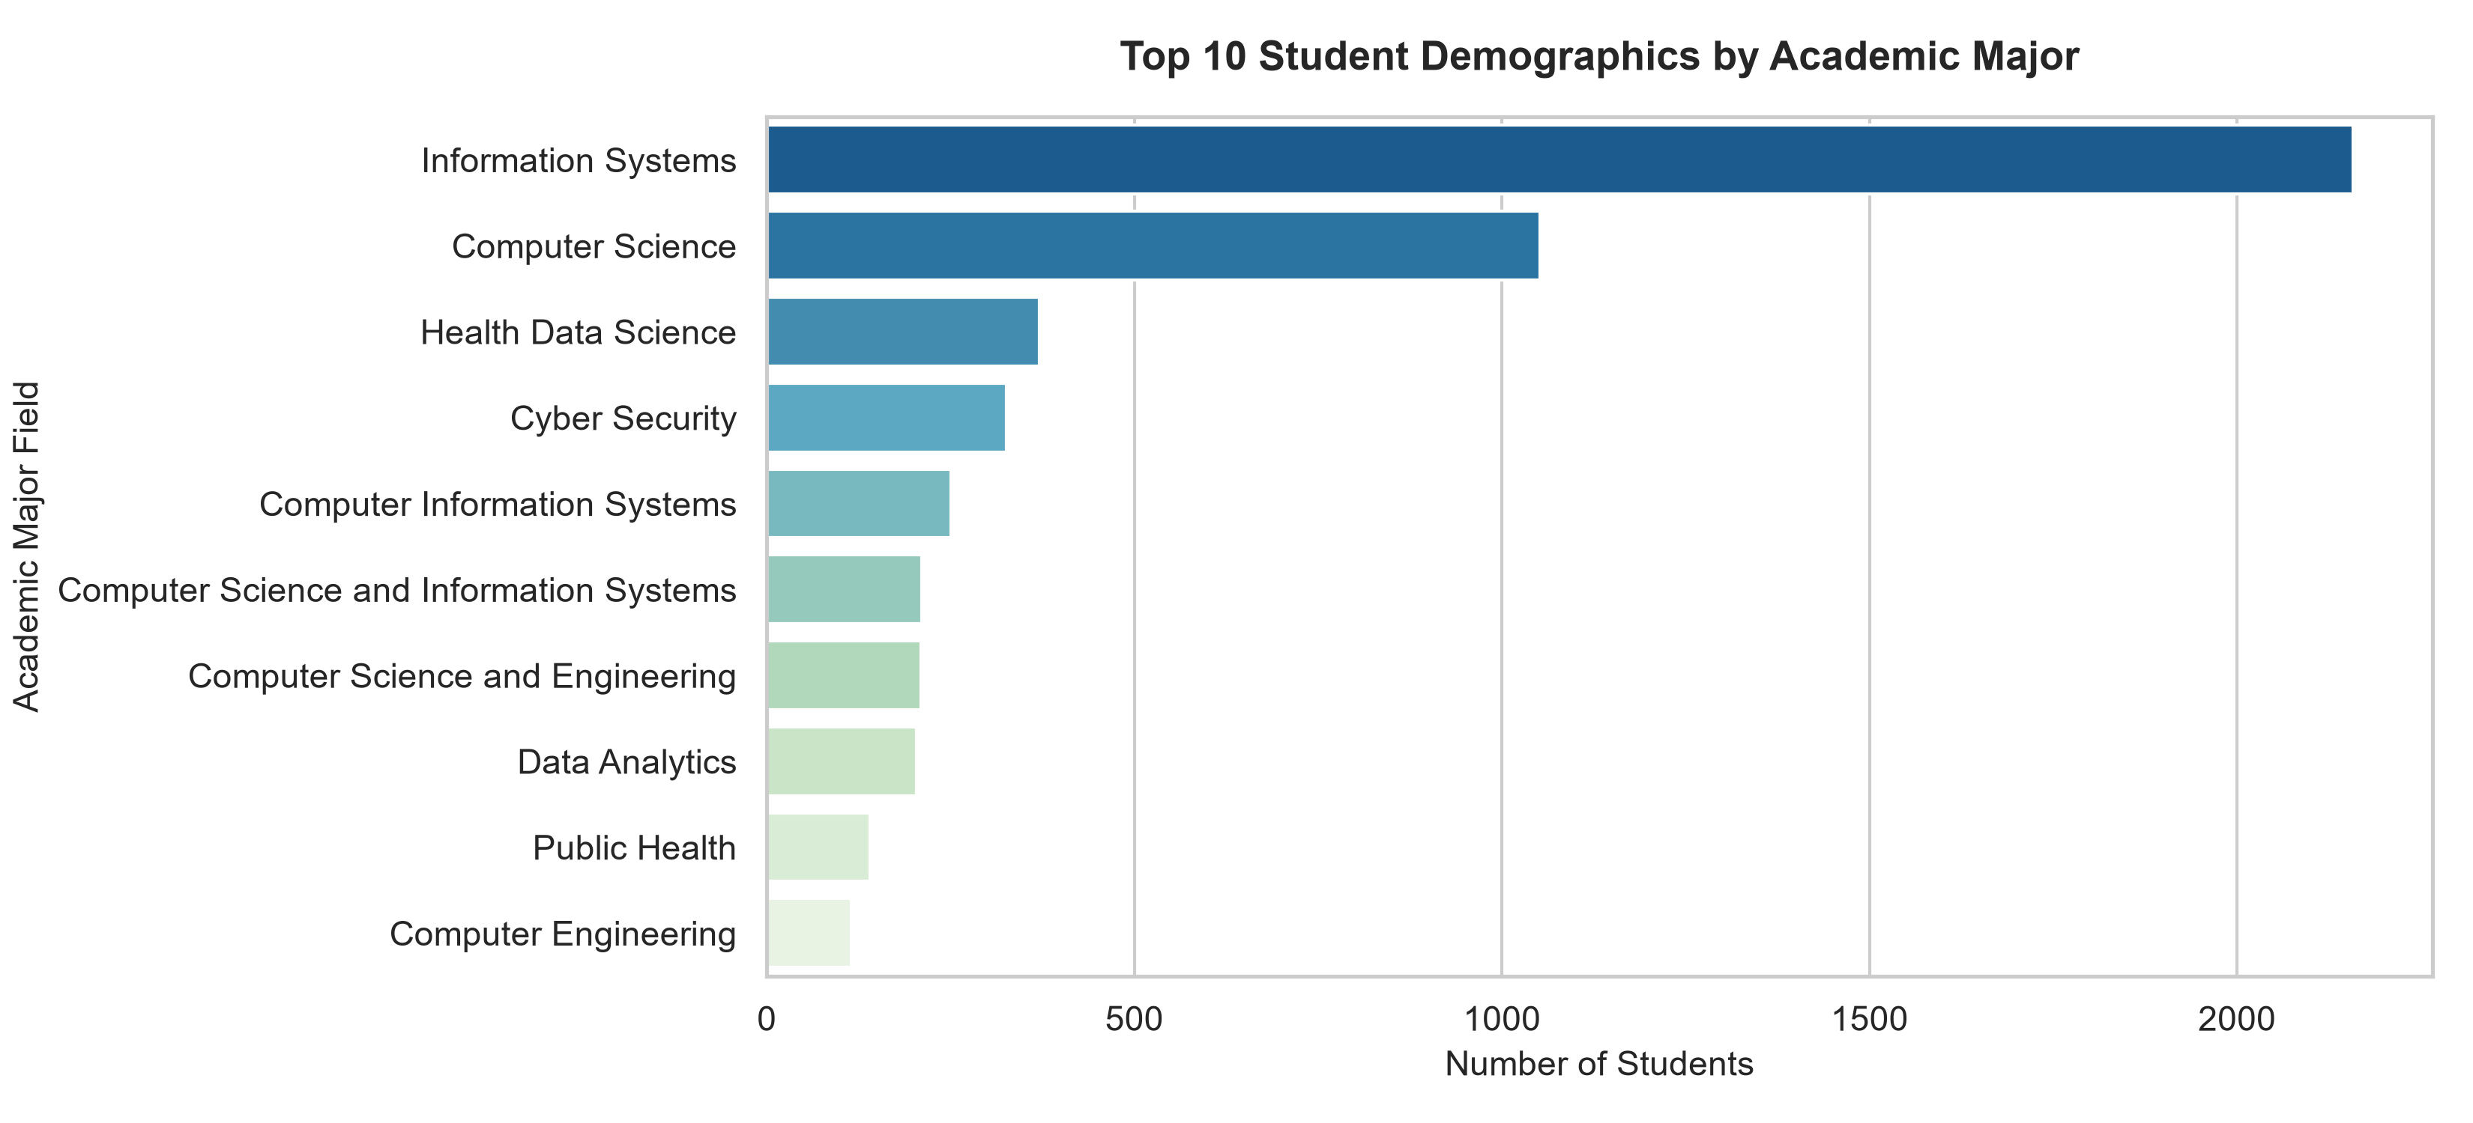

07_Top_10_Opportunity_Programs.png
This figure highlights the ten most popular opportunity programs.
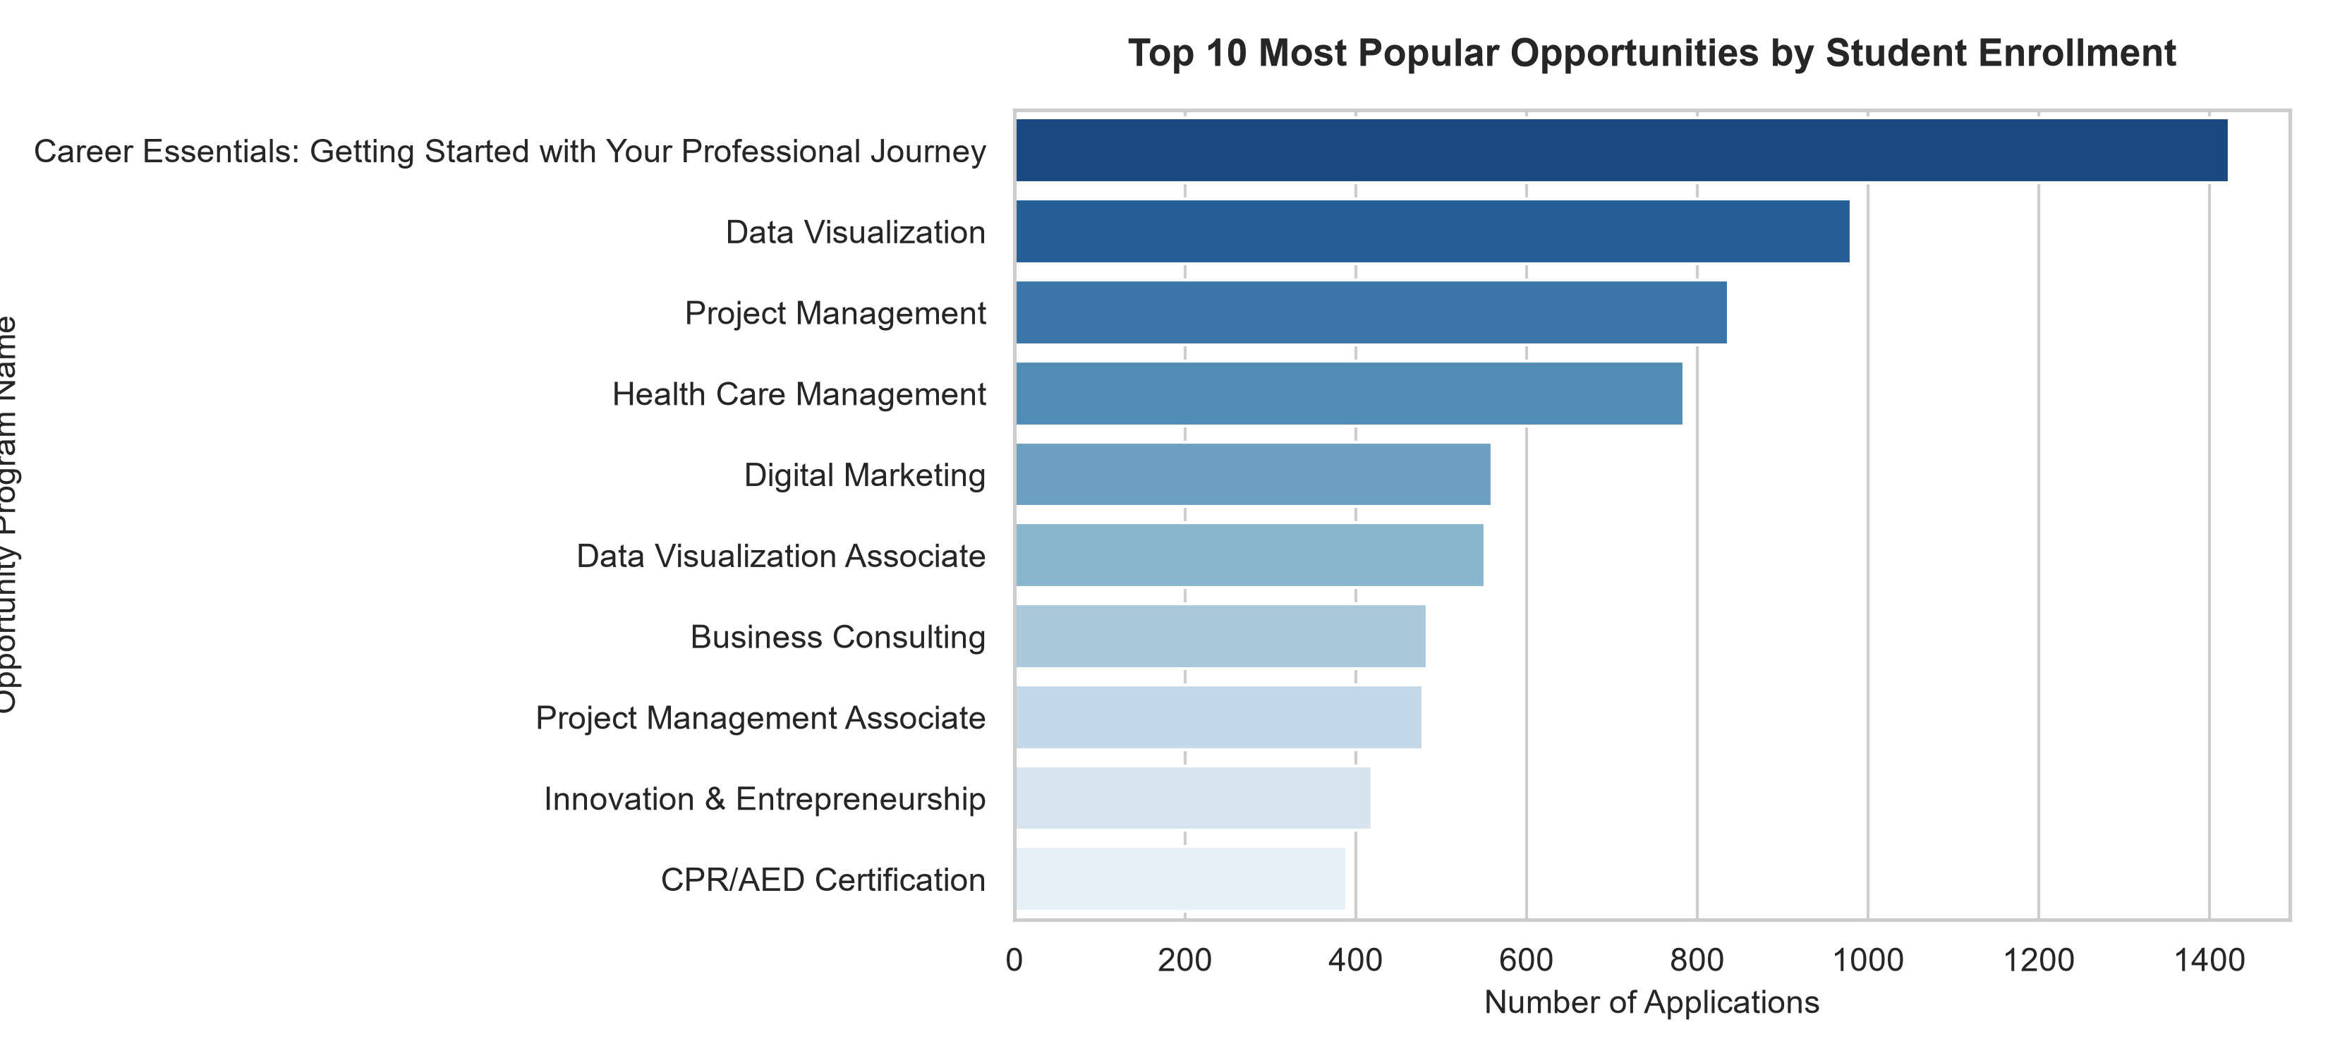

08_Crosstab_Heatmap.png
The heatmap visualizes the relationship between two categorical variables using color intensity.
