**Front End with React JS and React Material**

* Download Node React -[*Download | Node.js (nodejs.org)*](https://nodejs.org/en/download/)
* Command to create React App - npm create-react-app DXC_Forum_ui
* Command to run React App - npm start
* Mentor –
  + Component- Folder for Reusable components
    - Navbar Components
    - Sidebar Components
* Main components - Component which we are going to access using URL.
  + Child components
    - AddCertification.js
    - AddMentoring.js
    - CustomNavigation.js
    - EditMentoring.js
    - MentoringBarChat.js
    - MentoringExcel.js
    - PieChart.js
* Certification.js – components for display all the certificates.
* Dasboard.js - components for display charts.
* Mentoring.js- components for display mentors.
* Training.js- components for recorded and live sessions.
* Question.js
* UpdateTraining.js-components for
* UploadExcel.js-components uploaded from local storage excel file.
* Service
* BaseURL.js
* CertificationService.js
* javaFactory.js
* MentoringService.js
* TrainingService.js

**Back End with Spring Boot**

1. File -> New -> Spring Starter Project ->

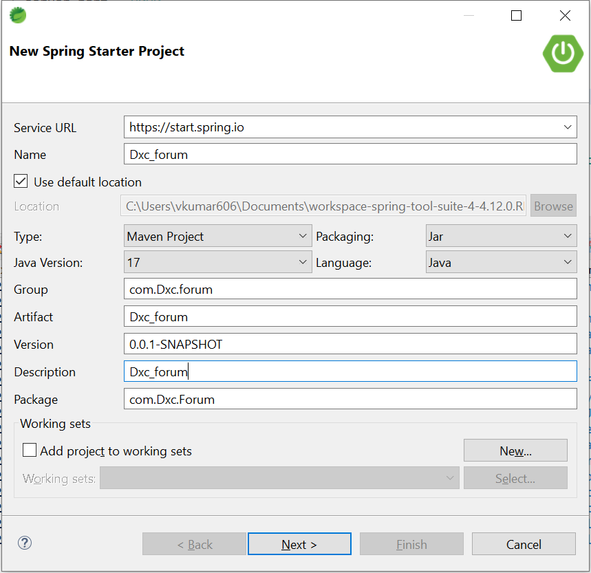

1. -> New Spring Starter Project Dependency

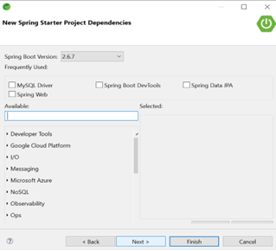

1. -> Select Spring Data JPA, Spring Boot DevTools, Spring Web and Oracle Driver Dependency -> Finish
2. Project is ready
3. **src/main/java**
   * com.dxc. forum (Package)

* DxcForumApplication.java (class File)
  + com.dxc. forum. Controller (Package)
* AnswerController.java (class File)
* CertificationController.java (class File)
* MentoringController.java (class File)
* QuestionController.java (class File)
* UploadSessionController.java (class File)
  + com.dxc. forum. custom. Exception (Package) –
* BusinessException.java (class File)
* ControllerException.java (class File)
  + com.dxc. forum. Entity(package)
* Answer.java (class File)
* Question.java (class File)
* Certification.java (class File)
* Mentoring.java (class File)
* UploadSession.java (class File)
  + com.dxc. forum. Helper (Package)
* MentoringExcelHelper.java (class File)
* SessionExcelhelper (class File)
  + com.dxc. forum. Repository (Package)
* AnswerRepo.java (class File)
* QuestionRepo (class File)
* CeritficationRepo.java (class File)
* MentoringRepo.java (class File)
* UploadSessionRepo.java (class File)
  + com.dxc. forum. Service (Package)
* AnswerService.java (class File)
* QuestionService.java (class File) )
* CertificationService.java (class File
* MentoringService.java (class File)
* UploadSessionService.java (class File)
  + com.dxc. forum. service. impl (Package)
* AnswerServiceImpl.java (class File)
* QuestionServiceImpl.java (class File)
* CertificationServiceImpl.java (class File
* MentoringServiceImpl.java (class File)
* UploadSessionServiceImpl.java (class File)

1. **src/main/resources**
   * application properties – This file contains database configuration, JPA Configuration.
2. **pom.xml** – This file contains all the dependencies
   * Right click on exam server (Project) -> maven -> update project.
   * Right click on exam server (Project) -> run as -> Spring Boot App

**Database: MySQL**

* Download MySQL -

[*https://www.mysql.com/downloads/*](https://www.mysql.com/downloads/)

* Command for create database

create database database name;

* Command for change database

use database name;

* Command for display table data

Select * from table name;