### CRUD JUnit Tests for Spring Data JPA - Testing Certification Repository Layer

# @DataJpaTest Annotation :

The Spring boot provides @DataJpaTest annotation. This annotation will disable full auto-configuration and instead apply only configuration relevant to JPA tests.

The @DataJpaTest annotation doesn’t load other Spring beans (@Component, @Controller, @Service, and annotated beans) into ApplicationContext.

# 1.Create Spring Boot Project

**Project Name:** dxc-forum

**Project Type:**Maven

**Choose dependencies:**  Spring Data JPA, MYSQL database, Spring Boot Dev Tools

**Package name:**com.dxc.forum

# 2. Maven Dependencies

Pom.xml :

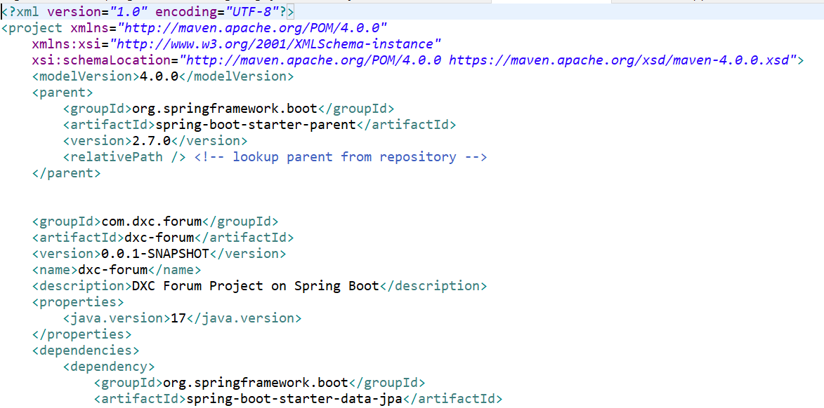

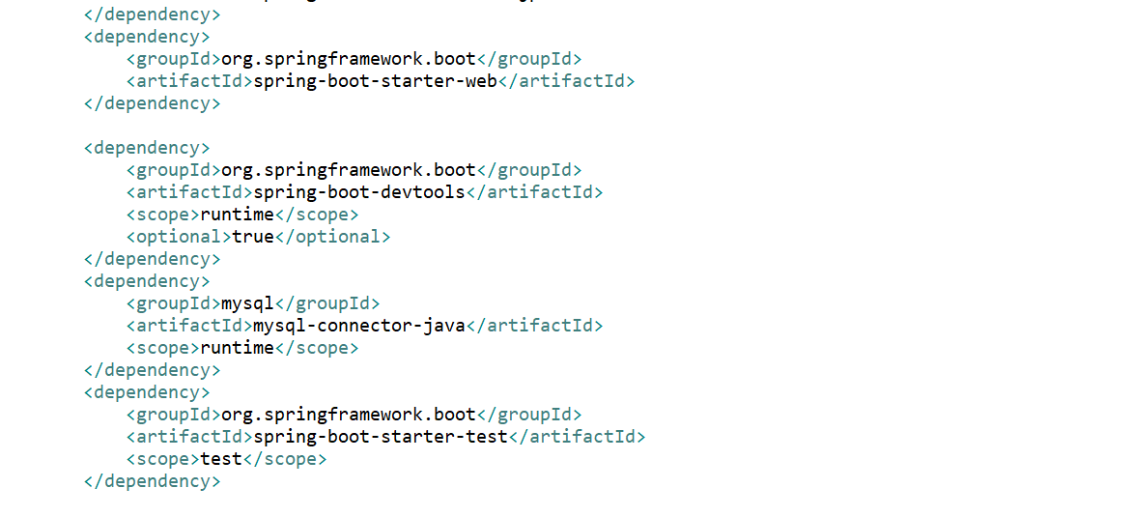

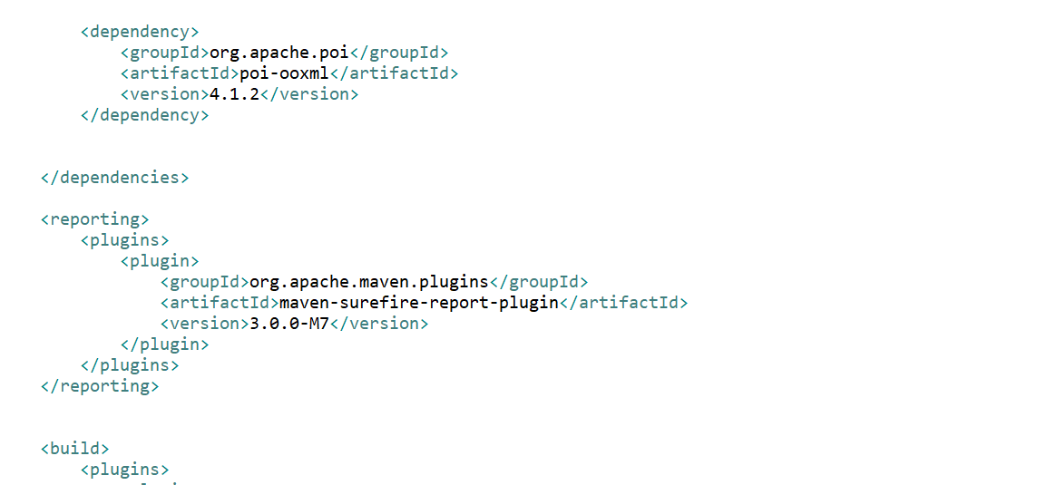

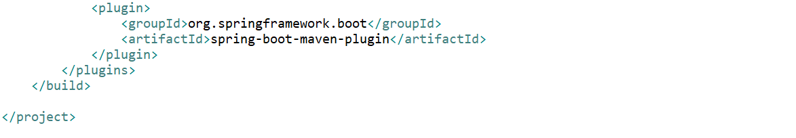

# 3. Create JPA Entity

Let's create an entity package inside a base package "com.dxc.forum". Within the entity package, create a Certification class.

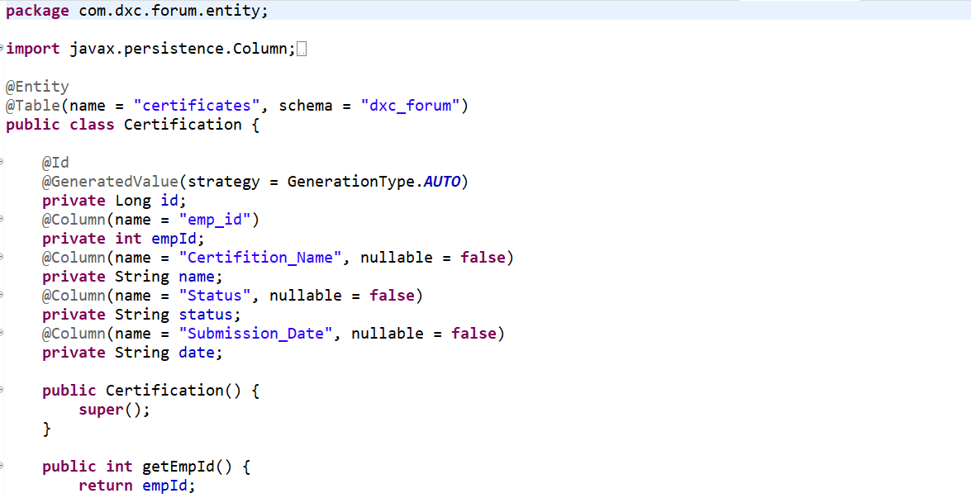

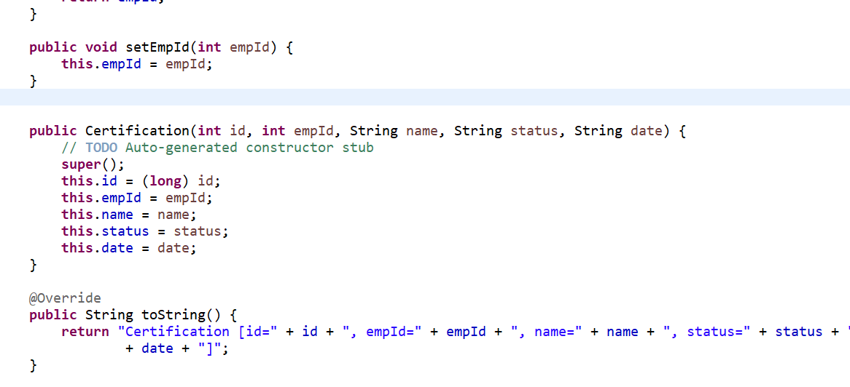

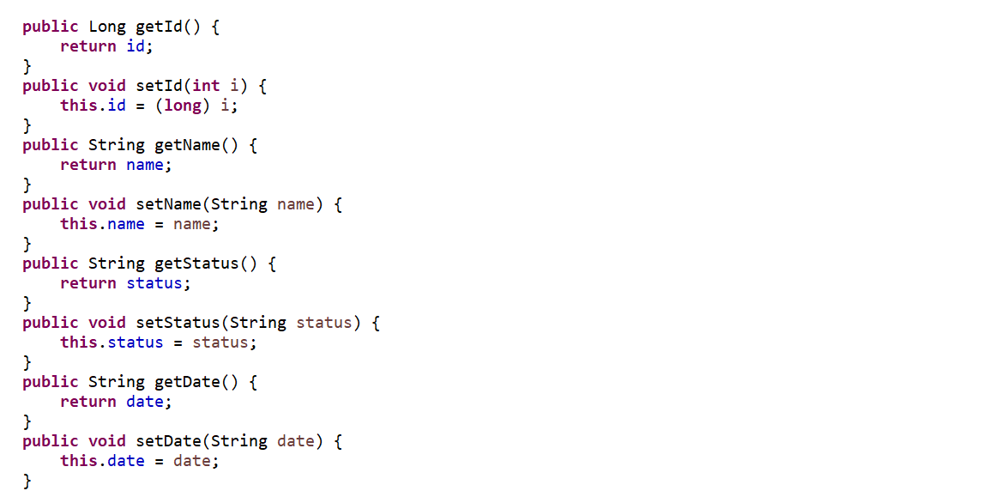

# 4. Create Spring Data JPA Repository

Let's create a repository package inside a base package "com.dxc.forum". Within the repository package, create a CertificationRepo interface with the following content:

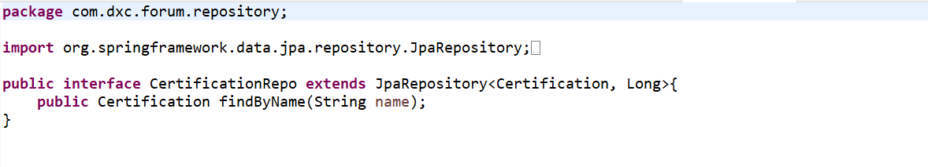

# 5. JUnit Tests for Spring Data JPA Repository:

create a CertificationTest class with the following content:

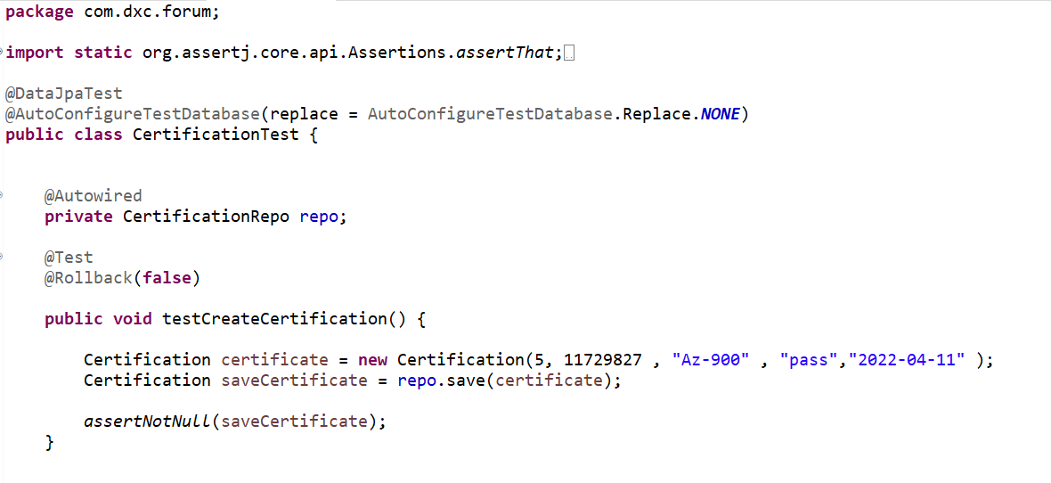

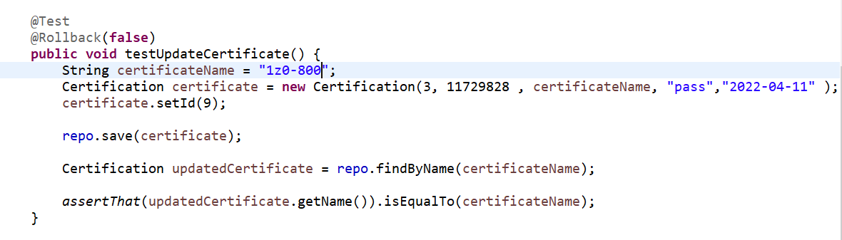

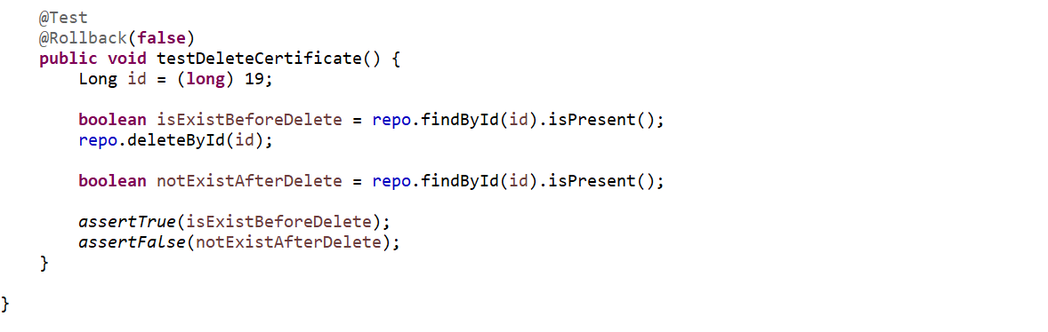

  @Rollblack(false) to disable roll back to the data will be committed to the database and available for the next test methods which will run separately.

assertThat() , assertTrue() , assertFalse() ,assertNotNull() method from AssertJ library for more readability than using JUnit’s assertion methods.

Test Report Result :

