Testing Report – NIFTY 50 ML Trading Guidance Platform
This testing report evaluates the functionality, data accuracy, and decision-support performance of the NIFTY 50 ML trading guidance platform. The system is designed to fetch live market information, apply machine learning-based trade analysis, and present risk-managed guidance for short-term trading decisions. During validation, the screenshots confirm that the core platform components are operating as intended and that the user interface is presenting meaningful market and prediction data.

1. Live Trade Guidance (Co-Pilot)
The Co-Pilot trade panel demonstrates live monitoring of an ADANIPORTS position. It displays the current market price, protected stop-loss level, target value, and live profit/loss, with values updating in real time. The Market Guardian section also provides a clear interpretation of trend direction and entry quality, confirming that the monitoring and alerting layer is functional and effectively communicates trade conditions to the user.
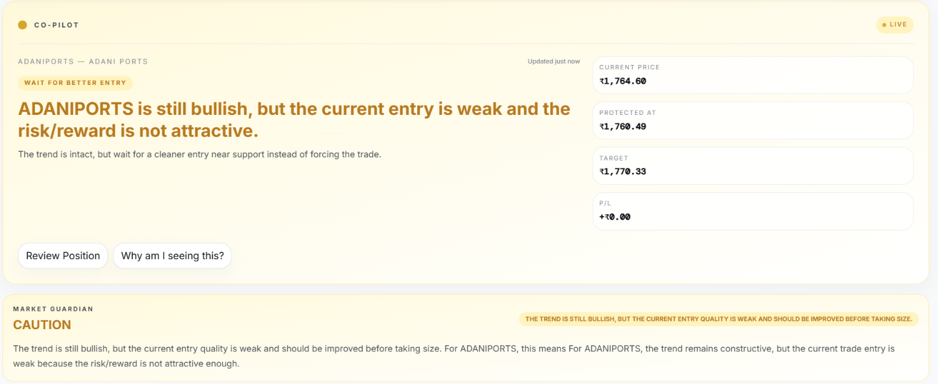

2. Risk Management and ML Prediction Metrics
This screenshot shows the detailed calculations behind the same trade: the dynamic stop-loss and target prices, the ATR (volatility) value, and the risk/reward ratio. It also shows the order analysis (capital required, potential profit, and maximum risk), the position-sizing recommendation, and the machine learning model's output — trade score, confidence, predicted return, and overall market trend. This confirms that the risk-management engine and the ML prediction model are both calculating and displaying results correctly.
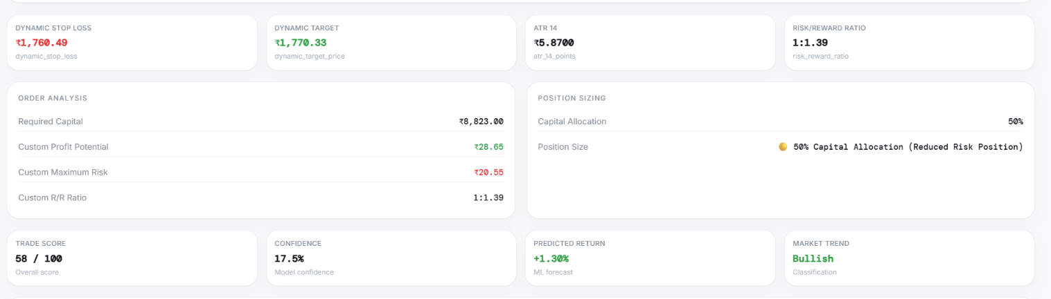

The live stock price values were observed to match the real-time NSE data, confirming that market data is being retrieved correctly. This is a critical validation point because accurate live data ensures that the prediction engine and risk calculations are based on reliable inputs.
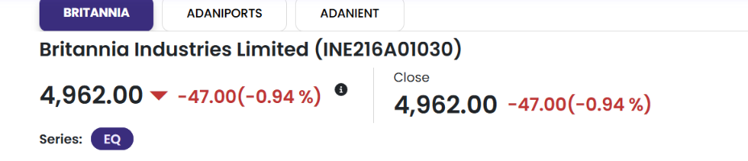

4. Real-Time Stock Prediction Card
This prediction card confirms the real-time analysis of Britannia stock. It includes sector information, current price, price movement, live syncing status, expected return, trade score, confidence level, and risk rating. The consistent update of these values indicates that the prediction card is functioning correctly and is effectively presenting model-generated output to the user.
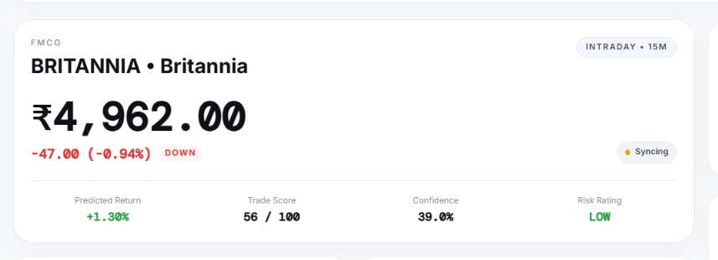

Conclusion
Based on this testing, all the core features of the website — live market data, Co-Pilot trade monitoring, risk-management calculations, and ML-based predictions — are working correctly. The website is functioning as intended and is ready to be demonstrated.

