Testing Report – NIFTY 50 ML Trading Guidance Platform
This testing report evaluates the functionality, data accuracy, and decision-support performance of the NIFTY 50 ML trading guidance platform. The system is designed to fetch live market information, apply machine learning-based trade analysis, and present risk-managed guidance for short-term trading decisions. During validation, the screenshots confirm that the core platform components are operating as intended and that the user interface is presenting meaningful market and prediction data.

1. Live Trade Guidance (Co-Pilot)
The Co-Pilot trade panel demonstrates live monitoring of an ADANIPORTS position. It displays the current market price, protected stop-loss level, target value, and live profit/loss, with values updating in real time. The Market Guardian section also provides a clear interpretation of trend direction and entry quality, confirming that the monitoring and alerting layer is functional and effectively communicates trade conditions to the user.
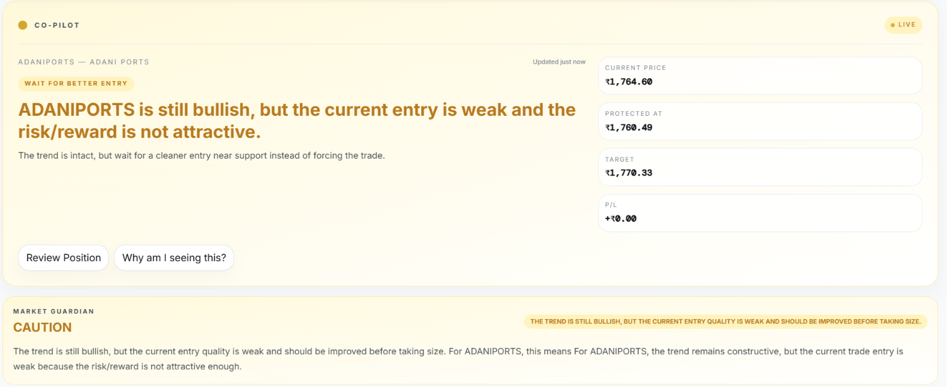

2. Risk Management and ML Prediction Metrics
This section validates the risk-management and model-analysis logic of the platform. It presents the dynamic stop-loss and target levels, ATR-based volatility measure, risk-to-reward ratio, capital requirement, expected profit, maximum risk, position-sizing suggestion, and ML-derived outputs such as trade score, confidence level, predicted return, and overall market trend. The results confirm that the system is calculating and displaying risk controls and prediction metrics correctly for trading decision support.
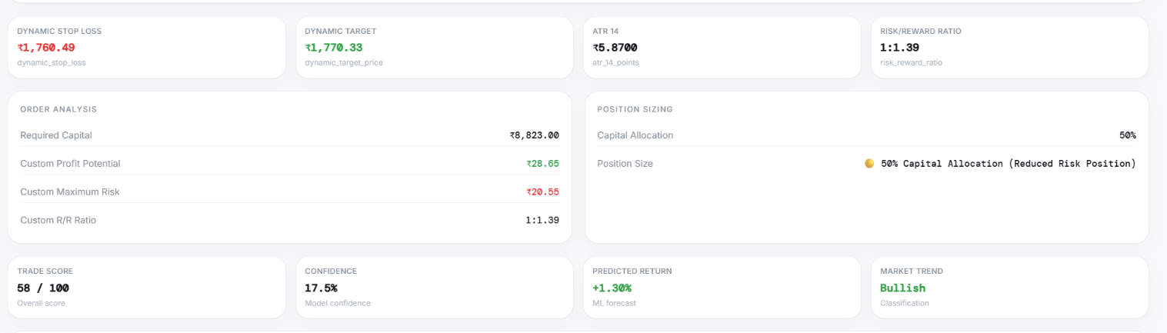

The live stock price values were observed to match the real-time NSE data, confirming that market data is being retrieved correctly. This is a critical validation point because accurate live data ensures that the prediction engine and risk calculations are based on reliable inputs.
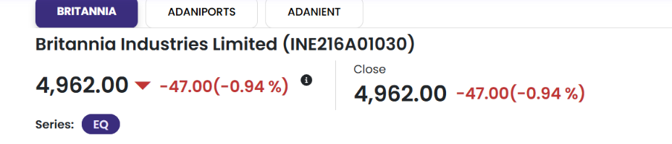

4. Real-Time Stock Prediction Card
This prediction card confirms the real-time analysis of Britannia stock. It includes sector information, current price, price movement, live syncing status, expected return, trade score, confidence level, and risk rating. The consistent update of these values indicates that the prediction card is functioning correctly and is effectively presenting model-generated output to the user.
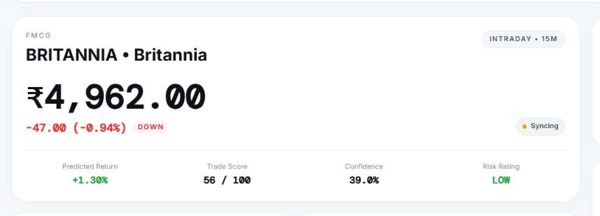

Conclusion
Based on the testing observations, the website successfully demonstrates the principal features expected of a trading decision-support system: live market data integration, real-time position monitoring, risk-management evaluation, and ML-based prediction analysis. The platform is functioning effectively for its intended purpose and provides a practical and useful decision-support experience for NIFTY 50 trading analysis.

