MICROCONTROLLER

& IT’S

APPLICATION

16BEC0195 TASK-2 KUMAR ARYAN L21+L22
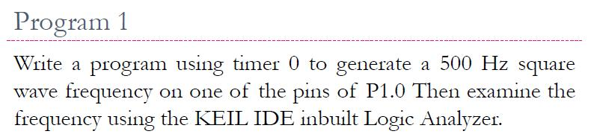

PROGRAM:
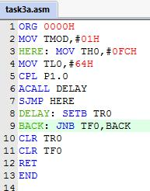

OUTPUT:
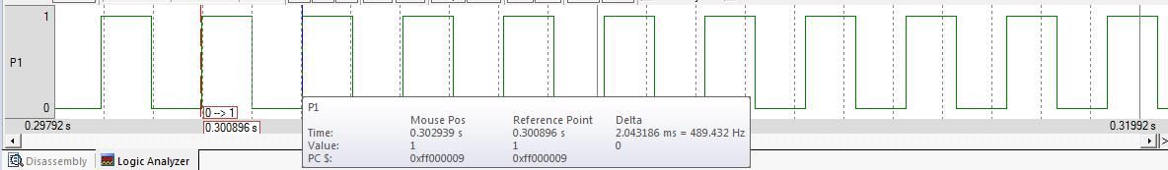
INFERENCE:

- Delay of the TIMER is defined by the oscillating frequency, generally set as 11.0592M Hz.

- Count for the timer is calculated at this frequency only.

- Timer start from the count FC64 reaches value FFFFH, after it roll over and becomes 0000H, and TF = 1, where we stop the timer and clears TF bit.
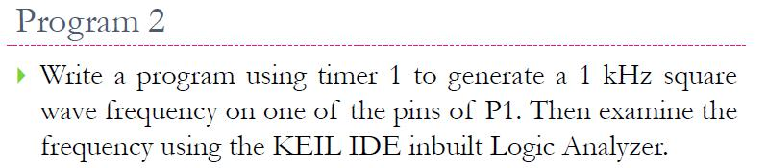

PROGRAM:
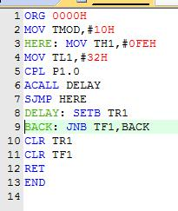

OUTPUT:

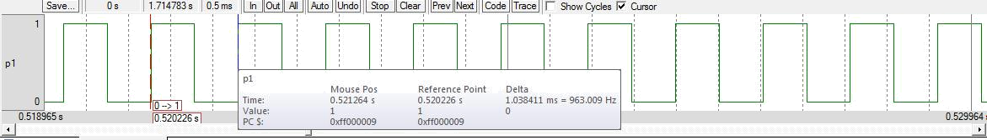

INFERENCE:

- Delay of the TIMER is defined by the oscillating frequency, generally set as 11.0592M Hz.

- Count for the timer is calculated this frequency only.

- Timer start from the count FE32 reaches value FFFFH, after it roll over and becomes 0000H, and TF = 1, where we stop the timer and clears TF bit.
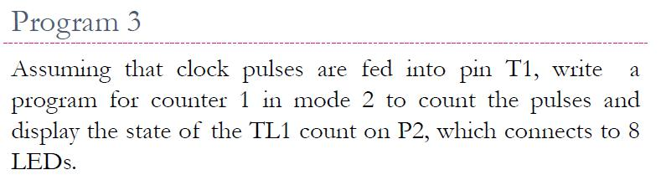

PROGRAM:
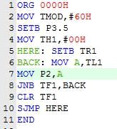

OUTPUT:
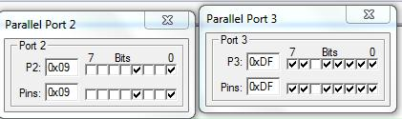

INFERENCE:

As we change the bit of P3.5 externally, it counts and the count value is displayed in binary form in port2.
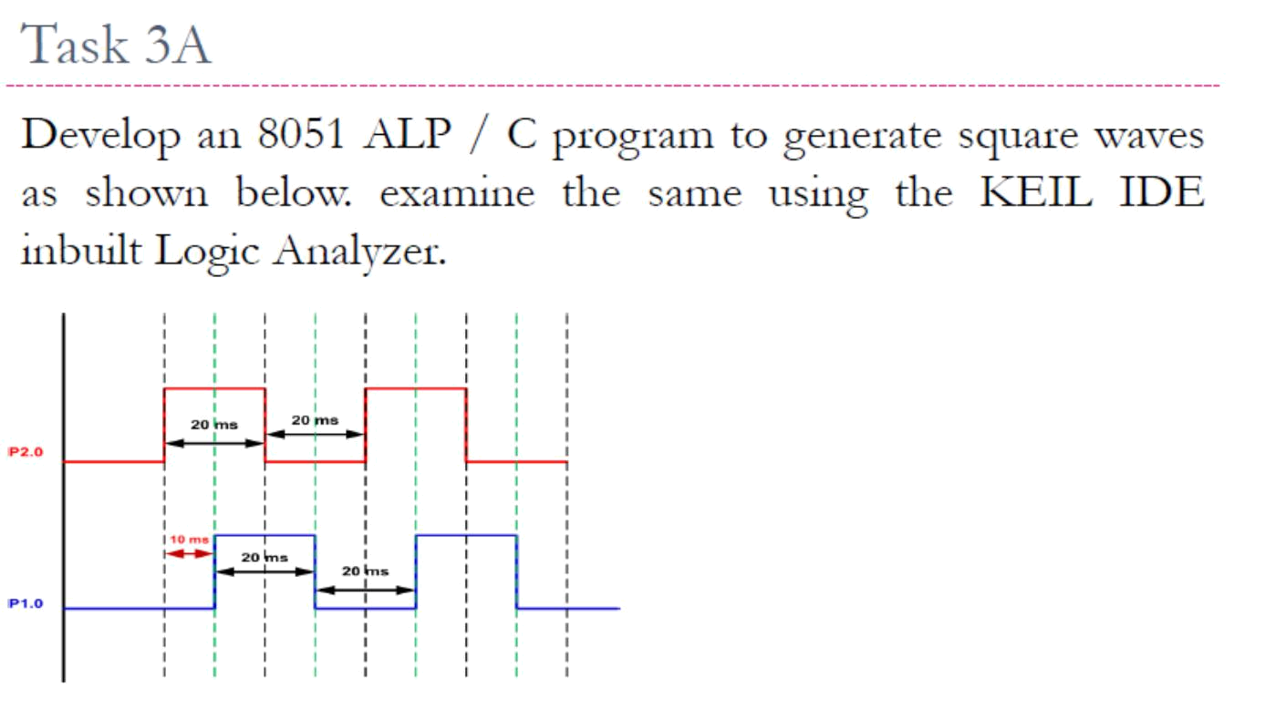

PROGRAM:
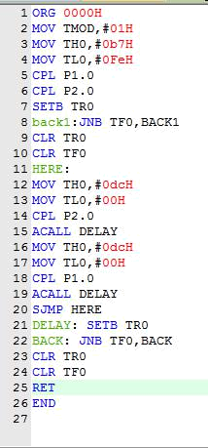

OUTPUT:
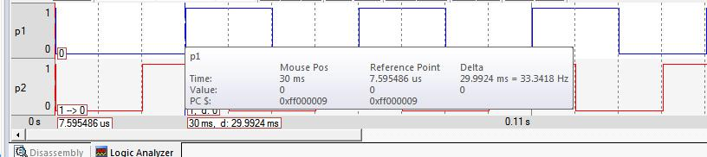

INFERENCE:

The expected graph is obtained by initially plotting 20 ms and then as per the graph changing the values by the count of 10 ms.
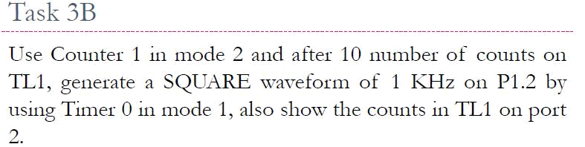

PROGRAM:
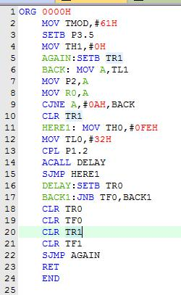

OUTPUT:
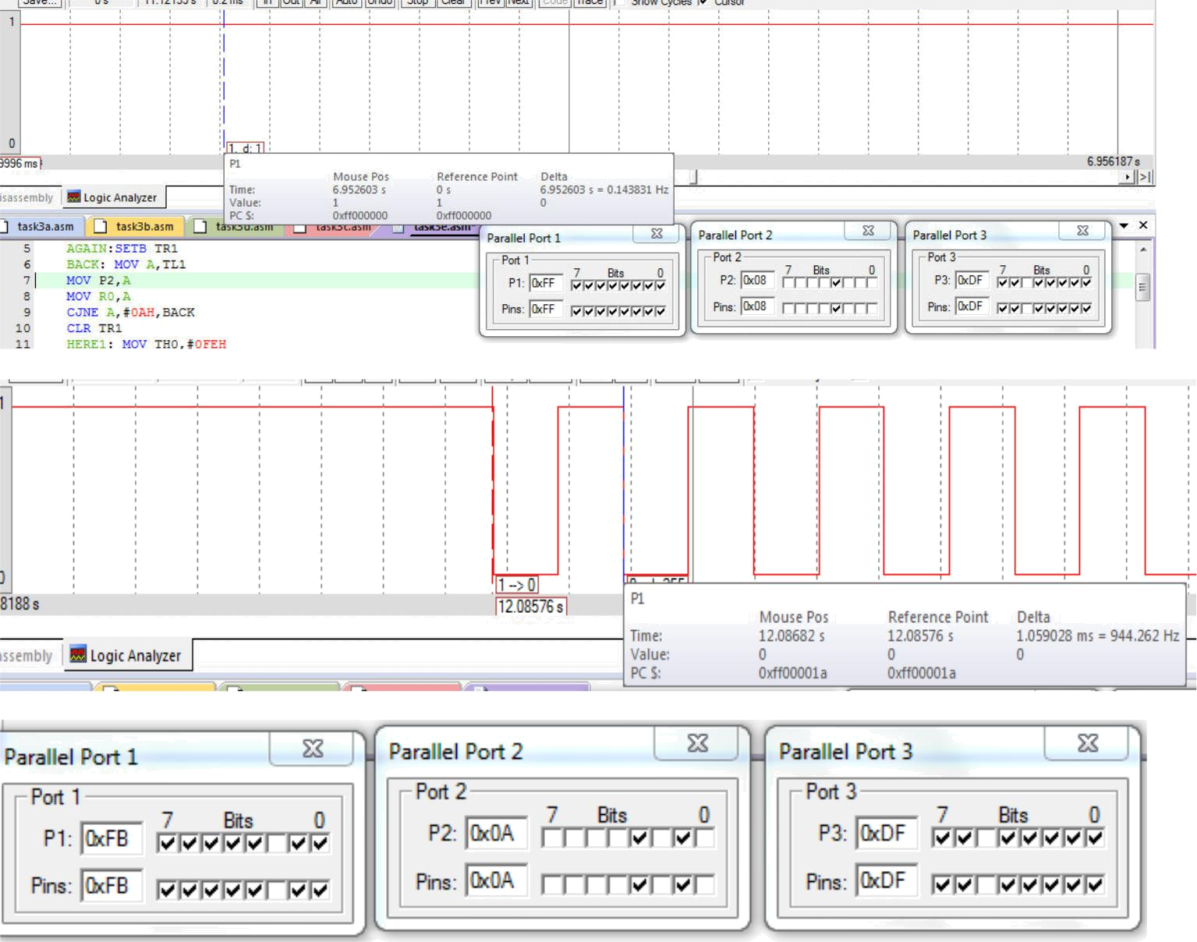

INFERENCE:

For count less than 10 there is no square wave generated but as soon as the count of pulse reaches 10 required square wave is generated.

