PHYSICS PROJECT

Course-Code : PHY1001
Course-Name: Physics for Engineers

School : SENSE
Branch : BTech ECE

Faculty Name : Prof. Murali R

Project Title : LASER Communication System

Group 8 :

16BEC0008 | Nipun Gupta
16BEC0357 | Prakhar Gupta
16BEC0403 | Sanskar Biswal
16BEC0542 | Paridhi Garg
16BEC0581 | Namrata Patel
16BEC0719 | Jayashree Sathiyanathan
16BEC0720 | Saransh Bhatia
16BEC0792 | Nitya Bhargava

Date : 31 August 2016
Wednesday

Project Contents

- Overview of Project
    - The Working Plan of the Project
    - Final Circuit Assembly
    - Expected Diagrammatic Setup of Final Project
    - Feasibility of Project
- Historical background
    - Invention of Laser
    - Developement of Laser based Communication System
    - Current Technologies in Laser Communications
- Theory Involved
    - Theory of LASER Transmission
    - Theory of Reciever Circuit
    - Theory of Multi-Channel Transmission
- Probable Apparatus and Tools to be Used
- Project Approach
    - Drawing Circuit Diagrams
    - Circuit Simulation
    - Cuircuit Assembly and Testing
- Project Testing Parameters

Project Overview

AIM : To design and develop a LASER based Communication System that can send and recieve messages from 1 or 2 other devices without loss of original data.

- The Working Plan of the Project :
The project will be carried out in three stages.
Stage 1 will comprise of carrying out research and drawing of circuits suitable to accomplish the AIM of the project. This will be followed by reduction of circuits to fit on a single module.
Stage 2 is when we shall test our circuits and modules of communication using simulation softwares like Pspice or Multisim.
Stage 3 is when we finally assemble the cicuit using real components and test the modules for their efficiency and functionality.
- Final Circuit Assembly :
Here are the circuit Assembly that is most likely to be used in the project.

LASER Transmitter:

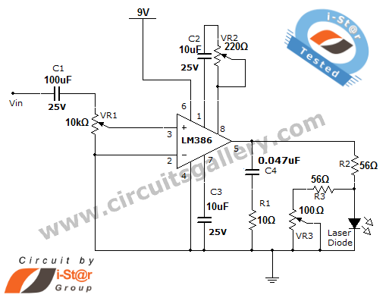
Laser Reciever :
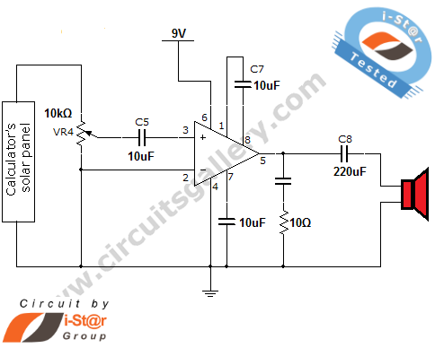

Source : http://www.circuitsgallery.com/2012/06/laser-communication-project-circuit.html

- Diagrammatic Assembly of Final Modules :
The following will be the experimental setup for testing of the outcome of the project.
Module 1
Transmitter
Reciever
Module 2
Transmitter
Reciever

Module 1
Transmitter
Reciever

Intervening Medium will be air.
- Feasibility of Project :
The feasiblity of the project depends on the efficiency of the module and the cost of building and maintaining of apparatus.
From the preliminary research done we can conclude that the cost of components is not going to excessively high and the only cost-excessive part is the circuit fabrication of the modules.
Thus, this project can feasibly be used in places where setting up wired systems is not economically feasible.

Historical Background

- Invention of LASER :
LASER is the abbreviation of Light Amplificatiion by Simulated Emission of Radiation. It was invented by Theodore H. Maiman in 1960 at Hughes Research Labratory.
A LASER consists of a Gain Medium, a mechanism to energise it, and something to provide optical feedback.
Free-Space-Optical Communnication is an optical technology that uses light propagating in free space to transmit data wirelessly for telecommunications or computer-networking.
The first practical use of laser came in optical telegraphy during World War II.
Many simple and inexpensive consumer remote controls use low-speed communication using InfraRed (IR) light.

- Developement of Laser Based Commnication System:
LASER based communication system became a technological necessecity with the advent of Space-Earth Line-of-Sight data transmission.
The pre-reqisite for Space-Earth communication is minimum loss of data. Since LASER’s are a coherent beam of light, it is possible to transmit data with minimum data scattering.
Telecommunication Technologies immediately adopted LASER’s for satellite commuications after 1960.
- Current Technologies in LASER Communication:
Free-space point-to-point optical links can be implemented using infrared laser light, although low-data-rate communication over short distances is possible using LEDs. Infrared Data Association (IrDA) technology is a very simple form of free-space optical communications.
- In 2008, MRV Communications introduced a free-space optics (FSO)-based system with a data rate of 10GB/s initially claiming a distance of 2 km at high availability. This equipment is no longer available; before end-of-life, the product's useful distance was changed down to 350m.
- In 2013, the company MOSTCOM started to serially produce a new wireless communication system that also had a data rate of 10Gb/s as well as an improved range of up to 2.5 km, but to get to 99.99% up-time the designers used an RF hybrid solution, meaning the data rate drops to extremely low levels during atmospheric disturbances (typically down to 10MB/s)

Theory Involved

    - Theory of LASER Transmission:

    - This laser communication system transmits sounds though a laser beam. The intensity of laser beam changes with the amplitude of sound signal.
    - The variation in LASER beam intensity is converted to variation in voltage level by using a calculator’s solar panel.
    - The voltage variation in solar panel is amplified by a low voltage audio power amplifier LM386 and reproduced by speaker.
    - The maximum output of this audio amplifier is 1 watt, while its voltage gain is 20 to 200.
    - Here a laser diode with maximum operating voltage of 2.6 volts and maximum operating current of 45 mA is used to transmit the audio signal.
    - The voltage divider formed by R2, R3, VR3 keeps the voltage as well as the current for the laser diode. Potentiometer VR1 is used to change the level of the input audio signal. You can apply the input audio signal from mic, CD player or any other device.
    - Capacitor C2 and preset VR2 are used to vary the gain of the amplifier IC.
    - Theory of Reciever Circuit:
        - The transmitted light is received by calculator’s solar panel and amplified by the LM386 IC.
        - The gain of the amplifier is fixed by capacitor C7.
        - Preset VR4 is used to change the signal level from solar panel.
        - C5 acts as coupling capacitor, it removes the DC voltages from the solar panel.
        - The output is fed to speaker via another coupling capacitor C8.
    - Theory of Multi-Channel Transmission:
        - This is the actual challenge of the project.
        - We have to design and develop a reciever and a transmitter that can identify and send data to a different communication module.
        - This can be achieved by dedicating a particular frequency for each module.
        - The other potential alternate to this is to have a data-hub or tower thorugh which all data passes. Thus the hub will have data of which frequency is free to transmit and receive from a module.

Module 1

Probable Apparatus and Tools

- Circuit Components:
    - LM386 IC x 2
    - Potentio meters (VR1=10k Ω, VR4=10k Ω)
    - Presets (VR2=220 Ω)
    - Resistors (10Ω x 2, 56 Ω x 2)
    - Capacitors (100µF-25V, 10µF-25V x 5, 0.047µF x 2, 220µF-25V)
    - Calculator’s solar panel
    - Laser diode
    - Speaker (8 Ω, 0.5W)
- Software Used:
    - Pspice - Circuit Simulation
    - MultiSim 11.0 Evaluation Version
    - MATLAB 2009b
- Other Equipments:
    - BreadBoard
    - PCB
    - Solder Gun
    - Antenna/Reciever

Project Approach

- Drawing Circuit Diagrams:
All individual circuits will be drawn and simplified to the maximum extent. An analysis of the circuit will be done to learn of the real signficance of the circuit components.
- Circuit Simulation:
The analysed circuits will then be simulated using a simulation tool. The results from the simulation will be tallied with the calculated results within an error margin not exceeding 2%.
- Circuit Assembly and Testing:
Finally we shall assemble the circuit on a breadboard. If the results are found to be within experimental parameters, the modules will be assembled and soldered onto PCB’s for final testing and evaluation.

Testing Parameters

The project model will be tested along the following parameters:
- The module must be able to transmit and receive data with an effciency loss not exceeding 25%.
- A single module should be able to send and receive data from multiple modules and recognize the source of each module.
- Finally, the modules must not be burdened by data traffic.
- Data may be binary or text or audio. Data must be handled at the modules.

