A MINI PROJECT REPORT
ON
LASER BASED COMMUNICATION SYSTEM



Ch.Ravi Kishore (Y8EC223)

DEPARTMENT OF ELECTRONICS AND COMMUNICATIONS
ENGINEERING
KONERU LAKSHMAIAH COLLEGE OF ENGINEERING
(AUTONOMOUS)
Green Fields, Vaddeswaram P.O, Guntur Dt-522 502

CONTENTS

1. ABSTRACT …………………………… 01
2. GENERAL …………………………… 02
3. CIRCUIT DIAGRAM …………………………… 03
&COMPONENTS
4. CONSTRUCTION ………………………….. 06
5. PROJECT DESCRIPTION ………………………….. 07
6. DETAILS OF COMPONENTS ………………………… 12
- Laser light
- Condenser mic
- Resistors
- Capacitors
- Opamp 741,386
- Transistors
7. PERFOMANCE ……………………… 25
8. APPLICATIONS …..…………………… 25
9. DRAWBACKS ………………………. 25
10. FINAL RESULT ………………………… 25
11. BIBILOGRAPHY ………………………… 26

ABSTRACT
Using this circuit you can communicate with your neighbors wirelessly. Instead of RF signals, light from a laser torch is used as the carrier in the circuit. The laser torch can transmit light up to a distance of about 500 meters. The phototransistor of the receiver must be accurately oriented towards the laser beam from the torch. If there is any obstruction in the path of the laser beam, no sound will be heard from the receiver. The transmitter circuit (Fig. 1) comprises condenser microphone transistor amplifier BC548 (T1) followed by an opamp stage built around μA741 (IC1). The gain of the op-amp can be controlled with the help of 1-mega-ohm pot meter VR1. The AF output from IC1 is coupled to the base of transistor BD139 (T2), which, in turn, modulates the laser beam. The transmitter uses 9V power supply. However, the 3-volt laser torch (after removal of its battery) can be directly connected to the circuit—with the body of the torch connected to the emitter of BD139 and the spring-loaded lead protruding from inside the torch to circuit ground. The receiver circuit (Fig. 2) uses an NPN phototransistor as the light sensor that is followed by a two-stage transistor preamplifier and LM386-based audio power amplifier. The receiver does not need any complicated alignment. Just keep the phototransistor oriented towards the remote transmitter’s laser point and adjust the volume control for a clear sound. To avoid 50Hz hum noise in the speaker, keep the phototransistor away from AC light sources such as bulbs.
GENERAL
Laser communications systems are wireless connections through the atmosphere. They work similarly to fiber optic links, except the beam is transmitted through free space. While the transmitter and receiver must require line-of-sight conditions, they have the benefit of eliminating the need for broadcast rights and buried cables. Laser communications systems can be easily deployed since they are inexpensive, small, low power and do not require any radio interference studies. The carrier used for the transmission signal is typically generated by a laser diode. Two parallel beams are needed, one for transmission and one for reception. Due to budget restrictions, the system implemented in this project is only one way.
Laser communications have been a hot topic lately, as solutions for how to satisfy ever increasing bandwidth needs are in high demand. Some have suggested that bandwidth could be distributed in neighborhoods by putting laser communication systems on top of homes and pointing them towards a common transceiver with a fast link to the Internet. With possible transmit speeds of up to a gigabit per second, this is an exciting area. Other applications for this technology include temporary connectivity needs (e.g. sporting events, disaster scenes, or conventions), or space based communications.
Using this circuit you can communicate with your neighbors wirelessly. Instead of RF signals, light from a laser torch is used as the carrier in the circuit. The laser torch can transmit light up to a distance of about 500 meters. The phototransistor of the receiver must be accurately oriented towards the laser beam from the torch. If there is any obstruction in the path of the laser beam, no sound will be heard from the receiver. The transmitter circuit (Fig. 1) comprises condenser microphone transistor amplifier BC548 (T1) followed by an opamp stage built around μA741 (IC1). The gain of the op-amp can be controlled with the help of 1-mega-ohm pot meter VR1. The AF output from IC1 is coupled to the base of transistor BD139 (T2), which, in turn, modulates the laser beam. The transmitter uses 9V power supply. However, the 3-volt laser torch (after removal of its battery) can be directly connected to the circuit—with the body of the torch connected to the emitter of BD139 and the spring-loaded lead protruding from inside the torch to circuit ground. The receiver circuit (Fig. 2) uses an NPN phototransistor as the light sensor that is followed by a two-stage transistor preamplifier and LM386-based audio power amplifier. The receiver does not need any complicated alignment. Just keep the phototransistor oriented towards the remote transmitter’s laser point and adjust the volume control for a clear sound. To avoid 50Hz hum noise in the speaker, keep the phototransistor away from AC light sources such as bulbs.
CIRCUIT DIAGRAMS
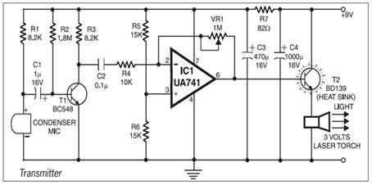
TRANSMITTER CIRCUIT
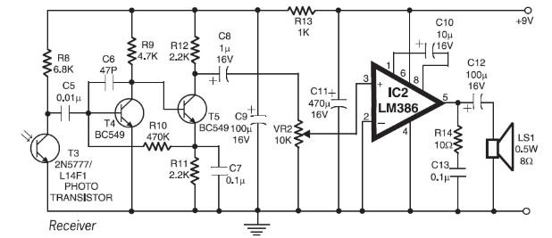
RECEIVER CIRCUIT

COMPONENTS LIST:
- NAME QUANTITY
- Ics 2
- Photo transistor(led) 1
- Resistors 11
- Battery 2(9.0V)
- Mic 1
- Speaker 1
- Transistors 4

❖ SEMICONDUCTORS
IC1 … UA741 OP-AMP
IC2 … LM386 AUDIO POWER AMPLIFIER
T1 … BC548 NPN TRANSISTOR

T2 ... BD139 POWER TRANSISTOR (HEAT SINK)
T4, T5 … BC549 NPN AMPLIFIER TRANSISTOR

❖ RESISTORS (All ¼ watt, 5% carbon, unless stated otherwise)
R1, R3 … 8.2KΩ
R2 … 2.2MΩ
R4 … 10KΩ
R5, R6 … 15KΩ
R7 … 82Ω
R8 … 6.8KΩ
R9 … 4.7KΩ
R10 … 470KΩ
R11, R12 … 2.2KΩ
R13 … 1KΩ
R14 … 10Ω
VR1 … 1MΩ
VR2 … 10KΩ
❖ CAPACITORS
Electrolytic Capacitor:
C1, C8 … 1μF, 16V
C3, C11 … 470μF, 16V
C4 … 1000μF, 16V
C9, C12 … 100μF, 16V
C10 … 10μF, 16V
Ceramic Capacitors:
C2, C13 … 0.1μF
C5, C7 … 0.01μF
C6 … 47pF
❖ MISCELLANEOUS
CONDENSER MIC
LASER TORCH OF 3 VOLT
SPEAKER – 0.5W, 8Ω

Construction:
Step in PCB designing
- The circuit to be fabricated out is board through carbon paper on PCB sheet.
- The carbon print is covered using permanent marker.
- Make a solution of ferric chloride (fecl3) in tray.
- Dip the PCB neatly in step 2 in the solution and mounting in continuously.
- Continue step 4 until the copper (except under permanent marker).
- Wash PCB with water, PCB is ready.
- Drill the hulls so that the component can be mounted.
- Mount the components.
- Soldering in done make the final circuit ready.

Tips in follow while soldering
1. While soldering ics always keep temperature b/w 150-250c.
2. During the soldering of component keep the temperature
B/w 250-350c.
3. Always take care that form does not get shorted while soldering.
4. Soldering should be thinner to be diameter.
5. For soldering use a soldering station is 10-25watt.
6. Solder wire should be of 60/40 where tin should 60% and lead should 40%.

PROJECT DESCRIPTION :
- LASER BASED VOICE TRANSMITTER
➢ The circuit is based upon the principle of LIGHT MODULATION where instead of radio frequency signals; light from a laser torch is used as the carrier in the circuit.
➢ Here, the transmitter uses 9V power supply.
➢ Audio signal or voice is taken as input from the condenser mic, which is, followed transistor amplifier BC548 along with op-amp stage built around UA741.
➢ The gain of the op-amp can be controlled with the help of 1 mega ohms pot meter.
➢ The AF output from op-amp UA741 is coupled to the base of the power transistor BD139, which in turn, modulates the laser.
➢ However, the three volts laser torch can be directly connected to the emitter of BD139 and the spring loaded lead protruding from inside the torch to the ground.

➢ In the transmitter circuit, audio signal of the non-sinusoidal waveform and having a few mV of amplitude is taken as input from condenser mic.
➢ Condenser mic is directly followed by the transistor amplifier stage consist of BC548. Transistor BC548 is connected in common emitter configuration.
➢ Resistor R1 is the source resistor, which is directly connected to the power-supply.
➢ R2, R3 and capacitor C1 are acting as self-biasing circuits, which is used for the biasing transistor. These circuit arrangements provide or establish a stable operating point. The biasing voltage is obtaining by R2 and R3 resistors network. Self-bias is used for obtaining entire audio signal as input.
➢ Capacitor C1 is the coupling capacitor, since audio input signal is having a non-sinusoidal waveform of different amplitude and frequency, coupling capacitor is used to reject some of the dc noise/line as well as level from audio input signal.
➢ The self-biased circuit is connected with the BC548 in CE configuration. It is transistor amplifier stage, where the low amplitude audio signal is amplified to the desired voltage.
➢ The output is taken from the collector terminal; so inverted audio input signal is obtained.
➢ Transistor pre-amplifier stage is coupled with op-amp stage built by ua741. C2 is the blocking capacitor while R4 is the op-amp stage resistor. Op-amp ua741 is easily available general-purpose operational amplifier.
➢ Pin configuration of UA741 is shown in the glossary. Here pin no. 1 and 5 are not connected in order to nullify input-offset voltage. Pin no. 7 and 4 are VCC as well as –VEE supply voltage. Pin no. 3 is non-inverting input while pin no. 2 is inverting input. Between pin no. 2 and 6, 1 mega-ohm pot meter is connected as voltage series negative feedback, which controls the infinite gain of the op-amp.
➢ Resistors R5 and R6 of its value acts as a voltage-divider network, thus it gives a fixed voltage at the non-inverting pin.
➢ Input inverted audio signal is applied to the inverting pin. Op-amp works on the differences into the applied two input voltage and provide an output at pin no. 6. Since, input is applied to the inverting pin the output is also an inverting one. Thus, again we get in phase high power and high amplitude level audio signal.
➢ Capacitors C3, C4 and resistor R7 are acting as diffusion capacitors and feedback resistor respectively. These diffusion capacitors stored the carriers like holes and electrons in the base and thus provide self-biasing of the transistor.

➢ Power dissipation rate of UA741 is very high, which is not practical for driving other electronics devices, so heat sink power transistor BD139 is used.
➢ Power transistor BD139 absorbs most of the power and supplies the suitable power to drive the laser torch.
➢ This in turns modulates the laser beam, since laser torch acts like a balanced modulator, where two signals – one is message signal (audio signal) and carrier laser signal, superimposed. So, laser beam modulates and transmits the signals to large distances.
- LASER BASED VOICE RECEIVER
➢ The receiver circuit uses an NPN phototransistor (2N5777) as the light sensor.
➢ Here, the phototransistor receives the audio signal of low power and low amplitude that is followed by a two-stage transistor pre-amplifier.

➢ In the pre-amplifier stage R8 is a source resistor, which is directly connected to the power supply.
➢ The pre amplifier stage is RC coupled amplifier in CE configuration.
➢ C5, C6 are the junction capacitances, which are taken in to the account when we consider high frequency response, which is limited by their presence.
➢ Resistors R9 and R12 are used to establish the biasing of the transistor BC549.
➢ R11 is self-bias resistor, which is used to avoid degeneration.
➢ C7 is a bypass capacitor, which acts as to prevent loss of amplification due to negative feedback arrangement.
➢ Transistors BC549 are the amplifier transistors, which amplifies the signal because the signal obtained by the phototransistor is of few mV.
➢ C8 is the blocking capacitor, which is connected to the variable resistor VR2, which in turn followed by audio power amplifier IC LM386. Pin configuration of LM386 is shown in the glossary.

➢ Pin no. 1 and 10 is followed by C10, which is an external capacitor, used to compensate internal error amplifier and thus avoid instability.

➢ Volume control can be adjusted from variable resistor VR2 of 10 kilo- ohms.
➢ LM386 provides suitable power output useful for drive the loudspeaker of 0.5W.
➢ From the pin no. 5, the high power as well as suitable amplitude received audio signal is taken as output.
➢ R14 and C13 are bypass arrangement used to prevent loss of amplification.
➢ C12 capacitor is used for preventing the noise as well as the hum produced by the ac sources.
➢ From the loudspeaker, the audio output is heard.

DETAILS OF CPMPONENTS:-
Laser Light:
Laser light is very different from normal light. Laser light has the following properties:

- The light released is monochromatic. It contains one specific wavelength of light (one specific color). The wavelength of light is determined by the amount of energy released when the electron drops to a lower orbit.

- The light released is coherent. It is “organized” -- each photon moves in step with the others. This means that all of the photons have wave fronts that launch in unison.

- The light is very directional. A laser light has a very tight beam and is very strong and concentrated. A flashlight, on the other hand, releases light in many directions, and the light is very weak and diffuse.

To make these three properties occur takes something called stimulated emission. This does not occur in your ordinary flashlight -- in a flashlight, all of the atoms release their photons randomly. In stimulated emission, photon emission is organized.
The photon that any atom releases has a certain wavelength that is dependent on the energy difference between the excited state and the ground state. If this photon (possessing a certain energy and phase) should encounter another atom that has an electron in the same excited state, stimulated emission can occur. The first photon can stimulate or induce atomic emission such that the subsequent emitted photon (from the second atom) vibrates with the same frequency and direction as the incoming photon.
The other key to a laser is a pair of mirrors, one at each end of the lasing medium. Photons, with a very specific wavelength and phase, reflect off the mirrors to travel back and forth through the lasing medium. In the process, they stimulate other electrons to make the downward energy jump and can cause the emission of more photons of the same wavelength and phase. A cascade effect occurs, and soon we have propagated many, many photons of the same wavelength and phase. The mirror at one end of the laser is "half-silvered," meaning it reflects some light and lets some light through. The light that makes it through is the laser light.

Condenser Microphones:
Condenser means capacitor, an electronic component which stores energy in the form of an electrostatic field. The term condenser is actually obsolete but has stuck as the name for this type of microphone, which uses a capacitor to convert acoustical energy into electrical energy
Condenser microphones require power from a battery or external source. The resulting audio signal is stronger signal than that from a dynamic. Condensers also tend to be more sensitive and responsive than dynamics, making them well-suited to capturing subtle nuances in a sound. They are not ideal for high-volume work, as their sensitivity makes them prone to distort.

How Condenser Microphones Work
A capacitor has two plates with a voltage between them. In the condenser mic, one of these plates is made of very light material and acts as the diaphragm. The diaphragm vibrates when struck by sound waves, changing the distance between the two plates and therefore changing the capacitance. Specifically, when the plates are closer together, capacitance increases and a charge current occurs. When the plates are further apart, capacitance decreases and a discharge current occurs.
A voltage is required across the capacitor for this to work. This voltage is supplied either by a battery in the mic or by external phantom power.

Cross-Section of a Typical Condenser Microphone
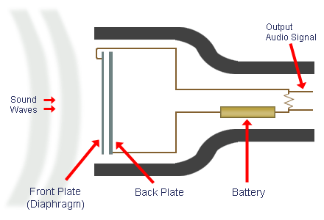

The Elect ret Condenser Microphone
The electret condenser mic uses a special type of capacitor which has a permanent voltage built in during manufacture. This is somewhat like a permanent magnet, in that it doesn't require any external power for operation. However good electret condensers mics usually include a pre-amplifier which does still require power.
Resistors:-A resistor is a two-terminal electronic component that produces a voltage across its terminals that is proportional to the electric current passing through it in accordance with Ohm's law: V = IR
Color | 1st band | 2nd band | 3rd band (multiplier) | 4th band (tolerance) | Temp. Coefficient
Black | 0 | 0 | ×10⁰
Brown | 1 | 1 | ×10¹ | ±1% (F) | 100 ppm
Red | 2 | 2 | ×10² | ±2% (G) | 50 ppm
Orange | 3 | 3 | ×10³ |  | 15 ppm
Yellow | 4 | 4 | ×10⁴ |  | 25 ppm
Green | 5 | 5 | ×10⁵ | ±0.5% (D)
Blue | 6 | 6 | ×10⁶ | ±0.25% (C)
Violet | 7 | 7 | ×10⁷ | ±0.1% (B)
Gray | 8 | 8 | ×10⁸ | ±0.05% (A)
White | 9 | 9 | ×10⁹
Gold |  |  | ×10⁻¹ | ±5% (J)
Silver |  |  | ×10⁻² | ±10% (K)
None |  |  |  | ±20% (M)
Capacitors:-
A capacitor or condenser is a passive electronic component consisting of a pair of conductors separated by a dielectric (insulator). When a potential difference (voltage) exists across the conductors, an electric field is present in the dielectric. This field stores energy and produces a mechanical force between the conductors. The effect is greatest when there is a narrow separation between large areas of conductor; hence capacitor conductors are often called plates.
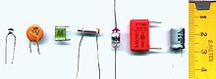
Capacitor materials: - From left: multilayer ceramic, ceramic disc, multilayer polyester film, tubular ceramic, polystyrene, metalized polyester film, aluminum electrolytic.
Operational Amplifier 741:
The Operational Amplifier is probably the most versatile Integrated Circuit available. It is very cheap especially keeping in mind the fact that it contains several hundred components. The most common Op-Amp is the 741 and it is used in many circuits.
The OP AMP is a ‘Linear Amplifier’ with an amazing variety of uses. Its main purpose is to amplify (increase) a weak signal - a little like a Darlington Pair.
The OP-AMP has two inputs, INVERTING (-) and NON-INVERTING (+), and one output at pin 6.

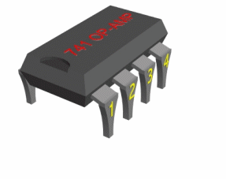
The chip can be used in a circuit in two ways. If the voltage goes into pin two then it is known as an INVERTING AMPLIFIER.
If the voltage goes into pin three then the circuit becomes a NON-INVERTING amplifier
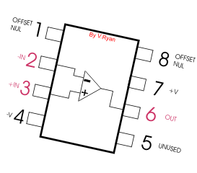
The 741 integrated circuit looks like any other ‘chip’. However, it is a general purpose OP-AMP. You need only to know basic information about its operation and use. The diagram opposite shows the pins of the 741 OP-AMP. The important pins are 2, 3 and 6 because these represent inverting, non-inverting and voltage out. Notice the triangular diagram that represents an Op-Amp integrated circuit.
THE 741 IS USED IN TWO WAYS
1. An inverting amplifier. Leg two is the input and the output is always reversed. In an inverting amplifier the voltage enters the 741 chip through leg two and comes out of the 741 chip at leg six. If the polarity is positive going into the chip, it negative by the time it comes out through leg six. The polarity has been ‘inverted’. 2. A non-inverting amplifier. Leg three is the input and the output is not reversed.
In a non-inverting amplifier the voltage enters the 741 chip through leg three and leaves the 741 through leg three and leaves the 741 chip through leg six. This time if it is positive going into the 741 then it is still positive coming out. Polarity remains the same.

Operational Amplifier 386:
The LM386 is a power amplifier designed for use in low voltage consumer applications. The gain is internally set to 20 to keep external part count low, but the addition of an external resistor and capacitor between pins 1 and 8 will increase the gain to any value from 20 to 200.
The inputs are ground referenced while the output automatically biases to one-half the supply voltage. The quiescent power drain is only 24 mill watts when operating from a 6 volt supply, making the LM386 ideal for battery operation.
The 386 is intended primarily for amplification of low voltage input signals. It is especially useful for audio amplification as its output can directly drive an 8 Ohm speaker. The default gain of the 386 is 20 (that is, the output signal is 20 times greater than the input signal). It can be increased up to 200 by connecting a capacitor across pins 1 and 8. The 386 operates from a single supply voltage; note the unusual location of the supply voltage pin (pin 6). 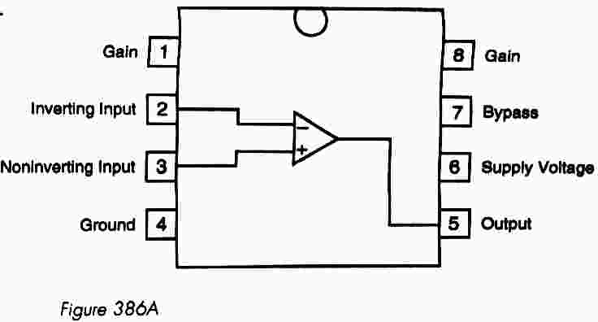
Specifications:
Maximum Supply Voltage: + 4 to +12 Volts
Standard Gain: 20
Maximum Gain: 200

TRANSISTORS:-
During the period 1904–1947, the vacuum tube was undoubtedly the electronic device of interest and development. In 1904, the vacuum-tube diode was introduced by J. A. Fleming. Shortly thereafter, in 1906, Lee De Forest added a third element, called the control grid, to the vacuum diode, resulting in the first amplifier, the triode. In the following years, radio and television provided great stimulation to the tube industry. Production rose from about 1 million tubes in 1922 to about 100 million in 1937. In the early 1930s the four-element tetrode and five-element pentode gained prominence in the electron-tube industry. In the years to follow, the industry became one of primary importance and rapid advances were made in design, manufacturing techniques, high-power and high-frequency applications, and miniaturization. On December 23, 1947, however, the electronics industry was to experience the advent of a completely new direction of interest and development. It was on the afternoon of this day that Walter H. Brattain and John Bardeen demonstrated the amplifying action of the first transistor at the Bell Telephone Laboratories. The original transistor (a point-contact transistor) is shown in. The advantages of this three terminal solid-state device over the tube were immediately obvious: It was smaller 112 and lightweight; had no heater requirement or heater loss; had rugged construction; and was more efficient since less power was absorbed by the device itself; it was instantly Available for use, requiring no warm-up period; and lower operating voltages were possible. Note in the discussion above that this chapter is our first discussion of devices with three or more terminals. You will find that all amplifiers (devices that increase the voltage, current, or power level) will have at least three terminals with one controlling the flow between two other terminals. The transistor is a three-layer semiconductor device consisting of either two n- and one p-type layers of material or two p- and one n-type layers of material. The former is called an npn transistor, while the latter is called a pnp transistor. Both are shown in with the proper dc biasing. We will find in Chapter 4 that the dc biasing is necessary to establish the proper region of operation for ac amplification. The emitter layer is heavily doped, the base lightly doped, and the collector only lightly doped. The outer layers have widths much greater than the sandwiched p- or n-type material. For the transistors shown in Fig. 3.2 the ratio of the total width to that of the center layer is 0.150/0.001 _ 150_1. The doping of the sandwiched layer is also considerably less than that of the outer layers (typically, 10_1 or less). This lower doping level decreases the conductivity (increases the resistance) of this material by limiting the number of “free” carriers For the biasing shown in the terminals have been indicated by the capital letters E for emitter, C for collector, and B for base. An appreciation for this choice of notation will develop when we discuss the basic operation of the transistor. The abbreviation BJT, from bipolar junction transistor, is often applied to this three terminal device. The term bipolar reflects the fact that holes and electrons participate in the injection process into the oppositely polarized material. If only one carrier is employed (electron or hole), it is considered a unipolar device.

Silicon photo transistor:-
Silicon photo transistor is designed for general purpose industrial photo detector applications
Features:

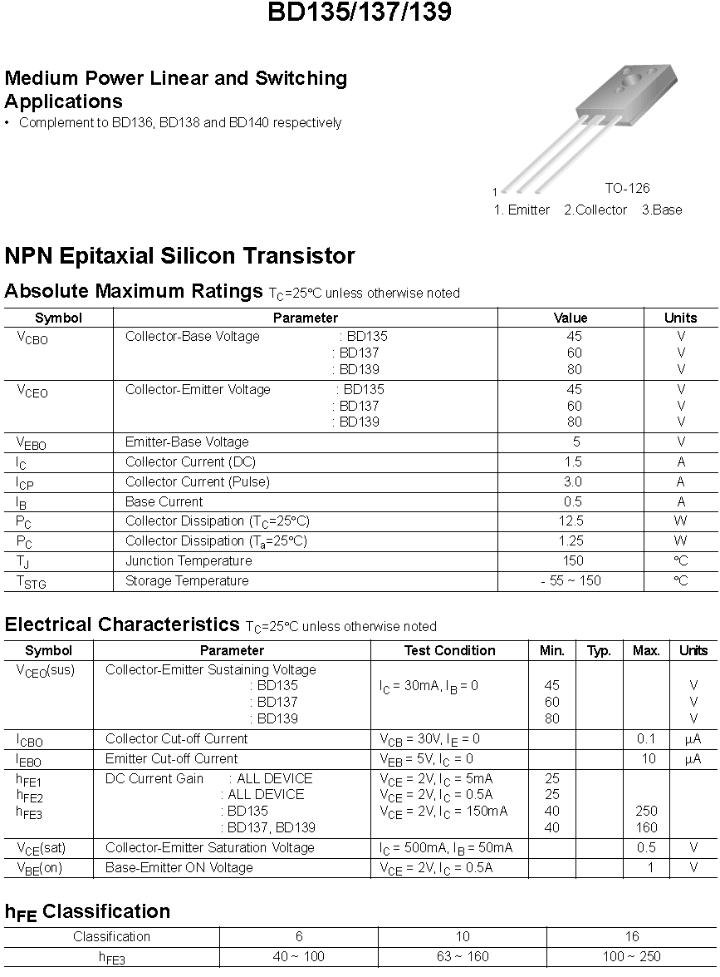

BC549:-
BC548:-

PERFOMANCE:
If the laser is properly aimed at the phototransistor as discussed in the mechanics section, the bit stream is received perfectly. As such text transmission works flawlessly at our largest test distance, across the Digital Systems Lab. Unfortunately, the quality of our focus application (voice transmission) is limited by 3 kHz sampling and 8 bit sound. The speaker on one end is clearly audible on the other, but it takes a trained ear to decipher what he or she is saying.

APPLICATIONS:-
- Can communicate without any cost except the instrument cost.
- It can be used in the places only where one side communication takes place like instructions given to workers etc.
DRAWBACKS:-
- If any obstacles are there in between the medium sound can’t be reached to receiver.

Final Result:-
The receiver and transmitter is successfully prepared on PCB and tested

Bibliography:-
- www.google.com
- Advanced semiconductors.inc
- www.wikipedia.com
- www.howthestuffworks.com
- www.efy.com
- Electronic devices and circuit theory Boylestad
- www.nptel.com

