**MICROCONTROLLER AND ITS APPLICATIONS**

**VARUN AGARWAL**

**16BEC0450**

**Slot : L37+38**

**Faculty: Prof.Chitra P.**

**TASK 5**

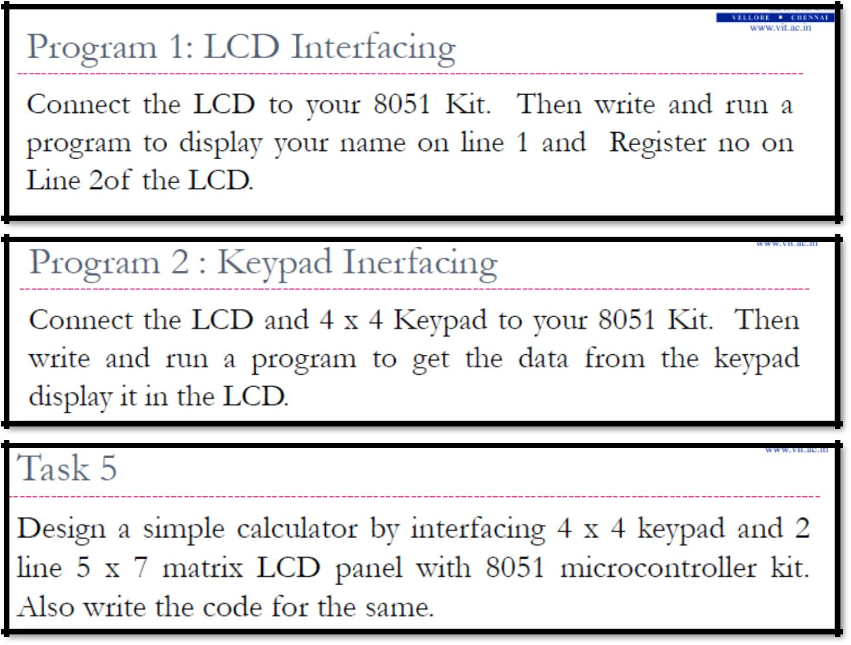

**PROGRAM 1**

ORG 0H

MOV A,#38H

ACALL CMDWRT

ACALL DELAY

MOV A,#0EH

ACALL CMDWRT

ACALL DELAY

MOV A,#01H

ACALL CMDWR

ACALL DELAY

MOV A,#06H

ACALL CMDWRT

ACALL DELAY

MOV A,#084H

ACALL CMDWRT

ACALL DELAY

MOV A,#'V'

ACALL DATAWRT

ACALL DELAY

MOV A,#'A'

ACALL DATAWRT

ACALL DELAY

MOV A,#'R'

ACALL DATAWRT

ACALL DELAY

MOV A,#'U'

ACALL DATAWRT

ACALL DELAY

MOV A,#'N'

MOV A,#0C4H

ACALL CMDWRT

ACALL DELAY

MOV A,#'1'

ACALL DATAWRT

ACALL DELAY

MOV A,#'6'

ACALL DATAWRT

ACALL DELAY

MOV A,#'B'

ACALL DATAWRT

ACALL DELAY

MOV A,#'E'

ACALL DATAWRT

ACALL DELAY

MOV A,#'C'

ACALL DATAWRT

ACALL DELAY

MOV A,#'0'

ACALL DATAWRT

ACALL DELAY

MOV A,#'4'

ACALL DATAWRT

ACALL DELAY

MOV A,#'5'

ACALL DATAWRT

ACALL DELAY

MOV A,#'0'

ACALL DATAWRT

ACALL DELAY

AGAIN: SJMP AGAIN

CMDWRT:MOV P1,A

CLR P2.0

CLR P2.1

SETB P2.2

ACALL DELAY

CLR P2.2

RET

DATAWRT:MOV P1,A

SETB P2.0

CLR P2.1

SETB P2.2

ACALL DELAY

CLR P2.2

RET

DELAY:MOV R3,#255

HERE2: MOV R4,#255

HERE:DJNZ R4,HERE

DJNZ R3,HERE2

RET

END

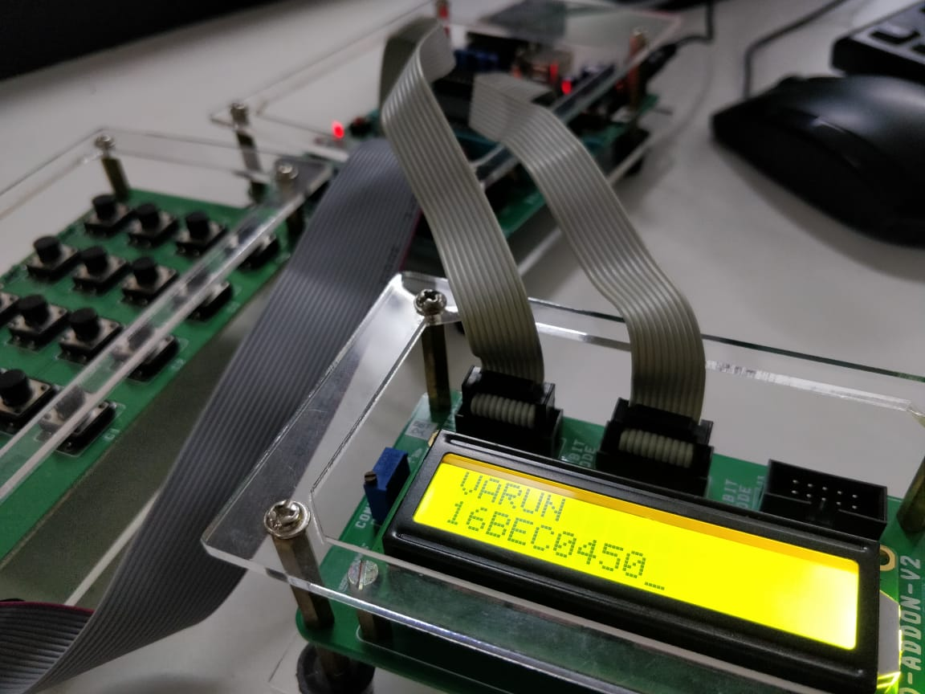

**PROGRAM 2**

ORG 0H

START:

ACALL LCDINIT

ACALL GETKEY

AGAIN: SJMP AGAIN

LCDINIT: MOV A,#38H

ACALL COMNWRT

ACALL DELAY

MOV A,#0EH

ACALL COMNWRT

ACALL DELAY

MOV A,#01

ACALL COMNWRT

ACALL DELAY

MOV A,#06H

ACALL COMNWRT

ACALL DELAY

MOV A,#0C0H

ACALL COMNWRT

ACALL DELAY

MOV A,#'K'

ACALL DATAWRT

ACALL DELAY

MOV A,#'E'

ACALL DATAWRT

ACALL DELAY

MOV A,#'Y'

ACALL DATAWRT

ACALL DELAY

MOV A,#':'

ACALL DATAWRT

ACALL DELAY

RET

COMNWRT:MOV P1,A

CLR P2.0

CLR P2.1

SETB P2.2

ACALL DELAY

CLR P2.2

RET

DATAWRT:MOV P1,A

SETB P2.0

CLR P2.1

SETB P2.2

ACALL DELAY

CLR P2.2

RET

DELAY:MOV R3,#50

HERE2:MOV R4,#255

HERE:DJNZ R4,HERE

DJNZ R3,HERE2

RET

GETKEY: MOV P0,#0FH

REP:MOV P0,#0FH

MOV A,P0

ANL A,#0FH

CJNE A,#0FH,OVER

SJMP REP

OVER:ACALL DELAY

MOV P0,#0FH

MOV A,P0

ANL A,#0FH

CJNE A,#0FH,OVER1

SJMP REP

OVER1:CLR P0.4

SETB P0.5

SETB P0.6

SETB P0.7

MOV A,P0

ANL A,#0FH

CJNE A,#0FH,ROW0

CLR P0.5

SETB P0.7

SETB P0.6

SETB P0.4

MOV A,P0

ANL A,#0FH

CJNE A,#0FH,ROW1

CLR P0.6

SETB P0.7

SETB P0.5

SETB P0.4

MOV A,P0

ANL A,#0FH

CJNE A,#0FH,ROW2

CLR P0.7

SETB P0.4

SETB P0.6

SETB P0.5

MOV A,P0

ANL A,#0FH

CJNE A,#0FH,ROW3

SJMP REP

MOV R0,#04H

ROW0:MOV DPTR,#KCODE0

SJMP FIND

ROW1:MOV DPTR,#KCODE1

SJMP FIND

ROW2:MOV DPTR,#KCODE2

SJMP FIND

ROW3:MOV DPTR,#KCODE3

FIND:RRC A

JNC MATCH

INC DPTR

DJNZ R0,FIND

MATCH:MOV A,#0C4H

ACALL COMNWRT

ACALL DELAY

CLR A

MOVC A,@A+DPTR

ACALL DATAWRT

ACALL DELAY

LJMP REP

ORG 300H

KCODE0: DB 'F','B','8','4' ;ROW 0

KCODE1: DB 'E','A','7','3' ;ROW 1

KCODE2: DB 'D','0','6','2' ;ROW 2

KCODE3: DB 'C','9','5','1' ;ROW 3

END

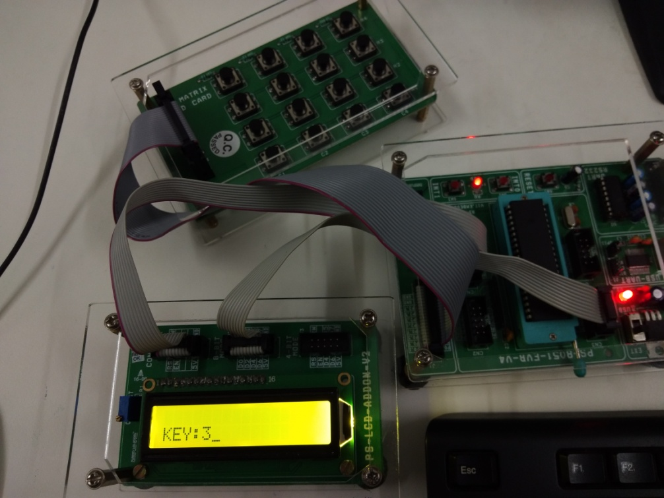

**Program 3**

ORG 0000H

MOV DPTR,#MYCOM

C1: CLR A

MOVC A,@A+DPTR

ACALL COMNWRT

ACALL DELAY

INC DPTR

JZ SEND_DAT1

SJMP C1

SEND_DAT1:

MOV DPTR,#MYDATA

D1: CLR A

MOVC A,@A+DPTR

ACALL DATAWRT

ACALL DELAY

INC DPTR

JZ NEXT

SJMP D1

NEXT: ACALL GETKEY

SUBB A,#30H

MOV R5,A

MOV DPTR,#MYDATA2

MOV A,#0C0H

ACALL COMNWRT

ACALL DELAY

D2: CLR A

MOVC A,@A+DPTR

ACALL DATAWRT

ACALL DELAY

INC DPTR

JZ NEXT2

SJMP D2

NEXT2: ACALL GETKEY

SUBB A,#30H

MOV R6,A

ACALL DELAY

MOV DPTR,#MYCOM

C2: CLR A

MOVC A,@A+DPTR

ACALL COMNWRT

ACALL DELAY

INC DPTR

JZ ADDITION

SJMP C2

ADDITION:MOV A,#080H

ACALL COMNWRT

ACALL DELAY

MOV DPTR,#MYDATA3

D3:CLR A

MOVC A,@A+DPTR

ACALL DATAWRT

ACALL DELAY

INC DPTR

JZ NEXT3

SJMP D3

NEXT3:

MOV A,R6

ADDC A,R5

ADDC A,#30H

ACALL DATAWRT

ACALL DELAY

MOV DPTR,#MYCOM

C3: CLR A

MOVC A,@A+DPTR

ACALL COMNWRT

ACALL DELAY

INC DPTR

JZ MULTIPLICATION

SJMP C3

MOV DPTR,#MYCOM

MUL:MOV A,#080H

ACALL COMNWRT

ACALL DELAY

MOV DPTR,#MYDATA5

D5:CLR A

MOVC A,@A+DPTR

ACALL DATAWRT

ACALL DELAY

INC DPTR

JZ NEXT5

SJMP D5

NEXT5:MOV A,R6

MOV B,R5

MUL AB

ADDC A,#30H

ACALL DATAWRT

ACALL DELAY

AGAIN:SJMP AGAIN

GETKEY:MOV P0,#0FH

REP:MOV P0,#0FH

MOV A,P0

ANL A,#0FH

CJNE A,#0FH,OVER

SJMP REP

OVER:ACALL DELAY

MOV P0,#0FH

MOV A,P0

ANL A,#0FH

CJNE A,#0FH,OVER1

SJMP REP

OVER1:CLR P0.4

SETB P0.6

SETB P0.7

MOV A,P0

ANL A,#0FH

CJNE A,#0FH,ROW0

CLR P0.5

SETB P0.7

SETB P0.6

SETB P0.4

MOV A,P0

ANL A,#0FH

CJNE A,#0FH,ROW1

CLR P0.6

SETB P0.7

SETB P0.5

SETB P0.4

MOV A,P0

ANL A,#0FH

CJNE A,#0FH,ROW2

CLR P0.7

SETB P0.4

SETB P0.6

SETB P0.5

MOV A,P0

ANL A,#0FH

CJNE A,#0FH,ROW3

SJMP REP

MOV R0,#04H

ROW0:MOV DPTR,#KCODE0

SJMP FIND

ROW1:MOV DPTR,#KCODE1

SJMP FIND

ROW2:MOV DPTR,#KCODE2

SJMP FIND

ROW3:MOV DPTR,#KCODE3

FIND:RRC A

JNC MATCH

INC DPTR

DJNZ R0,FIND

MATCH:CLR A

MOVC A,@A+DPTR

ACALL DATAWRT

ACALL DELAY

RET

COMNWRT:MOV P1,A

CLR P2.0

CLR P2.1

SETB P2.2

ACALL DELAY

CLR P2.2

RET

DATAWRT:MOV P1,A

SETB P2.0

CLR P2.1

SETB P2.2

ACALL DELAY

CLR P2.2

RET

DELAY:

MOV R3,#150

HERE2:MOV R4,#255

HERE:DJNZ R4,HERE

DJNZ R3,HERE2

RET

ORG 200H

MYCOM: DB 38H,0EH,01,06,80H,0

MYDATA: DB 'INPUT 1 ',0

MYDATA2: DB 'INPUT 2 ',0

MYDATA3: DB 'ADDITION ',0

MYDATA5: DB 'MUL ',0

ORG 300H

KCODE0: DB '4','3','2','1' ;ROW 0

KCODE1: DB '8','7','6','5' ;ROW 1

KCODE2: DB '3','2','1','9' ;ROW 2

KCODE3: DB '7','6','5','4' ;ROW 3

END

