**“Electronic Voting Machine”**

**PROJECT REPORT**

Submitted for the course: Microcontroller and its Applications (ECE3003)

By

|  |  |
| --- | --- |
| **Name** | **Registration No.** |
| **Sanskar Biswal** | **16BEC0403** |
| **Nitya Bhargava** | **16BEC0792** |

Slot: E1

**Name of faculty**: **Sundar S**



October 2018

**CERTIFICATE**

This is to certify that the project work entitled **“ *Electronic Voting Machine*”** that is being submitted by “Sanskar Biswal(16BEC0403), Venkat Sreevatsav(16BEC0628), Nitya Bhargava (16BEC0792)” for Microcontroller and its Applications (ECE3003) is a record of bonafide work done under my supervision. The contents of this Project work, in full or in parts, have neither been taken from any other source nor have been submitted for any other CAL course.

Place: Vellore

Date: 25/10/18

**Signature of Students**:

Sanskar Biswal(16BEC0403)

Venkat Sreevatsav(16BEC0628)

**Signature of Faculty:**

# 

**ACKNOWLEDGEMENTS**

The student is free to acknowledge all those he feels he should acknowledge on the basis of the guidance and help provided during the implementation of the project. If the student has conducted his project elsewhere (viz. outside VIT) appropriate acknowledgement should be given to all concerned.

It is customary to acknowledge the University Management / respective School Dean for giving the candidate an opportunity to carry out his /her studies at the University.

Sanskar Biswal(16BEC0403)

Venkat Sreevatsav(16BEC0628

Nitya Bhargava (16BEC0792)

# CONTENTS

**1. ABSTRACT …………………………… 05**

**2. INTRODUCTION …………………………… 06**

**3. CIRCUIT DIAGRAM …………………………… 06**

**&COMPONENTS**

**4. PROJECT DESCRIPTION ………………………….. 07**

**5. DETAILS OF COMPONENTS ………………………… 08**

* **Transistor BC547**
* **AT89C51**
* **Seventh Segment Display**

**6. PROCEDURE, ADVANTAGES, LIMITATIONS ….. 10**

**6. BIBILOGRAPHY ………………………… 11**

**ABSTRACT**

Electronic voting machine has now replaced the traditional mechanism of voting due to several advantages like security, automatic counting etc. This project presents a way to develop an electronic voting machine which displays the count of votes on a 4-LED interface. A user can get his/her vote register through a set of switches (one for each candidate). After every cast of vote, the subsequent count can be seen on LED. The circuit uses 8051 microcontroller and the code for the project has been written in C.**INTRODUCTION**

The project is designed for eight contestants. Voters can poll their vote to any one of the contestant. In this project, one port is dedicated for 8 push-button switches for eight contestants, and a master switch for polling officer. A simple yet powerful program is written in assembly language and is burnt onto the microcontroller to accept votes and to keep counting the total votes polled. A Polling-officer switch (master) is provided to avoid multiple polling by a single voter. Every voter gets approval from the polling officer. If the polling officer issues approval with his control switch, then only the voter can poll his vote.  
This topic is chosen in order to understand the practical application of 8051 microcontroller in real world scenario.

**CIRCUIT DIAGRAM**

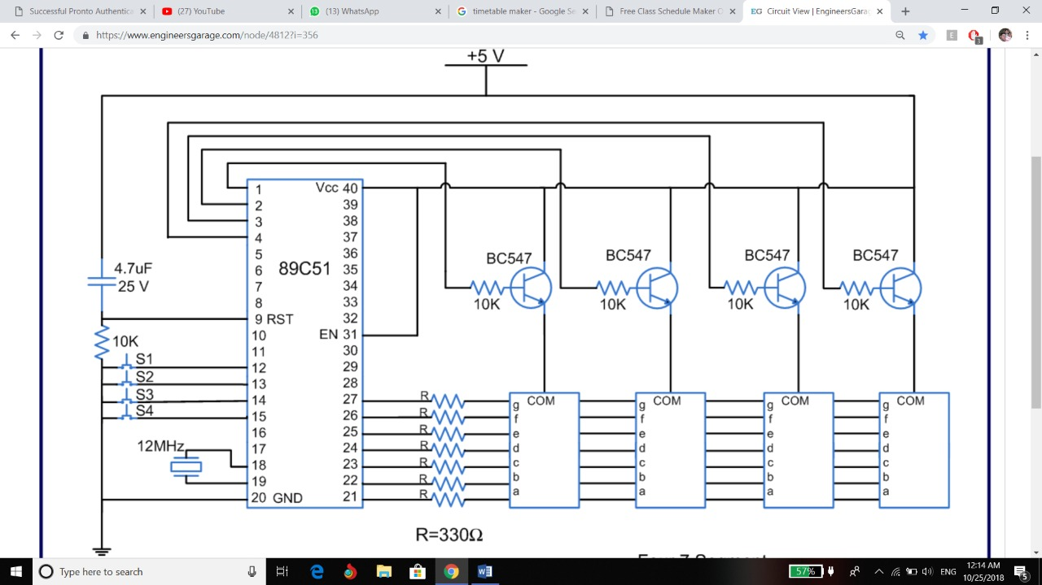

**BLOCK DIAGRAM**

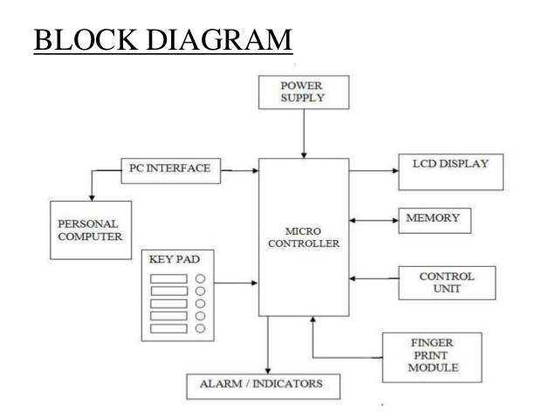

4-LED DISPLAY

**COMPONENTS LIST**

* 8051 series Microcontroller
* Push Buttons
* Transistors
* Transformer
* Voltage Regulator
* LED
* Resistors
* Capacitor
* EEPROM
* Buzzer

http://sagarpanchal.tripod.com/imagelib/sitebuilder/layout/spacer.gif

|  |
| --- |
| **PROJECT DESCRIPTION**  This voting machine is designed for four candidates. The provision of casting vote has been provided by means of four tactile switches. These switches take manual inputs from the user and transfer them to the pins of controller. Based on these inputs, the vote count for different candidates is increased by microcontroller 8051.  To display the vote count, four seven segment displays are also connected to the microcontroller. The count value for each candidate is sent to the corresponding segment. The four counts appear continuously by multiplexing these segments through 8051.  Pins 2-5 of the port P3 are configured to take inputs through switches connected to them. The data pins of the seven segments are connected to port P2. Pins 0-3, of port P1, are configured as output to act as control/enable pins of the seven segments. |

**DETAILS OF COMPONENTS**

1. **Transistor BC547**

BC547 is an NPN bi-polar junction transistor. A transistor, stands for transfer of resistance, is commonly used to amplify current. A small current at its base controls a larger current at collector & emitter terminals.

BC547 is mainly used for amplification and switching purposes. It has a maximum current gain of 800. Its equivalent transistors are BC548 and BC549.

The transistor terminals require a fixed DC voltage to operate in the desired region of its characteristic curves. This is known as the biasing. For amplification applications, the transistor is biased such that it is partly on for all input conditions. The input signal at base is amplified and taken at the emitter. BC547 is used in common emitter configuration for amplifiers. The voltage divider is the commonly used biasing mode. For switching applications, transistor is biased so that it remains fully on if there is a signal at its base. In the absence of base signal, it gets completely off.

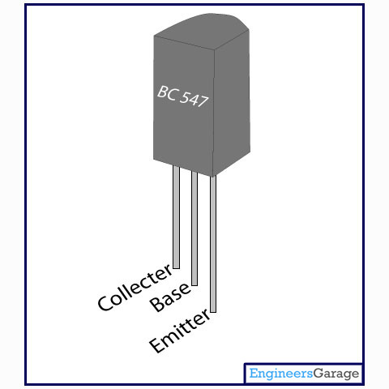

1. **ATMEL 89C51**

AT89C51 is an 8-bit microcontroller and belongs to Atmel's 8051 family. **ATMEL 89C51** has 4KB of Flash programmable and erasable read only memory (PEROM) and 128 bytes of RAM. It can be erased and program to a maximum of 1000 times.

In 40 pin AT89C51, there are four ports designated as P1, P2, P3 and P0. All these ports are 8-bit bi-directional ports, *i.e.*, they can be used as both input and output ports. Except P0 which needs external pull-ups, rest of the ports have internal pull-ups. When 1s are written to these port pins, they are pulled high by the internal pull-ups and can be used as inputs. These ports are also bit addressable and so their bits can also be accessed individually.

Port P0 and P2 are also used to provide low byte and high byte addresses, respectively, when connected to an external memory. Port 3 has multiplexed pins for special functions like serial communication, hardware interrupts, timer inputs and read/write operation from external memory. AT89C51 has an inbuilt UART for serial communication. It can be programmed to operate at different baud rates. Including two timers & hardware interrupts, it has a total of six interrupts.

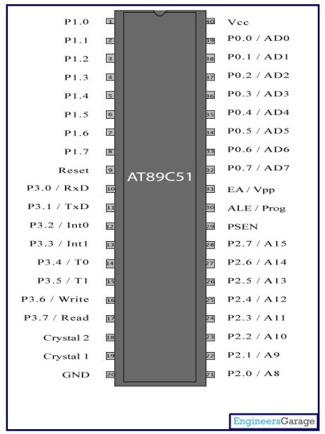

1. **Seven Segment Display**

A **seven segment display** is the most basic electronic display device that can display digits from 0-9. They find wide application in devices that display numeric information like digital clocks, radio, microwave ovens, electronic meters etc. The most common configuration has an array of eight LEDs arranged in a special pattern to display these digits. They are laid out as a squared-off figure ‘8’. Every LED is assigned a name from 'a' to 'h' and is identified by its name. Seven LEDs 'a' to 'g' are used to display the numerals while eighth LED 'h' is used to display the dot/decimal.

 A seven segment is generally available in ten pin package. While eight pins correspond to the eight LEDs, the remaining two pins (at middle) are common and internally shorted. These segments come in two configurations, namely, Common cathode (CC) and Common anode (CA). In CC configuration, the negative terminals of all LEDs are connected to the common pins. The common is connected to ground and a particular LED glows when its corresponding pin is given high. In CA arrangement, the common pin is given a high logic and the LED pins are given low to display a number. Find out more information about a seven segment display and its working.

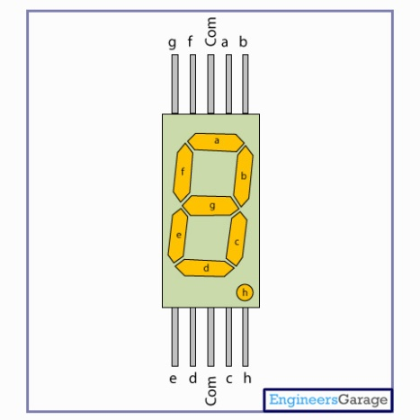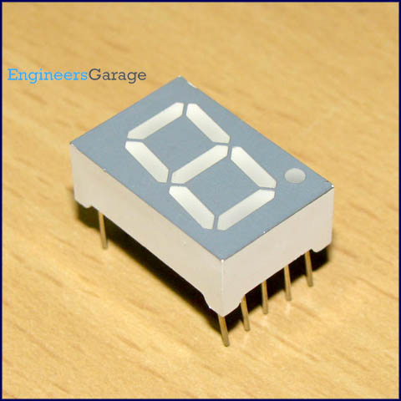

**PROCEDURE**

In this circuit we are using 4-LED for display and 8051 as microcontroller.

* As for giving input we are using Keypad.
* There is Voting portion and Result portion in it.
* In the voting process the voting for different party is started.
* In result one we can show the result of the Voting Process.

**ADVANTAGES**

The cost per EVM was ₹5,500 (equivalent to ₹41,000 or US$640 in 2016) at the time the machines were purchased in 1989–90. The cost was estimated to be ₹10,500 (equivalent to ₹12,000 or US$180 in 2016) per unit as per an additional order issued in 2014. Even though the initial investment was heavy, it has since been expected to save costs of production and printing of crores of ballot papers, their transportation and storage, substantial reduction in the counting staff and the remuneration paid to them. For each national election, it is estimated that about 10,000 tonnes of ballot paper is saved. EVMs are easier to transport compared to ballot boxes as they are lighter, more portable, and come with polypropylene carrying cases. Vote counting is also faster. In places where illiteracy is a factor, illiterate people find EVMs easier than ballot paper system. Bogus voting is greatly reduced as the vote is recorded only once. The unit can store the result in its memory before it is erased manually. The battery is required only to activate the EVMs at the time of polling and counting and as soon as the polling is over, the battery can be switched off. The shelf life of Indian EVMs is estimated at 15 years.

**LIMITATIONS**

A candidate can know how many people from a polling station voted for him. This is a significant issue particularly if lop-sided votes for/against a candidate are cast in individual polling stations and the winning candidate might show favouritism or hold grudge on specific areas. The Election Commission of India has stated that the manufacturers of the EVMs have developed a Totalizer unit which can connect several balloting units and would display only the overall results from an Assembly or a Lok Sabha constituency instead of votes from individual polling stations. ¬ The control units do not electronically transmit their results back to the Election Commission, even though a simple and unconditionally secure protocol for doing this exists. The Indian EVMs are purposely designed as stand-alone units to prevent any intrusion during electronic transmission of results. Instead, the EVMs are collected in counting booths and tallied on the assigned counting day(s) in the presence of polling agents of the candidates.

**SNAPSHOTS WITH SETUP**

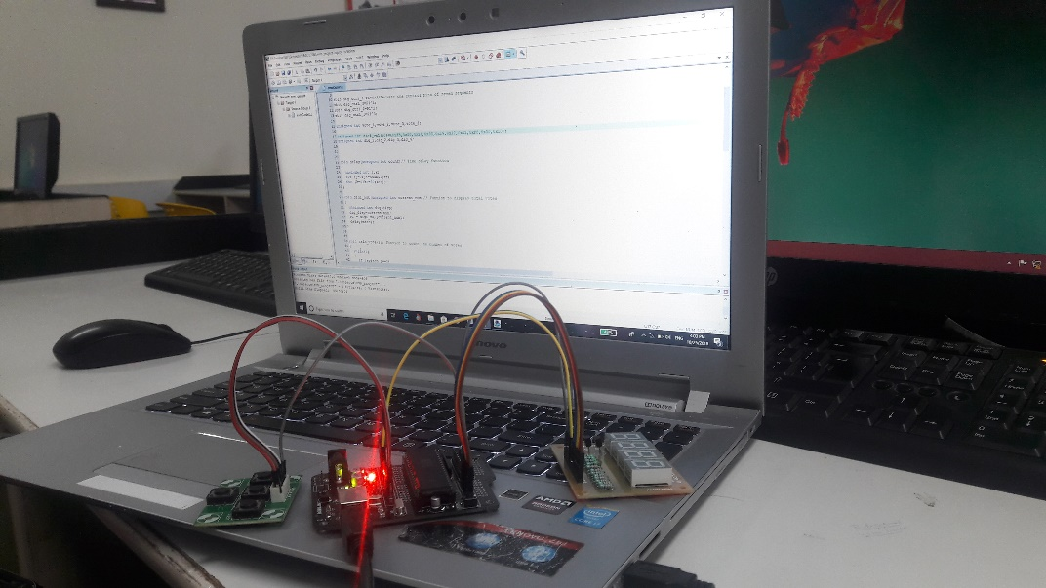

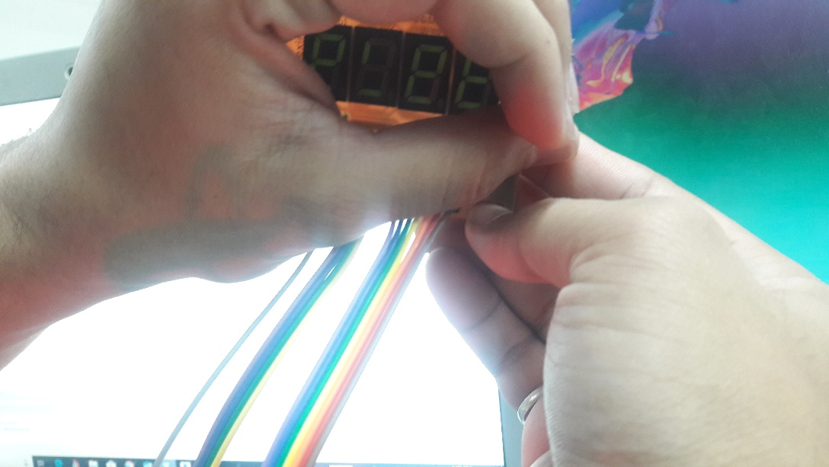

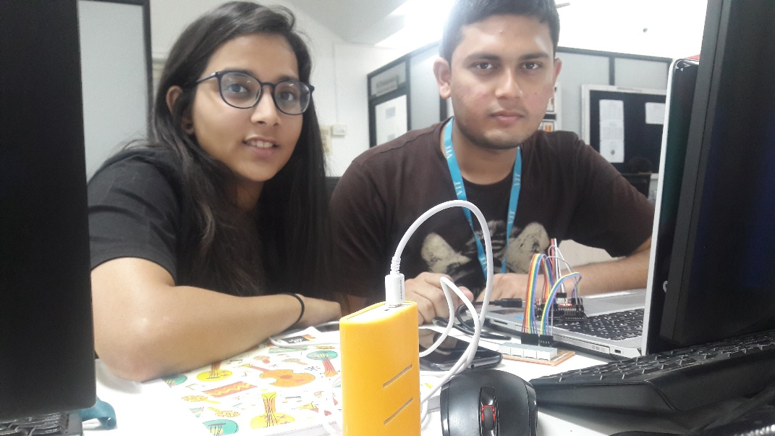

**BIBLIOGRAPHY**

* [**www.keil.com/docs/datashts/atmel/8051**](http://www.keil.com/docs/datashts/atmel/8051)
* [**https://www.tutorialspoint.com/embedded_systems/es_microcontroller.htm**](https://www.tutorialspoint.com/embedded_systems/es_microcontroller.htm)
* [**www.google.com**](http://www.google.com/)