**SHORT-RANGE MOBILITY MODULE FOR THE VISUALLY CHALLENGED**

**PROJECT REPORT**

Submitted for the Course: Semi Conducting Devices and Circuits (ECE1002)

By

|  |  |
| --- | --- |
| **KRISHNAM TIBREWAL** | **16BEC0208** |
| **CHARCHIT ARORA** | **16BEC0315** |
| **PRAKHAR GUPTA** | **16BEC0357** |
| **SANSKAR BISWAL** | **16BEC0403** |
| **NITYA BHARGAVA** | **16BEC0792** |

Slot: A1 + TA1

**Anand S**



April 2017

**CERTIFICATE**

This is to certify that the project work entitled “***SHORT-RANGE MOBILITY MODULE FOR THE VISUALLY CHALLENGED”*** that is being submitted by “***Krishnam Tibrewal, Charchit Arora, Prakhar Gupta, Sanskar Biswal***  and ***Nitya Bhargava***” for Semi Conducting Devices and Circuits (ECE1002) is a record of bonafide work done under my supervision. The contents of this project work, in full or in parts, have neither been taken from any other source nor have been submitted for any other CAL course.

Place: Vellore

Date : April 2017

**Krishnam Tibrewal :**

**Charchit Arora :**

**Prakhar Gupta :**

**Sanskar Biswal :**

**Nitya Bhargava :**

**Anand S :**

**ACKNOWLEDGEMENTS**

The final output of this project would not have been possible without the extensive research that existed open source for use and deployment. Much of the material was obtained from hobbyist websites like

[www.instructables.com](http://www.instructables.com/)

<https://roboindia.com/tutorials/direct.php?route=arduino-ultrasonic-range-sensor-HC-SR04>

<http://blog.circuits4you.com/2016/04/text-to-speech-on-arduino.html>

<https://blogspot.tenettech.com/text-to-speech-using-arduino-and-processing.html>

<http://howtomechatronics.com/tutorials/arduino/ultrasonic-sensor-hc-sr04/>

<http://www.theengineeringprojects.com/2015/02/interfacing-multiple-ultrasonic-sensor-arduino.html>

[www.stackoverflow.com](http://www.stackoverflow.com/)

We would also like to acknowledge the assistance of the store managers at Balaji stationary shop in acquiring all the materials needed to realize the project. We would also like to thank the lab assistants in the physics labs for their assistance in soldering of the PCB components.

Finally, we would want to thank the management of VIT University and the Dean of School of Electronics and Communication Engineering (SENSE) for providing us with the this opportunity to work on this project to the realize the objectives of the given title.

In conclusion, we would also thank our faculty in-charge, Anand S for his guidance and inputs to make our project successful

**Krishanm Tibrewal (16BEC0208)**

**Charchit Arora (16BEC0315)**

**Prakhar Gupta (16BEC0357)**

**Sanskar Biswal (16BEC0403)**

**Nitya Bhargava (16BEC0792)**

**ABSTRACT**

The primary objective of the project is to design a system for industrial use that will aid visually challenged people to navigate around in unfamiliar surroundings. The prototype will be developed to work in a closed space with a short range mobility.

The initial project design was to have a position locating module on a walking stick of the user which by the means of triangulation and gesture guidance and hence let the system compute a guidance path for the user. However on further analysis and project development we found that the chosen method was not a feasible alternative to the problem. In addition, the implementation of the chosen method could not be extended to real-life scenarios involving multiple users and actors.

Thus an alternate prototype was designed and modelled to facilitate the objective of the project. Thus the final working prototype was designed such that the module can be fitted as the buckle of the belt of the user. This module comprises of an ultrasonic sensor module which computes the distance of the user from any major obstacle and depending on the distance from the obstacle, suggest the best alternate course to be taken. This information will be conveyed to the user via a speech module. The developed prototype has a working range and accuracy of up to 2 meters and the module developed is larger in size than expected. This can however be rectified by miniaturizing the speech delivery module.

**Introduction**

In the recent times, there have been a lot of innovations that seek to alleviate the day to day issues of those who are physically challenged and help them in their integration into the normal stream of the society.

One common problem faced by the visually challenged is in navigating around in closed spaces in a new locality or surrounding. They normally resort to the use of walking sticks but this leads to the risk of the stick knocking off something causing fragile items to break. More over, the walking sticks are something that is designed to be used in the outside environment. Thus we felt the need to design something that can be used in closed spaces by the visually challenged to find their way around in close quarters without bumping into objects or any other form of obstacles.

The target of the project was thus to equip the user with a tool that is non-intrusive but at the same time assist in guiding the user. We thus decided to mount the prototype device onto the belt buckle of the user. This ensures the sensor always faces in the direction of the user’s motion and thus the module maintains its accuracy.

The ultrasonic sensor (SR 04) is interfaced with an Arduino UNO. The sensor relays its data to the Arduino which computes the distance of the obstacle and depending on this, the system decides the which guide command to issue to the user. This command is then sent as an input to the transponder circuit which converts the digital signals into a voice analog output which is communicated to the user. A low-pass filter circuit is used to reduce the inconsistent noise emanating from the output of the transponder.

The final prototype developed is a little large in size to deploy as the transponder circuit was developed on a PCB using macro components. This circuit can be reduced to a minuscule size by simple industrial miniaturization.

The broad objectives of the project were as follows:

* Develop and test a sensor based obstacle detection and location detection module based on the principles of SONAR (**SO**und **N**avigation **A**nd **R**anging).
* Design a transponder circuit that can convert a text to speech (TTS) module using digital input to deliver analog output to the amplification circuit.
* Unify both the above mentioned modules into a single system and interface them by the use of an Arduino UNO.

**Methodology and Experiments**

* **The Ultrasonic Positioning System**

This module comprises primarily of the Ultrasonic trans-receiver sensor and the corresponding embedded-C code for the Arduino to utilize the input from the sensor and compute the distance of the nearest obstacle.

The primary principle applied here is that of SONAR. The sensor emits a clocked pulse at 40kHz. This wave travels through air medium, hits an obstacle and returns back to the receiver of the module. The total time taken in this cycle is twice the actual time needed for the wave to reach the obstacle.

Assuming that the velocity of the ultrasonic wave in air medium is 340m/s and the time taken by the wave in its total cycle is **‘*t*’**

The distance **d = t*0.034/2 cm**

Using this formula we can calculate the distance between the sensor and any obstacle in its path.

This distance is then used as a parameter to guide the user in any given direction.

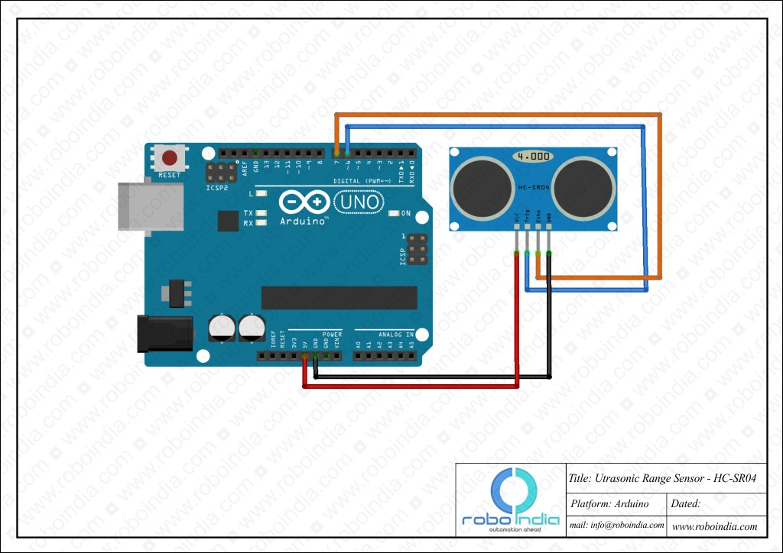

* **Voice Guided Transducer**

The distance calculated from the sensor is then measured in terms of the mobility it grants the user.

* + - If d < 20 then the user is asked to turn right as the path ahead is blocked.
    - If d >=20 and d<=100 the user is asked to move forward two steps
    - if d>100 and d<=200 then the user is asked to move forward by 3 steps
    - else the user is asked to move forward for 6 steps

These commands are passed on as digital notes to the Arduino. The transducer circuit converts this into analog signals which then are fed into the speaker. The speaker guides the user on the right path by providing the user with directions.

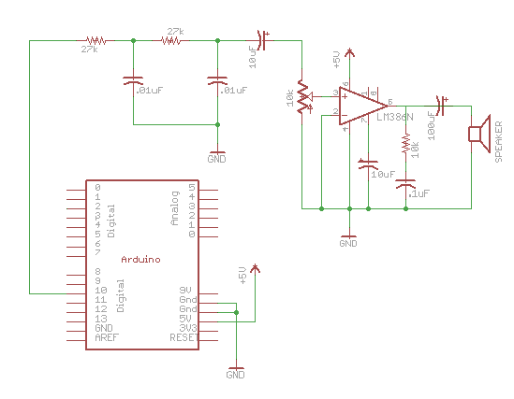

* **The Integrated Circuit Design**

The above two modules operate on an operating voltage of 5 volts. Since the Arduino has only one power slot of 5V, we use a breadboard to create a channel for 5 volt DC source and another channel for the ground connections as both the sensor and the transducer utilize these sources of the Arduino.

All components are connected to each other by the means of jumper wires.

**Experimental Output and Observation**

* The sensor and the transducer module worked flawlessly without overloading the Arduino.
* The range of the sensor was extended to almost 4 meters by creation of custom code for use with the sensor.
* The transducer gives the desired output via the speaker. However due to complex and out-dated legacy code used for the Text to Speech engine the output is not very clear and consists of considerable amount of noise.
* An attempt was made to remove the noise by the use of low-pass filter but that was unsuccessful due to the poor quality of the library used and also due to the script incompatibility of the TTS engine with the modern Arduino library.

**Results and Conclusion**

The project yielded satisfactory results which were on par with the parameters required as the objective of the project. The Ultrasonic sensor module works fine to deliver the accurate distance from the obstacle and this data was successfully utilized further to create a guidance system for the user.

The only unexpected error in the output is the noise emanating from the output due to poor and legacy code of the TTS library and engine. The entire project was tested in a closed space environment to verify and validate the path guidance expected of the project. It was found that in spaces not exceeding 6-7 sq.meters in area, the module operated with an accuracy of 1mm.

In conclusion we confer that the project stands successfully completed which is able to meet the required parameters of testing. The field test of the prototype functioned within reasonable parameters.

There however remains a lot of scope for improving the basic prototype. The following are some suggested improvements that can be made to the prototype to make it market and consumer ready:

* Miniaturizing the transducer circuit and adding an audio jack in place of the speaker will let the user make use of ear-phones to be guided by the software.
* The use of an audio jack will also help eliminate or at least considerably reduce the noise caused at the output of the transducer.
* An improved and efficient speech library can be employed to reduce noise creation and amplification at the source itself.
* A lithium ion powered battery can be used to operate the prototype, making the system rechargeable and enhancing the compactness and mobility of the system.

While conducting the experiment it is essential to keep in mind that the lower body of the Arduino does not come in contact with the ground as then there is a possibility of the overload and this may cause severe damage to the circuit and its components. Also, caution has to exercised while soldering the components.

With that we would draw our project to a conclusion. Thank you.