DTL Shell Assignments

Name: Sanskar Sanjay Dudhe MIS:111903088 SYComp div2

Switch calculator program:

clear

sum=0

i="y"

echo " Enter one no."

read n1

echo "Enter second no."

read n2

while [ $i = "y" ]

do

echo "1.Addition"

echo "2.Subtraction"

echo "3.Multiplication"

echo "4.Division"

echo "Enter your choice"

read ch

case $ch in

1)sum=`expr $n1 + $n2`

echo "Sum ="$sum;;

2)sum=`expr $n1 - $n2`

echo "Sub = "$sum;;

3)sum=`expr $n1 \* $n2`

echo "Mul = "$sum;;

4)sum=`expr $n1 / $n2`

echo "Div = "$sum;;

*)echo "Invalid choice";;

esac

echo "Do u want to continue ?"

read i

if [ $i != "y" ]

then

exit

fi

done

Output:



2.String Manipulation Program:

#!/bin/sh

i='y'

while [ $i = 'y' ]

do

clear

echo "STRING MANIPULATION PROGRAM"

echo "1. COMPARE STRINGS"

echo "2. JOINT TWO STRINGS"

echo "3. LENGTH OF STRING"

echo "4. OCCURANCE OF CHARACTER"

echo "5. OCCURANCE OF WORD"

echo "6. REVERSE STRING"

echo "ENTER CHOICE: "

read ch

echo

case $ch in

1)

echo "Enter String1:\c"

read str1

echo "Enter String2:\c"

read str2

if [ "$str1" = "$str2" ]; then

echo "String is equal"

else

echo "Strings are not equal"

fi

;;

2)

echo "Enter String1:\c"

read str1

echo "Enter String2:\c"

read str2

str3="$str1$str2"

echo "Join String: \c"` echo $str3`

;;

3)

len=0

echo "Enter String1: \c"

read str1

len=$(echo "$str1" | wc -c)

len=`expr $len - 1`

echo "Length: " $len

;;

4)

echo "Enter String:\c"

read str

echo "Enter Character to find:\c"

read char

echo "Character '$char' occures "` echo $str | grep -o $char | wc -l` "TIME/S"

;;

5)

echo "Enter String1:\c"

read str

echo "Enter Word to find"

read word

echo "Word '$word' occures "` echo $str | grep -o $word | wc -l` "TIME/S"

;;

6)

echo "Enter String:"

read str

echo "Reverse string is:"` echo $str | rev`

;;

esac

echo "Do you want to continue ?"

read i

if [ $i != "y" ]

then

exit

fi

done

Output:





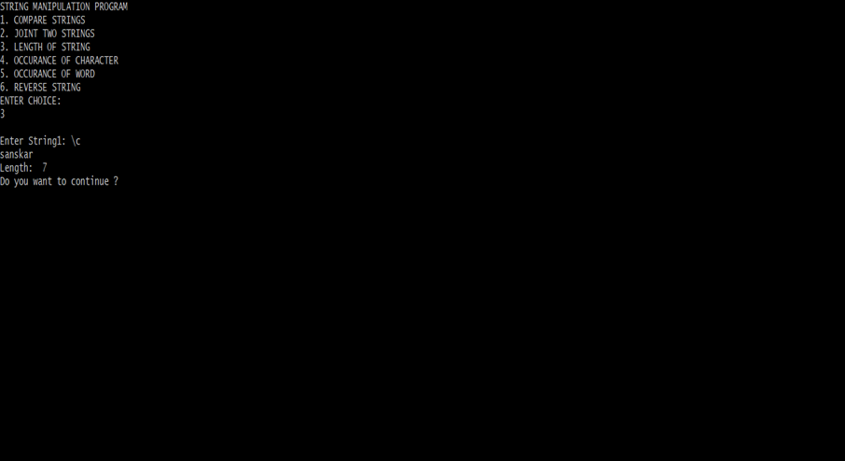



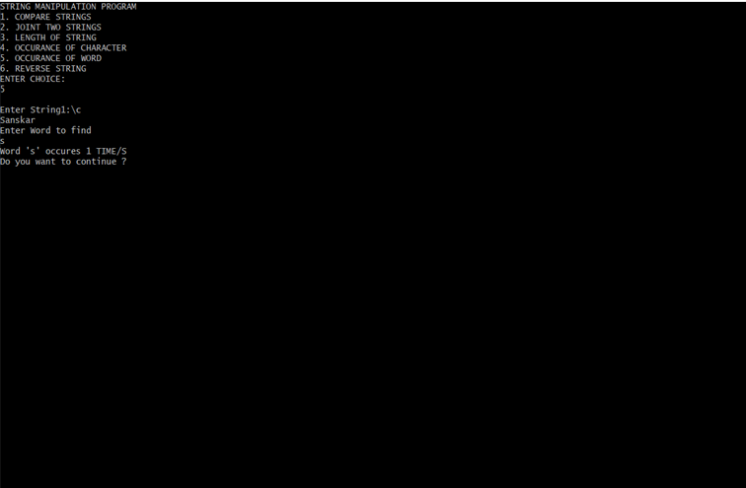

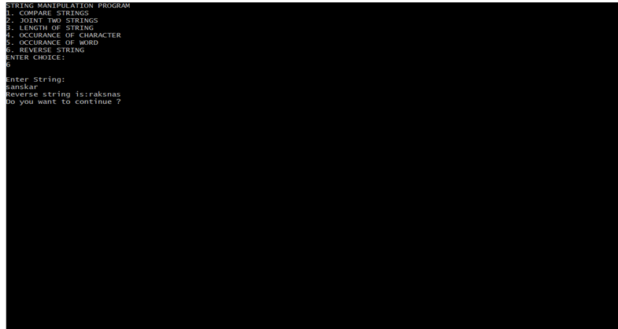

3.File program:

file="/home/user/DTL/coe.sh"

if [ -r $file ]

then

echo "File has read access"

else

echo "File does not have read access"

fi

if [ -w $file ]

then

echo "File has write permission"

else

echo "File does not have write permission"

fi

if [ -x $file ]

then

echo "File has execute permission"

else

echo "File does not have execute permission"

fi

if [ -f $file ]

then

echo "File is an ordinary file"

else

echo "File is a special file"

fi

if [ -d $file ]

then

echo "File is a directory"

else

echo "File is not a directory"

fi

if [ -s $file ]

then

echo "File size is not zero"

else

echo "File size is zero"

fi

if [ -e $file ]

then

echo "File exists"

else

echo "File does not exists"

fi



4.CSV program:

#!/bin/bash

IFS=','

for F in DData.txt ; do

while read -r Get_http ; do

read -r User_Agent

read -r Pragma

read -r Cache_Control

read -r Accept

read -r Accept_Encoding

read -r Accept_Charset

read -r Language

read -r Host

read -r Cookie

read -r Connection

echo "${Get#*=},${User_Agent#*=},${Pragma#*=},${Cache_Control#*=},${Accept#*=},${Accept_Encoding#*=},${Accept_Charset#*=},${Language#*=},${Host#*=},${Cookie#*=},${Connection#*=}" >> outputfile

done < "$F"

done

5.Awk Program:

