PPL ASSIGNMENT 2

NAME: SANSKAR SANJAY DUDHE

MIS : 111903088, DIV : 2

SOLUTIONS:

A-1:

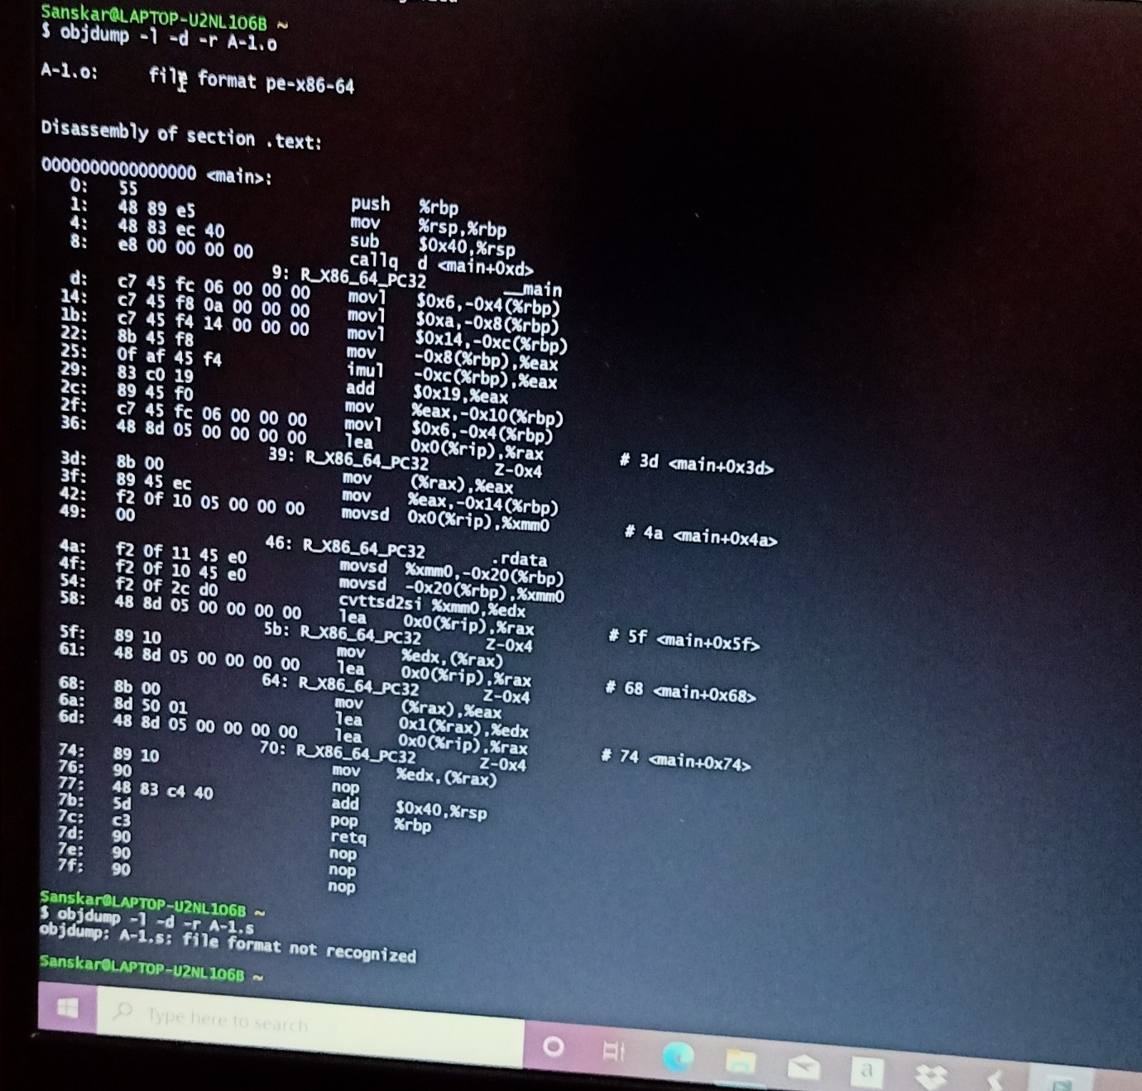

A-2 SOLUTIONS:

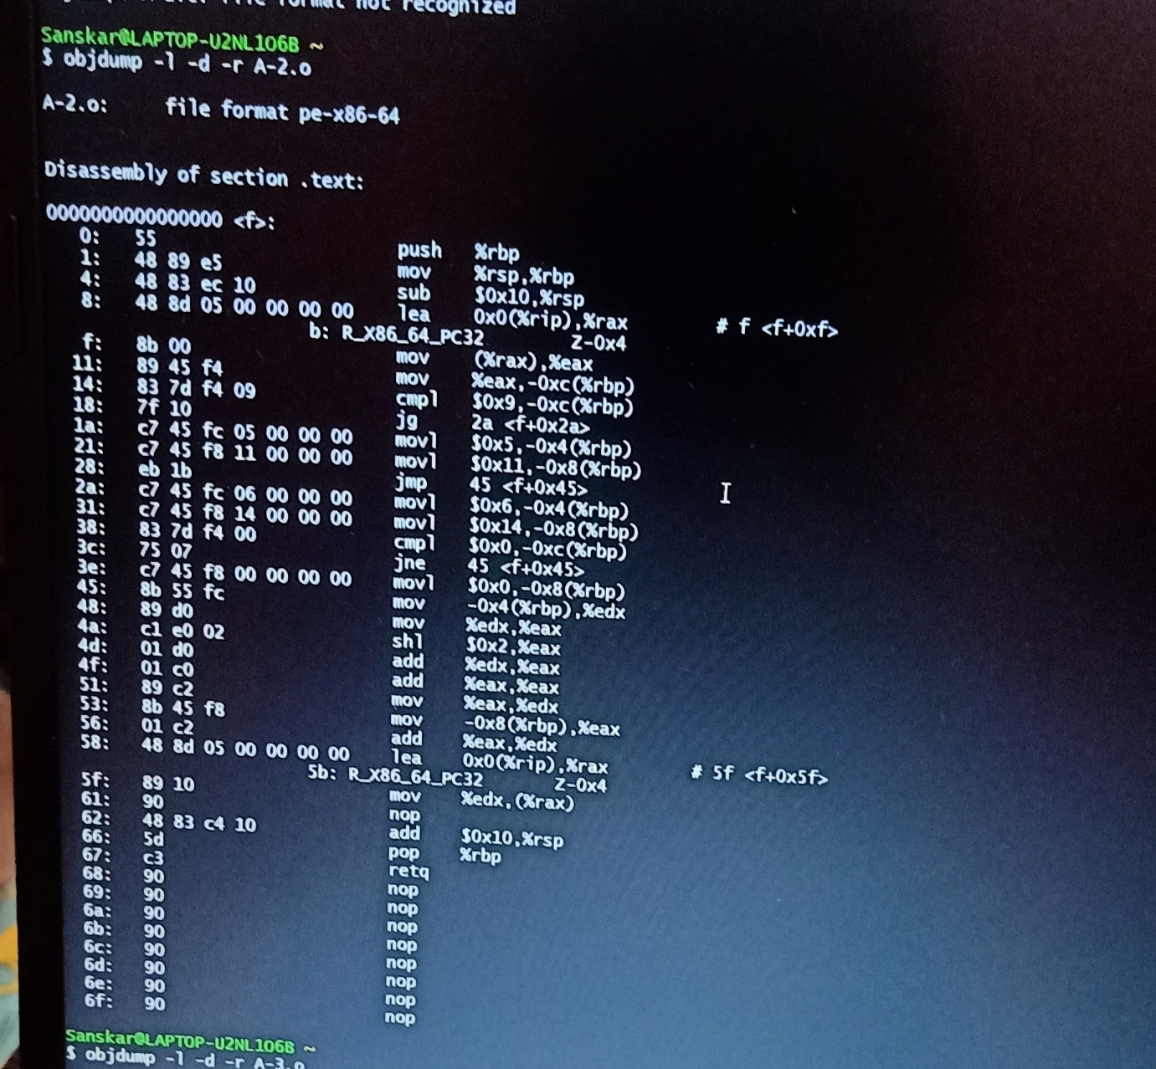

A-3 SOLUTONS:

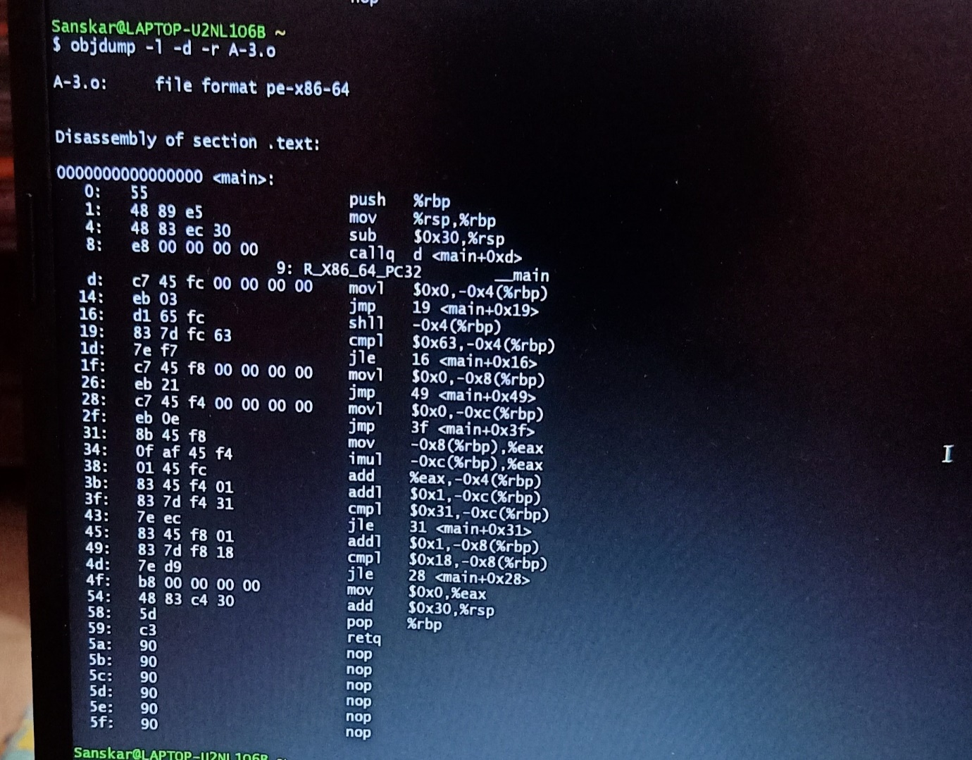

A-4 SOLUITONS:

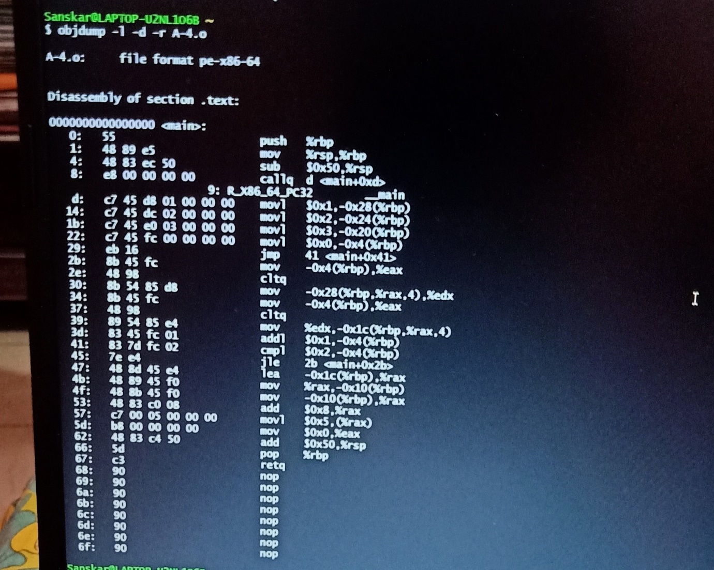

A-5 SOLUTIONS:

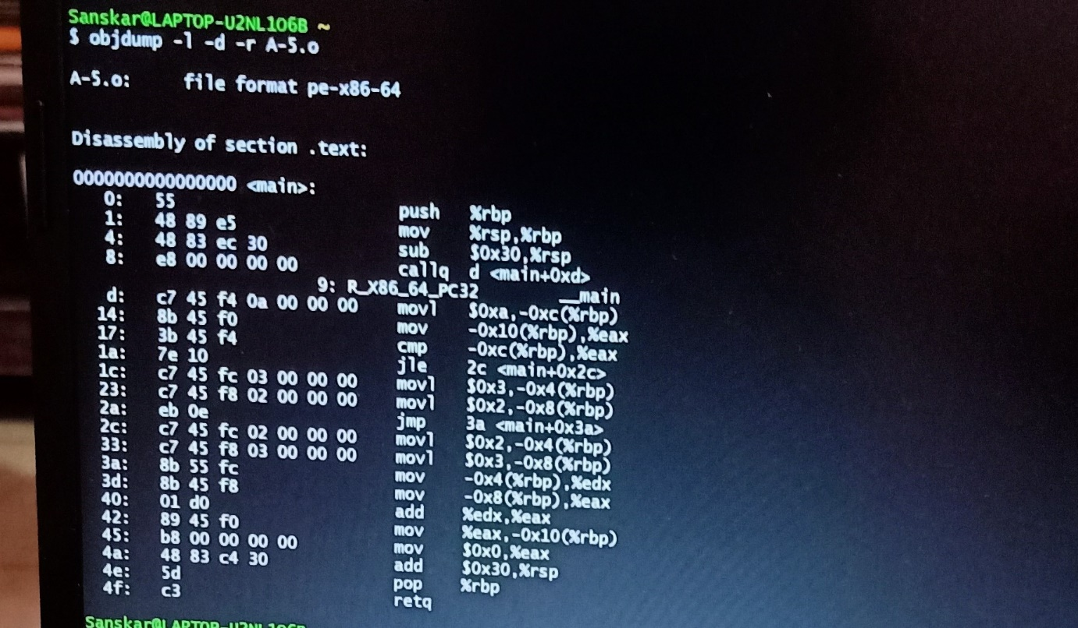

B-1 SOLUTIONS:

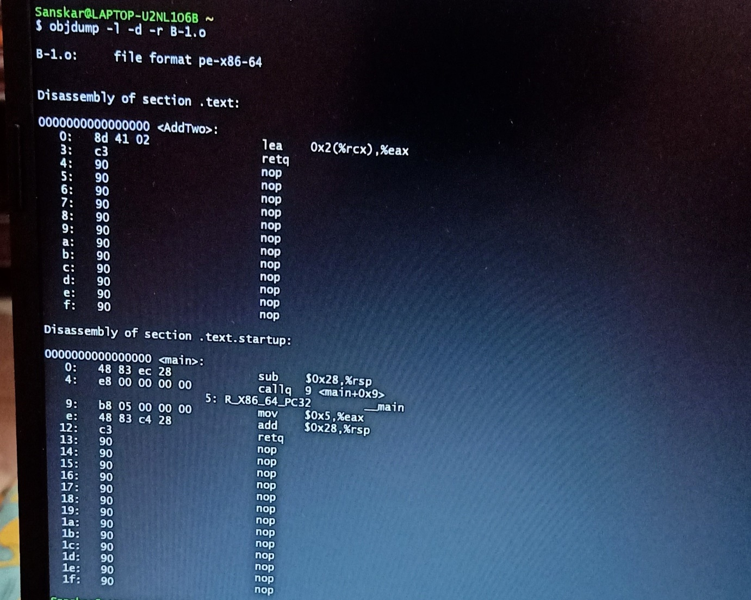

B-2 SOLUTIONS:

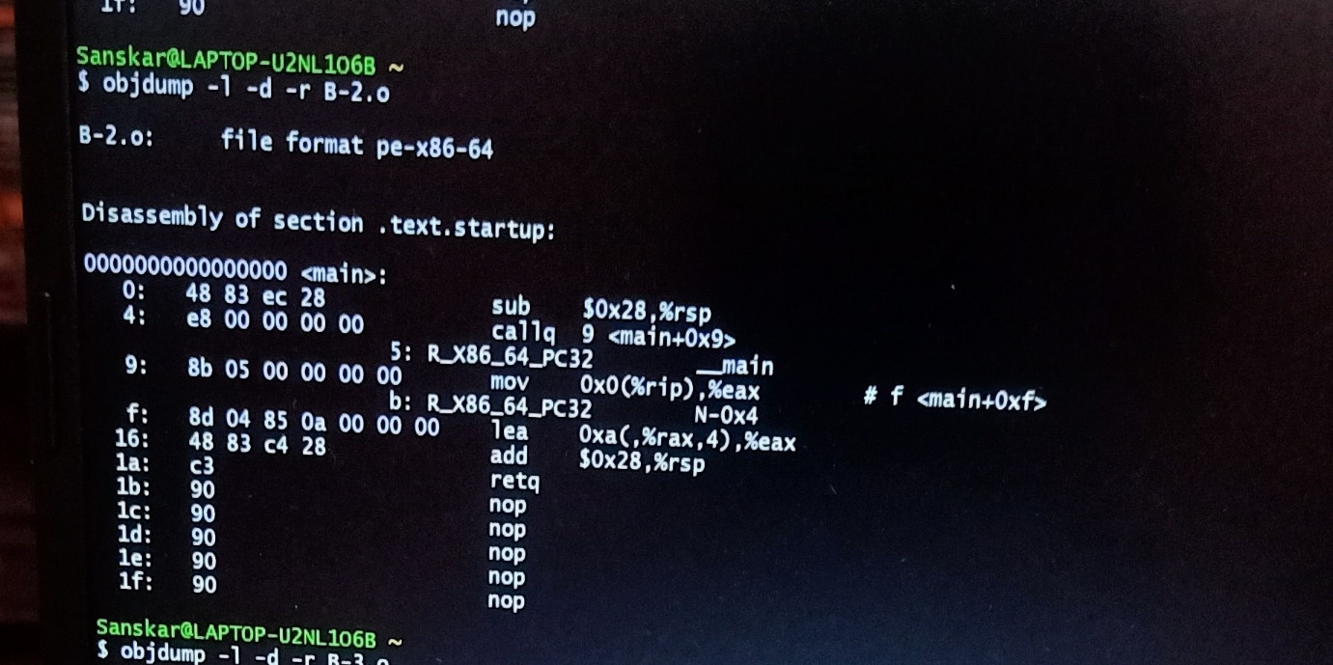

B-3 SOLUTIONS:

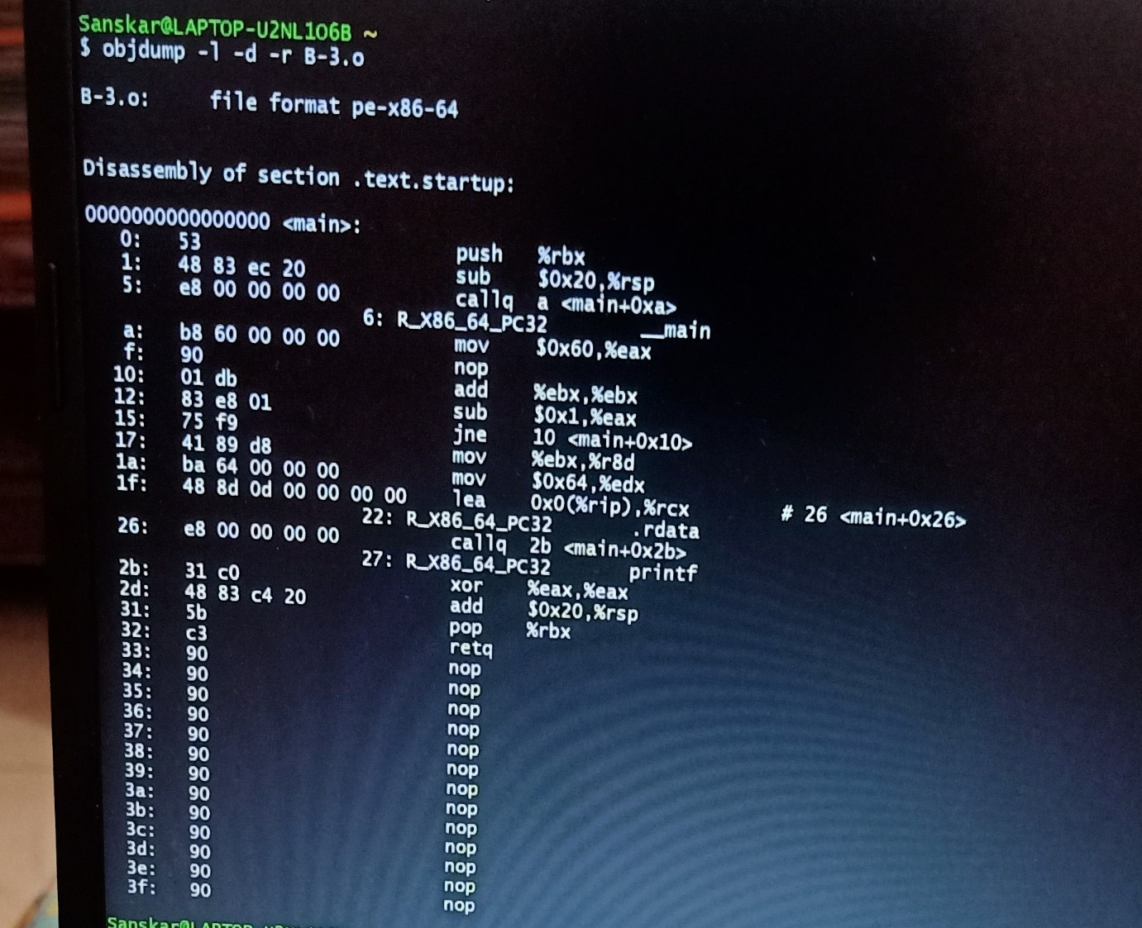

B-4 SOLUTIONS:

