LAB ASSIGNMENT RECORD
On
ECS-456
Java Programming Lab



Faculty of Engineering &
College of Computing Sciences & IT
TMU, MORADABAD
Jan 2024– June2024

Submitted To: Submitted By:
Mr. Pankaj Kumar Student Name:
Mr. Vineet Saxena Course:
Semester/Section:
Enroll. No.:

Assignment-No. 1
S.NO | PROGRAM NAME | PAGE NO | DATE | SIGN | REMARK
1 | Write a program to print Hello JAVA.
2 | Write a program to print whatever value is given by user using command line arguments.
3 | Write a program print the sum of two numbers given by user using command line argument.
4 | Write a program print the sum of two numbers given by user using Scanner Class.
3 | Write a program to calculate sum and average of five numbers entered by user.
4 | - Write a program to interchange values of two numbers using third variable.  b. Write a program to interchange values of two numbers without using third variable.
5 | Write a program to find and display greater number from three numbers.
6 | Write a program to find whether a year is leap or not.
7 | Write a program to find factorial of a given number.
8 | Write a program to Generate Fibonacci series as per given range which is entered by the user.
9 | Write a program to check the given number is Armstrong number or not.
10 | Write a program to print all the prime number between 1 to 300
11 | Write a program to print the following pattern  *  * *  * * *  * * * *  * * * * *
12 | Write a program to print the following pattern  1  1 2  1 2 3  1 2 3 4  1 2 3 4 5  1 2 3 4 5 6
13 | Write a program to print the following pattern  1 2 3 4 5 6  1 2 3 4 5  1 2 3 4  1 2 3  1 2  1
14 | Write a program to print the following pattern  1  2 3  4 5 6  7 8 9 10  11 12 13 14 15  16 17 18 19 20 21
15 | Write a program to print the following pattern  *  ***  *****  *******  *********  ***********  *********  *******  *****  ***  *
16 | Write a program to print the following pattern  *  **  ***  ****  *****  ******
17 | Write a program to print the following pattern  ******  *****  ****  ***  **  *
18 | Write a program to print the following pattern  ******  *****  ****  ***  **  *
19 | Write a program to print the following pattern  *  * *  * * *  * * * *  * * * * *  * * * * * *
20 | Write a program to print the following pattern  1 2 3 4 5 6  2 3 4 5 6  3 4 5 6  4 5 6  5 6  6  Write a program to print the following pattern  1 2 3 4 5 6  2 3 4 5 6  3 4 5 6  4 5 6  5 6  6  5 6  4 5 6  3 4 5 6  2 3 4 5 6  1 2 3 4 5 6
21 | Write a Program to print the reverse of an integer number entered by user.
22 | Write a program to find the sum of digits of the given integer.
23 | Write a program to obtain the gross salary by calculating dearness allowance and house rent.
24 | Write a program to find the sum and average of ten different numbers using for loop,while loop and do while loop.
25 | Write a program to search a number from 1 to 100 using break statement.
26 | Write a program to print odd and even numbers from an array.
27 | Write a program to find the highest and lowest number from 10 entered numbers
28 | Write a program to find the G.C.D of the entered number.
 | Write a Java program to check whether a number is palindrome or not.
 | Write a Java program for following grading system. Note: Percentage>=90% : Grade A Percentage>=80% : Grade B Percentage>=70% : Grade C Percentage>=60% : Grade D Percentage>=40% : Grade E Percentage
29 | Write a program that will illustrate the concept of default constructor.
30 | Create a class Person with properties(name and age) with following features:  - Default age of person should be 18.  - A person object can be initialized with name and age  - Method to display name and age of person.
- Create a class Employee with(empNo ,salary and totalSalary) ) with following features.
- a.Only parameterized constructor;
- b.totalSalary always represent total of all the salaries of all employees created.
- c.empNo should be auto incremented.
- d.display total employees and totalSalary using class method.
31 | Write a program that will illustrate the concept of parameterized constructor and object parameterized constructor.
32 | Write a program to illustrate the concept of this keyword.
33 | Write a program to demonstrate static and instance data members and methods.
34 | Write a Java program to implement the concept of importing classes from user defined package and creating packages
35 | Write a program which illustrates the concept of inheritance.
36 | Write a program to demonstrate the concept of method overloading and overriding.
37 | Write a Java Program to demonstrate use of nested class.
38 | Create a general class ThreeDObject and derive the classes Box, Cube, Cylinder and Cone from it. The class ThreeDObject has methods wholeSurfaceArea ( ) and volume ( ). Override these two methods in each of the derived classes to calculate the volume and whole surface area of each type of three-dimensional objects. The dimensions of the objects are to be taken from the users and passed through the respective constructors of each derived class. Write a main method to test these classes.
39 | Write a program which illustrates the concept of super keyword at variable and method level.
40 | Write a program which will calculate the sum of two integer and two floats values using an abstract method sum()
41 | Write a program to demonstrate use of implementing and extends interfaces.
42 | Write program to demonstrate use of final keyword.

Assignment-No. 2
S.NO | PROGRAM NAME | PAGE NO | DATE | SIGN | REMARK
1 | Write a program to implement the concept of Exception Handling using predefined  Exception.
2 | Write a program to implement the concept of Exception Handling using throw keyword.
3 | Write a program to write a string in a text file using IO package.
4 | Write a program to draw different shapes in an applet using graphic class.
5 | Write a program using Applet to display a message in the Applet.
6 | Write a java program which will create a window and an empty area within that window (extends Frame class)
7 | Write a Java Program to demonstrate Keyboard event
8 | Write a Java Program to demonstrate Mouse event.
9 | WAP to enter two numbers in two different text boxes. Add a button on the Applet. The program should print the sum of the two numbers of the Applet window.

Assignment-No. 3
S.NO | PROGRAM NAME | PAGE NO | DATE | SIGN | REMARK
1 | Write a program to print text into Text Area using JText Area
2 | Create this frame Using JFrame  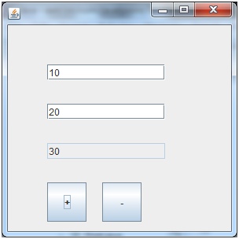
3 | Write a program to display selected item from JCombo box in a label on click of Show button.
4 | Create a swing application to display a menu bar where each menu item should display a dialog box to show its working.
5 | Create this frame message will show according to radio button clicked.  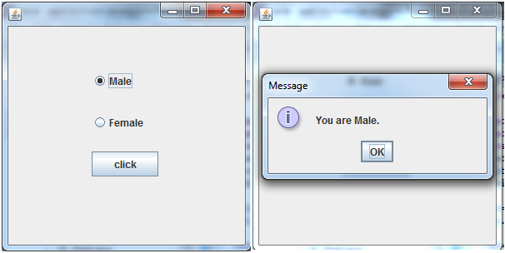
6 | Create this food ordering System.  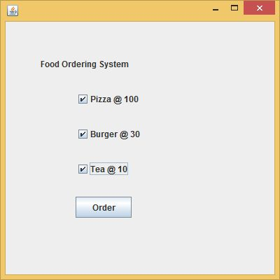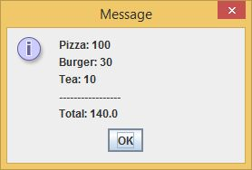
7 | Write a program to implement the concept of threading by extending Thread Class
8 | Write a program to implement the concept of threading by implementing Runnable Interface
9 | Write a Java program that connects to a database using JDBC
10. | WAP to enter the details of an employee in a window. The window should display a button which when clicked, adds the employee record in the database (My-SQL).
11 | To write program for Client Server Interaction with stream socket connections.
12 | WAP to create a simple Web application using Servlet interface and print hello on browser.
13 | WAP to create a simple Web application using Generic Servlet class and print hello on browser.
14 | WAP to create a simple Web application using HttpServlet class and print hello on browser
15 | WAP to create a simple Web application using HttpServlet and demonstrate the Get and Post request.

