LAB EXPERIMENT RECORD
SET 7: CUSTOMER DEMOGRAPHICS ANALYSIS
Department | AI & DS
Course Code / Course Name | DSA0602 / Data Handling and Visualization
Experiment | Data Visualization using R
Name | Sanskar Ravi Singh
Register Number | 1924260298
Date | 03 October 2026
Day | Saturday
SET 7: CUSTOMER DEMOGRAPHICS ANALYSIS
Dataset: Product Inventory
Customer ID | Age | Gender
1 | 28 | Female
2 | 35 | Male
3 | 42 | Female
PROGRAM 1: Customer Age Bar Chart
Create a bar chart to visualize the distribution of customer ages. Label the axes and title the chart.
# Dataset
customer_id <- c(1, 2, 3)
age <- c(28, 35, 42)
gender <- c("Female", "Male", "Female")
income <- c(50000, 60000, 75000)
customers <- data.frame(customer_id, age, gender, income)

# Bar Chart
barplot(customers$age,
names.arg = customers$customer_id,
main = "Customer Age Distribution",
xlab = "Customer ID",
ylab = "Age")
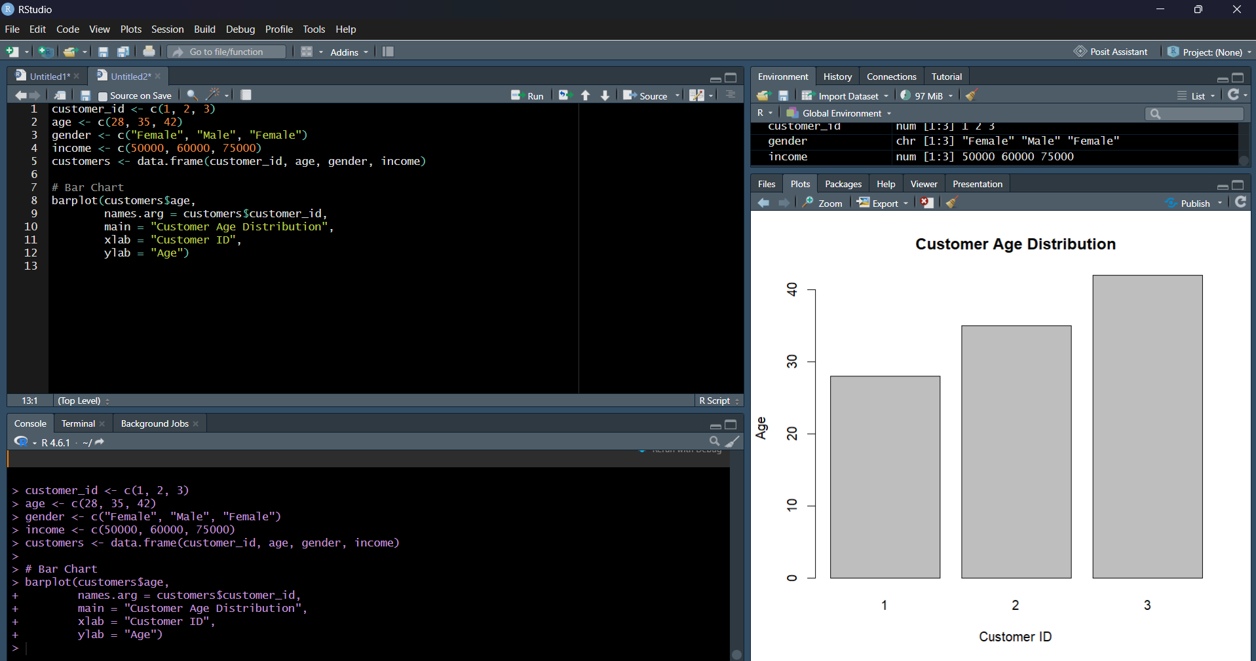
Output 1: Customer Age Bar Chart
Observation: The bar chart compares the ages of the three customers. Customer 1 is 28, Customer 2 is 35, and Customer 3 is 42 years old.
PROGRAM 2: Customer Gender Pie Chart
Generate a pie chart to represent the distribution of customers by gender.
# Dataset
# Gender Distribution
gender_count <- table(customers$gender)

# Pie Chart
pie(gender_count,
main = "Customer Distribution by Gender",
labels = paste(names(gender_count), gender_count, sep = ": "))
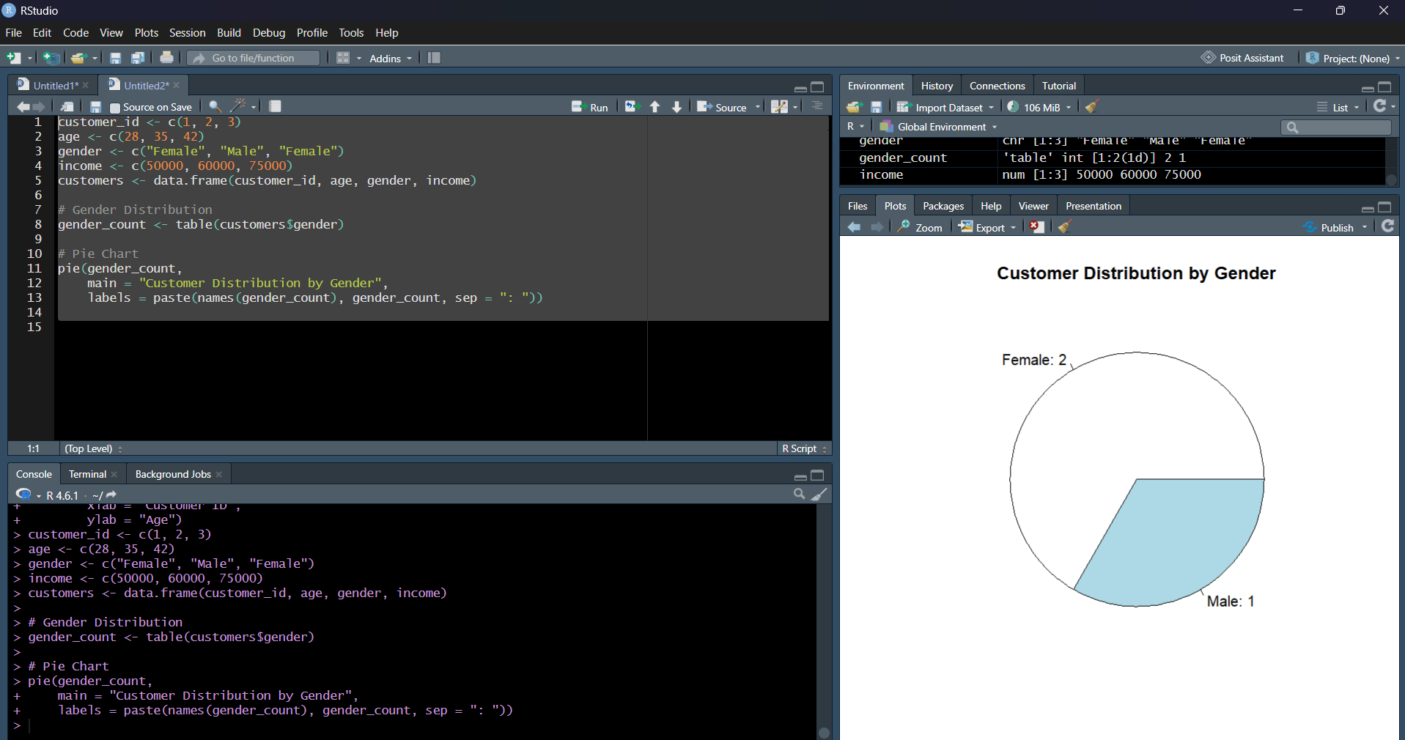
Output 2: Customer Gender Pie Chart
Observation: The pie chart shows 2 Female customers and 1 Male customer in the supplied dataset.
PROGRAM 3: Customer Demographic Table
Build a table to show the demographic information for each customer. Label the table elements.
# Dataset
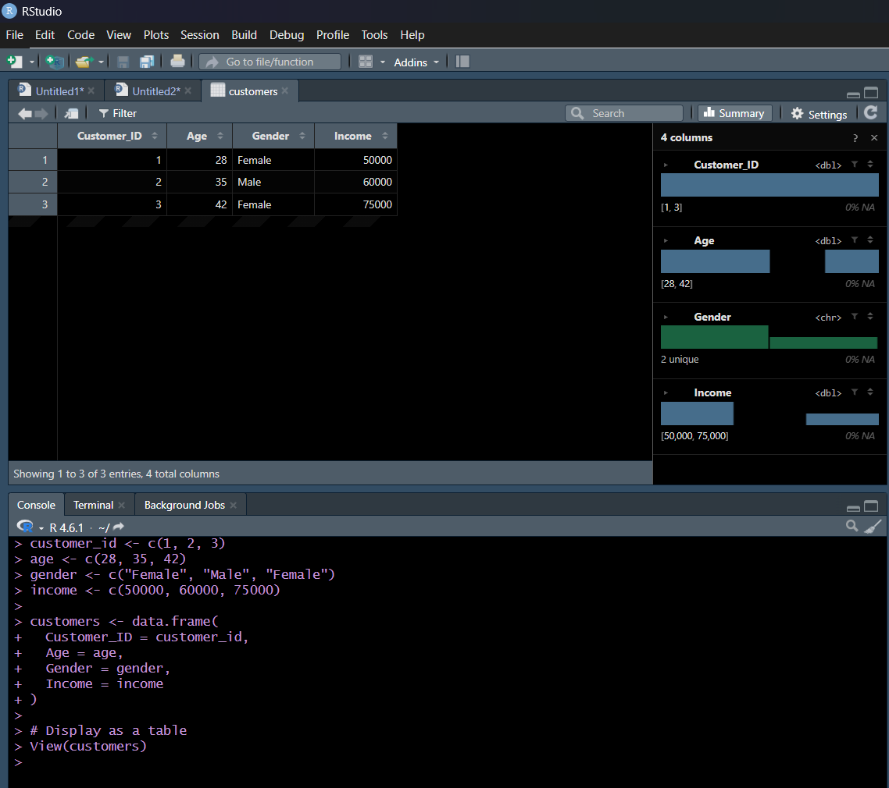
# Display Customer Demographic Information
Customers

Observation: The table displays Customer ID, Age, Gender, and Income for each customer.
PROGRAM 4: Tableau Dashboard
Develop a Tableau dashboard combining the bar chart, pie chart, and the table for interactive exploration of customer demographics.
# Dataset
# Tableau Dashboard
# 1. Connect the Customer Demographics dataset.
# 2. Create a worksheet for the customer age bar chart.
# 3. Create a worksheet for the gender pie chart.
# 4. Create a worksheet containing the demographic table.
# 5. Open a new dashboard and add all three worksheets.
# 6. Add filters/actions to allow interactive exploration.
Observation: The Tableau dashboard combines the age bar chart, gender pie chart, and demographic table.
Set 7 Procedure
Create the Customer Demographics dataset with Customer ID, Age, Gender, and Income.
Use barplot() to visualize customer ages.
Use table() and pie() to summarize demographic information and gender distribution.
Prepare the customer demographic table with labelled fields.
Combine the visualizations and table in Tableau to create an interactive dashboard.
Set 7 Result
The customer demographic data was visualized using a bar chart, pie chart, and demographic table. The views can be combined in Tableau for interactive exploration of customer demographics.

