LAB EXPERIMENT RECORD
SET 8: EMPLOYEE PERFORMANCE ANALYSIS
Department | AI & DS
Course Code / Course Name | DSA0602 / Data Handling and Visualization
Experiment | Data Visualization using R
Name | Sanskar Ravi Singh
Register Number | 1924260298
Date | 03 October 2026
Day | Saturday
SET 8: EMPLOYEE PERFORMANCE ANALYSIS
Dataset: Employee Performance
Employee ID | Department | Years of Service | Performance Score
1 | Sales | 5 | 85
2 | HR | 3 | 92
3 | Marketing | 7 | 78

PROGRAM 1: Employee Performance Trend
Create a line chart to visualize the performance trend of employees over time. Label the axes and title the chart.
# Dataset
employee_id <- c(1, 2, 3)
department <- c("Sales", "HR", "Marketing")
years_service <- c(5, 3, 7)
performance_score <- c(85, 92, 78)
employees <- data.frame(employee_id, department, years_service, performance_score)

# Line Chart
plot(employees$years_service,
employees$performance_score,
type = "o",
main = "Employee Performance Trend Over Time",
xlab = "Years of Service",
ylab = "Performance Score")
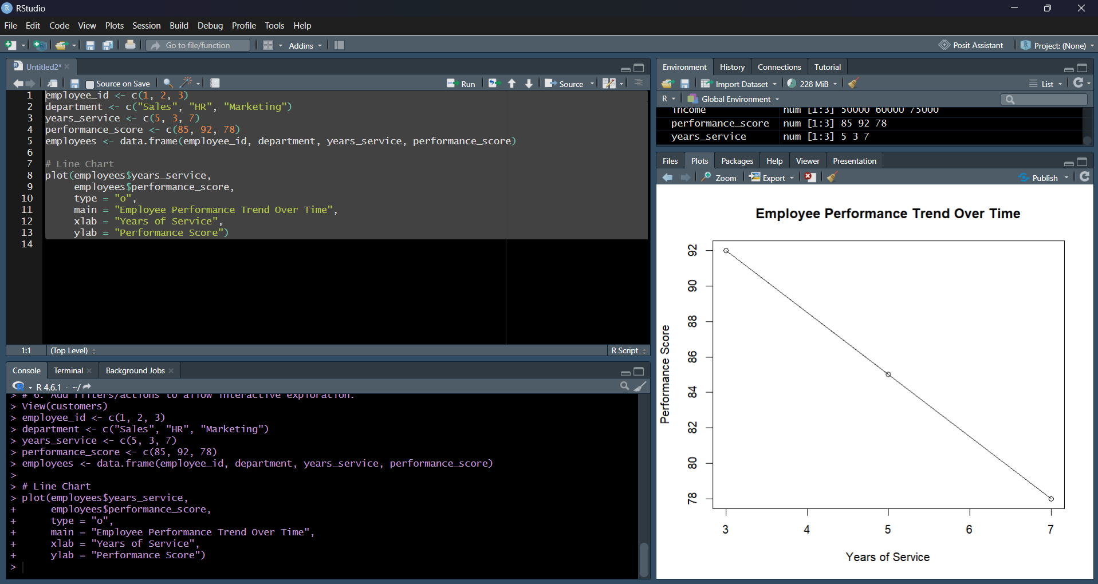
Output 1: Employee Performance Trend
Observation: The line chart compares performance scores at different years of service. The highest score is 92, while the lowest is 78.
PROGRAM 2: Employee Distribution by Department
Generate a bar chart showing the distribution of employees across different departments. Label the chart elements.
# Dataset
# Employee Count by Department
department_count <- table(employees$department)

# Bar Chart
barplot(department_count,
main = "Employee Distribution by Department",
xlab = "Department",
ylab = "Number of Employees")
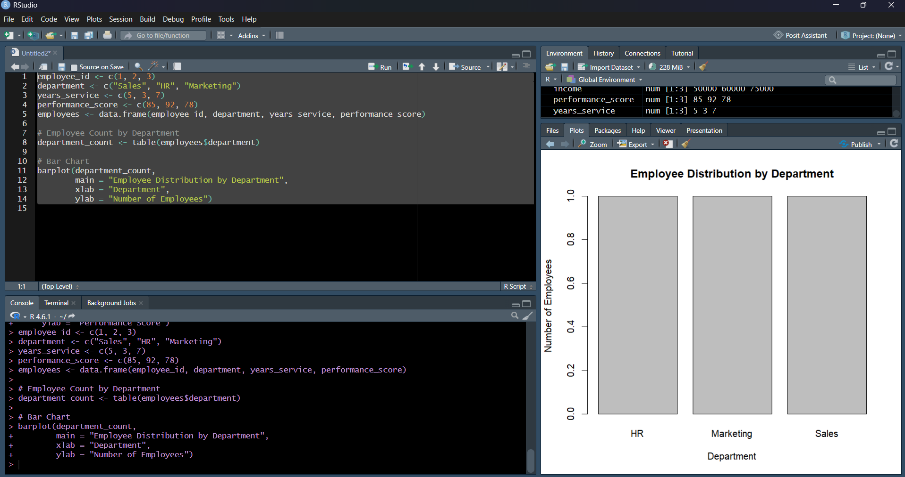
Output 2: Employee Distribution by Department
Observation: Each department has one employee in the supplied dataset. The departments are Sales, HR, and Marketing.
PROGRAM 3: Employee Performance Table
Build a table to display the performance data for each employee. Label the table elements.
# Dataset
# Display Employee Performance Information
Employees
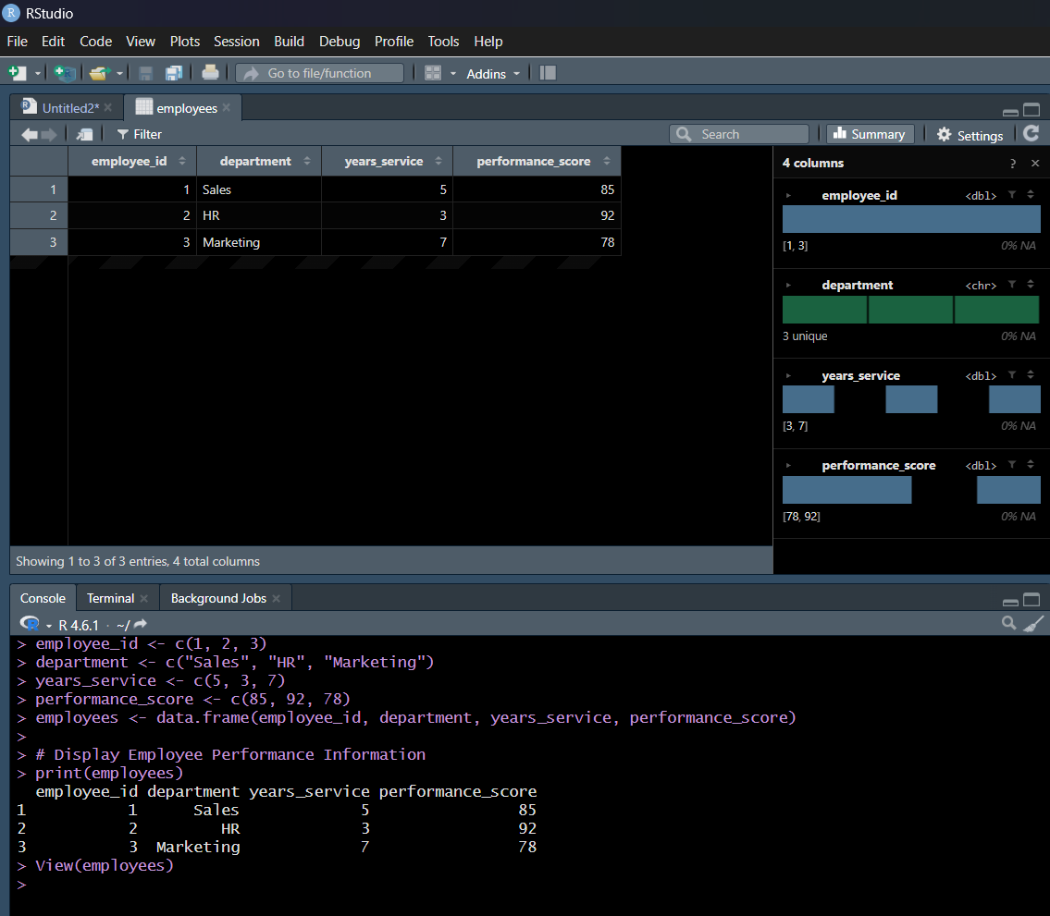
Observation: The table displays Employee ID, Department, Years of Service, and Performance Score for each employee.
PROGRAM 4: Tableau Dashboard
Develop a Tableau dashboard combining the line chart, bar chart, and the table for interactive exploration of employee performance data.
# Dataset
# Tableau Dashboard
# 1. Connect the Employee Performance dataset.
# 2. Create a worksheet for the performance line chart.
# 3. Create a worksheet for department distribution.
# 4. Create a worksheet containing the performance table.
# 5. Combine all worksheets in a dashboard.
# 6. Add filters/actions for interactive exploration.
Observation: The Tableau dashboard combines the performance trend, department chart, and employee performance table.
Set 8 Procedure
Create the Employee Performance dataset with Employee ID, Department, Years of Service, and Performance Score.
Use plot() with type = "o" to visualize the performance trend.
Use table() and barplot() to summarize employees by department.
Prepare the employee performance table with labelled fields.
Combine the line chart, bar chart, and table in Tableau.
Set 8 Result
The employee performance data was visualized using a line chart, bar chart, and performance table. These visualizations can be combined in Tableau for interactive employee performance analysis.

