LAB EXPERIMENT RECORD
SET 9: ONLINE LEARNING ACTIVITY
Department | AI & DS
Course Code / Course Name | DSA0602 / Data Handling and Visualization
Experiment | Data Visualization using R
Name | Sanskar Ravi Singh
Register Number | 1924260298
Date | 03 October 2026
Day | Saturday
SET 9: ONLINE LEARNING ACTIVITY
Dataset: Online_Learning_Activity.csv
Student_ID | Gender | Age | Course | Study_Time (hrs) | Videos_Watched | Quiz_Score | Login_Date
L01 | Male | 20 | R | 3.5 | 12 | 78 | 2025-01-05
L02 | Female | 22 | R | 4.2 | 15 | 85 | 2025-01-05
L03 | Male | 19 | SQL | 2.0 | 8 | 65 | 2025-02-08
L04 | Female | 21 | R | 5.0 | 18 | 92 | 2025-02-08
L05 | Male | 23 | R | 2.5 | 9 | 70 | 2025-03-12
L06 | Female | 20 | SQL | 4.0 | 14 | 88 | 2025-03-12

PROGRAM 1: Quiz Score Distribution
Import the dataset in R. Plot a histogram for Quiz_Score. Draw a boxplot of Quiz_Score by Course. Add title and labels. Interpret student performance.
# Dataset
data <- read.csv("Online_Learning_Activity.csv")

# Convert Login_Date to Date
data$Login_Date <- as.Date(data$Login_Date)

# Histogram
hist(data$Quiz_Score,
main = "Distribution of Quiz Scores",
xlab = "Quiz Score",
ylab = "Number of Students")

# Boxplot of Quiz Score by Course
boxplot(data$Quiz_Score ~ data$Course,
main = "Quiz Score by Course",
xlab = "Course",
ylab = "Quiz Score")
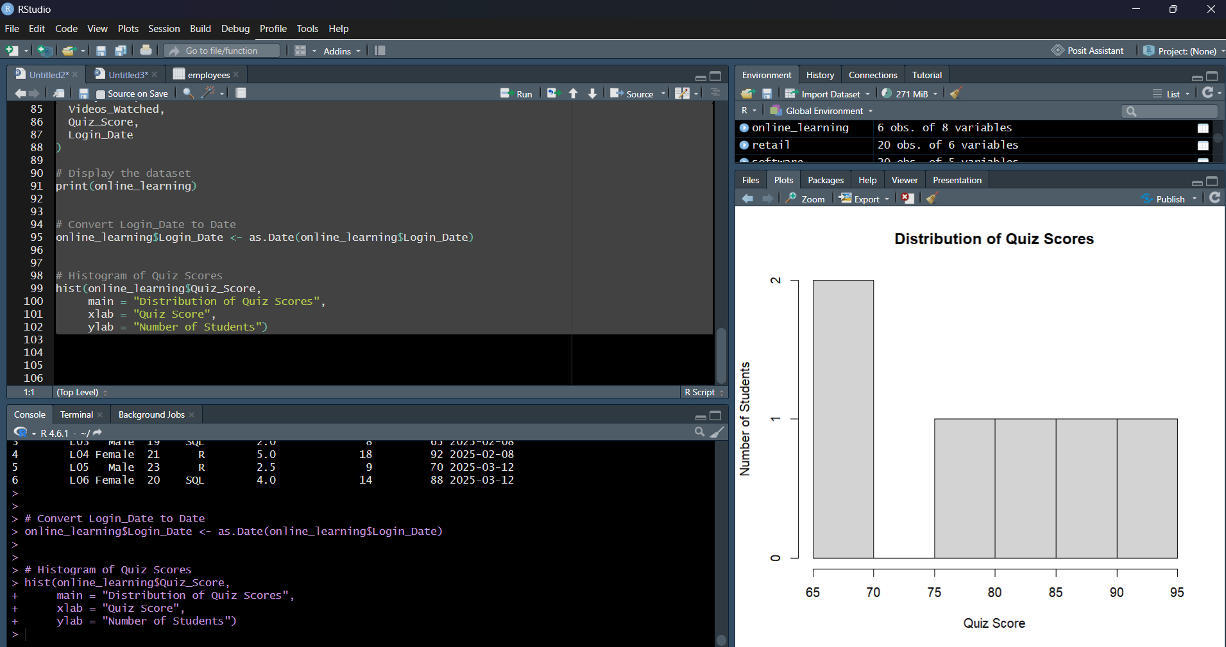
Output 1A: Quiz Score Distribution
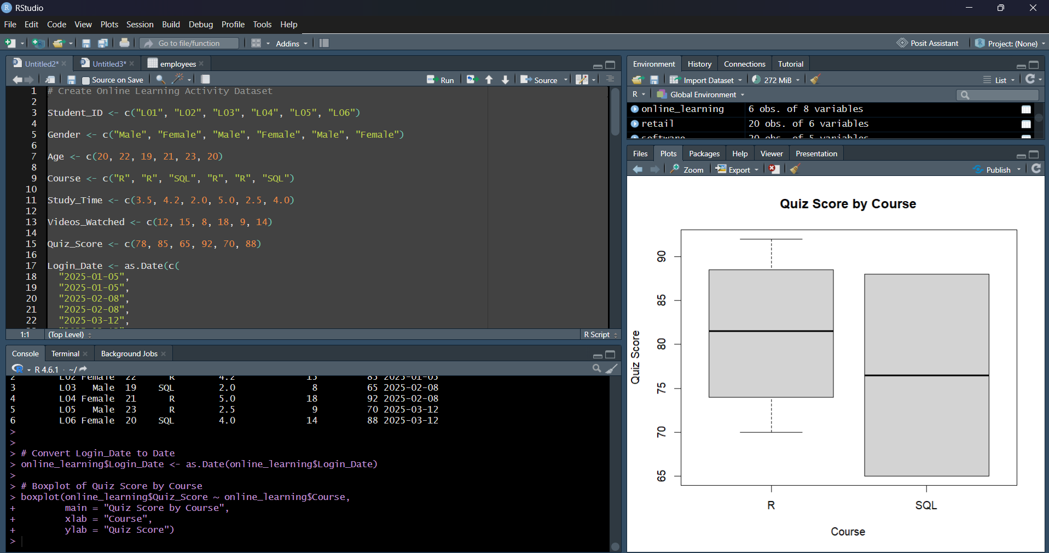
Output 1B: Quiz Score Distribution
Observation: Quiz scores range from 65 to 92. The R-course scores are generally high, while the SQL records show a wider spread because the two SQL scores are 65 and 88.
PROGRAM 2: Study Time vs Quiz Score
Create a scatter plot using R programming between Study_Time and Quiz_Score. Represent Videos_Watched using bubble size. Apply transparency. Explain the learning pattern.
# Dataset
# Bubble Scatter Plot
plot(data$Study_Time,
data$Quiz_Score,
cex = data$Videos_Watched / 6,
pch = 19,
col = rgb(0, 0, 0, alpha = 0.5),
main = "Study Time vs Quiz Score",
xlab = "Study Time (hrs)",
ylab = "Quiz Score")
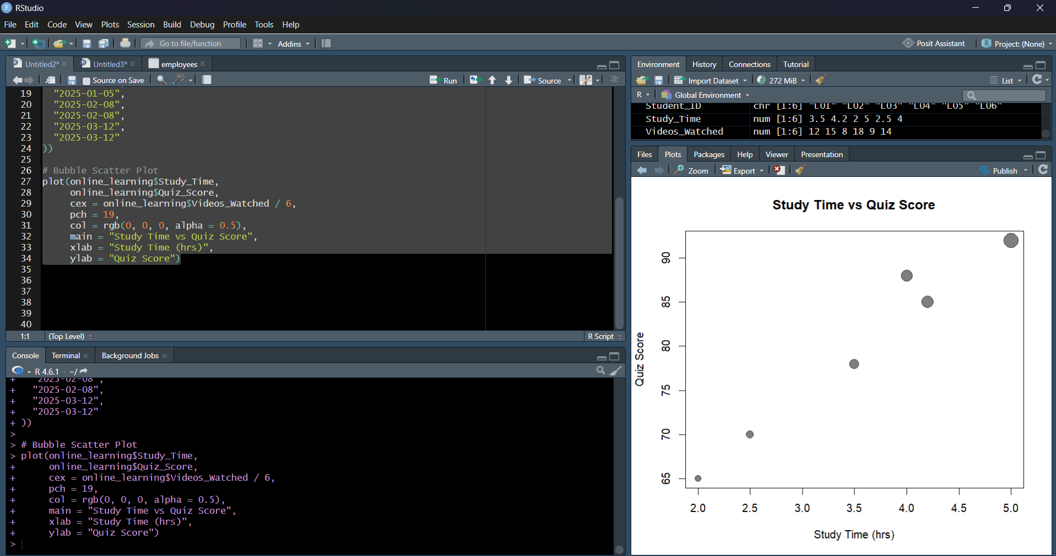
Output 2: Study Time vs Quiz Score
Observation: The scatter plot indicates a positive learning pattern in the supplied data: higher study time is generally associated with higher quiz scores. Larger bubbles indicate more videos watched.
PROGRAM 3: Monthly Average Quiz Score
Using R programming, convert Login_Date into Date format. Calculate average quiz score per month. Plot a line chart. Apply moving average smoothing. Identify the trend.
# Dataset
# Convert Login_Date into Date format
data$Login_Date <- as.Date(data$Login_Date)

# Create Month variable
data$Month <- format(data$Login_Date, "%Y-%m")

# Calculate average quiz score per month
monthly_avg <- aggregate(Quiz_Score ~ Month,
data = data,
FUN = mean)

# Moving Average Smoothing
monthly_avg$Moving_Average <- stats::filter(
monthly_avg$Quiz_Score,
rep(1/2, 2),
sides = 1)

# Line Chart
plot(monthly_avg$Quiz_Score,
type = "o",
xaxt = "n",
main = "Monthly Average Quiz Score",
xlab = "Month",
ylab = "Average Quiz Score")

axis(1,
at = seq_along(monthly_avg$Month),
labels = monthly_avg$Month)

lines(monthly_avg$Moving_Average,
type = "o")
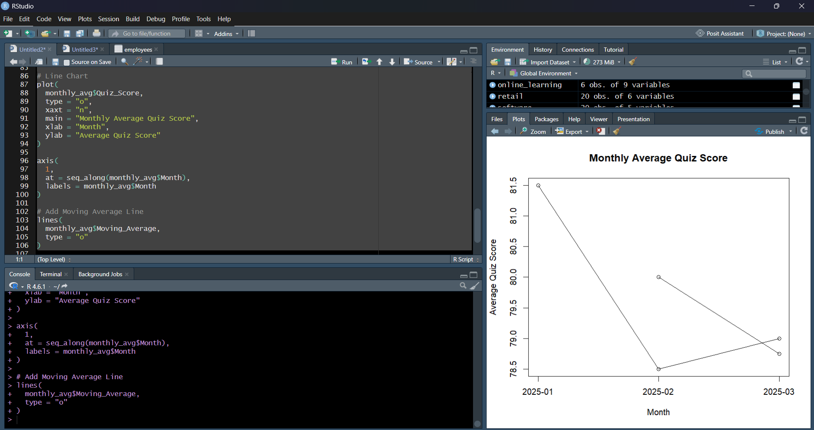
Output 3: Monthly Average Quiz Score
Observation: The monthly average quiz scores are 81.5 in January, 78.5 in February, and 79.0 in March. The trend decreases in February and rises slightly in March; the moving average smooths the short-term change.
PROGRAM 4: Tableau Mini Interactive Dashboard
Import Online_Learning_Activity.csv into Tableau. Create a bar chart showing average quiz score by Course. Create a scatter plot (Study Time vs Quiz Score). Add filter for Gender and Course. Design a mini interactive dashboard.
# Dataset
# Tableau Dashboard Procedure
# 1. Connect Online_Learning_Activity.csv.
# 2. Create a bar chart with Course and AVG(Quiz_Score).
# 3. Create a scatter plot with Study_Time and Quiz_Score.
# 4. Place Videos_Watched on Size.
# 5. Add Gender as a filter.
# 6. Add Course as a filter.
# 7. Combine the worksheets into a mini dashboard.
# 8. Apply the filters to the dashboard for interactive exploration.
Observation: The mini dashboard combines course-wise average quiz score and the Study Time versus Quiz Score scatter plot. Gender and Course filters allow interactive exploration.
Set 9 Procedure
Import Online_Learning_Activity.csv into R and Tableau.
Use hist() and boxplot() to analyze Quiz_Score distribution and course-wise performance.
Use plot() to create a bubble scatter plot between Study_Time and Quiz_Score with Videos_Watched represented by bubble size.
Convert Login_Date into Date format, calculate monthly average quiz scores, and apply moving-average smoothing.
Create Tableau worksheets for average quiz score by Course and Study Time versus Quiz Score, then combine them into an interactive dashboard with Gender and Course filters.
Set 9 Result
The Online Learning Activity data was analyzed using a histogram, boxplot, bubble scatter plot, and monthly line chart with moving-average smoothing. A Tableau mini dashboard was designed to combine course performance and learning-pattern analysis with interactive Gender and Course filters.

