**Task1:** Perform VNet Peering

VNet peering (or Virtual Network peering) enables you to connect virtual networks. A VNet peering connection between virtual networks enables you to route traffic between them privately through IPv4 addresses. Virtual machines in the peered VNets can communicate with each other as if they are within the same network.

Steps to perform VNet peering between two vm’s:

Step 1. Open Azure portal and search inside dashboard ‘Virtual Machine’.

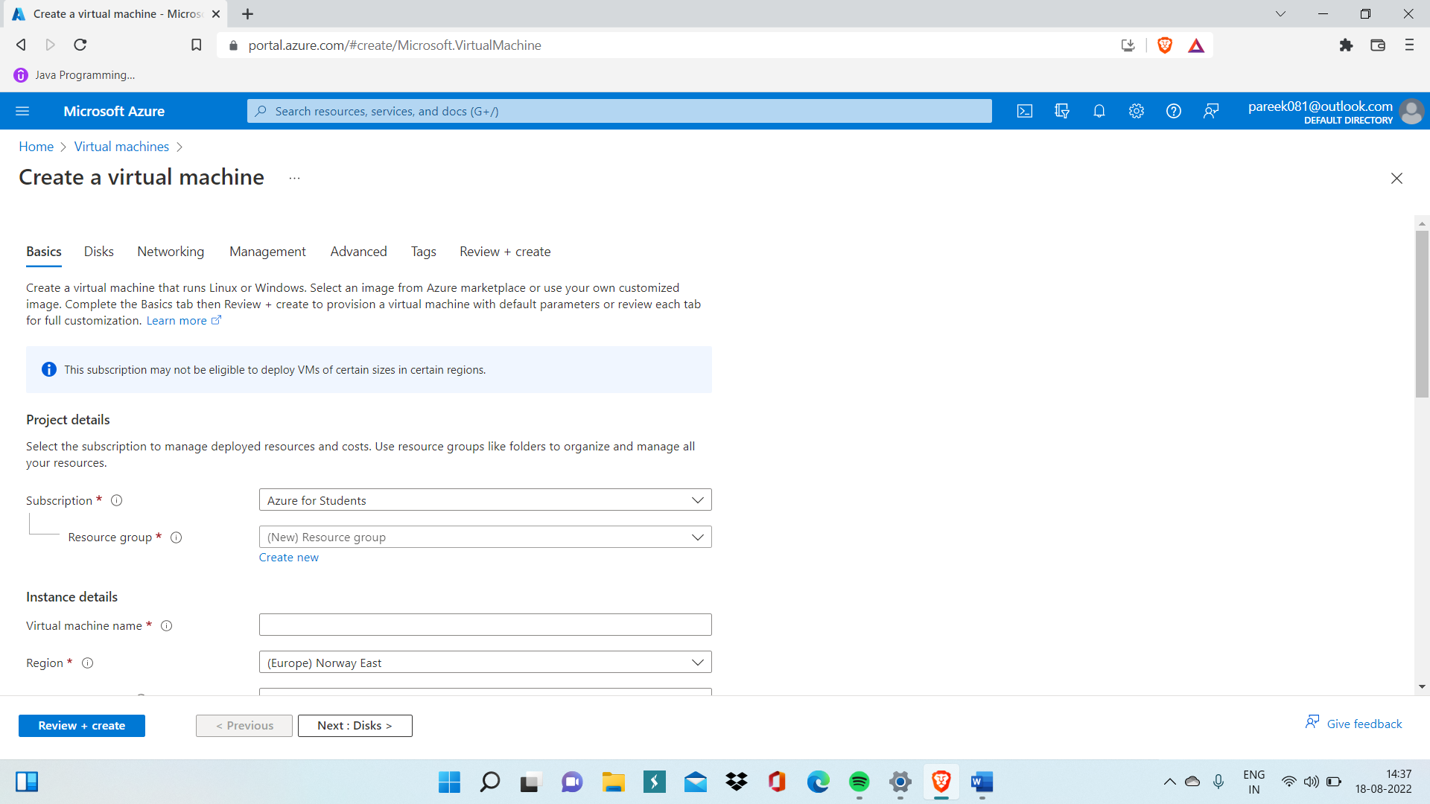

Step 2. Now fill the details related to VM like VM name, Region, VM image and then inside networking section choose VNet inside which you are creating your VM and then ‘Review and Create’.

Step 3. Then, Open Virtual machine you have created and then download RDP file to open VM. You can find RDP file easily inside Connection dropdown menu.

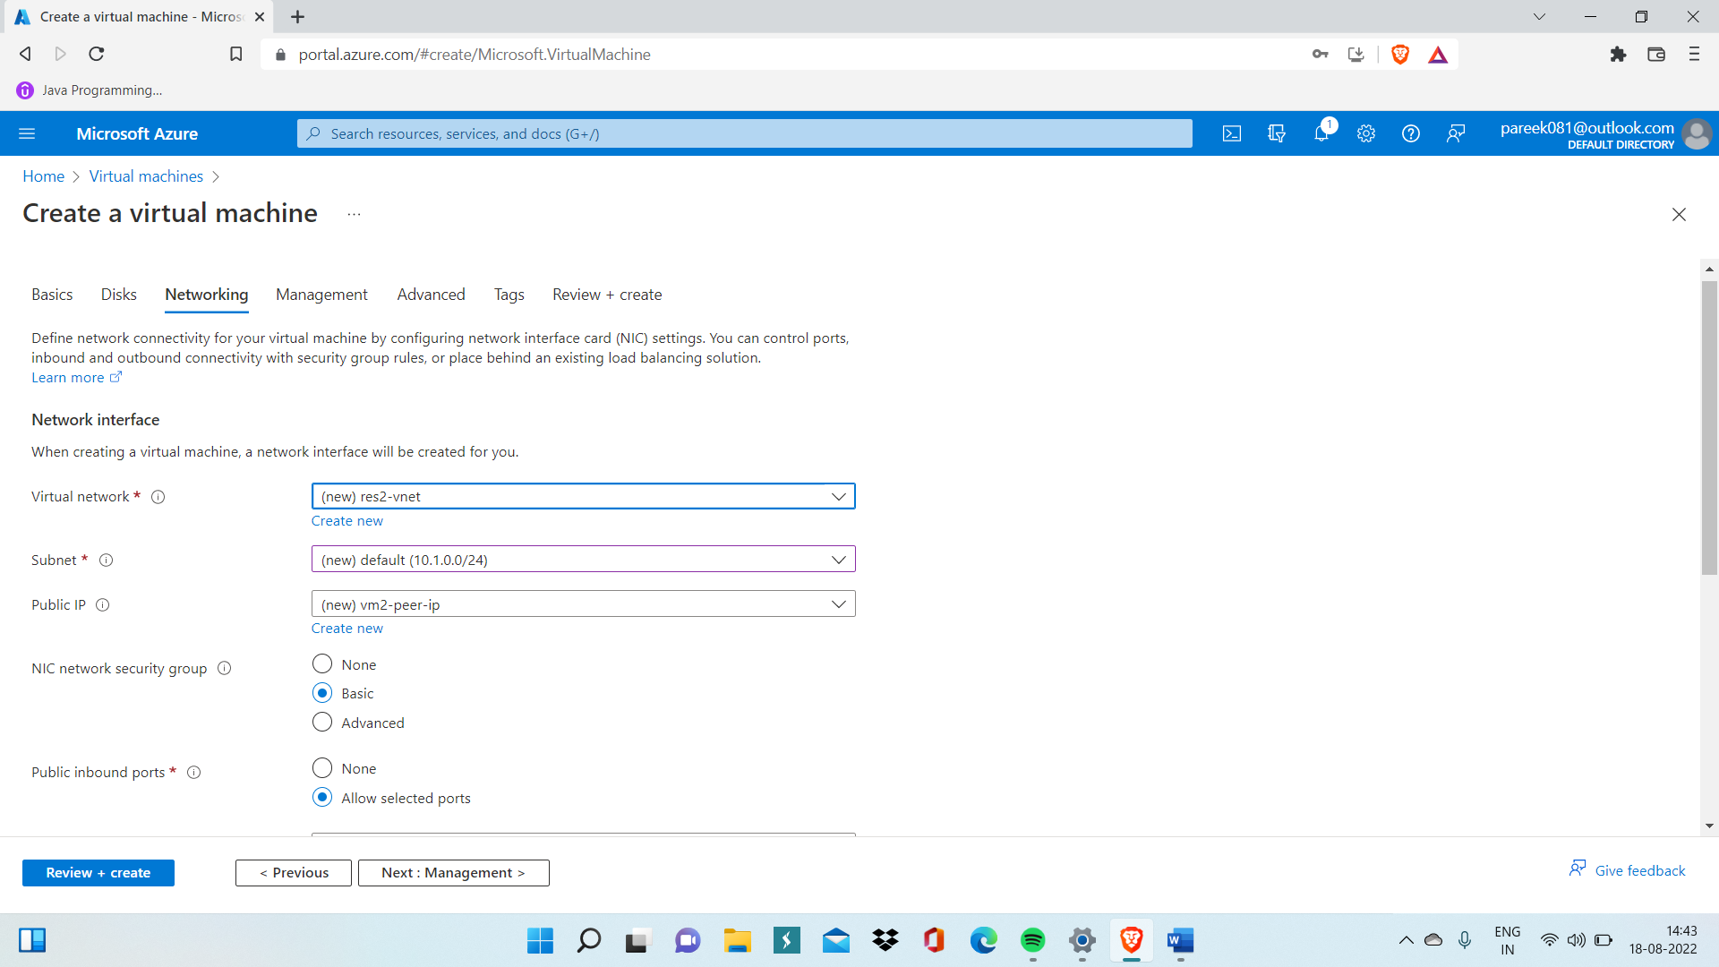

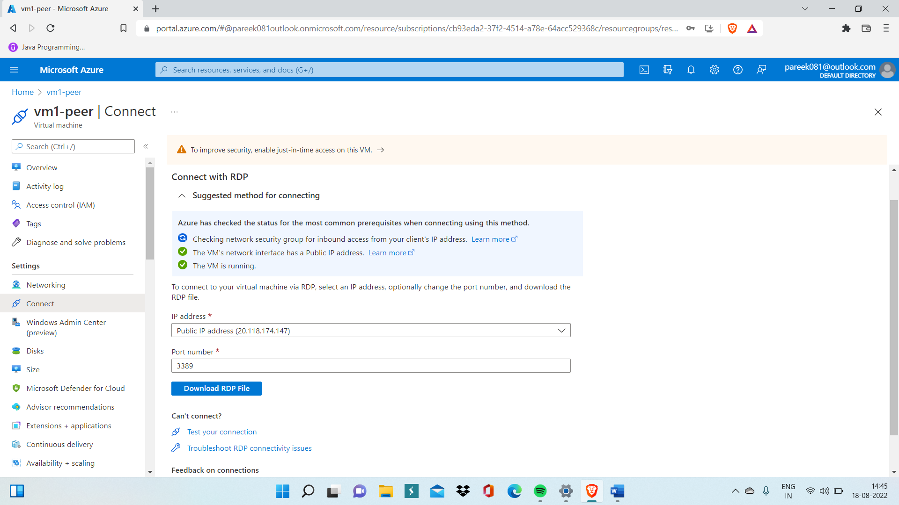

Step 4. Now repeat step 1 to 3 to create another VM and make sure that inside networking section of second VM you have selected another VNet.

Step 5. Now open VNet1 (virtual network in which you have created your first virtual machine) and go inside peering menu.

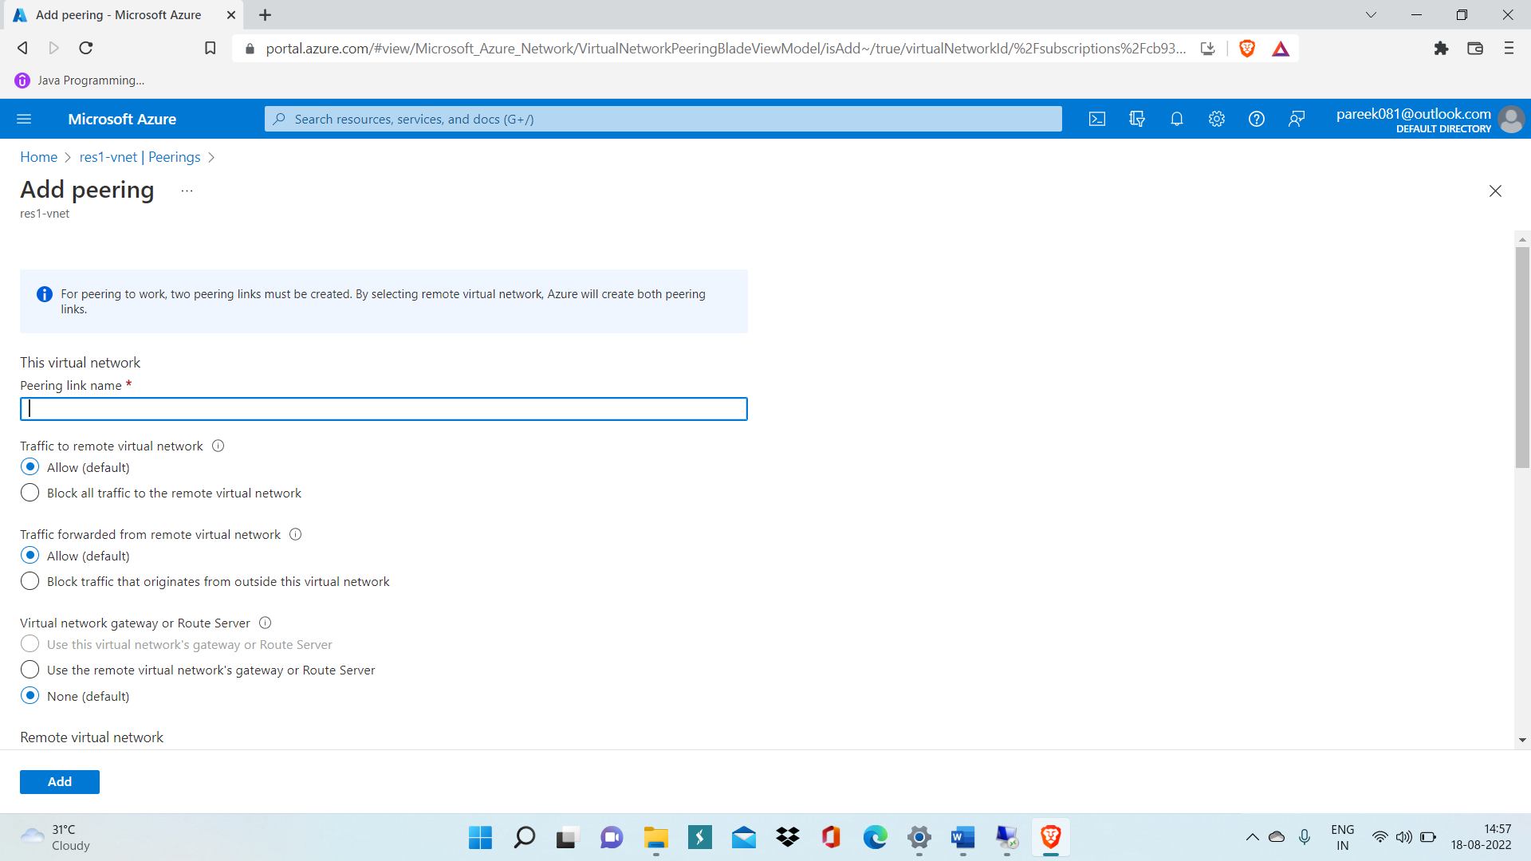

Step 6. Select Vnet2(another virtual network in which second VM is created) inside peered virtual network section and then click Add.

Step 7. Now inside both Vm’s, go inside Advanced firewall advanced settings and then go inside inbound rules.

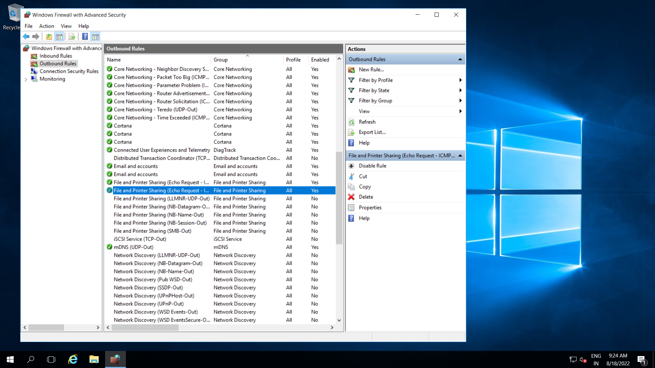

Step 8. Inside inbound rules, Enables File and Printer sharing rules for both ICMPv4 and ICMPv6.

Step 9. go inside powershell of any of the VM and write ping command to check it is properly connected or not ‘ping <private IP of another VM>’ For eg. ping 10.1.0.4 here private IP of one VM is 10.0.0.4 and another VM private IP is 10.1.0.4.

